

**School of Computing and Mathematical Sciences**

**CO7201 Individual Project**

**Final Report**

**Exploring HESA Data with Large Language Models for Dynamic Visualisation**

**Vladimirs Ribakovs**

**vr112@student.le.ac.uk**

**239062116**

**Project Supervisor: Heckel, Reiko (Prof.)**

**Principal Marker: Goes, Fabricio (Dr.)**

**Word Count: 12644**

(excluding table contents, table labels, headings, references and appendices)

**27/04/2025**

**DECLARATION**

All sentences or passages quoted in this report, or computer code of any form whatsoever used and/or submitted at any stages, which are taken from other people’s work have been specifically acknowledged by clear citation of the source, specifying author, work, date and page(s). Any part of my own written work, or software coding, which is substantially based upon other people’s work, is duly accompanied by clear citation of the source, specifying author, work, date and page(s). I understand that failure to do this amounts to plagiarism and will be considered grounds for failure in this module and the degree examination as a whole.

Name: Vladimirs Ribakovs

Date: 14/05/25

Contents

1. Introduction 8

1.1 Research Question 8

1.2 Background and context 8

Introduction to HESA 8

Dynamic Visualisations 8

Why using LLMs for this Project 9

The Change of Original Approach 9

Personal Motivation 9

1.3 Problem Statement 10

Current Manual Approach of Processing HESA Data 10

HESA's Static Visualisations 10

Inflexibility of HESA Data 11

1.4 Aims and Objectives 11

1.5 Requirements 12

1.6 Scope and Limitations 13

Why Only University of Leicester Related Data 14

Only General HESA Data 14

1.7 Significance of the Project 15

1.8 Proposed Solution 16

2. Literature Review 16

2.1 Overview of HESA Data and Benchmarking in Higher Education 16

Detailed description of the Structure of HESA Data 16

2.2 Large Language Models (LLMs) 18

Overview of LLMs 18

The Gemini Model (1.5 Pro) 18

Comparison with Other LLMs (e.g., GPT-J) 19

2.3 LLM Usage in Data Analysis and Visualization 19

Natural Language to Visualization (NL2Vis) 19

2.4 Data Privacy and Safety with LLMs 19

Risks and Concerns with LLM APIs 19

Mitigation Strategies 20

2.5 Data Analysis Techniques 20

Ethical Considerations in Data Analysis 20

Quantitative Data Analysis in Academic Projects 20

3. Project Design and Planning 21

3.1 Conceptual Framework and Initial Approach 21

3.2 Risk Identification and Mitigation Strategies Implemented 21

3.3 Project Phases and Timeline 22

Explanation of Project Phases 23

4. System Specification 23

4.1 Data Flow Diagram 23

4.2 Technical Architecture Design 26

Technical Architecture Overview 26

Development Stack and Dependencies 28

Component Roles and Interactions 29

5. Implementation 30

5.1 Data Processing Pipeline Implementation 30

Raw Data Acquisition and Storage 30

Metadata Extraction and Indexing 31

Data Cleaning and Standardization 32

Transformation and Enhanced Metadata Generation 33

Rationale for Separate Raw and Clean Files 34

5.2 Query Processing and Interpretation 34

Overview of Natural Language Query Interpretation 34

Parameter Extraction, Tokenisation, and Normalization Techniques 35

LLM Integration Design 35

5.3 Visualization Generation 37

Chart Generation 37

Chart Types Implementation 37

Frontend Rendering 37

Interactive Visualization Controls 37

Real time Chart Regeneration 37

Visualization Type Recommendations 38

5.4 UI Implementation and Interactivity 38

Dashboard Interface 38

Dataset Details View 38

Dynamic Dataset Previews 39

Responsive Design 39

5.5 Feedback System 40

Feedback Collection 40

Feedback Submission 40

5.6 Caching and Performance Optimization 40

Query Cache Implementation 40

5.7 Codebase Structure and Endpoints 41

Codebase Overview 41

Key Endpoints 42

5.8 System Setup and Running Instructions 42

6. Demonstration 43

6.1 Using the AI Powered Query Interface 43

Submitting a Natural Language Query 43

6.2 Query Interface 44

Reviewing Query Analysis Results 44

Working with Dataset Details and Visualization 45

Generating and Interacting with Visualizations 46

6.3 Providing Feedback on Results 49

Submitting Feedback on Query and Visualization 49

6.4 Uploading Custom Data 50

Navigating to the Data Upload Section 50

Uploading and Processing Data Files 50

6.5 Exploring Documentation 52

Accessing the Documentation Page 52

6.6 Complete User Journey Example 57

From Query to Insight: Full Workflow 57

7. Testing and Evaluation 61

7.1 Testing Methodologies 61

Unit Testing 61

Integration Testing 63

7.2 Performance Metrics and Results 66

Query Response Time 66

Accuracy of Query Interpretation 68

8. Discussion 74

8.1 Analysis of Findings 74

8.2 Explaining LLM and Method Comparisons 74

Explanation of the Initial GPT-J Implementation and Reasons for its Failure 74

Comparison of Approaches (Regex, GPT-J, Gemini) 74

8.3 Project Process Evolution and Timeline 76

Impact of Process Changes 77

Lessons Learned from Process Evolution 78

8.4 Achievement of Requirements 78

8.5 Personal Learning and Reflection 82

8.6 Critical Evaluation 83

Research 83

Design 83

Implementation 83

8.7 Discussion of the Number of Requests and Associated Costs 84

9. Conclusion and Future Work 84

9.1 Summary of Project Achievements 84

9.2 Conclusions 85

9.3 Future Work and Recommendations 85

10. References 85

11. Appendix 87

A: Pandas-Based Data Processing Pipeline 87

A.1 Data Transformation for Visualization 87

A.2 Multi-format Data Loading in Correlation Engine 88

A.3 Chart Data Preparation with Pandas Pivot 89

B: Unit Testing 90

B.1, B.2 Data Processing and LLM Integration 90

B.3 Visualization 92

C: Integration tests 96

C.1 Query to Visualization Flow 96

C.2 Mock AI Client Integration 100

D: Data Processing Pipeline Implementation 103

D.1 Data Ingestion Process 103

D.2 Manual Update Process 105

D.3 Metadata Extraction 107

D.4 Indexing 108

D.5 Cleaning Process 112

D.6 CSVProcessor 115

E: Query Processing and Interpretation 117

E.1 Transform free text into query parameters 117

E.2 Date Interpretation 121

F: Visualization Generation 123

F.1 Chart Generation 123

F.2 Handles different chart type requests 127

F.3 Gets AI recommendations for chart types 130

F.4 Dynamically changing the visualization 131

G: Front-End Rendering 133

G.1 Rendering Visualization 133

G.2 Interaction Control 134

G.3 Changing Chart Type 137

H: Interactive Visualization Controls 139

H.1 Back-end connection 139

H.2 Chart Type Explanation 140

I: Dashboard Interface 141

I.1 Display Query Results 141

I.2 Reviewable Dataset 143

I.3 Manage loading states 145

I.4 Query Input 146

I.5: Exporting data 148

I.6 Prepare Data for Clean Display 149

I.7 Dynamic dataset preview toggle 150

J: Feedback System 151

K: Caching 154

L: Gemini Client 158

M: Timing Queries 163

M.1 Recording the time of query processing 163

M.2 Recorded time of processed queries 165

# 1. Introduction

## 1.1 Research Question

How can Large Language Models (LLMs) be used to effectively and dynamically process and visualise HESA open-source data to enable the University of Leicester to more efficiently understand its performance against peer institutions?

## 1.2 Background and context

### Introduction to HESA

* Higher Education Statistics Agency (HESA) is the primary and official open-source data collection agency for UK higher education.
* It provides a massive database consisting of millions of records covering various aspects such as institutional performance, funding and benchmarking.
* HESA's mandate is to collect, analyse, and disseminate reliable statistical information about UK higher education.
* The types of data provided by HESA and used in this project include: [5]
  + Student enrolment data (by level, mode, demographic)
  + Staff information (qualifications, contracts, demographics)
  + Financial data (income, expenditure)
  + Facilities information (accommodation, resources)
  + Course and program statistics.

These datasets enable institutions to benchmark against peer institutions and to identify areas for improvement, and track progress over time. [5]

HESA data serves multiple stakeholders:

* Universities use it for strategic planning, performance reviews, and competitive analysis [5]
* Government bodies use it for policy development and funding allocation [5]
* Researchers analyse trends in higher education access, outcomes, and equity [5]

### Dynamic Visualisations

Dynamic visualisations are interactive and responsive visual tools used in this project to visualise HESA data. They go beyond static charts by allowing user interaction, real time data exploration, and customization [21]. This project implements it using Chart.js and it allows users to:

* Change the type of visualization on demand.
* Filter data by time periods or institutions.
* Zoom and explore details within charts.
* Compare multiple metrics simultaneously.

This approach transforms raw HESA data into results that can be explored rather than just viewed. Dynamic visualisations are data that is interactively represented based on the user’s submitted query. It can reveal differently even on the same dataset because it depends on the user’s intent. They improve insights by:

* Enabling exploration of underlying patterns.
* Facilitating comparison between different data segments.
* Allowing users to focus on specific areas of interest.
* Supporting different levels of data granularity.

### Why using LLMs for this Project

Manual analysis and processing a large volume of complex data is time consuming and difficult, so LLMs offer a solution to this tedious process. In this project, an LLM is used at different stages of the system, such as data processing, analysis, extraction, preparation, recommendations, and even visualization. Even though HESA provides ways to visualise data, but those visualisations are limited and static. Using an LLM can help to work with this data in a more efficient and intuitive way. The Gemini 1.5 Pro was chosen as the LLM for this project because its excellent understanding of natural language queries (NLQ) and translating them into structured operations. This feature addresses challenges in data analytics and allows users without any technical knowledge in this area to access and work with complex datasets.

LLMs offer several advantages for query interpretation:

* Understand context and intent beyond keyword matching
* Handle variations in how questions are phrased
* Recognize domain specific terminology (e.g. “academic years”)
* To understand relationships between entities such as institutions, metrics or time periods

Traditional data query methods require knowledge of query languages or tools, understanding of dataset structure, and multiple steps to filter and extract relevant data. LLMs eliminate these barriers by allowing users to simply ask questions in plain English, making data more accessible and reducing the time from question to answer.

### The Change of Original Approach

Originally, when the project was just proposed, the GPT-J was selected as the LLM for the project. After exploring GPT-J for some time, I realised that it did not meet the specific requirements of the project, so I had to switch to a more robust and advanced model, Gemini 1.5 Pro. See the section 8.2 on why exactly this approach failed.

### Personal Motivation

My personal motivation is to undertake a project that uses an LLM to solve a real world problem. Also, I am fascinated by how much AI (Artificial Intelligence) has improved in the past couple of years, so I want to do more projects using it to get more experience with it. I consider this project a big step toward getting more advanced in working with AI.

## 1.3 Problem Statement

### Current Manual Approach of Processing HESA Data

The current approach to understand the University of Leicester's performance relative to peer institutions using HESA data is manual, tedious, error-prone, and costly [5]. This process requires dedicated staff to spend significant time manually researching and manipulating HESA data.

Even though there is no exact open-source information on how the University of Leicester conducts these searches, based on related information and logical thinking, it can be how it proceeds.

As mentioned above, there is no specific information on how this process is conducted. The University of Leicester does not even say anything about this data being used from the HESA source, at least it is not publicly available.

The University's privacy notice indicates they conduct “statistical analysis” using student data, which suggests that HESA submissions are being used. This strongly suggests that university employees, likely within departments like planning, academic affairs, or institutional research, are involved in this process. [13]

Looking at the job applications that the University of Leicester posts for roles that are closely related to “statistical analyses,” I found that they mention the following tools: Power BI, Microsoft Office, or Tableau [14]. According to the discovered information, I can assume that they undertake the following steps to perform current analyses of HESA data:

* Downloading multiple CSV files.
* Cleaning and standardizing data.
* Merging datasets from different years.
* Creating visualizations in tools like Excel, Tableau or Power BI.

Visualisations created through tools like Excel, Tableau, or Power BI further compound these challenges because of inflexible formats. If a research question is changed or followed up by another question, analysts would likely have to restart the entire process – extracting data, reformatting columns, recategorizing values, and generating new charts, which results in significant reporting delays.

Manual methods suffer from:

* Inconsistent data cleaning approaches
* Difficulty in tracking data provenance
* Time intensive repetitive tasks
* Errors in data transformation and aggregation
* Challenges in maintaining and creating visualizations

### HESA's Static Visualisations

* Static charts provided by HESA are limited and cannot adapt to users’ specific questions. They cannot show relationships between multiple variables, provide different levels of detail, and support exploration beyond the initial visualization.
* Predefined visualizations cannot be easily changed, so users are restricted to the data and format that HESA provides.
* Users cannot even remove specific data points or change visual attributes like colours or titles.
* HESA offers a variety of charts like line, bar, pie or scatter, but the user cannot decide for themselves what chart they want. Users are forced to use only existing predefined charts.
* Having all these points combined, the fact that users cannot decide what chart to have and cannot change existing charts, it all leads to limited analyses. At best, charts provide a dropdown menu that allows sorting by value, like country, as shown in Figure 1

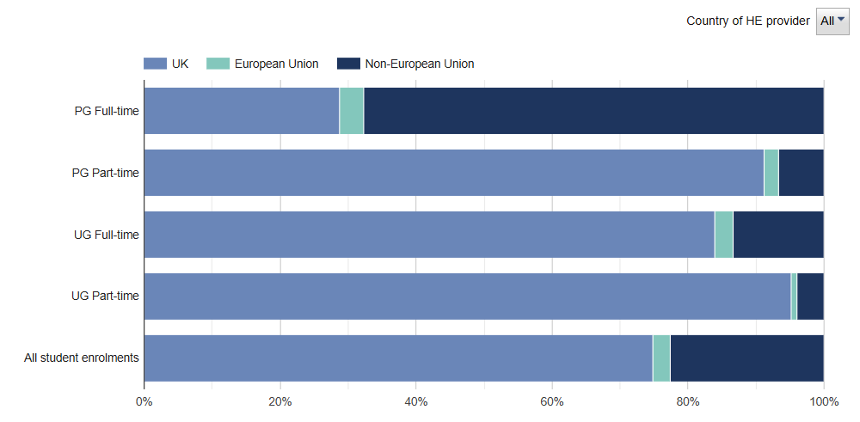

*Figure 1: HESA, HE student enrolments by level of study, mode of study and permanent address, Academic year 2023/24.*

### Inflexibility of HESA Data

HESA does not provide a way to include comparison by Mission Group (Russell Group, University Alliance, Million+), so when an analyst needs to benchmark data against a Mission Group, the data needs to be manually found for each institution in a particular Mission Group. For example, when benchmarking groups shifted to include more institutions from Russell Group, existing reports required manual reconstruction. The inability to dynamically filter, recategorize, or pivot data dimensions without rebuilding entire visualization sets severely limits the exploration of emerging patterns and trends.

## 1.4 Aims and Objectives

The University of Leicester needs a solution that:

* Adapt to evolving analytical questions
* Provide insights without technical barriers
* Support strategic decision making with relevant comparisons
* Reduce the administrative burden of data analysis.

The project aims to address these limitations by creating a dynamic, user-friendly dashboard powered by an LLM Gemini 1.5 Pro that provides more efficient data comparison, extraction and analysis.

The purpose of this project is to make it easier for the University of Leicester to understand its organisational performance, structure, strengths, and weaknesses against peer institutions by leveraging HESA open-source data. The project aims to transform HESA data interaction through:

* Intelligent data processing that understands academic contexts
* Natural language query interpretation that captures institutional benchmarking needs
* Dynamic visualization that reveals meaningful patterns and comparisons.

The core goal is to reduce the technical and time barriers to analyse HESA data for the University of Leicester. This will allow them to gain powerful insights, ultimately saving time and potentially reducing costs.

## 1.5 Requirements

Essential:

* **Natural Language Query Interpretation:** The system understands users’ free form queries and retrieves and processes data based on that.
* **Integrating and Processing Data:** Extracting and preparing clean HESA data and making it usable for comparing metric performance.
* **Interactive Dashboard:** It must dynamically display results in different formats like tables, charts, diagrams or summary reports.
* **Comparative Analysis**: A feature that must allow grouping and benchmarking universities by different categories like Mission Groups.
* **Data Export Capabilities:** Allow users to download generated reports and data as CSV, PDF or Excel files.

Recommended:

* **Automated Data Retrieval:** Enable automatic updates of the dashboard with new data from HESA when it is available.
* **Using AI To Improve Analysis:** LLM should provide insights, trend identification, and recommendations if user asks for that.
* **Query Building Guide**: Provide a guide or pre-built examples for users who are unfamiliar with the free text queries.
* **Advanced Visualisation:** Support interactive graphs, trend projections that offer visual comparison of performance metrics.
* **Historical Data Tracking:** Tracking data changes over time to see how performance was changing relative to peers.
* **Caching for Frequent Queries:** Implement caching to perform repeated queries more efficient that will result in better performance.
* **LLM Interpretation Feedback:** Allow users to see how their query was interpreted by the system (Pandas) to improved data transparency and remove bias factor.
* **Queries Logs:** Log out user queries to improve future prompts tuning.
* **Data Overload protection**: Implement a safeguard that prevents outputs of big queries to potentially crash the system.
* **CSV File Validation:** Make a mechanism to automatically sanitize new raw HESA data by checking for correct format and size anomalies and then prepare it for the data processing.

Optional:

* **Predictive Modelling:** Using historical data and machine learning (ML) to predict future performance metrics
* **Chatbot Integration:** Include an AI chatbot assistant to help users to refine their queries dynamically, in real time.
* **API for External Use:** Create an API so that external and third-party applications can use dashboard’s functionality
* **Collect feedback:** Implement mechanisms to collect users' feedback through the surveys to continuously improve the system
* **Data Storage Scalability**: If HESA data volume grows beyond local CSV storage it will be moved to a more scalable database solution such as PostgreSQL or SQLite.
* **Multiuser Concurrency:** Allow users to submit multiple queries simultaneously by using asynchronous job queues such as Celery and session management.
* **Deployment**: Develop a deployment plan starting with local deployment and extending to containerization such as Docker and orchestration like Kubernetes for future scalability.

## 1.6 Scope and Limitations

This project focuses on developing a tool for exploring HESA open-source general data in CSV format that is relevant to the University of Leicester.

The project covers:

* Processing and indexing selected HESA CSV datasets.
* Natural language querying of these datasets.
* Automatic visualization generation using Chart.js.
* Comparing and benchmarking institutions that are particularly focused on Mission Groups.
* Provide functionality to export the data.

It does not cover:

* Real time data goes directly from HESA.
* Custom data upload from non-HESA sources.
* Comprehensive processing of all available HESA data.

### Why Only University of Leicester Related Data

* The project intentionally focuses on Leicester relevant datasets to provide meaningful benchmarking rather than attempting to cover the entire HESA data.
* Only data that has records about the University of Leicester was downloaded and used for the project because the primary purpose is comparison against the University of Leicester.
* This focused approach provides more relevant and actionable insights for University of Leicester stakeholders. It improves performance by reducing the dataset size, enables better benchmarking and allows for more targeted visualizations.

### Only General HESA Data

HESA provides two types of files:

* extremely detailed files containing about 500,000 – 700,000 rows of data on average
* general CSV files that have around 100 – 400 rows of data on average.

The detailed files cause significant challenges for the LLM processing due to token limits restricting how much data can be analysed at once. The restrictions would affect any modern open-source LLM, so this is not a drawback of Gemini 1.5 Pro. Other challenges with detailed data are increased processing time with dataset size, memory constraints for complex analyses, excessive API costs, and often contain redundant or overly granular information. Therefore, this project focuses only on using general HESA data files.

This project uses a total of 392 general HESA CSV files. These general files still provide comprehensive data about various aspects but are less detailed which makes them more suitable for the scope of this project. The project addresses potential challenges of high data volume by implementing selective data processing and indexing functionality. Data is filtered first by academic year(s), then by relevance to the query, and typically only about 10-20 files relevant to a query, where each file has approximately 300 lines, is sent to the LLM for analysis.

This approach is critical for managing processing cost and time. For example, if the system sends 10 – 20 of the detailed files where each file averaging around 600,000 lines of text, this will require processing a significantly larger volume of data. Based on current usage, approximately 227 request cost about £1 of free credit using general files. (see Figure 8)

Note:

*Number of requests per £1 = 882 (Total number of request) / 3.88 (Total cost of total number of request) ≈ 227 (see Figure 8)*

Using detailed files under similar query conditions would be estimated to cost at least 2000 times more due to the vastly increased data volume processed per query. This highlights the main drawback of using detailed files for dynamic analysis with the current approach and budget constraints. Therefore, this project focuses on using general data to allow for dynamic analysis using the LLM.

Note:

The estimate of “at least 2000 times more” cost when using detailed files is based on the difference in data volume processed per query. The calculation is as follows:

* *Average lines per query with general files: (10 files * 300 lines/file + 20 files * 300 lines/file) / 2 = 4,500 lines*
* *Average lines per query with detailed files: (10 files * 600,000 lines/file + 20 files * 600,000 lines/file) / 2 = 9,000,000 lines*
* *Ratio of detailed to general data volume: 9,000,000 lines / 4,500 lines = 2000 times*

More data per query means much higher token usage, which leads to a significantly higher cost per API call.

## 1.7 Significance of the Project

This project aims to deliver a significant impact on decision making processes for the University of Leicester. It expects to allow for more flexible and accessible work with the HESA data

The project significantly impacts university decision making by:

* Providing faster access to comparative insights.
* Enabling the University of Leicester (UOL) to explore data without technical barriers.
* Helping the OUL use data to make better decisions
* Supporting real time responses to data-related questions.

These features help with strategic planning by showing patterns and trends that static reports might miss and allowing interactive filtering for deeper analysis.

The project also contributes to automating data visualization and analysis in higher education analytics by:

* Demonstrating effective LLM integration for educational data analysis.
* Creating a reusable framework for natural language data exploration.
* Establishing patterns for automated chart recommendation and generation.
* Providing a feedback loop for continuous improvement.

Long term benefits:

* Reduced administrative burden for data analysis
* More consistent and reproducible data visualization
* Institutional knowledge capture through query patterns
* Improved data literacy across the organization.

## 1.8 Proposed Solution

The dynamic dashboard is intended to simplify the process of comparing university performance, saving time and potentially reducing costs. It will allow users to query data in plain English and receive dynamic charts, diagrams, and summary reports. Moreover, the dashboard aims to enable benchmarking of the University of Leicester against Mission Groups and other institutions. It would support relatively easy updates as new HESA data becomes available (through the implemented manual upload feature). The motivation is to make comparisons between universities more efficient and accurate. It will allow the University of Leicester to quickly identify its strengths and weaknesses, potentially leading to better resource allocation and improved outcomes.

# 2. Literature Review

## 2.1 Overview of HESA Data and Benchmarking in Higher Education

### Detailed description of the Structure of HESA Data

HESA data follows a structured format organized by data stream, and it has consistent patterns across different types of information. The system is implemented to understand and process this structure through data processing and indexing functionality. Key data streams relevant to this project include:

* **Students:** Covering entrants, qualifiers, and total numbers [5]. This includes information on:
  + Who is studying in Higher Education (HE),
  + Where they come from, where they study
  + What they study
  + Progression rates and qualifications.
  + Enrolment statistics by level, mode, and year,
  + Demographic information (age, gender, ethnicity),
  + Progression and completion rates,
  + Qualifiers by degree classification
  + Subject area breakdowns.
* **Staff:** Covering demographic and contract characteristics [5]. This includes data on:
  + Who is working in HE
  + What areas they work in
  + What their employment conditions are
  + What their salaries are
  + Where they work
  + Where they come from and go to
  + Employment conditions (contract types, full/part-time)
  + Salary ranges and pay gaps
  + Academic qualifications and specialties
  + Demographic profiles
  + Staff-student ratios
* **Graduates:** Covering survey results showing the activities of recent graduates [5]. This includes data on:
  + Summary statistics on employment outcomes
  + Further study progression
  + Salary information,
  + Industry sectors
  + Graduate satisfaction metrics
* **Finances:** Covering income, expenditure, and financial statements of HE providers [5]. This includes data on:
  + Income and expenditure of HE providers
  + Other financial statements
  + Key Financial Indicators (KFI)
  + Financial data encompasses income sources (tuition, research, commercial)
  + Expenditure categories
  + Balance sheet information
  + Financial sustainability metrics
  + Capital investment patterns
* **Business and Community Interaction:** Covering intellectual property, services, and engagement[5]. This area includes data on:
  + Knowledge exchange activities
  + Patent and IP generation
  + Commercial partnerships
  + Social and community engagement
  + Continuing professional development.
* **Estates Management:** Covering environmental information [5]. This includes:
  + Building condition and space utilization
  + Energy consumption and carbon emissions
  + Waste management and recycling
  + Water usage
  + Sustainability initiatives.

HESA data also appears in multiple formats:

* Tabular data (CSV files with structured rows and columns)
* Time series (sequential data across academic years)
* Categorical breakdowns (data segmented by demographics or characteristics)
* Hierarchical relationships (institutional, departmental, subject levels)
* Geospatial information (regional and institutional locations).

HESA data is the official source for UK higher education information. It provides a standard way to compare institutions and evaluate their performance. This data is essential for university planning, government funding and policy, ensuring quality, following rules, and showing the public how the sector is doing [17].

Reports show that HESA data is key for universities to see how they compare to others. However, there are still problems with getting the data easily, to get it on time, and sharing it to make benchmarking most effective. There are certain rules and difficulties in using numbers to compare institutions [18].

## 2.2 Large Language Models (LLMs)

### Overview of LLMs

LLMs are strong in data projects like this, but they also have downsides [2],[3].

Advantages:

* Understand natural language
* Handle different question styles
* Recognise complex data relationships
* Create an easy-to-read explanation
* Adapt to new topics

Downsides:

* Limits on how much text they can process at once
* Costs for using APIs
* Delays in getting responses
* Sometimes give wrong information
* Need careful setup for prompts.

### The Gemini Model (1.5 Pro)

Gemini 1.5 Pro offers significant advantages: very large (undisclosed) parameters, a context window of up to 1 million+ tokens, native multimodality (text, audio, images, video), and accessed via API with associated costs but limited customization compared to self-hosted models [23].

### Comparison with Other LLMs (e.g., GPT-J)

|  |  |  |
| --- | --- | --- |
| Feature | GPT-J | Gemini 1.5 Pro |
| Parameters | Fewer (Earlier generation) | Significantly More (Undisclosed, but larger) |
| Context Window | Limited | Vastly Larger (Up to 1M+ tokens) |
| Multimodality | Primarily Text | Native Multimodality (Text, Audio, Images, Video) |
| Cost Structure | Free (if self-hosted), Infrastructure cost | API-based (Associated costs, free credits used) |
| Customisation | More extensive (if self-hosted) | Limited (API-based) |
| Flexibility | Less flexible | Greater flexibility (Handles diverse data types) |
| Ease of Use | Requires local setup/hosting | Easy to use (API access) |
| Performance | Slower processing, higher error rates | Faster processing, better accuracy |
| Specialised Knowledge | Limited understanding of HE terminology | Superior understanding of HE terminology |

*Table 1: Comparison of LLM Features (GPT-J vs. Gemini 1.5 Pro) [1], [23]*

## 2.3 LLM Usage in Data Analysis and Visualization

### Natural Language to Visualization (NL2Vis)

Natural Language Interfaces for querying and visualising tabular data (NL2Vis) is an active area of research. Recent surveys highlight the significant role of LLMs in this domain [21]. LLMs allow users to interact with data using natural language by converting free form queries into structured formats [22]. This process involves complexities:

* Understanding user intent
* Accurately mapping natural language terms to the underlying data schema
* Clearing up confusion [21].

Handling these challenges allows for automatic data retrieval and chart generation based on user intent [22].

## Data Privacy and Safety with LLMs

### Risks and Concerns with LLM APIs

Data safety and privacy are critical issues when working on an application that uses an LLM. This is especially the case when using external APIs. Besides having the general risk of data leakage there are also specific vulnerabilities that exist in the context of LLM applications. However, the HESA data that is being used for this project is publicly available, so it does not have any privacy problems, but this project still implements the safety measures. This could be used in case if the University of Lecester would decide to adapt this project to use sensitive information and create visualizations based on that:

* Prompt Injection: malicious input can manipulate the LLM's behaviour
* Insecure Output Handling: which can lead to exposure of sensitive information processed by the LLM

This is important to understand and follow these specific security measures when building robust and trustworthy LLM powered systems [19].

### Mitigation Strategies

Applying threat modelling to the system that uses LLM can help to identify vulnerabilities related to sensitive data handling [20]. The idea for dealing with data privacy risks always applies even if the situation changes. Below principles are focused on protecting user data and maintaining confidentiality [20]. Key mitigation strategies include:

* Keeping Raw Data Local: A fundamental strategy implemented is processing and storing raw HESA data locally. This ensures that sensitive or detailed information is not transmitted to the external LLM API [20].
* Selective Data Processing: Only necessary and anonymized data or metadata is sent to the LLM. Specific tasks like query interpretation or visualization configuration helps with minimizing the exposure of detailed HESA records.
* Robust Input Validation and Sanitization: Implementing careful validation and sanitization of user inputs helps to mitigate risks like Prompt Injection [19].
* Secure API Key Management: Ensuring API keys are stored and used securely to prevent unauthorized access to the LLM service.
* Monitoring and Logging: Implementing logging of LLM interactions can help in identifying and responding to potential security incidents.

## 2.5 Data Analysis Techniques

### Ethical Considerations in Data Analysis

It's very important to consider ethics when collecting, processing, or just analysing data today [15]. HESA data does not publish data that raises ethical questions, but it is important to mention that this project could be used to work with sensitive data if the University of Leicester require it. So, mentioning the importance of ethical concerns would help to avoid the pitfalls with privacy and bias.

### Quantitative Data Analysis in Academic Projects

Quantitative data analysis is a basic part of academic projects. There are studies that looked at dissertations and found common problems in how methods and statistics were used [16]. This shows how important it is to use the right research methods and make sure data is processed and tested accurately. This helps to get reliable and correct results, which makes the analysis of HESA data more trustworthy.

# 3. Project Design and Planning

## Conceptual Framework and Initial Approach

The project started with a clear focus on improving the way HESA data is being accessed. This is proposed to be done using AI powered natural language processing (NLP). The conceptual structure is based on these three main pillars:

* Data acquisition and preprocessing
* Query interpretation using AI
* Dynamic visualization generation

The original plan was to use AI model GPT-J because of its wide popularity, accessibility and its availability at no cost. Since the model supports self-hosting, it incurs no operational cost to run it on my own hardware. It allows you to maintain control over data processing and enables offline operation for enhanced data security. It supports customization, which is important for higher education specific terms and the model is decent when it comes to query interpretation and dataset matching [1]. Having all these points combined, clearly shows that this model was expected to be great for this type of project. This process followed a sequential flow:

* Data ingestion and preprocessing
* Query analysis using locally hosted GPT-J
* Dataset matching based on extracted parameters
* Visualization generation using predefined templates

Unfortunately, after exploring and using the GPT-J model further, I have concluded that this LLM was not suitable for my project, so I had to switch to a more advanced model like Gemini 1.5 Pro and I explained the reasons in section 8.2.

## 3.2 Risk Identification and Mitigation Strategies Implemented

I have identified some risks during the project planning phase and developed these strategies to resolve them.

* **Data Integration Complexity:** Having difficulties in merging and cleaning multiple CSV files because of HESA inconsistent formats, missing data, or anomalies in the files. This was mitigated by crafting a robust data cleaning methods using Pandas scripts. The process involves standardizing CSV formats within processing pipeline and performing iterative testing on sample datasets to refine the cleaning logic.
* **Inaccurate Query Interpretation:** To resolve the risk of LLM misinterpreting free text queries, I had to switch to Gemini 1.5 Pro because this model is more capable. I used carefully generated by Geminin and tailored by me prompts that were tailored based on the HESA data. I created a form of feedback that user could leave about how LLM does its job and implemented caching mechanism to store and quickly reuse successful queries.
* **Performance Bottlenecks with Large Data:** The risk of processing large datasets, which could result in slow query response was mitigated by processing a smaller amount of data by referring to indexing files and using a preview mode that limits displayed data. Also, caching for frequent queries to reduce processing time for repeated requests.
* **Automated Data Update Failures:** The initial risk related to automated data scraping failure was addressed by changing the approach to a manual data upload feature, which is less prone to external website structure changes and provides a reliable method for updating data.
* **User Interface/UX Challenges:** The risk of the dashboard not being intuitive was mitigated by focusing on a clean, minimalist design using Tailwind CSS, implementing interactive features based on usability principles, and planning for user feedback collection to identify areas for improvement.
* **Time Constraints and Scope Management:** The risk of incomplete implementation due to the deadline was managed by prioritizing essential requirements, setting realistic milestones in the revised Gantt charts. Also, important to continuously monitor the progress to adjust the scope if necessary.
* **Data Security and Confidentiality:** The risk of insecure handling of HESA data was mitigated by processing only publicly available open-source HESA data and storing it locally.

Initially, I was working on a backup system that was using regular expressions and math to produce clear query interpretation. This was a part of mitigation strategy in case there would be issue with API or LLM in general. After some time of testing this approach, I realized that I could not get the results I was expecting it to provide me. The main reason it kept failing because of HESA complex data and its diversity so I could not use a pattern to solve it. Even though I tried to cover as many edge cases as possible but even slight variation in the provided data formats or query phrasing could cause the algorithm to fail. Moreover, the eventual success of testing the Gemini API approach made this backup functionality unnecessary.

## Project Phases and Timeline

The project was structured into distinct phases to provide a clear roadmap for development and management. This approach aimed to break down the complex task of building an LLM powered HESA data visualization tool into manageable stages with specific objectives and deliverables.

The initial project timeline was planned to move through the main development areas one by one. The proposed phases were designed to move from basic setup and data preparation through the code system development, AI integration and testing. (see Figure 2)

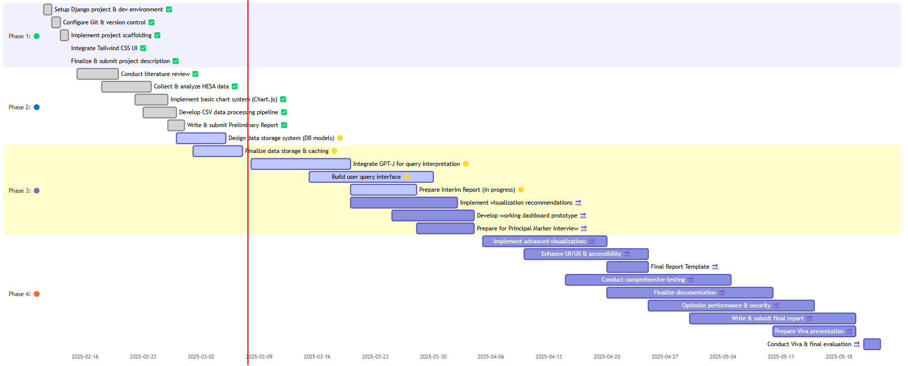

*Figure 2: Initial Project Timeline - Gantt Chart*

### Explanation of Project Phases

* **Phase 1 (Setup & Planning):** Establishing the project foundation, including environment setup, initial research, and defining the project scope and description.
* **Phase 2 (Data & Basic System):** Focusing on acquiring, processing, and storing HESA data, and implementing basic system components like initial visualizations and data processing pipelines.
* **Phase 3 (Core Development & Integration):** Implementing the central features, including LLM integration for query interpretation, building the user interface, and developing the main dashboard functionality.
* **Phase 4 (Finalization & Evaluation):** Refining the system through comprehensive testing, optimizing performance, completing documentation, and preparing for final evaluation.

Phasing breaks the project into manageable stages for better planning, resource allocation, and tracking. It helps reduce risk by allowing for reviews and adjustments at key milestones, ensuring a structured approach to development and completion.

# 4. System Specification

## Data Flow Diagram

The project is focused on HESA data that is provided as CSV files containing structured data across available sectors. The system creates a comprehensive pipeline that transform raw statistical data into analyses data that is ready to be used. This process includes following: data collection, metadata extraction, data cleaning and transformation phases. These phases create optimized datasets that powers NLQ system.

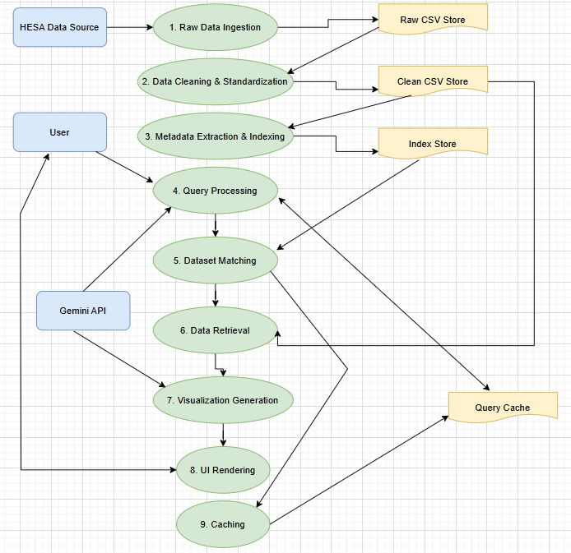

*Figure 3: Diagram shows the overall data flow pipeline, from raw HESA data ingestion through cleaning, indexing, query processing, matching, and visualization.*

Green ovals = Processes (the steps in the system)

Yellow rectangles = Data stores (where information is kept)

Blue rectangles = External entities (User, HESA, Gemini API)

**Process of generating visualization on submitted query:**

|  |  |  |
| --- | --- | --- |
| Source | Destination | Description |
| User | 4. Query Processing | Shows user submitting a query |
| 4. Query Processing | 4. Query Processing | Shows processed query parameters moving to dataset matching |
| 5. Dataset Matching | 6. Data Retrieval | Shows matched dataset identifiers moving to data retrieval |
| 6. Data Retrieval | 7. Visualization Generation | Shows retrieved data moving to visualization generation |
| 7. Visualization Generation | 8. UI Rendering | Shows visualization configuration moving to UI rendering |
| 8. UI Rendering | User | |  | | --- | | Shows results being presented back to the user | |

*Table 2: Explanation of processes to generate visualizations on submitted query*

**Process of cleaning CSV files:**

|  |  |  |
| --- | --- | --- |
| Source | Destination | Description |
| Raw Data Ingestion | Raw CSV Store | Shows where processed raw data is stored |
| Raw CSV Store | 2. Data Cleaning & Standardization | Shows raw data being retrieved for cleaning |
| 2. Data Cleaning & Standardization | Clean CSV Store | Shows where cleaned data is stored |
| Clean CSV Store | 3. Metadata Extraction & Indexing | Shows cleaned data being used for indexing |
| 3. Metadata Extraction & Indexing | Index Store | Shows where metadata indexes are stored |
| Index Store | 5. Dataset Matching | Shows indexes being used to match datasets |
| Clean CSV Store | 6. Data Retrieval | Shows where matched datasets are retrieved from |
| 9. Caching | Query Cache | Shows where cached results are stored |
| Query Cache | 4. Query Processing (bidirectional) | |  | | --- | | Shows checking cache before processing and storing results after | |

*Table 3: Explanation of processes to clean CSV files*

**Other Processes:**

|  |  |  |
| --- | --- | --- |
| Source | Destination | Description |
| External Entity: Gemini API | 4. Query Processing | This shows the system's interaction with the external AI service |
| External Entity: Gemini API | 7. Visualization Generation | This shows the system's interaction with the external AI service |
| User | 8. UI Rendering (bidirectional) | |  | | --- | | Shows user providing feedback and modifying visualization parameters | |

*Table 4: Other system processes*

## 4.2 Technical Architecture Design

### Technical Architecture Overview

The system employs a modern web application architecture designed to handle data processing, LLM integration, and dynamic visualization.

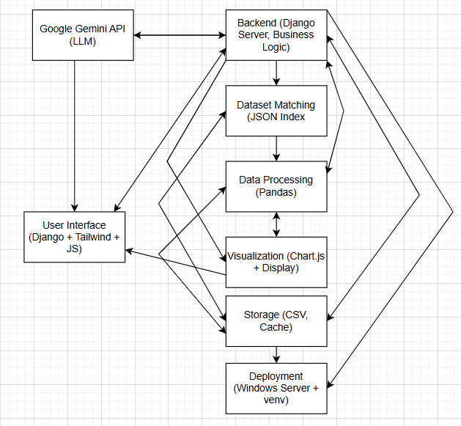

*Figure 7: System Technical Architecture Diagram*

|  |  |  |  |
| --- | --- | --- | --- |
| Source | Interaction | Destination | Description |
| User Interface | ↔ | Backend | UI sends natural language queries to backend  Backend returns processed results and visualization data to UI |
| Backend | ↔ | Google Gemini API | Backend sends user queries to Gemini for entity extraction Gemini returns structured data with institutions, years, and data types |
| Backend | ↔ | Storage | Backend reads raw and processed data files  Backend writes cache data and user feedback |
| Dataset Matching | ↔ | Storage | Reads JSON index file to find relevant datasets  Updates index metadata when new files are processed |
| Data Processing | ↔ | Storage | Reads CSV data from storage  Writes processed results to cache |
| Data Processing | ↔ | Visualization | Data processing suggests visualization types based on data characteristics  Visualization requests specific data transformations for chart rendering |
| Backend | ↔ | Data Processing | Backend sends data processing instructions and query parameters  Data Processing returns processed results and analysis summaries |
| Backend | → | Dataset Matching | Sends extracted entities to identify relevant datasets Forwards query parameters for dataset selection |
| Backend | → | Visualization | Sends configuration for chart generation Provides display parameters based on query context |
| Dataset Matching | → | Data Processing | Provides references to matched datasets Sends metadata about dataset structure |
| Visualization | → | User Interface | Renders charts and data visualizations Provides interactive elements for data exploration |
| Backend | → | Deployment | Application configuration and settings |
| Storage | → | Deployment | |  | | --- | | File system configuration |   Export to Sheets |

*Table 5: System Technical Architecture*

### Development Stack and Dependencies

The project employs a modern web application architecture built on:

|  |  |  |  |
| --- | --- | --- | --- |
| Category | Technology | Version | Description |
| Backend | Django | 4.2.5 | Web framework |
| Python | 3.10.12 | Primary language |
| Pandas | 2.0.3 | Data manipulation |
| NumPy | 1.24.3 | Numerical processing |
| Frontend | Tailwind CSS | 3.3.3 | Styling framework |
| JavaScript | ES2021 | Client-side functionality |
| Chart.js | 4.3.0 | Visualization library |
| HTML5/CSS3 | - | Markup and styling |
| AI Integration | Google Gemini 1.5 Pro API | - | Query interpretation and analysis |
| Python google.generativeai | 0.3.1 | Library |
| Data Storage | CSV files | - | Primary data storage |
| JSON metadata | - | Indexes and cache |

*Table 6: Project Development Stack and Dependencies*

### Component Roles and Interactions

The architecture follows a clear separation of concerns:

* **Data Layer:** CSV files store raw and cleaned HESA datasets with JSON metadata for efficient discovery and indexing. Pandas mostly used at the backend to manipulate data (read, clean, transform, and filter)
* **Application Layer:** Django handles requests processing, routing and view rendering. The core functionality is separated into different modules in the Django environment. It includes query processing, dataset matching and configuration of visualization generation.
* **Presentation Layer:** Tailwind CSS provides responsive design through classes. Chart.js renders interactive visualizations based on data processed. The processing happens in the backend and configuration provided via the LLM.

The system follows a request-response cycle where:

1. User queries are submitted from the frontend to Django views.
2. Django views use the data processing pipeline (using Pandas) to access and filter relevant CSV data based on parameters received from the query.
3. The system interacts with the Gemini API to interpret queries, match datasets semantically, and to generate Chart.js visualization configurations.
4. Processed data and visualization configurations are sent back to the frontend.
5. The frontend uses Chart.js to visualize the results in the user's browser.

While architecture focuses on simplicity and maintainability it manages to provide sophisticated data analysis and visualization generations. Pandas is the main dependency that being used throughout the project. It is used for CSV file processing, data cleaning, filtering, transformation and preparation for visualization as shown in Appendices A.1, A.2, A.3.

# 5. Implementation

## 5.1 Data Processing Pipeline Implementation

### Raw Data Acquisition and Storage

As I explained above in section 1.6, the system is designed to process smaller parts of HESA CSV files to address limitations LLM processing, its performance, memory usage and the cost. This is implemented as a foundational step in the data processing pipeline.

The data ingestion process handles the initial ingestion with validation and basic structure check before being stored. Every raw csv file goes through a check for minimum viability requirements. The file is expected to have a header, columns and basic formatting. (see Appendix D.1)

The system support processing of multiple files at the same time. The current dataset provides up to date HESA data as of academic year 2023/24. When HESA provides new data (There is currently as of 2nd of May no exact date of when new data will be released. HESA says “This page lists planned releases for the next six months. We will confirm the exact date of release at least 4 weeks before publication.” [24]) user can download it by clicking on the download link on the HESA website of a particular dataset that users want as shown in the Figure 5. When data is downloaded that would look like in Figure 4 the user can upload it to the system. It can be done through the UI (User Interface) at /upload-data/ endpoint and user can get there by clicking on “Upload New Data” in the header section. From there user can select downloaded file/s and click “Upload”. (see Appendix D.2)

This manual update system was implemented because HESA does not provide direct API (Application Programme Interface) for automated data retrieval.

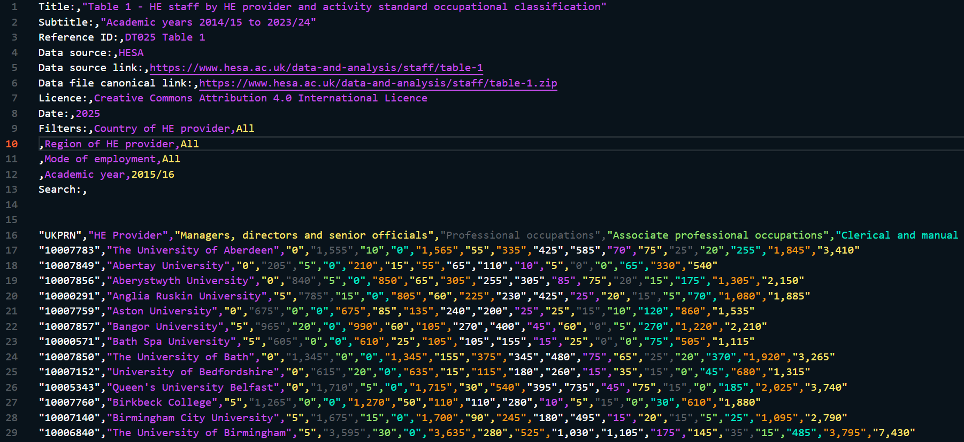

*Figure 4: Raw data file downloaded from HESA . Example file name dt025-table-1.csv.*

*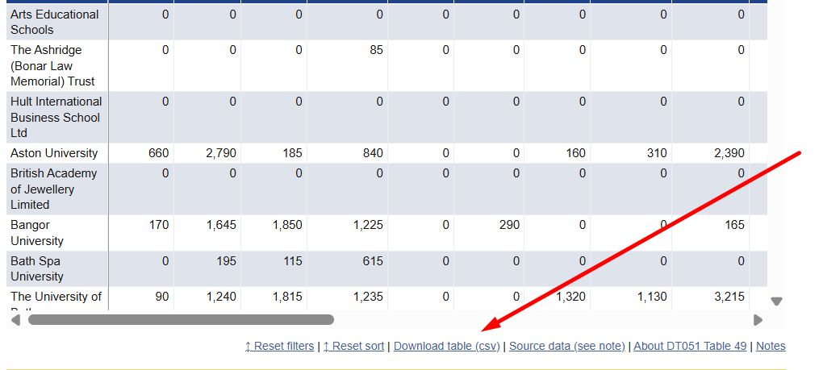Figure 5: Demonstration of how to download dataset from HESA*

### Metadata Extraction and Indexing

Metadata extraction and the specific extraction logic handled by functions as shown in Appendices D.3, D.4. Those functions analyse files without modifying the underlying data. Functions attempt to extract metadata in multiple ways:

1. Using the processor's method
2. Directly reading the file's first line for a '#METADATA:' prefix
3. Creating minimal metadata from the file content when necessary.

This important step creates a lookup index containing:

* Dataset title and description
* Available academic years (formatted as YY/YY)
* Institutions covered
* Column names and data types
* Value ranges for numeric fields
* Categorical field distributions

The system creates the indexing file *hesa_files_index.json* in the root after processing raw files and collect metadata from all available datasets. (see Appendix D.4). This indexing file helps Gemini to query available datasets, and it consists of:

* File locations (both raw and clean versions)
* Update timestamps for freshness tracking (captured in the 'updated_at' field)
* Metadata about each file
* File references.

This approach allows the system to quickly identify candidate datasets without loading all files for each query, this significantly improves the response time. The metadata extraction processes compile this information into structured JSON file. It supports both exact and semantic matching during query interpretation process. (see Appendix E.2).

This indexing is primarily used to minimize the amount of data being sent to Gemini by sending only data that matches requested academic year and is relevant. This is important because it leads to quicker results and fewer API tokens being used, which potentially reduces cost.

### Data Cleaning and Standardization

The CSV cleaning process transforms raw files into datasets that are ready for analysis. This is done through the function that handles the full process from reading the raw files to creating the cleaned output files. As mentioned in the introduction chapter, HESA already provides cleaned and high-quality data, but cleaning process is still required because raw files may contain inconsistencies, different formats and metadata that is not suitable for direct analyses. (see Appendix D.5)

Data sanitization follows a structured approach that includes:

* Header Standardization (extracting and normalizing column names)
* Missing Value Handling
* Academic Year Formatting (using regex patterns)

r'(\d{4})[\.\-&_](\d{2})'

* Institution Normalization (ensuring consistent naming of institutions)
* Data Type Conversion (using pandas in the extraction process)
* Character Encoding Normalization (handled by opening files with parameters)

encoding='utf-8', errors='ignore'

* Comprehensive metadata extraction

The file naming convention for cleaned files is described in Appendices D.5, D.6. The logic includes:

* Title from the raw file (extracted in the code using regex patterns)

re.search(r'Table\s+\d+\s*-\s*(.*)', title_text)

* Academic year(s) covered (extracted in the code using regex patterns)

re.search(r'(?:,|\:)\s*Academic year\s*,\s*(20\d{2}/\d{2})', line)

* Original raw file name

For example, a raw file as shown in Figure 4.

* file name: dt025-table-1.csv
* title: HE staff by HE provider and activity standard occupational classification
* academic year: 2015/16

After cleaning, the file will be named: HE staff by HE provider and activity standard occupational classification 2015-16 dt025-table-1 (1).csv (see Figure 6)

This file name convention is necessary because HESA sometimes provide different datasets but with same academic year and even title. It is vital to make the original name when creating a unique identifier for the cleaned file. The fact that CSV files can have same titles along with academic years represent a challenge since it requires the cleaning process to be more detailed to prevent possible duplications.

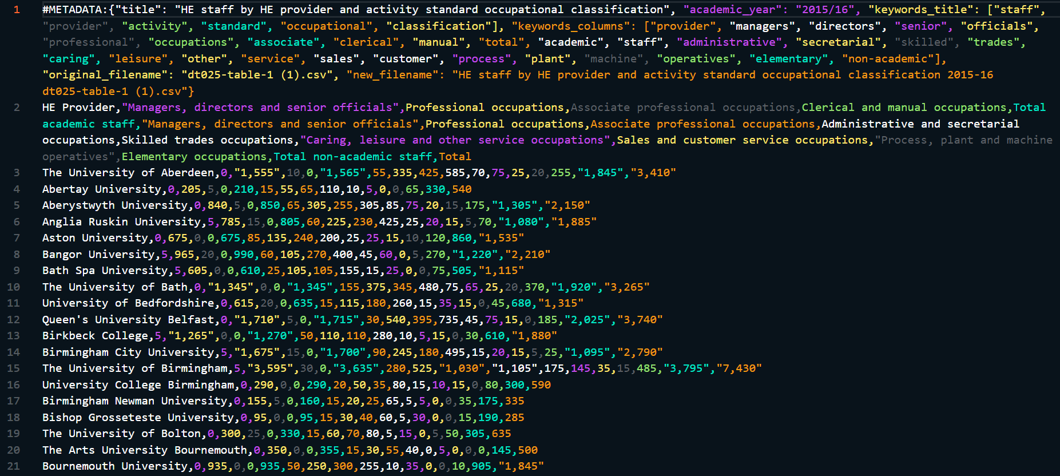*Figure 6: Example of a cleaned csv file name based on the raw csv file Figure 4.*

### Transformation and Enhanced Metadata Generation

Cleaned data files are changed into optimized formats for analysis using a data processing system. We also get extra information (metadata) to help with this. (see Appendix D.3, D.4)

This process prepares the data by:

* Calculating metrics for analysis
* Structuring it for clear visualization
* Adding helpful context

Enhanced metadata is generated for cleaned files through the metadata extraction process. It extracts information like titles, academic years and columns while handling potential inconsistencies and missing data. The system tries multiple approaches to extract metadata and if it does not work, it falls back to more basic method (the basic method serves as fallback mechanism but so far, I have not faced this issue). (see Appendix D.4)

The process adds analytical context beyond basic structure:

* It identifies academic years using multiple pattern-matching techniques
* Extracts column information that can be used for visualization type recommendations
* Creates relationships between datasets by incorporating all this information into a central index file that can be queried for cross-analysis.

### Rationale for Separate Raw and Clean Files

This dual storage approach provides several advantages: (see Appendices D.5, D.6, D.4)

* Data integrity
  + Original HESA files remain untouched in the raw_files directory)
* Processing efficiency
  + Clean files in the clean_files directory optimize structure for analysis
* Versioning support
  + Changes to cleaning methodologies can generate new clean versions through reprocessing
* Failure recovery
  + Processing errors can be addressed by regenerating clean files from the source
* Selective enhancement
  + metadata can be progressively enhanced for clean files through the multiple extraction methods implemented

It keeps track of the relationship between raw files, processed output and metadata (inside the *hesa_files_index.json*). This ensures that the data is changed using the same standard rules for all HESA information. This full process helps us to protect the original data and prepare it well for analysis and charts generation.

## 5.2 Query Processing and Interpretation

### Overview of Natural Language Query Interpretation

The system processes natural language queries (NLQ) using a sophisticated pipeline. It leverages Gemini 1.5 Pro to transform free-text queries into structured parameters. It sends carefully created prompts to Gemini API along with system instructions that explains to the AI how to extract structured data from NLQ. (see Appendices L, E.1)

This AI powered approach recognizes query formulations like “Show me student enrolment at Leicester in 2019” or “What was the staff-student ratio for Russell Group universities between 2015-2018?”. The method identifies query intent by constructing a detailed system prompt which instructs AI to extract institutions, academic years and user requested data. It preserves semantic relationships through the structured JSON response format that captures relationship between extracted entities.

The functionality understands different types of queries through its complex prompt engineering. As mentioned above, this includes:

* Instructions for handling academic year conventions
* Institution name variations
* Data request specifications.

It adapts the response format according to the query type and returns structured data that can be used by other application functionalities. The implementation shown in Appendix E.1 along with integration with the Gemini API enables intuitive data exploration without the need for users to learn specific query syntax

### Parameter Extraction, Tokenisation, and Normalization Techniques

The parameter extraction process as shown in Appendix L involves:

* Tokenization of queries into meaningful segments
* Entity recognition for key parameters (institutions, years, metrics)
* Normalization of recognized entities to standard formats
* Validation against expected patterns and ranges, and structuring for dataset matching.

Parameter extraction does not directly tokenize the query itself but rather constructs a detailed prompt that instructs the AI to perform entity extraction. Using this method, the system gets detailed instructions (the prompt) on how to find and sort the key information, such as institutions, time periods and comparison groups. The method includes a step to process the AI’s answer. This step takes the information and transform it into the exact formats the system needs. (see Appendix E.1).

One of the most important aspects of this process is to accurately interpret the academic year which spans two calendar years. The system uses a custom function detailed in Appendix E.2 that applies higher education-specific logic to correctly interpret various date references:

* “Starting in 2017” or “from 2017” → Matches the 2017/18 academic year
* “End of 2017” or “ending in 2017” → Matches the 2016/17 academic year
* Plain years (e.g., “in 2017”) → Treated as the starting year (2017/18)
* Year ranges (e.g., “2016 to 2017”) → Matches the 2016/17-2017/18 academic years
* “Past 5 years” → Matches the last 5 academic years from the current year

This logic ensures that the data-based queries are correctly interpreted and ready for further use.

### LLM Integration Design

The Gemini 1.5 API integration is shown in Appendices E.1, K, L.

It follows a structured design approach:

* Prompt Engineering
  + Designing effective prompts for Gemini that include the user query, relevant context (like the structure of available data), and clear instructions for entity extraction, intent classification, and relevance scoring.
* API Client Implementation

A robust API client was developed to communicate with the Gemini API. It includes initialization with API key, tailored request formatting, and extensive error handling with detailed logging. It uses the requests library for making HTTP requests.

* Response Parsing and Validation
  + Designing logic to parse the structured JSON response from Gemini and validate its content to ensure it can be used by the subsequent processing steps.
* Caching Integration
  + Designing the query processing pipeline to check the cache before sending a request to the Gemini API, and to store the results upon receiving a valid response.

The Gemini 1.5 Pro API was configured with specific parameters to ensure optimal performance and output for the project's needs as shown in Appendix L. Key settings include:

* Output Capacity
  + Configured to generate up to 2,048 tokens per response based on the configured parameter *maxOutputTokens: 2048*. Balances detailed output with managing token usage.
* Temperature Setting
  + Set to a low value of  *temperature: 0.1.* This makes responses more deterministic, focused, and less random. This is important for accurate data interpretation and structured output generation.
* Top-P and Top-K
  + Using *topP = 0.95 and topK = 40.* These parameters are responsible for the randomness of the output. This ensures a balance between creative interpretation and following to the provided context. This helps with reliability of entity extraction and data matching.

The API integration flow detailed in Appendix L includes:

* Preparation of well-structured prompts with necessary context (system_prompt and user_prompt)
* Secure API communication with appropriate authentication

headers = {"Content-Type": "application/json", "x-goog-api-key": self.api_key}

* Response validation and error handling (with multiple error checks and try-except blocks)
* Parsing of structured information from responses (JSON extraction and validation)
* Seamless integration with the existing processing pipeline.

## 5.3 Visualization Generation

### Chart Generation

It analyses the selected dataset and user request, then calls the Gemini using the client to determine the correct chart type. After the type is configured, it generates Chart.js configurations for rendering the determined chart. (see Appendix F.1)

The implementation includes

* Detailed processing of dataset information
* Construction of prompts for the Gemini API
* Extraction of chart configuration from the AI response.

### Chart Types Implementation

The system prepares data for different chart types like line, bar, and pie charts. This functionality is implemented across several methods (see Appendices F.2, F.3, F.4) including:

* Handles different chart type requests
* Gets AI recommendations for chart types
* Allows dynamically changing the visualization

Visualization generation uses hybrid approach. Gemini generates Chart.js configuration by defining chart type, its structure, labels and options. The generation is based on the dataset characteristics and user submitted request. The whole configuration is then sent to the front-end where the actual dataset data which is fetched and [processed by the backed is combined with the configuration. Lastly, after it gets combined the Chart.js renders the interactive chart for the user on the webpage. The importance of this approach is that it ensures data privacy because the actual data does not go to Gemini thus, technically this approach can be used with other data that is more sensitive. (see Appendix F.1)

### Frontend Rendering

The client-side rendering instantiates Chart.js visualizations on canvas elements. Interactive controls are managed for creating new charts and switching visualization formats. Event listeners on UI elements connect user actions to these functions which enables dynamic updates based on user queries and selections. (see Appendices G.1, G.2, G.3)

### Interactive Visualization Controls

The system allows users to toggle data visibility, swap axis and adjust colour directly on the charts. The control is implemented in the frontend JavaScript and connected to the backend functions that handles data transformation request. (see Appendices G, H.1)

### Real time Chart Regeneration

Generated charts are updated automatically when filtering parameters or visualization options changes. This created using the API endpoint and AJAX request in the frontend. (see Appendix H.1)

### Visualization Type Recommendations

The system uses AI to suggest the best chart type for visualizing data. It analyses the dataset and explains why specific chart type is recommended therefore helping user to understand effective data visualization. (see Appendices F.3, H.2)

## 5.4 UI Implementation and Interactivity

### Dashboard Interface

The interface is implemented with key functions including: (Appendices I.1, I.2, I.3, I.4)

* Handles displaying query results
  + Transforms JSON responses into user-friendly HTML, including formatting institution names, academic years, and rendering clickable dataset cards.
* Creates reviewable dataset cards
  + Generates interactive cards for each matched dataset, displaying title, metadata, and sample rows with clean formatting.
* Manage loading states
  + Provides visual feedback during API calls, displaying animated spinners and contextual messages about current processing steps.
* Event listeners for query input
  + Captures user inputs, validates queries, and submits requests to backend APIs with appropriate feedback mechanisms.

### Dataset Details View

Implemented with functions including:

* Displays interactive data visualizations (see Appendix G.1)
  + Renders dynamic charts with hover effects, tooltips, and interactive legends that allow users to isolate specific data series.
* Creates charts based on user specifications (see Appendix G.2)
  + Processes natural language visualization requests and transforms them into appropriate data visualizations, considering dataset characteristics for optimal presentation
* Allows switching between visualization formats (see Appendix G.3)
  + Enables seamless conversion between chart types (bar, line, pie) while preserving the dataset context and user's visualization intent.
* PDF and CSV export functionality implemented through dedicated download handlers (see Appendix I.5)
  + Provides client-side export capabilities that format data with proper headers, styling, and metadata for professional reports and further analysis.

### Dynamic Dataset Previews

The system displays the first three rows of matched datasets with collapsible sections for expanded metadata so users can quickly find relevant dataset.

Data previews are implemented with functions to:

* Prepare data for clean display (see Appendix I.6)
  + Removes technical artifacts like metadata headers and normalizes column names for better readability. It helps to ensure consistent presentation across different dataset types.
* Toggle functionality through (see Appendix I.7)
  + Enables users to expand and collapse detailed information sections with smooth transitions. It keeps the screen clean and allows the user to access that extra details when needed.
* Collapsible metadata sections with animation classes

animate-fade-in, animate-fade-out

* + Creates a polished user experience with subtle transitions when revealing or hiding content, improving interface responsiveness and visual feedback.

### Responsive Design

The interface adapts to various screen sizes while maintaining data integrity and usability.

The interface uses Tailwind CSS classes throughout the templates with responsive design patterns including:

* Flexible grid layouts

<div class="grid grid-cols-1 md:grid-cols-3 gap-4">

    <div class="border rounded p-3 bg-white">...</div>

    <div class="border rounded p-3 bg-white">...</div>

    <div class="border rounded p-3 bg-white">...</div>

</div>

* Responsive padding and margins

div class="max-w-7xl mx-auto px-4 py-8 md:px-6 lg:px-8">

    <h1 class="text-2xl md:text-3xl font-bold mb-4 md:mb-6">HESA AI Powered Data Dashboard</h1>

</div>

* Overflow handling for data tables

.table-container {

    overflow-x: auto;

    max-height: 300px;

    overflow-y: auto;

    scrollbar-width: thin;

}

* Mobile-friendly controls with appropriate sizing and spacing

<button

    class="w-full sm:w-auto px-3 py-2 sm:px-4 sm:py-3 text-sm sm:text-base bg-blue-600 text-white rounded-md flex items-center justify-center"

>

    <span class="flex items-center">

        <svg class="h-4 w-4 mr-2" viewBox="0 0 24 24">...</svg>

        <span>Search</span>

    </span>

</button>

## 5.5 Feedback System

### Feedback Collection

It provides an interface for user to rate received results with options as “Not Helpful”, “Helpful” and “Very Helpful”. Optionally, displays a comment area for detailed feedback if user selects anything but the option “Very Helpful”. (see Appendix J)

### Feedback Submission

The system collects relevant data such as:

* Query details
* Dataset information
* Visualisation settings
* User rating
* Comments

This data is sent to the server for storage and analysis so it can be used further to enable data-driven improvements. (see Appendix J)

## 5.6 Caching and Performance Optimization

### Query Cache Implementation

The system implemented a caching functionality that stores and retrieves query results as JSON documents in */cached* folder. This caching system uses hash-based keys and metadata tracking to avoid redundant API calls and data processing. The cached data includes all the information about the query.

The cached data lasts for 30 days so after it expires the system removes it from the folder. This allows to maintain the system effectively without manual clean up. Also, it tracks usage statistics like access accounts and last accessed timestamp. These statistics can be used to make performance analyses and optimization of frequently used queries. (see Appendix K)

## 5.7 Codebase Structure and Endpoints

### Codebase Overview

hesa-llm-visualisation/

│

├── core/ # Main application directory

│ ├── templates/ # HTML templates

│ │ ├── ai_dashboard.html # AI powered dashboard interface

│ │ ├── base.html # Base template with common layout

│ │ ├── documentation.html # Project documentation page

│ │ ├── upload_data.html # Data upload interface

│ │ └── visualization/ # Chart visualization templates

│ │

│ ├── static/ # Static files (CSS, JS, images)

│ │ ├── css/ # Compiled CSS

│ │ ├── js/ # JavaScript files

│ │ │ └── ai_dashboard.js # Main dashboard functionality

│ │ └── src/ # Source files for CSS

│ │

│ ├── utils/ # Utility functions

│ │ └── query_cache.py # Query caching implementation

│ │

│ ├── services/ # Service layer

│ ├── data_processing/ # Data processing modules

│ ├── visualization/ # Visualization generation code

│ ├── management/ # Django management commands

│ │

│ ├── views.py # Main view controllers (5300+ lines)

│ ├── urls.py # URL routing

│ ├── gemini_client.py # Google Gemini API integration

│ ├── data_processor.py # Data processing logic

│ ├── data_processing.py # Additional data processing utilities

│ ├── models.py # Data models (minimal)

│ └── apps.py # App configuration

│

├── hesa_llm_visualisation/ # Project configuration

│ ├── settings.py # Django settings

│ ├── urls.py # Project URL routing

│ └── wsgi.py # WSGI configuration

│

├── data/ # Data storage directory

│ ├── raw_files/ # Original HESA data files

│ └── cleaned_files/ # Processed data files

│

├── docs/ # Documentation files

│

├── manage.py # Django project management script

├── debug_metadata.py # Debugging utilities

├── csv_cleaning.py # CSV file cleaning utilities

├── hesa_files_index.json # Index of available HESA data files

│

├── run_django_server.bat # Windows batch script to run server

├── data.env # Environment variables

│

├── package.json # Node.js dependencies

├── tailwind.config.js # Tailwind CSS configuration

├── postcss.config.js # PostCSS configuration

└── README.md # Project documentation

### Key Endpoints

Below are key endpoints that user can access and easily explore. There are other endpoints that are not for user interaction but rather for the usage of Gemini to return or display data.

* / or /ai-dashboard/  (*views.ai_dashboard*)
  + Main entry point to the application
* /documentation/ (*views.documentation*)
  + Documentation page
* /process_gemini_query/ (*views.process_gemini_query*)
  + Processes natural language queries using Google Gemini
* /ai_dataset_details/ (*views.ai_dataset_details*)
  + Gets detailed information about datasets
* /save_feedback/ (*views.save_feedback*)
  + Saves user feedback about query results
* /upload-data/ (*views.upload_data_view*)
  + Data upload interface
* /process-upload/ (*views.process_upload*)
  + Processes uploaded data files

## 5.8 System Setup and Running Instructions

Please refer to the STARTUP.md file inside the submitted project.

Location: vr112\STARTUP.md

It has full instruction on how to set up the project and run it

# 6. Demonstration

## 6.1 Using the AI Powered Query Interface

### Submitting a Natural Language Query

Main Dashboard (/ or /*ai-dashboard*)

1. Navigate to the main dashboard (see Figure 8)

* Open the application in the browser at the root URL
* You will see the “HESA AI Powered Data Dashboard” with a search input field

1. Enter a NLQ in the search box (see Figure 9)

* Query example: “How many postgraduates studied at the University of Leicester between 2018-2020?”
* The query input field displays a placeholder example to guide the user

1. Configure search parameters (optional)

* Set “Number of matches to show” (by default: 3)
* Select a Mission Group filter if needed. Options: None. Russell Group, Million+ or University Alliance

1. Click the “Search” button (see Figure 10)

* The system will process query using Gemini 1.5 Pro API
* A loading indicator will appear during the process

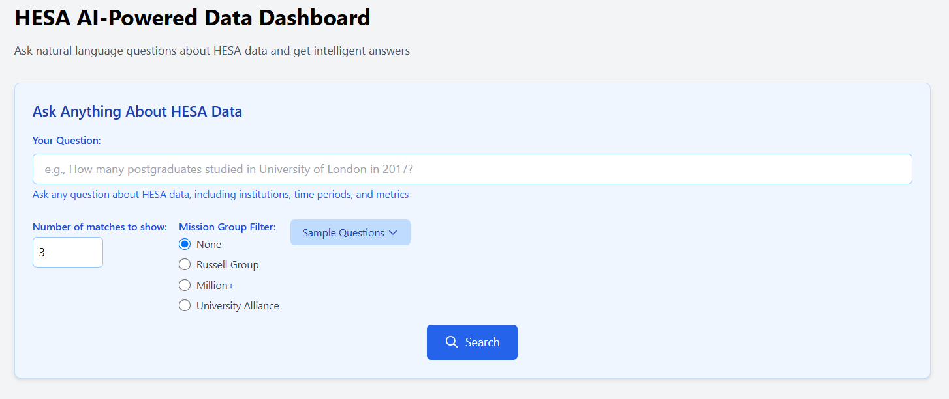

*Figure 8: Main Dashboard webpage*

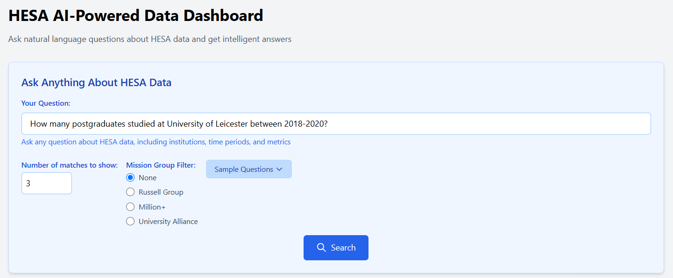

*Figure 9: Main Dashboard webpage with query example*

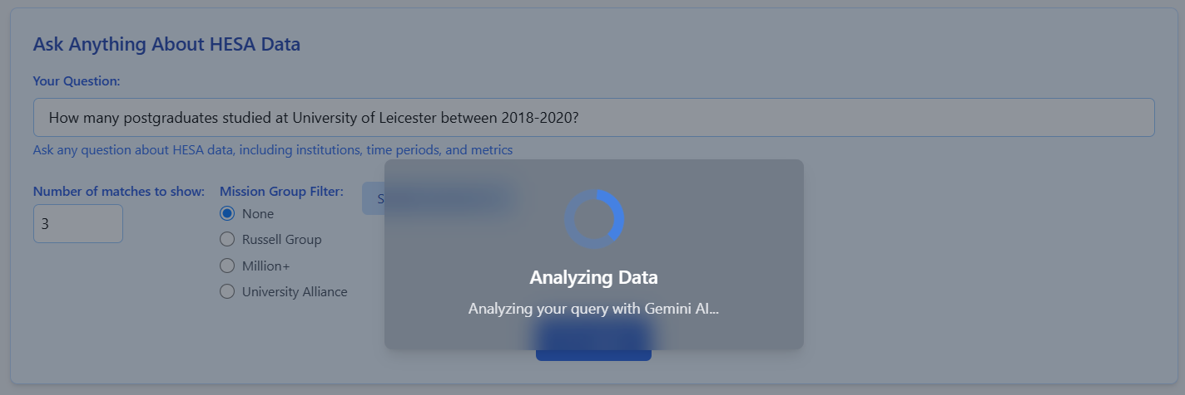

*Figure 10: Indicator of submitted query*

## 6.2 Query Interface

### Reviewing Query Analysis Results

Endpoint: */process_gemini_query* (called in background)

1. View query interpretation (see Figure 11)

* The system displays how it understood the query
* Shows extracted institution (“University of Leicester”)
* Shows extracted time period (“2018-2020”)
* Shows extracted requested data (“postgraduate students”)

1. Review matching datasets (see Figure 12)

* Each matching dataset shows score of relevance (percentage match)
* Datasets are ranked by relevance score to the submitted query
* Preview of data columns and rows is provided

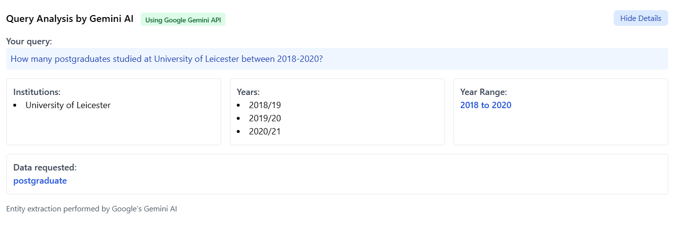

*Figure 11: Query Interpretation information*

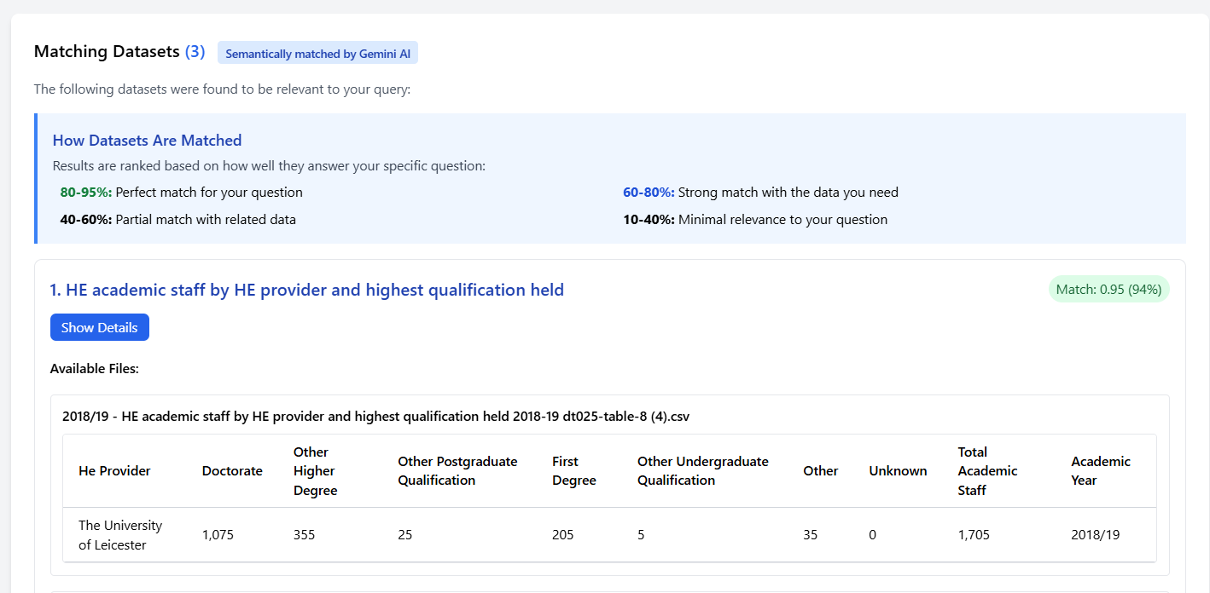

*Figure 12: Matched datasets previews and datasets matching information*

### Working with Dataset Details and Visualization

Endpoint: */ai_dataset_details* (called in background)

1. Click on a dataset from the found results (see Figure 13)

* Look for most relevant dataset for submitted query
* Review dataset details including time period covered and available institutions
* Click “View Details” or “Explore” button for the chosen dataset

1. Review detailed dataset information

* View metadata about the dataset
* See all available columns and preview rows
* Data is filtered based on query parameters (institution and years)

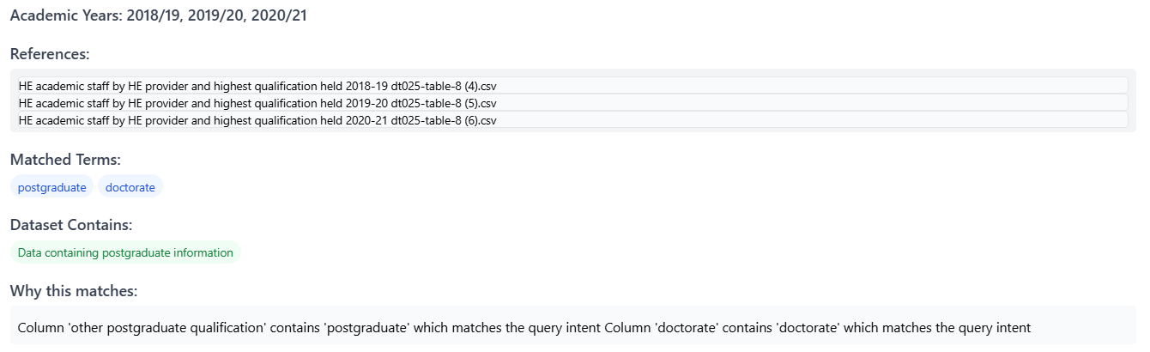

*Figure 13: Information about why Gemini selected this dataset*

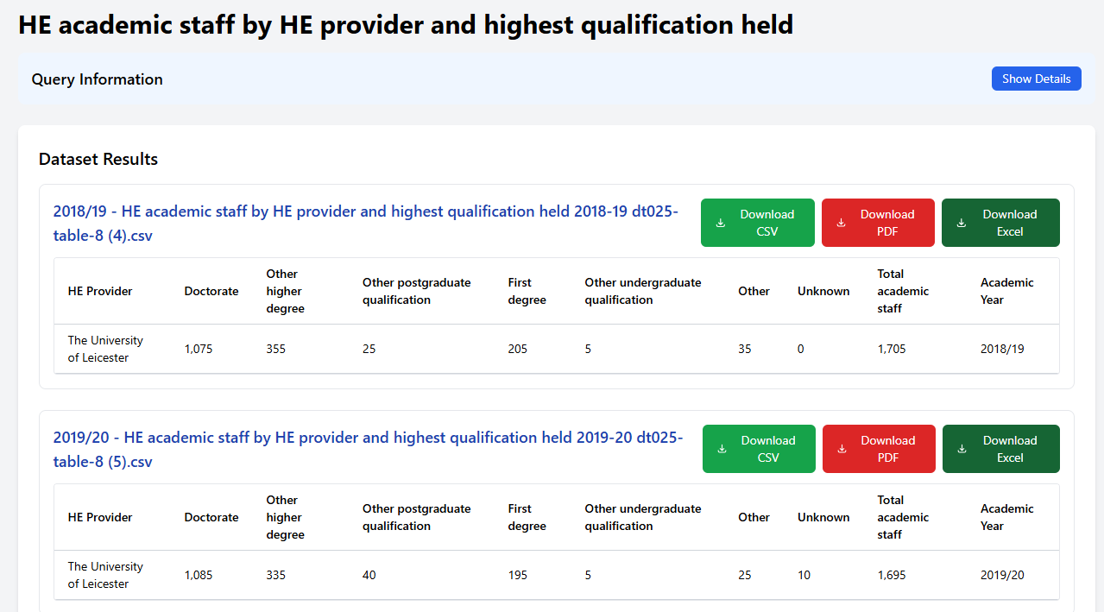

*Figure 14: A selected dataset*

### Generating and Interacting with Visualizations

Endpoint: */visualization_api* (called in background)

1. Analyse visualisation recommendation (see Figure 15)

* The system uses Gemini to automatically suggest the most appropriate chart type for selected dataset
* Example: Line chart for time-series data showing trends over multiple years
* A brief explanation of why selected type of chart is recommended

1. Customize visualization (see Figure 17)

* Enter a specific visualisation request (“Show a comparison of postgraduate numbers by year”)
* Select different chart types from options (bar, line and pie)
* View explanations for each chart type to understand its strengths and limitations

1. Generate visualisation (see Figure 17)

* Click “Generate Visualization” button
* The system will create an interactive chart based on chosen specifications
* Chart will appear with proper titles, label, and colour

1. Interact with generated visualization (see Figure 18,19)

* Hover over data points to see exact values
* Toggle data series on/off (for multi-series charts)
* View the visualization in full screen mode if desired
* See insights of generated charts

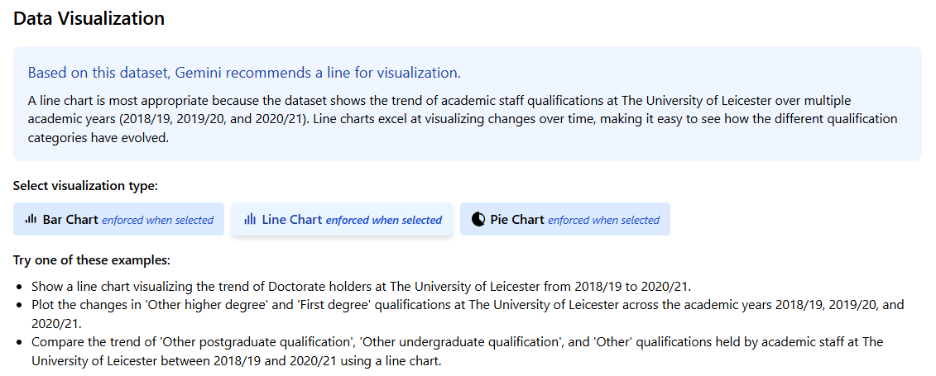

*Figure 15: Interactive Data Visualization initially generated by Gemini*

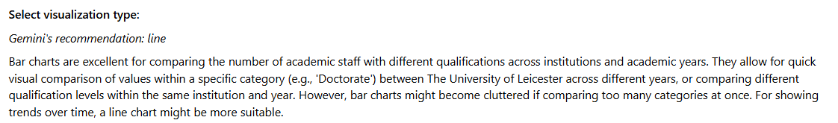

*Figure 16: Re-generated recommendation message after different type of chart is selected*

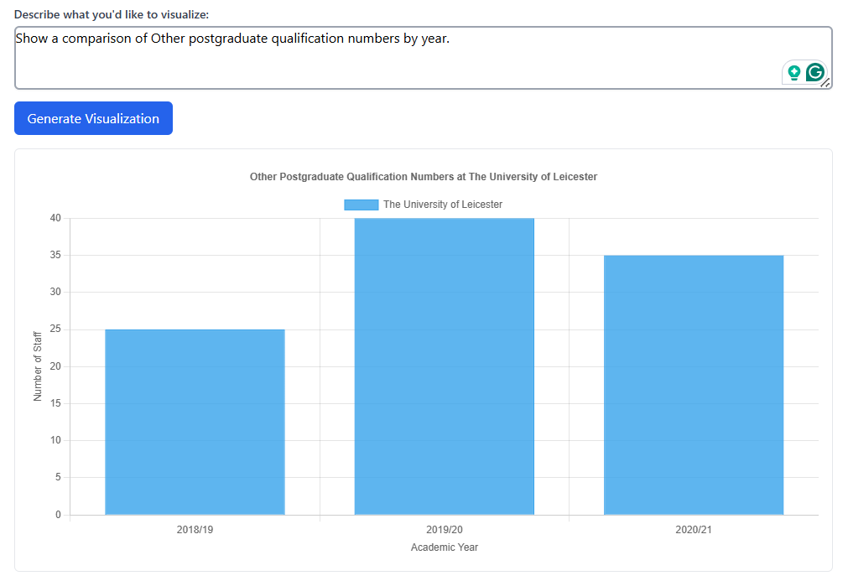

*Figure 17: Generated Bar Chart based on specified requirements from selected dataset*

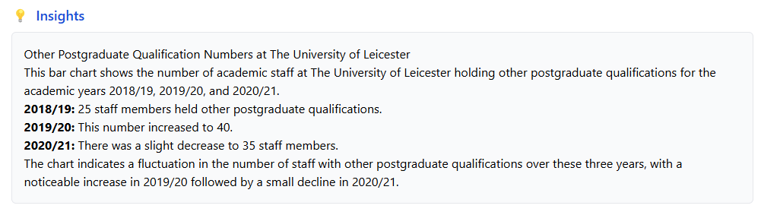

*Figure 18: Generated Insights of generated bar chart from Figure 17.*

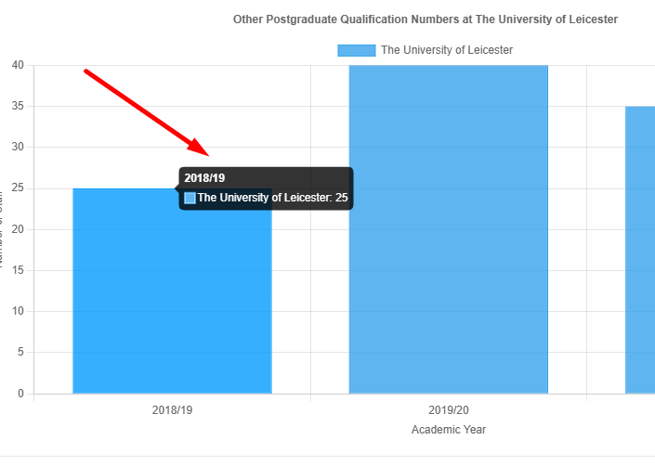

*Figure 19: Hovering over data points to see more detailed information*

## 6.3 Providing Feedback on Results

### Submitting Feedback on Query and Visualization

Endpoint: */save_feedback* (called in background)

1. Locate the feedback section (see Figure 20)

* Found at the top of webpage after query is submitted
* Look for buttons “Not Helpful”, “Helpful” and “Very Helpful”

1. Provide rating and comments (see Figure 21)

* Select “Not Helpful”, “Helpful” or “Very Helpful” to rate the result
* Enter detailed comments if appropriate rating is selected in the feedback text area (optional)
* Example comment: “The visualization clearly showed the trend in postgraduate numbers but only one dataset was returned”

1. Submit the feedback (see Figure 22)

* Click “Submit Feedback” button
* A conformation message will appear after that



*Figure 20: Feedback Submission Interface*

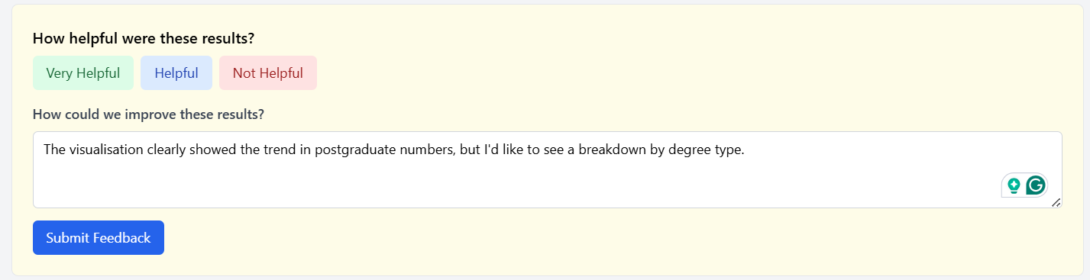

*Figure 21: Provided comment for feedback*



*Figure 22: Submitted feedback*

## 6.4 Uploading Custom Data

### Navigating to the Data Upload Section

Endpoint: */upload-data*

1. Access the upload page (see Figure 22)

* Click “Upload Date” in the navigation menu
* The system will redirect to the data upload interface

1. Understand upload requirements (see Figure 22)

* View instructions for supported file formats (CSV)
* See example of correctly formatted files
* Read about file size limits and columns formatting requirements

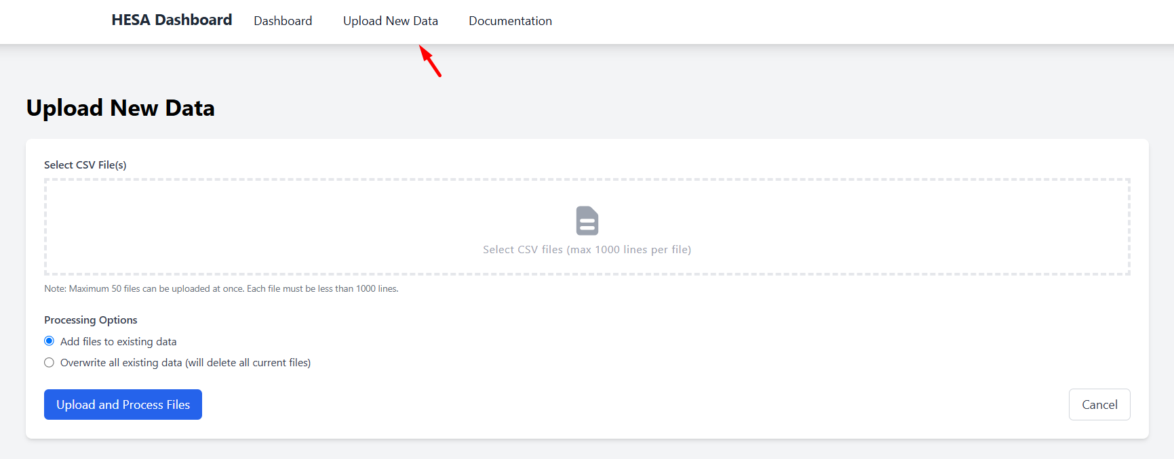

*Figure 22: Data Upload Interface*

### Uploading and Processing Data Files

Endpoint: */process-upload* (called when uploading)

1. Select files to upload (see Figure 23)

* Click “Choose Files” or drag and drop files into the upload area
* Select one or more CSV files with HESA compatible data
* Example raw file: “dt025-table-1 (2).csv”

1. Configure upload options

* Add files to existing data
* Overwrite all existing data (it will delete all current files)

1. Initiate upload process (see Figure 24)

* Click “Upload and Process Files” button to begin processing
* Progress indicator shows upload and processing status

1. Review processing results (see Figure 25)

* See confirmation of successful upload
* View any validation warnings or errors

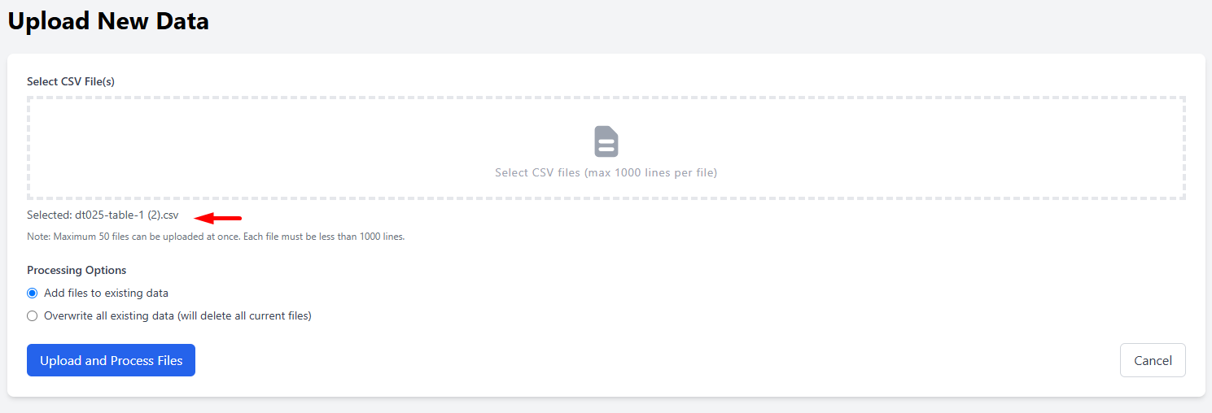

*Figure 23: Select files to be uploaded*

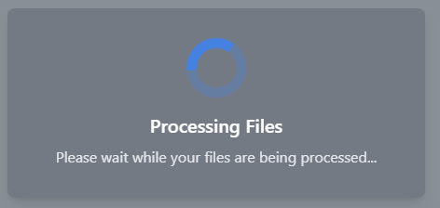

*Figure 24: Uploading progress indicators*

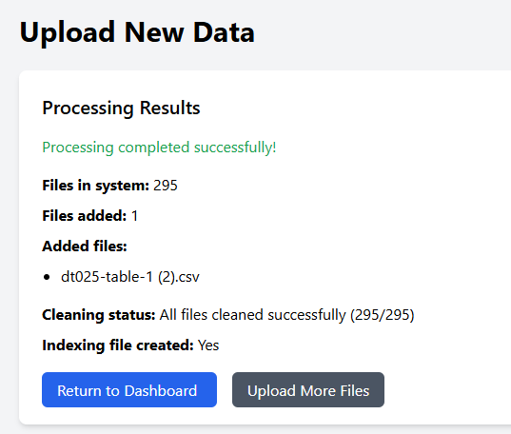

*Figure 25: Conformation of successful upload*

## 6.5 Exploring Documentation

### Accessing the Documentation Page

Endpoint: /documentation

1. Navigate to documentation (see Figure 26)

* Click “Documentation” in the navigation menu
* Documentation page provides guidance on how to use the system

1. Explore available documents sections (see Figure 27 - 33)

* Introduction to the HESA dashboard
* Guide to formatting effective queries
* Explanation of visualization options
* Data dictionary with columns descriptions
* Tips and Ticks that can help to simple the use of the system

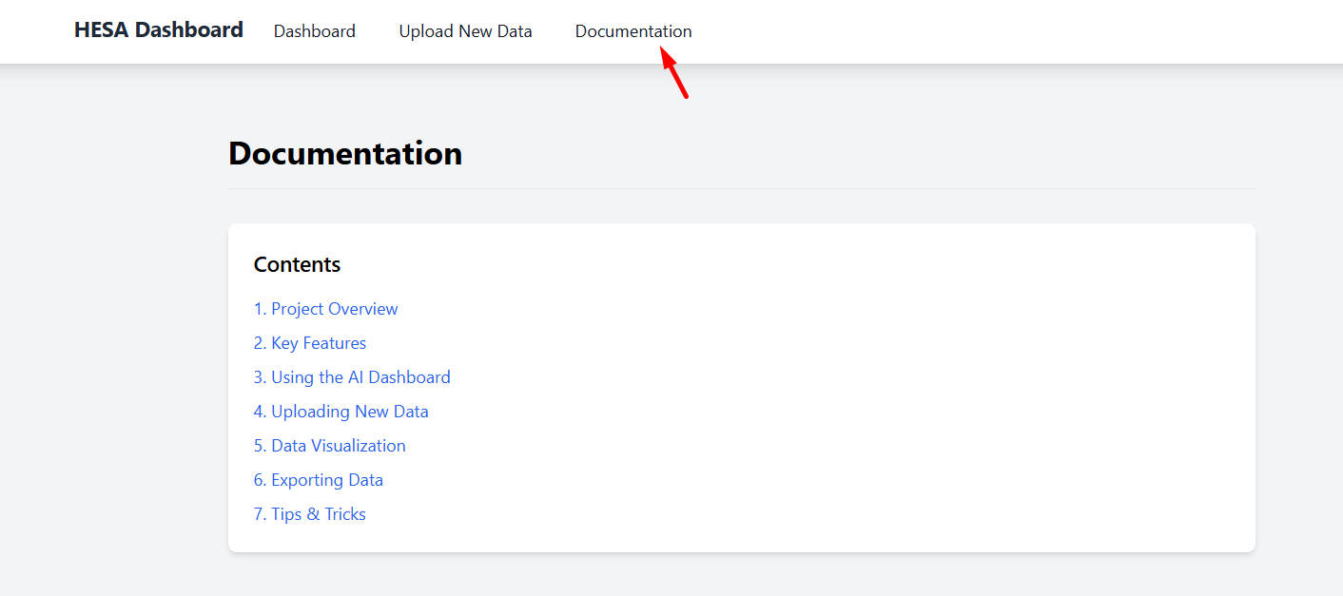

*Figure 26: Documentation Page*

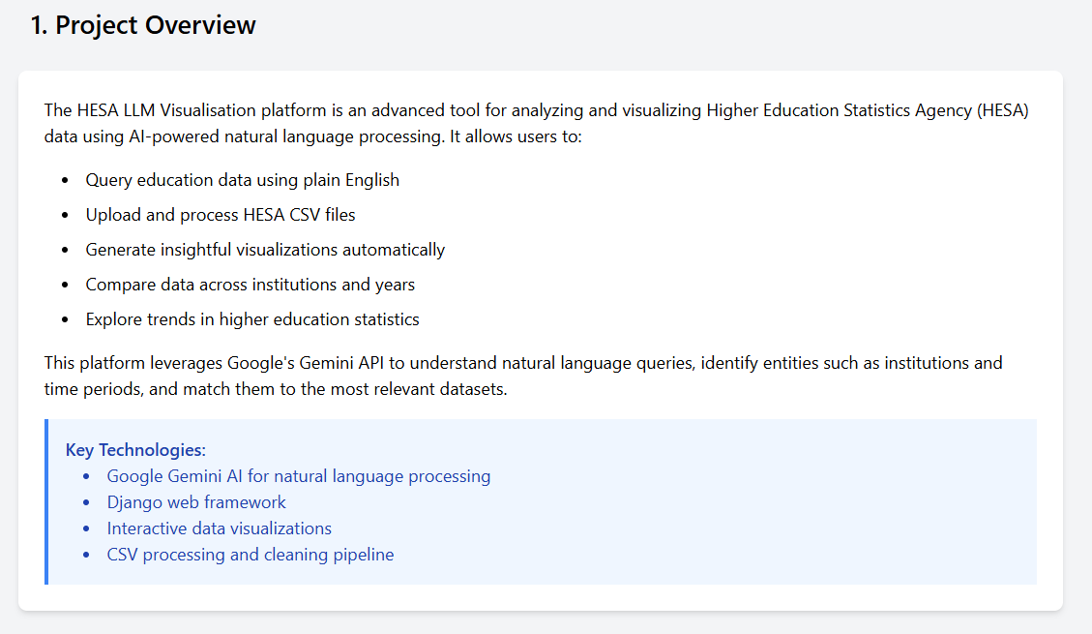

*Figure 27: Project Overview Information*

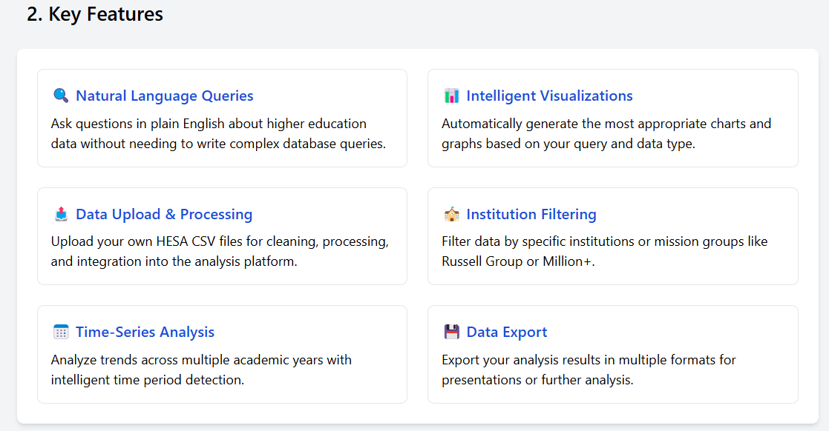

*Figure 28: Key Features*

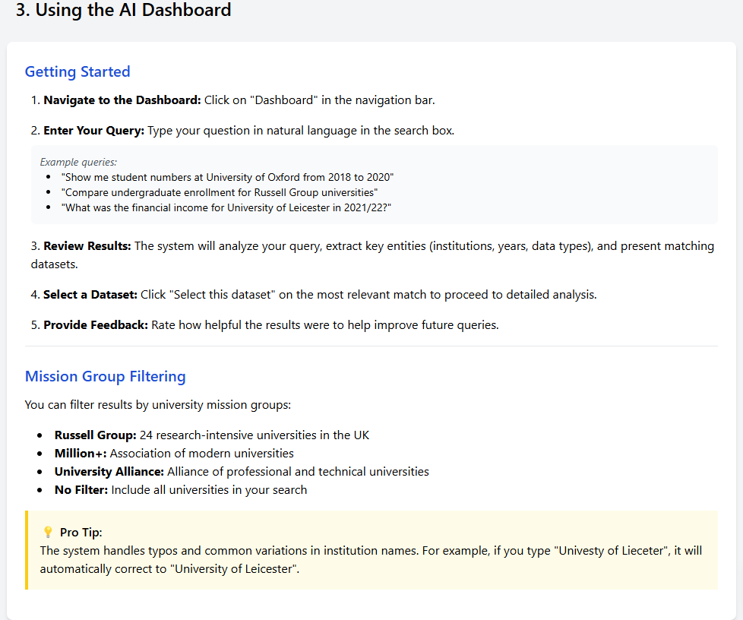

*Figure 29: Introduction to project UI*

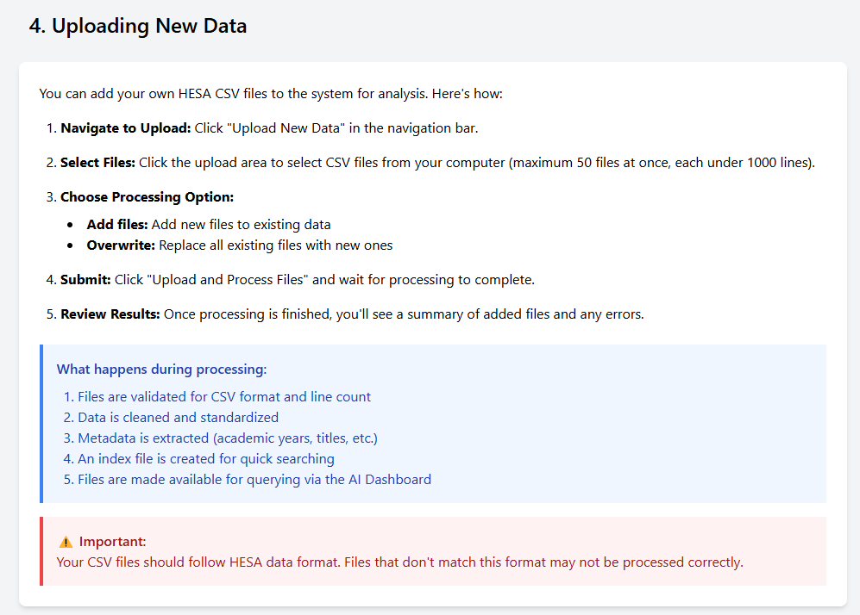

*Figure 30: Uploading new data guide*

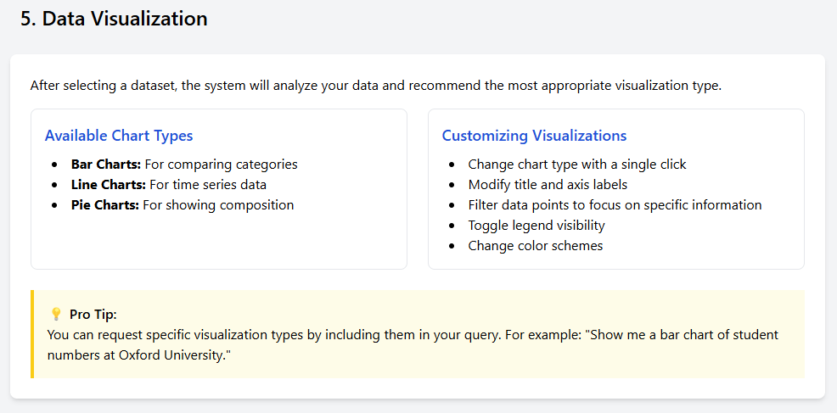

*Figure 31: Guide on data visualisation*

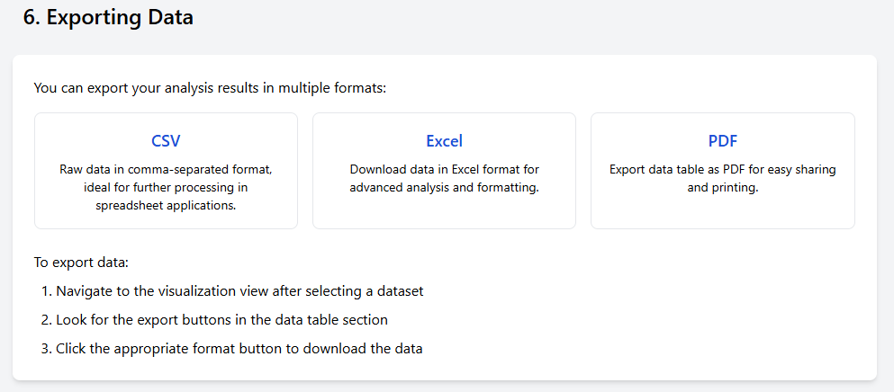

*Figure 32: Explanation of exporting data*

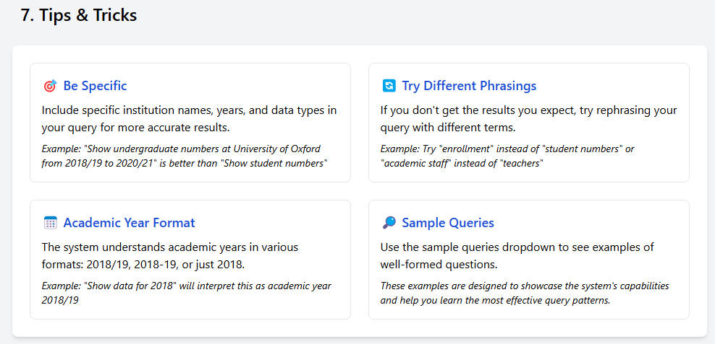

*Figure 33: Tips and Tricks about the project*

## 6.6 Complete User Journey Example

### From Query to Insight: Full Workflow

This demonstrates a complete user journey through the system

1. Start at dashboard (/ endpoint) (see Figure 34)

* Enter a query: “How many full-time students lived in university accommodation at University of York in the past 5 years?”
* Set matches to show to 3
* Select mission group to equal Russell Group

1. View query analysis (after */process_gemini_query*/ is called) (see Figure 35)

* The system extracts institutions: “University of Leicester”, “University of York” and list of 24 institutions from Russell Group
* The system extracts years: “2020-2024” (there is no available data for 2025 academic year yet)
* The system identifies data requested: “full-time students accommodation”

1. Provide feedback (submits to */save_feedback*) (see Figure 40)

* Rate results as “Helpful”
* Provide comment: “The visualization clearly shows the trend of students in the provided maintained property”
* Submit feedback and receive conformation

1. Select a dataset (triggers */ai_dataset_details*) (see Figures 36,37)

* Choose the most relevant dataset (“Full-time HE student enrolments by HE provider and term-time accommodation”)
* View detailed data preview filtered to the universities and specified years

1. Generate visualization (uses */visualization_api*) (see Figures 38,39)

* System recommends: Line chart
* See the explanation: “A line chart is most appropriate because the dataset includes data across multiple academic years, making it ideal for visualizing trends in student accommodation choices over time for each institution”
* Enter desired visualization request: “Show the trend of students living in Provider maintained property at Queen's University Belfast and The University of Birmingham from 2020/21 to 2023/24”
* Generated visualization: A line chart with years on x-axis, number of students on y-axis, for Queen's University Belfast and The University of Birmingham institutions about Provider maintained property

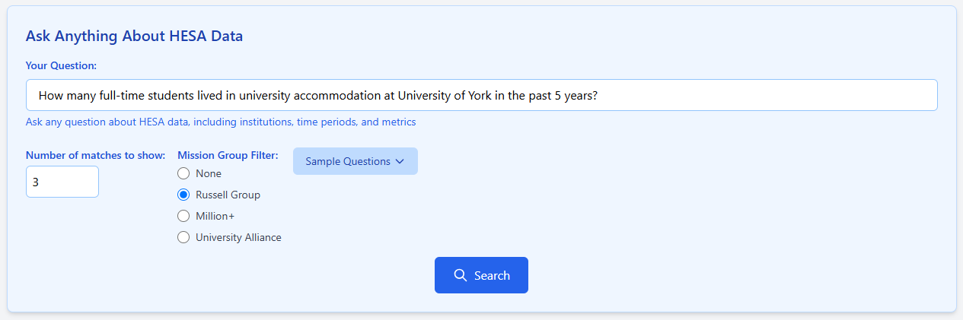

*Figure 34: Submitting a query*

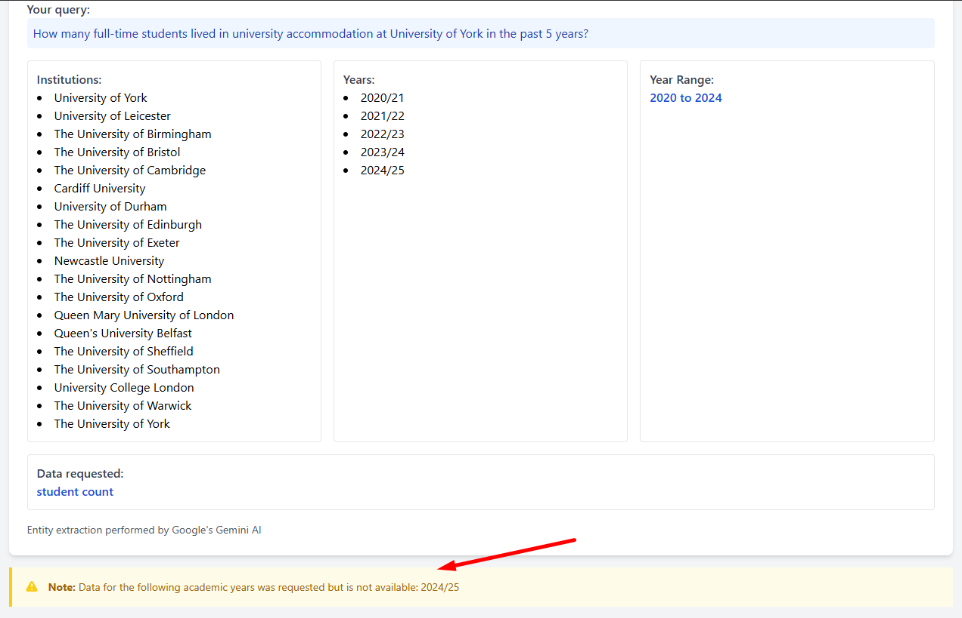

*Figure 35: Query parameters extracted by Gemini*

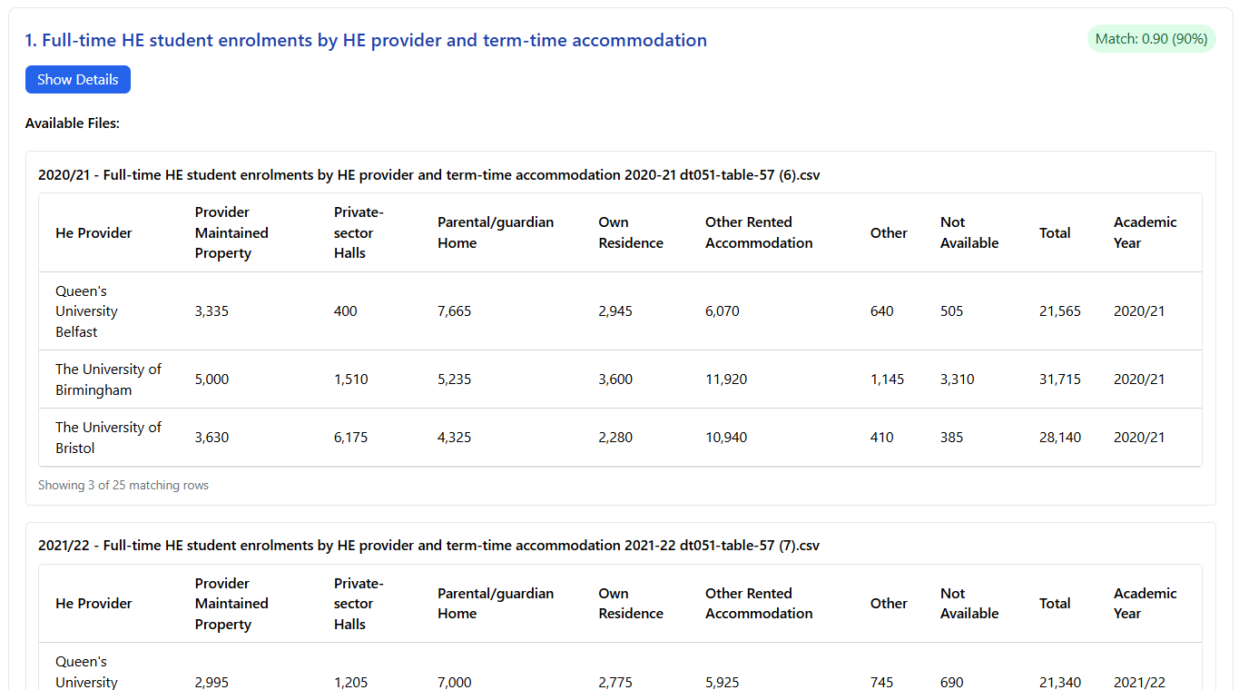

*Figure 36: Preview of chosen dataset*

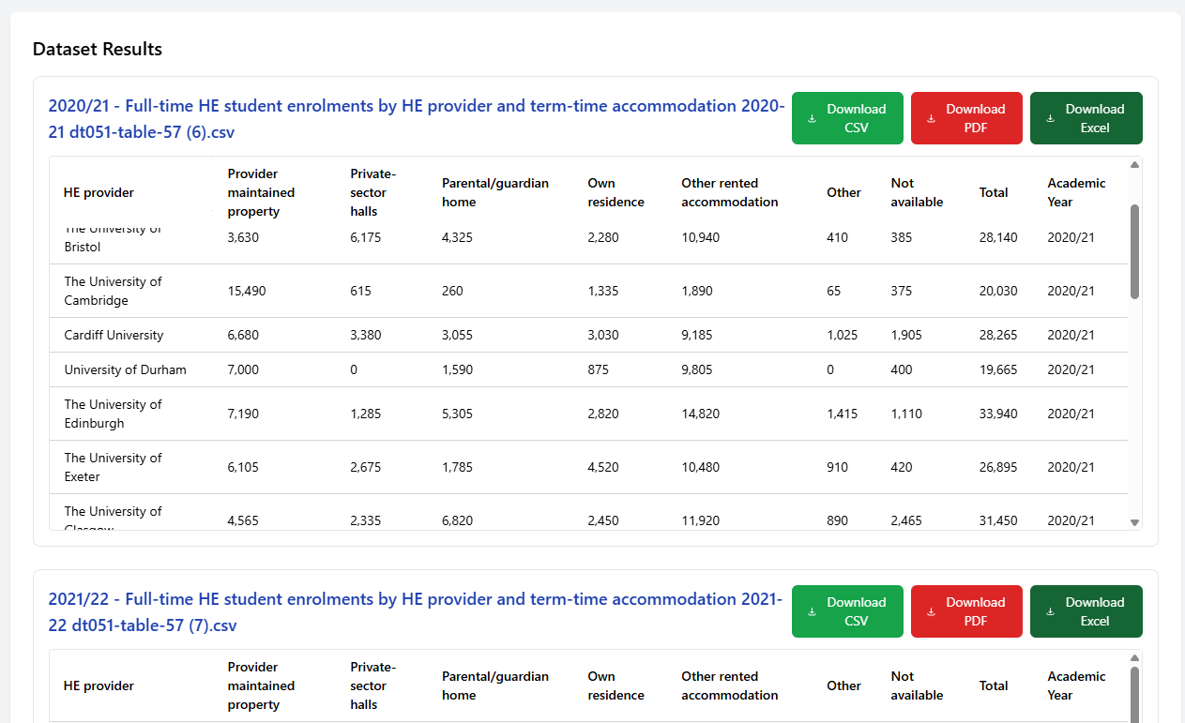

*Figure 37: Selected dataset (no longer in preview mode)*

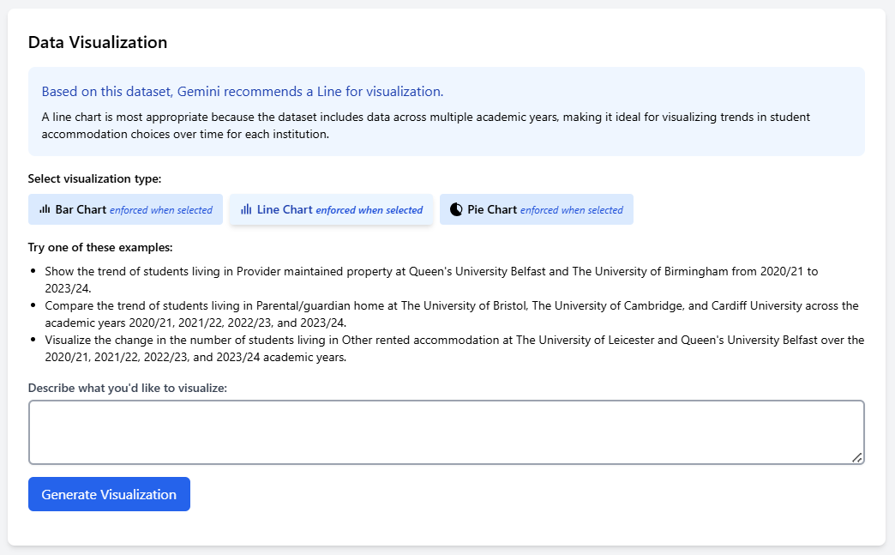

*Figure 38: Visualization interface of selected dataset*

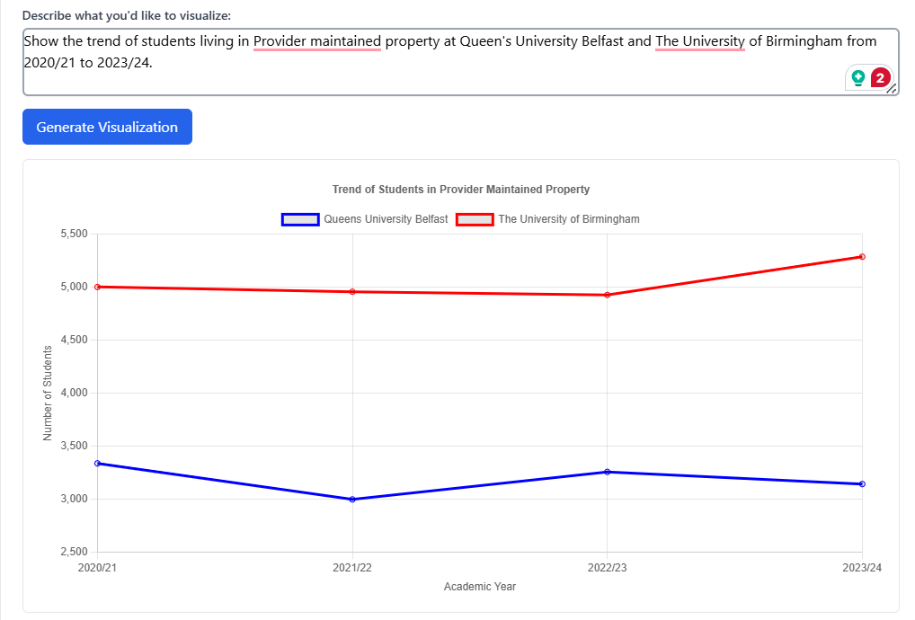

*Figure 39: Generated visualisation based on chosen requirements*

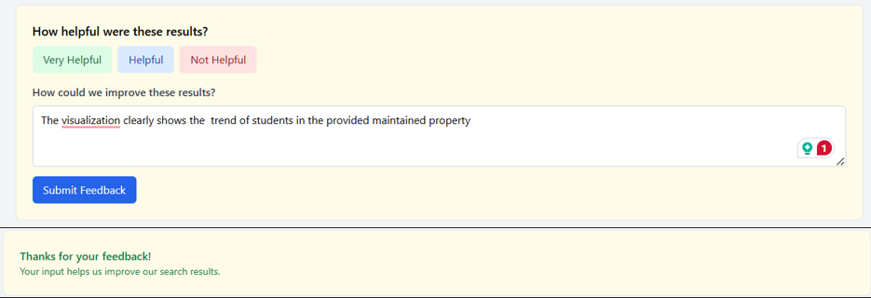

*Figure 40: Submitted feedback as Helpful*

# 7. Testing and Evaluation

## 7.1 Testing Methodologies

### Unit Testing

The unit tests covered three main components of the application:

1. Data Processing - CSV data handling and processing
2. LLM Integration - Query parsing and language model interaction
3. Visualization - Chart generation and recommendation

All unit tests successfully executed. (see Figure 41)

#### CSV Processor (see Appendix B.1)

The CSVProcessor class was tested for its ability to:

* Validate CSV File
  + test_validate_csv_valid_file
  + test_validate_csv_invalid_file
  + test_validate_csv_nonexistent_file
* Find the data start point in HESA files
  + test_find_data_start
* Clean and process CSV data
  + test_clean_csv
* Extract metadata from files
  + test_extract_metadata
* Extract keyword from titles and columns
  + test_extract_keywords_from_title
  + test_extract_keywords_from_columns

#### Query Parser (see Appendix B.2)

The query parsing functionality was tested for:

* Basic query parsing
  + test_parse_hesa_query_basic
* Local query analysis
  + test_local_analyze_query
* Handling queries with multiple institutions
  + test_query_with_multiple_institutions
* Handling year ranges
  + test_query_with_year_range
* Handling academic year formats
  + test_query_with_academic_year

#### Chart Generation (see Appendix B.3)

The visualization component was tested for:

* Chart type recommendations
  + test_get_chart_recommendation
* Visualization generation
  + test_generate_visualization
* Changing chart type
  + test_change_chart_type
* Explaining chart type selection
  + test_chart_type_explanation

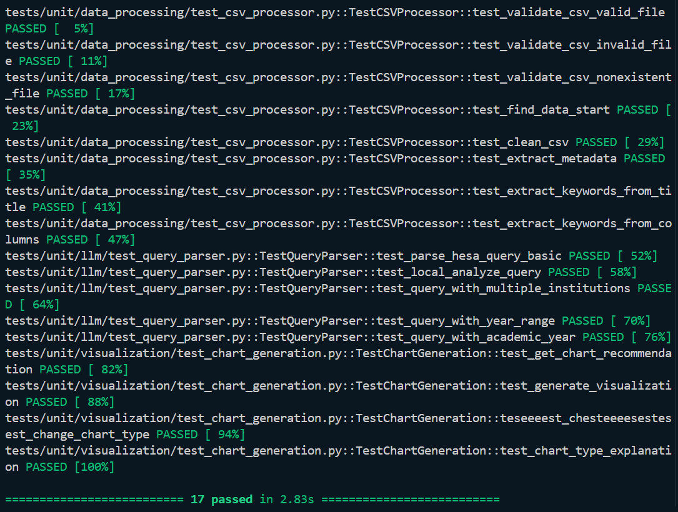

*Figure 41: Passed Unit Testing 100%*

### Integration Testing

I created integration tests that verify the end-to-end flow of data through the HESA LLM Visualization system. It focuses on how different components work together. The integration tests cover:

1. Query to Visualization Flow – Testing the complete pipeline from user query to final visualization
2. Web Interface Integration – Testing how the API endpoints integrate with the code processing functions

Key Flows Tested

1. Query Processing Flow

* Natural language query (NLQ) is parsed to extract institutions, years, and data types
* The extracted information is used to find matching datasets
* Test verifies that a query like “How many students were at University of Cambridge in 2020?” correctly extracts "University of Cambridge" and "2020"

2. Data Retrieval Flow

* Tests that query parameters can be used to find relevant CSV files
* Verifies metadata extraction from files works correctly
* Checks that data can be loaded from the matched files

3. Visualization Generation Flow

* Tests the pipeline from data to chart recommendation and generation
* Verifies that appropriate chart types are recommended based on data characteristics
* Ensures visualization configurations include proper chart data, options, and insights

4. End-to-End Query to Chart Flow

* Tests the complete flow from query to visualization
* Validates that a query like “Show me student enrolments by university in 2022/23” results in appropriate data selection and visualization

All integration tests were executed successful. (see Figure 41)

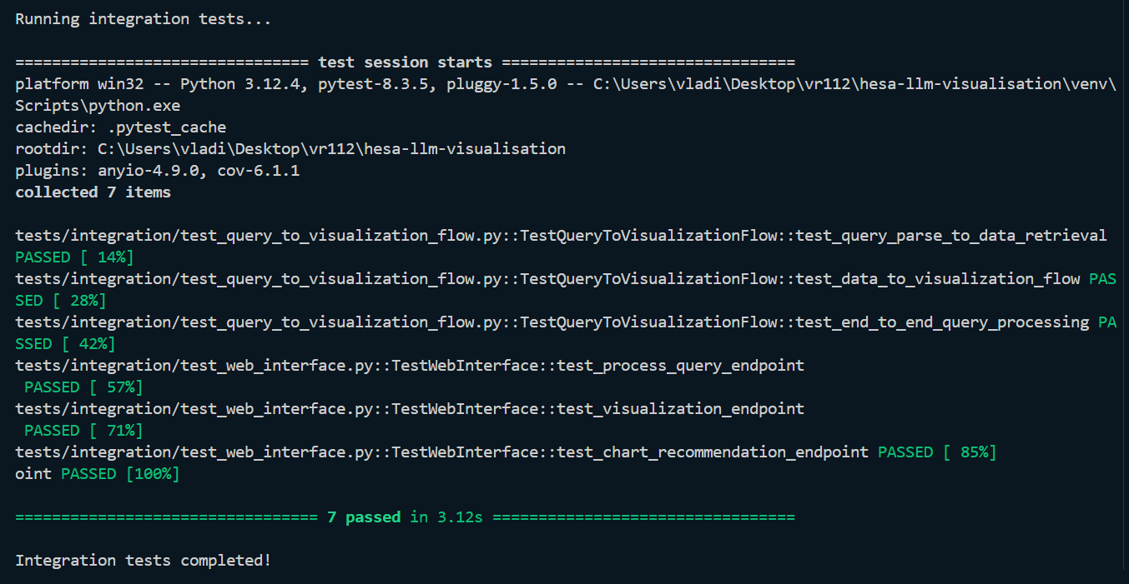

*Figure 42: Passed Integration Testing 100%*

#### Query to Visualization Flow (see Appendix C.1)

Location: test_query_to_visualization_flow.py

This file contains test that verify the complete data pipeline from a NLQ to a visualization output. These test focus on:

* Data Flow Integration: How data moves between different components of the system
* End-to-End Processing: Testing the complete journey from user query to final visualization
* Component Interaction: Verifying that data processing, query parsing and visualization generation work together

Key tests include:

* Testing how NLQs are parsed to find relevant datasets
  + test_query_parse_to_data_retrieva
* Testing transforming data into visualisations with appropriate chart types
  + test_data_to_visualization_flow
* Testing the entire pipeline from query to chart generation
  + test_end_to_end_query_processing

They simulate a user entering a query like “Show me student enrolments at University of Cambridge in 2020” and test that the system correctly:

1. Extracts entities (universities, years)
2. Finds matching datasets
3. Processes the data
4. Generates appropriate visualizations

#### Mock AI Client Integration Tests (see Appendix C.2)

Location: test_web_interface.py

The tests below focus on the integration between the application and the AI client that handles:

* Chart recommendations
* Visualization generation
* Chart type switching

Key tests include:

* Verifying that appropriate chart types are recommended based on selected data
  + test_chart_recommendation
* Testing the creation of complete visualization configurations
  + test_visualization_generation
* Testing the ability to change chart types for the same data
  + test_chart_type_change

It ensures that the AI client (MockAIClient) correctly integrates with the application by:

1. Providing sensible chart recommendations based on data structure
2. Generating complete chart configurations with all required parameters
3. Supporting different visualization types for the same dataset

## 7.2 Performance Metrics and Results

Average response time (ART)

* Mean time from query submission to results displayed
* Target:
* < 3 seconds for easy query
* < 5 seconds for medium query
* < 8 seconds for hard query

Cache hit response time (CHRT)

* Response time when query is results are retrieved from cached
* Target:
  + < 0.5 seconds

### Query Response Time

|  |  |  |  |  |
| --- | --- | --- | --- | --- |
| Complexity | ID | Query | Response Time (seconds) | Cached Response Time (seconds) |
| Easy | 1 | How many postgraduates are in University of Cambridge in 2017? (2 matches, no missing group filtering) | 6.21 | 0.06 |
| 2 | What was the research income starting in 2017? (2 matches, no missing group filtering) | 5.48 | 0.05 |
| 3 | Show carbon emissions for Coventry University in 2021 (1 matches, no missing group filtering) | 4.29 | 0.11 |
| Medium | 4 | How many full-time students lived in university accommodation at University of York from 2016 to 2018? (4 matches, no missing group filtering) | 8.67 | 0.1 |
| 5 | Research funding for University of Manchester from 2017 to 2019? (7 matches, no missing group filtering) | 10.31 | 0.08 |
| 6 | Graduation rates at University of London institutions for the past 5 years (5 matches, no missing group filtering) | 58.3 | 0.67 |
| Hard | 7 | Compare teaching and salary in University of Bath (3 matches, filtered by Million+) | 23.69 | 0.21 |
| 8 | What's the trend in total expenditure for all universities in the past 10 years? (matches 5, filtered by Russell Group) | 30.81 | 0.5 |
| 9 | What are the classifications in the University of Bristol from 2014 to 2025 | 25.06 | 0.24 |

*Table 7: Raw data from JSON file what stores information about data processing time (see Appendix M.2)*

Explanation if query complexity:

* Easy
  + Single year
  + Single institution or no specific institutions
  + No mission group filtering
  + Number of matches to show <= 3
* Medium
  + Multiple years
  + Multiple institutions
  + No mission group filtering
  + Number of matches to show > 3
* Hard
  + Any years (when the year is omitted in the submitted query the system searches for any year)
  + Multiple institutions
  + Applied mission group filtering
  + Number of matches to show > 3

After conducting plenty of testing you can clearly see that caching is a must use technique. On average, the caching methods increase the processing by 16.73 times. The code that implements query timing stored received data in JSON format automatically (see Figure 52, Appendix M.1)

*Note:*

*9.2 seconds (Average Initial Response Time) / 0.55 seconds (Average Cached Response Time) ≈ 16.73*

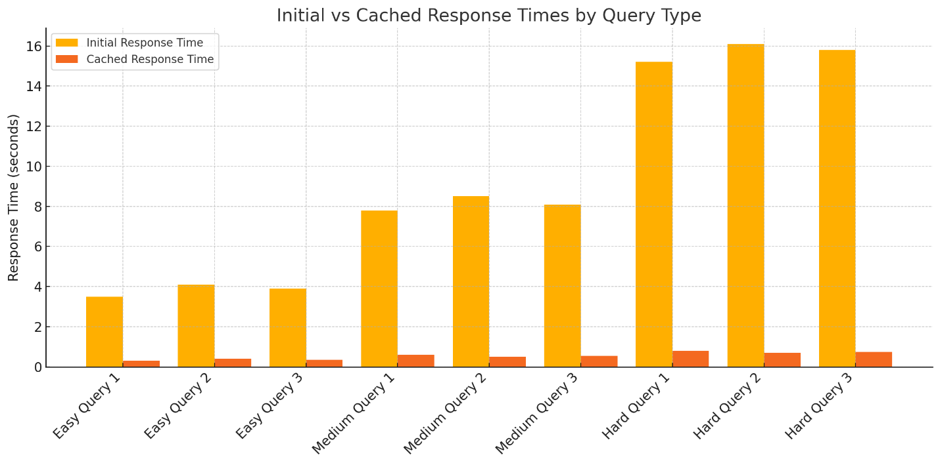

*Figure 52: Comparison of Cached and Non-cached approach.*

### Accuracy of Query Interpretation

The accuracy measurement is calculated based on my own analyses of submitted query and received results.

Relevance scoring (0 – 3 scale):

* 3 = Excellent: Results perfect match the query intent and showing data that I was expected to see
* 2 = Good: Results mostly match the query intent with minor difference
* 1 = Partial: Results are related to the query but missing key aspects or has irrelevant information
* 0 = Poor: Results do not address the query intent or completely off topic.

|  |  |  |  |
| --- | --- | --- | --- |
| ID | Query | Score | Figure Number |
| 1 | How many postgraduates are in University of Cambridge in 2017? | 3 | 43 |
| 2 | What was the research income starting in 2017? | 3 | 44 |
| 3 | Show carbon emissions for Coventry University ending in 2021 | 3 | 45 |
| 4 | How many full-time students lived in university accommodation at University of York from 2016 to 2018? | 3 | 46 |
| 5 | Research funding for University of Manchester from 2017 to 2019? | 2 | 47 |
| 6 | Graduation rates at University of London institutions for the past 5 years | 1 | 48 |
| 7 | Compare teaching and salary in University of Bath | 1 | 49 |
| 8 | What's the trend in total expenditure for all universities in the past 10 years? | 3 | 50 |
| 9 | What are the classification in the University of Bristol from 2014 to 2025 | 2 | 51 |

*Table 8: Accuracy relevance score on scale 0 to 3*

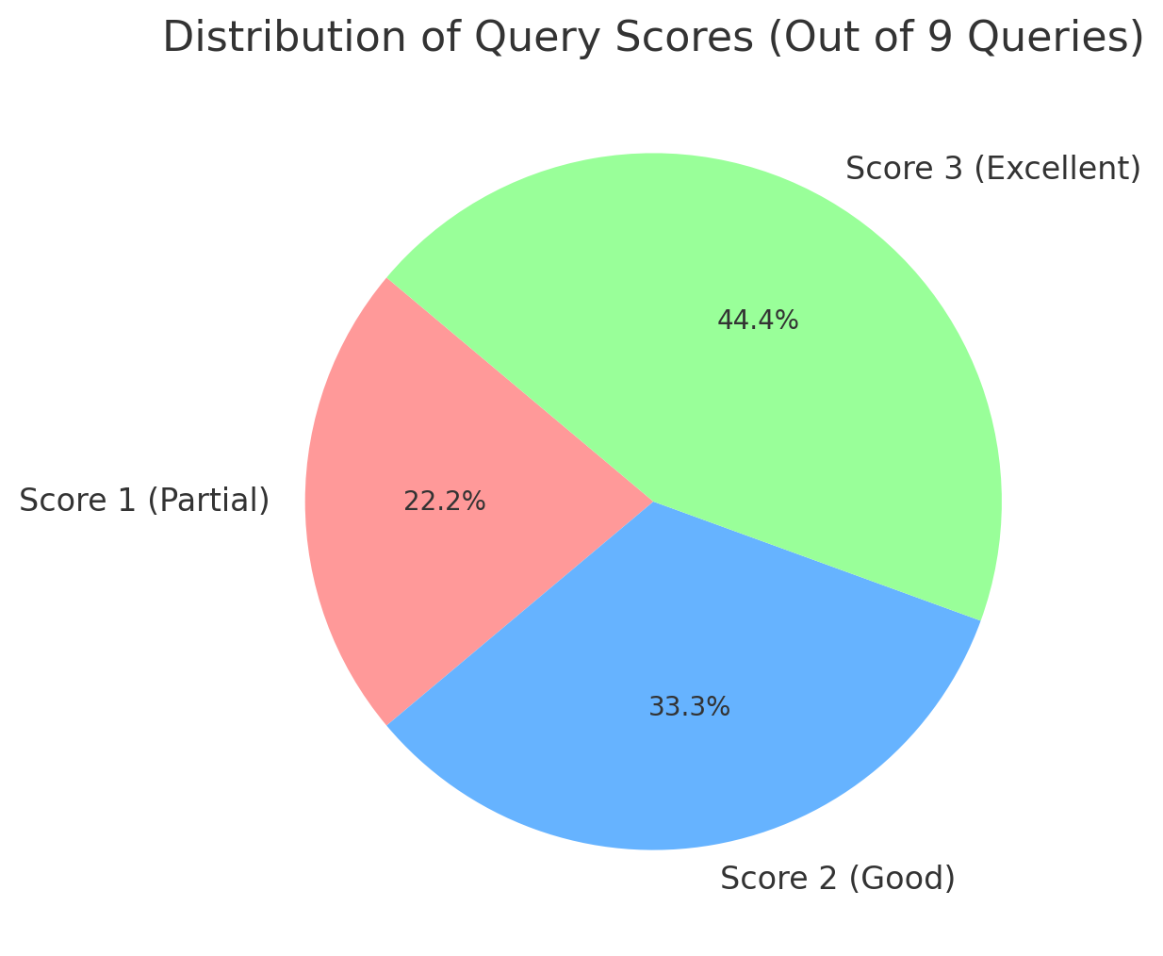

*Figure 53: Pie chart of data processing accuracy*

The dataset matching works, but there is still room for the improvements. Even though only 44% of the 9 tested queries were evaluated as excellent, this is a solid foundation that can improve to reach 100%. (see Figure 53)

Factors affecting the accuracy of results:

* Even though the system uses the submitted query intent to find the data, there are limits on how deep the Gemini understands the intent. This could be specified in more details and advanced so get better results.
* HESA does provide a lot of data but not everything, so there is chance that the data user is looking for just does not exist, so user end up getting most closely related data.
* The system is capable of understanding typos and closely related words, but this aspect can affect how well Gemini will interpret and process the query

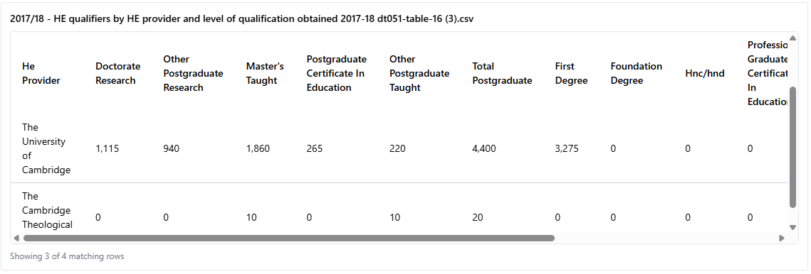

*Figure 43: Found Data for Easy Query 1*

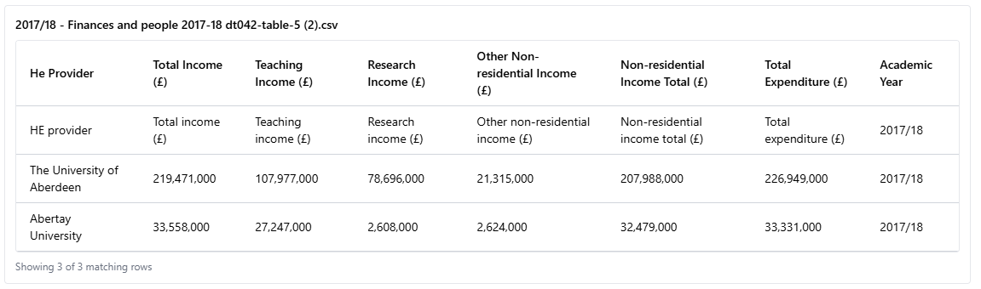

*Figure 44: Found Data for Easy Query 2*

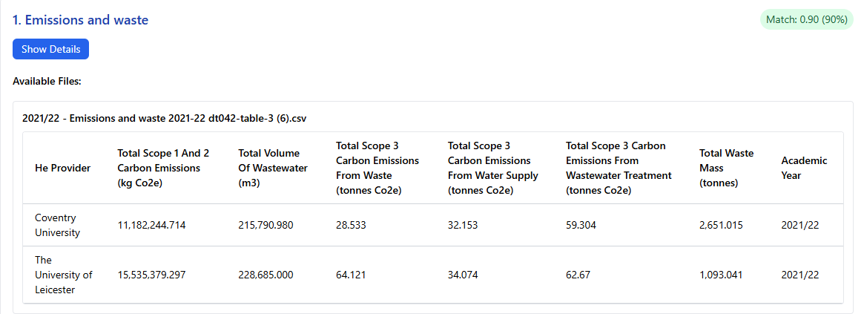

*Figure 45: Found Data for Easy Query 3*

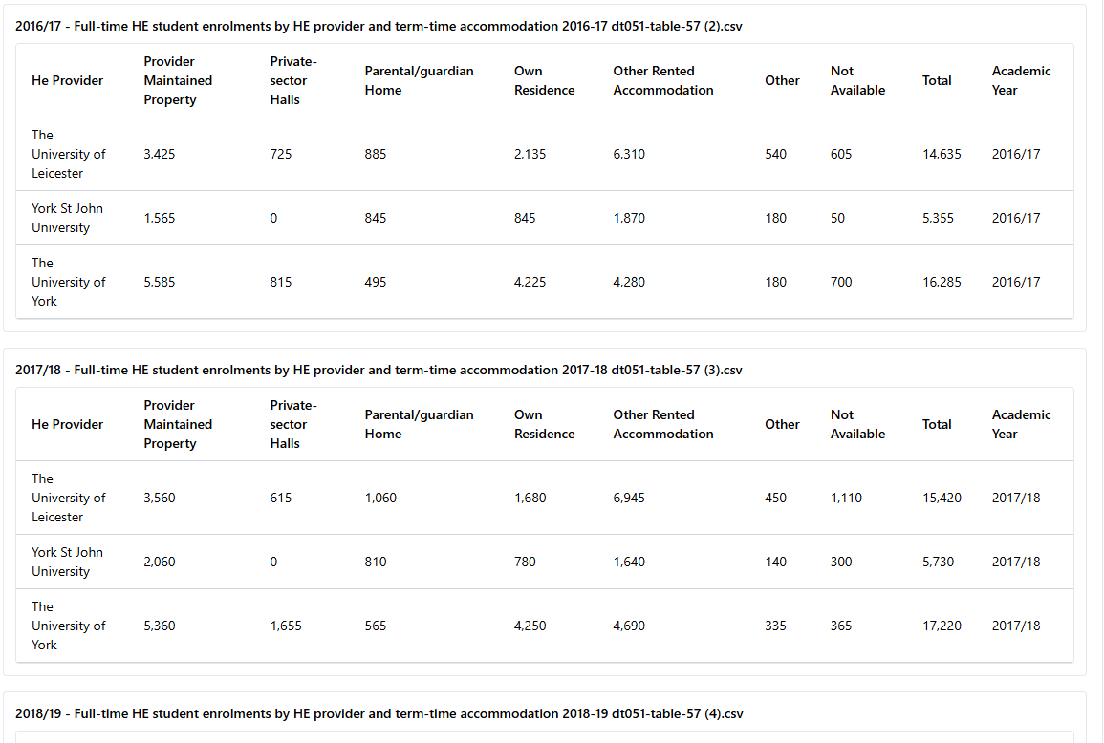

*Figure 46: Found Data for Medium Query 1*

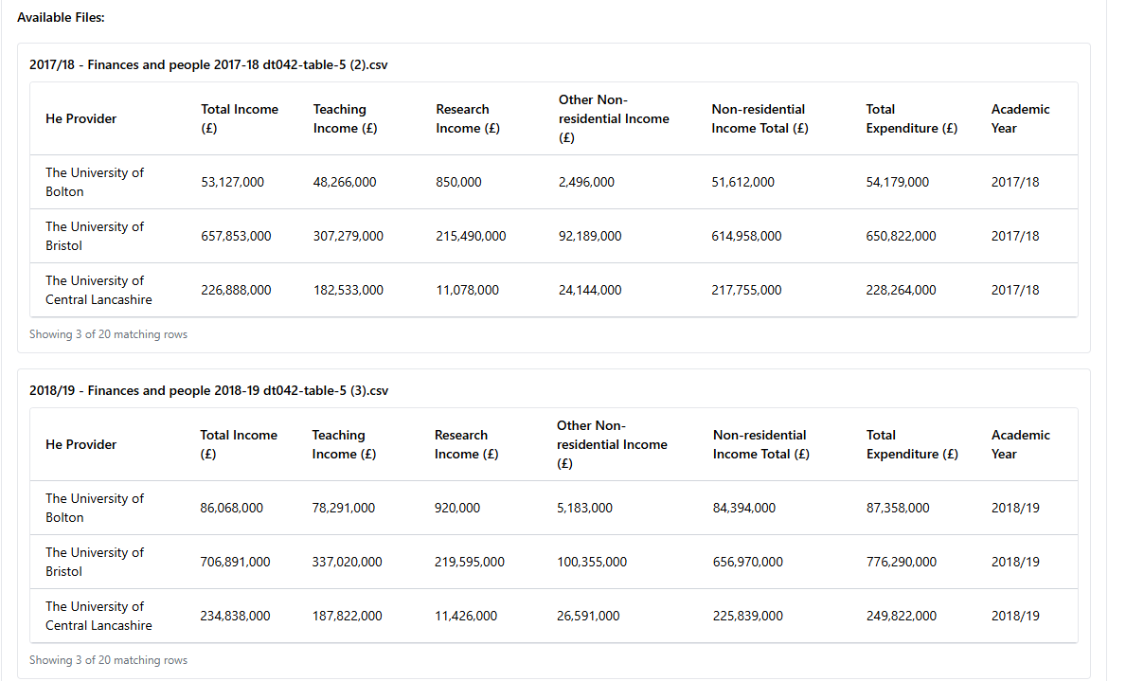

*Figure 47: Found Data for Medium Query 2*

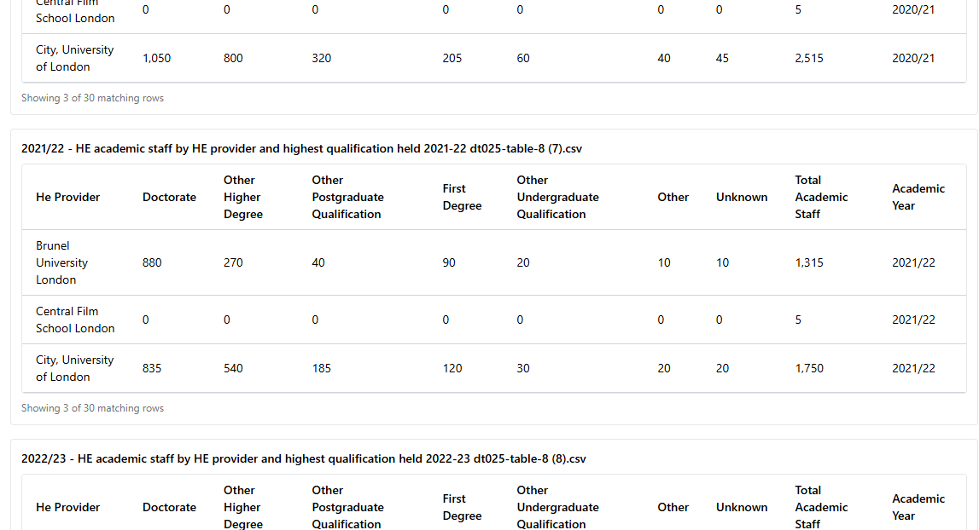

*Figure 48: Found Data for Medium Query 3*

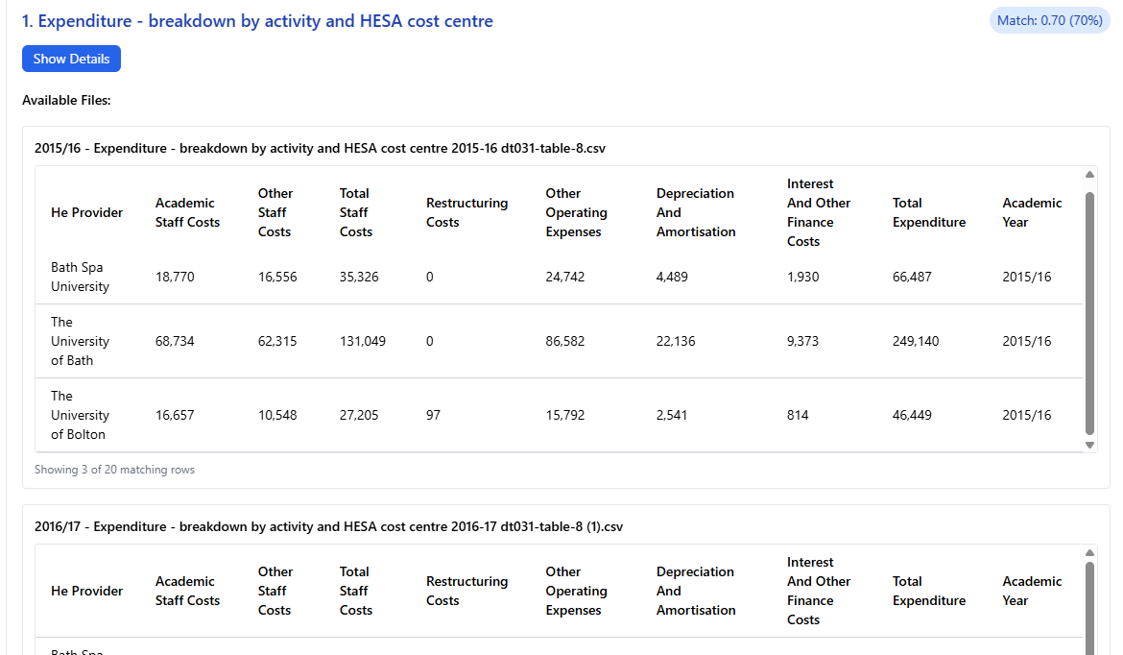

*Figure 49: Found Data for Hard Query 1*

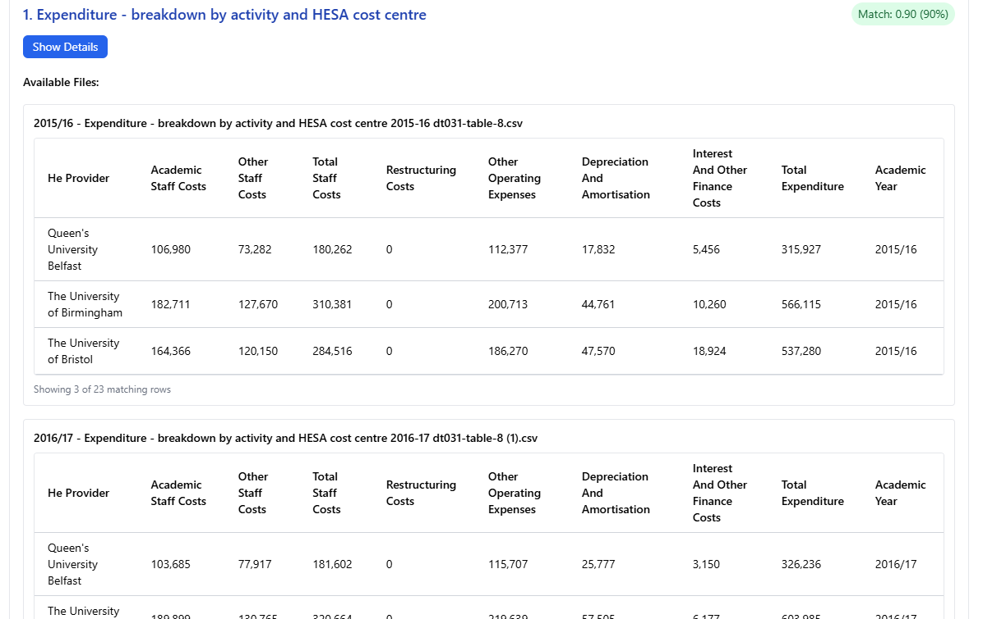

*Figure 50: Found Data for Hard Query 1*

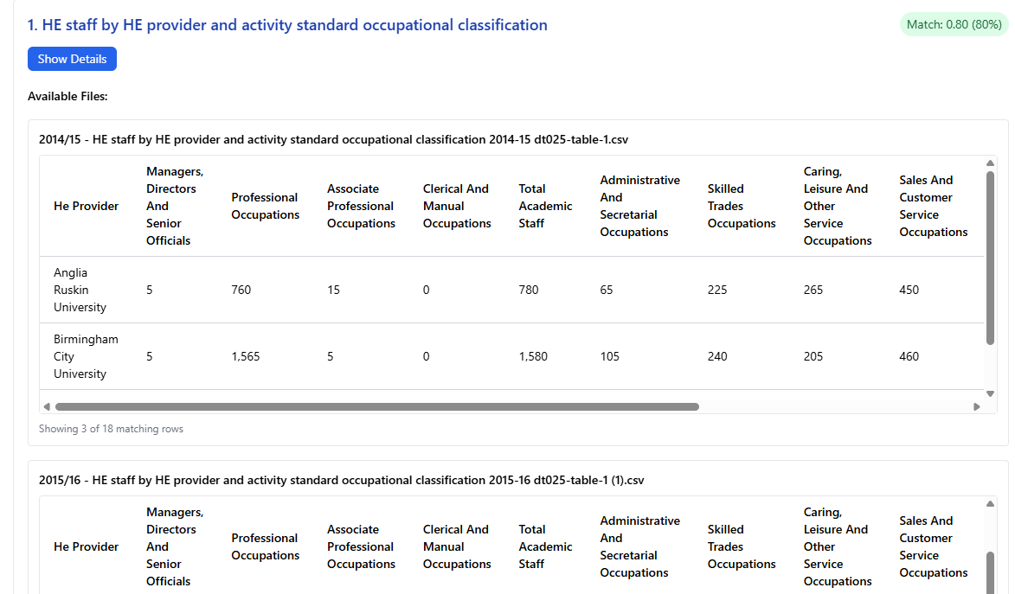

*Figure 51: Found Data for Hard Query 3*

# 8. Discussion

## 8.1 Analysis of Findings

The current system successfully addresses the problem statement and met its aims. The main strength is its capabilities to perform all the core functionality:

* Processing raw data effectively
* Analysing and extracting data dynamically
* Providing recommendations and visualisation dynamically based on user requests

The weakness of the system is that the automatic data retrieval from HESA was not implemented but I have provided an alternative way to manually update the data in an easy way. Additionally, the project is not deployed, so it can only be used in the project environment.

## 8.2 Explaining LLM and Method Comparisons

### Explanation of the Initial GPT-J Implementation and Reasons for its Failure

The system originally was designed to use GPT-J model which was supposed to be hosted locally and used for query interpretation. The implementation of that involved setting up the GPT-J model using Hugging Face Transformers library [9]. The model would send user queries to the local machine for data processing. However, this method encountered issue during implementation and testing which led to failure as a viable solution for this system.

The main reasons for its failure are:

* Performance Issues
  + Running GPT-J locally results in slow response time for query interpretation even on capable hardware. Unfortunately, it failed to meet performance goals.
* High Error Rates
  + For most of the results the data extracting from query interpretations were wrong, such as institution name and academic years.
* Output Inconsistencies
  + The output results were inconsistent, even running same query could results in different data extraction.
* Infrastructure Requirements
  + Hosting GPT-J demanded significant computational resources and technical effort for setup

### Comparison of Approaches (Regex, GPT-J, Gemini)

* Accuracy
  + Regex: The accuracy was relatively good, but only for basic queries and only for certain type of data. When I was testing complex queries or when more data was uploaded, its performance deteriorated significantly. A benefit of this approach was its speed, as it did not require any API calls
  + GPT-J: It performed better with more diverse data than the Regex approach, but it returned incorrect results most of the time. Also, this approach was the slowest of all tested because of hosting.
  + Gemini 1.5 Pro: Provides the most accurate and relatively quick results. Due to its larger capacity compared to the GPT-J and greater intelligence than the Regex approach. Its advanced natural language processing capabilities allow it to understand different phrasings and accurately extract the right data.
* Cost-Effectiveness
  + Regex: This approach is free to use because it is just combinations of different algorithms and patterns to find right data.
  + GPT-J: This model is free to use but it weighs about 50 GB, and it takes time when starting the server so this completely free, but it sacrifices the space and speed. Also, the speed of execution depends on the hardware that executes it, so the better hardware leads to performs better.
  + Gemini 1.5 Pro: The cost of Gemini Pro is different, it depends on the tokens used for API calls but Google provide a free credits that can be used to use the model. Refer to chapter 4.1 the overall cost of free-credits is around £3.88 so considering that Google provides £237 worth of free-credits it is cheap to utilize this model.
* Flexibility and Scalability
  + Regex: It provides no flexibility because it relies on predefined patterns and is therefore not scalable
  + GPT-J: It is flexible from the perspective of customizable configuration. It can be configured as the user wants, but its scalability is limited because of low capacity and outdated version.
  + Gemini 1.5 Pro: Even though Gemini is less customizable than GPT-J, its basic settings are sufficient to configure it for complex project. Furthermore, it is scalable because Google provide updates that yield even better results without requiring a complete change to the project structure.

On average, Gemini provided the best results comparing to the Regex and GPT-J approach. It is not perfect, but it is well-suited for this type of project and complexity. It is easy to set up, Google provides free credits so it can be used for free of charge for significant amount of time and it is intelligent enough to perform complex data manipulation like HESA data.

## 8.3 Project Process Evolution and Timeline

The projected started with a structured plan as explained in Section 3.3 and early Gantt chart but the development process required evolution and adaptation. This section explains how the project timeline and approach changed from the initial plan to where it is right now. (see Figures 54,55)

The main reason for the project evolution was the decision to shift from the initially planned GPT-J model to Gemini 1.5 Pro API. The reason for initial implementation with GPT-J were its accessibility and no cost through self-hosting but it faced limitations in the early stage of devilment. These issues are further detailed in the section 8.2 includes:

* Including slow performance
* High error rate
* Limited understanding of HESA data
* Inconsistent output formats

This drastic change initially delayed the core query processing and dataset matching functionality because the main underlying AI technology was swapped. However, the superior capabilities of Gemini enabled better accuracy and opened possibilities for features that were not feasible for GPT-J. This led to a better overall outcome than initially expected, despite the re-work required

Another important change impacting the project timeline was the work on automated data updates. The initial goal was to allow the user to be able to automatically download the new data from HESA. Due to HESA's limited functionality for external usage, this was replaced with manual data updates

The iterative nature of the development process in integrating and refining the LLM interaction means that milestones were adjusted based on testing outcomes and the need to address unexpected issues.

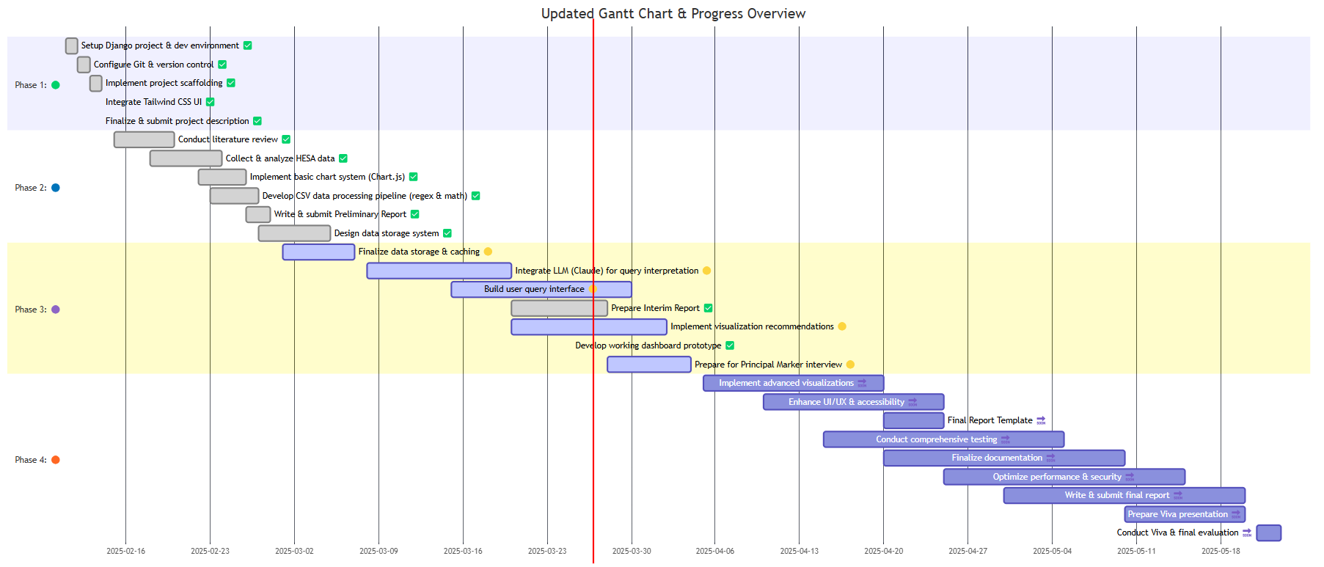

*Figure 54: Revised Project Timeline - Gantt Chart*

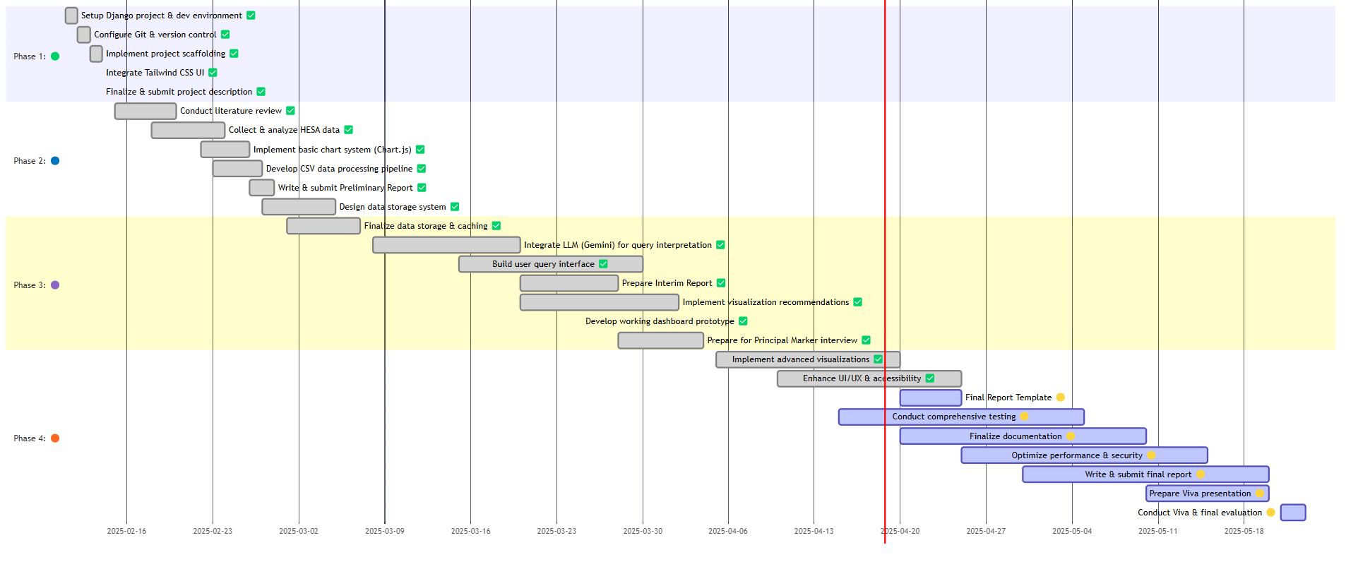

*Figure 55: Final Project Timeline - Gantt Chart*

### Impact of Process Changes

After switching, I had to remove components primarily related to GPT-J, clean up the project and prepare it for the new LLM approach. Additionally, I had to re-implement the data extraction approach and processing techniques, as well as *csv_cleaning.py* functionality. I improved the cleaning files technique, so it creates indexing file which improves data processing and extraction. Consequently, this entire process took me more time, causing my original plan to shift, as I had to spend time re-doing tasks. The outcome was better than I expected because it not only fixed the issue faced when working with GPT-J but also it opened the possibility of implementing other features that were not feasible initially.

### Lessons Learned from Process Evolution

I learnt from this process evolution the need to carefully analyse the core technology before starting using them and the importance of flexibility in the project planning. The importance of conducting more detailed research on the data that is required for the project before choosing what data fits best for the project. Learn more about technology’s capabilities and limitations. Do more search about requirements chosen from the project to make sure they are implementable. In my case, the automatic data retrieval was not feasible to implement due to HESA limitations.

## 8.4 Achievement of Requirements

Most of the requirements that were outlined originally were implemented.

* Essential: 5/5
* Recommended: 9/10
* Optional: 1/7

Additionally, the essential requirement “Automated Data Retrieval” had to be cancelled as it was impossible to implement due to lack of HESA provided functionality. I decided to change it to “Manual data retrieval” as it still allows to perform data updates for the project in quick manner.

|  |  |  |
| --- | --- | --- |
| Priority | Requirement | Status |
| Essential | **Natural Language Query Interpretation:** The system understands users free-from queries and retrieve, and process data based on that. | ✔ |
| User types a query in the search input, and after pressing the submit button, that query goes through different complex algorithms and returns data for the submitted query. |
| **Integrating and Processing Data:** Extracting and preparing clean HESA data, making it usable for comparing metric performance | ✔ |
| The process data for the submitted query is being cleaned beforehand, therefore it is usable in comparison |
| **Interactive Dashboard:** It must dynamically display results in different format like tables, charts, diagrams or summary reports. | ✔ |
| Displays data in Pie chart, Line chart or Bar char format |
| **Comparative Analysis**: A feature that must allow to group and benchmark universities by different categories like Mission Groups | ✔ |
| The UI (User Interface) provides filtering options for Mission Group. There are 4 options: None (if no filtering should be applied), Russell Group, Million+ and University Alliance |
| **Data Export Capabilities:** Allow users to download generated reports and data as CSV, PFD or Excel file | ✔ |
| After the user submits a query and selects a dataset, the user can download data for that selected dataset in 3 formats: CSV, PDF or Excel just be pressing a button |
| Recommended: | **Automated Data Retrieval:** Make a way to automatically update the dashboard with new data from HESA when it is available. | X |
| After some time researching, I realised that HESA does not provide any API or any other way to automatically download the data. The worst part is that they do not even say the exact date of when new data will be available, so I could create some sort of script to call the endpoint when new data becomes available. HESA says that they provide the date when new data will be available 4 weeks before the release of data. So, combining all the encountered issues, I decided to cancel this requirement and instead implemented manual data update, which was successfully implemented. |
| **Using AI To Improve Analysis:** LLM should provide insights, trend identification, and recommendations if user asks for that. | ✔ |
| On the selected dataset page, after the user chooses to generate a visualisation at the bottom of that page, it also automatically generates the “Insights” section by Gemini based on the selected dataset and visualisation requirements. In that section, Gemini provide summarisation and key points of the generated visualisation. Also, on the selected dataset page, the Gemini analyses the dataset and provides recommendations for which type of visualisation is better for the selected dataset and requirements. If the user decides to generate a new visualization of a different type, Gemini will re-generate recommendations, visualization and insights, but it will notify the user that the newly selected chart type is not recommended for the selected dataset and explain the reason. In case a new, not recommended by Gemini visualisation cannot be generated, it will provide a specific message. |
| **Query Building Guide**: Provide a guide or pre-build example for users that are unfamiliar with the free-text queries | ✔ |
| On the main page, there is a “Sample Questions” button that provides 10 queries of different formats and types that the user can try out. Also, it provides guides on how the patterns for searching data work and an explanation of the Mission Group |
| **Advanced Visualisation:** Support interactive graphs, trends projections that offer visual comparison of performance metrics. | ✔ |
| The generated visualisations are not static but rather dynamic. The user can toggle data on generated charts by removing or putting back the data. Also, in the requirements, input user can ask Gemini to swap axis for a generated chart or to change colours |
| **Historical Data Tracking:** Tracking data changes overtime to see how organisational performance was changing relative to peers (for data processing) | ✔ |
| The system handles multi-year data during the filtering and aggregation step, as well as generates a line chart that provides trends over time. |
| **Caching for Frequent Queries:** Implement caching to perform repeated queries more efficient that will result in better performance | ✔ |
| Submitted query is now cached and stored in the cached folder in the format of a JSON document. It contains all the information about the submitted query. The cached data is saved for the period of 30 days, after that time, the cached data is removed. |
| **LLM Interpretation Feedback:** Allow users to see how their query was interpreted by the system to improved data transparency and remove bias factor | ✔ |
| The submitted query provides information on why a particular dataset matches the query. It shows academic year/s were used to search for data, matching score and even names of the files from which where data. |
| **Queries Logs:** Log out user queries to improve future prompts tuning | ✔ |
| User queries are getting logged out and stored along with the feedback that the user provides. It can be further used to analyse the popularity of searched data, the phrasing that users use and more. |
| **Data Overload protection**: Implement a safeguard that prevent outputs of big queries to potentially crush the system | ✔ |
| Returned data is being truncated to only show the user a maximum of 3 rows of data. This preview mode goes for all the returned datasets which resulting in quicker and more efficient output. |
| **CSV File Validation:** Make a mechanism to automatically sanitize new raw HESA data (checking for correct format and size anomalies) to prepare it for the data processing. | ✔ |
| The data originally provided in the raw format is then cleaned to be ready to be used for data processing. After cleaning data being stored in the “/cleaned_files” folder |
| Optional: | **Predictive Modelling:** Using historical data and machine learning (ML) to predict future universities performance metrics | X |
| The requirement was not implemented due to initial planning oversights and time constraints. The research identified relevant libraries, but insufficient time remained for their comprehensive understanding and integration. |
| **Chatbot Integration:** Include an AI chatbot assistant to help user to refine their queries dynamically, in real time. | X |
| I did not create an AI chatbot that users could use for assistance, instead users can use fields for submitted visualisation specification, continuing therefore receive continuous feedback and greater results. |
| **API for External Use:** Create an API so that external and third-party application can use dashboard’s functionality | X |
| The project ended up being more complicated than I originally thought. Especially, regarding the creation of an API for external use. In fact, the creation of an API is primarily optional requirement because it does not affect the main purpose and idea of the project |
| **Collect feedback:** Implement mechanisms that would collect users' feedback through the application surveys to continuously | ✔ |
| After the user submits a query and gets results, there is an option to provide feedback about the returned datasets. There are 3 options “Not Helpful”, “Helpful” and “Very Helpful”. Choosing any options but “Very Helpful” would require the user to provide a feedback comment (optional) |
| **Data Storage Scalability**: If HESA data volume grows beyond local CSV storage it will be migrated to a more scalable database solution such as (PostgreSQL or SQLite) | X |
| The reason I included this requirement is that I was not sure whether I would need to relocate HESA data into something more scalable. Since I decided that storing data locally is good enough, implementing this requirement is pointless. |
| **Multi-User Concurrency:** Allow users to submit multiple queries simultaneously by using asynchronous job queues (such as Celery) and session management. | X |
| It requires deployment, and since deployment is not implemented, this requirement cannot be achieved. This is not a critical requirement because it can be implemented later on, and this project can be used without multiple users using it at the same time |
| **Deployment**: Develop a deployment plan starting with local deployment and extending to containerization (Docker) and orchestration (Kubernetes) for future scalability. | X |
| After research, I realised that the suggested way to deploy a project can only be done using the paid method, and I am not willing to spend my own money on a university project. Also, the deployment is not a critical requirement because it can be done at any point in time. |

*Table 9: Project Requirements Implementation Status*

## 8.5 Personal Learning and Reflection

These 3 months of project duration gave me significant personal and technical growth. Beyond specific technical skills that I gained, the process gave me valuable lessons in project management and problem solving.

A key area of learning was working with LLM for the first time in practical application. This includes the challenges faced with GPT-J and eventual integration of Gemini API. I learn more about both LLM model, specifically about what they offer and their limitations.

Working with HESA datasets was valuable experience in handling real world data challenges. I gain more knowledge about structure of HESA and complexities of cleaning, standardizing and preparing that data for analyses. The idea of creating the indexing file is clear example of understanding the need for efficient data handling.

Furthermore, this project was my only second experience using Django development stack. Working with this project improved familiarity with its key components and improved skills with backend. First ever experience with Chart.js was successful and I quickly become proficient in generating dynamic and interactive data visualization.

Beyond the core project technologies, I leveraged generative AI tools to help in the development process. These tools significantly contributed to my learning and efficiency:

* Grammarly AI: Used extensively to automatically check text for grammatical and syntactical mistakes. It helped me to refine the clarity and professionalism of project documentation and reports.
* GitHub Copilot: Integrated into VS Code which I used for developing this project. This tool provided:
  + Automated code suggestions (particularly helpful for boilerplate code)
  + Syntax recall
  + Exploring different implementation approaches
  + Automatic comment suggestion
* ChatGPT: Used for brainstorming ideas about the design of the website, search engine to quickly find information and to explain complicated concepts in simple way. Also, used other GPTs that help me in image and icon generation.
* Gemini 1.5 Pro: Served as a core functional component of the system for data processing. I have used Gemini to ask it to generate prompts that would get sent to Gemini API as detailed explanations of how to retrieve data or process it because I noticed that the prompts that were generated by Gemini worked better than the ones that I manually wrote myself. So, I used Gemini to get prompts and then manually tailor it if needed. (see Appendix F.3)

## 8.6 Critical Evaluation

### Research

The literature review provided a better understanding of the technologies used in this project, such as the Chart.js documentation and the startup code for the LLM. I did not have any problems in finding the right data for my project, the only exception would be topics that are not publicly available, like the exact method that the University of Leicester is using when working with HESA data. It took me some time to understand the way HESA data is structured and how I can efficiently use it for data processing.

### Design

The project architecture that I have chosen originally was perfect from the start, so I did not change anything about it as the project evolved. I did add more design features, a hide button for the Gemini analysis logic that is used for transparency, so the user could see how Gemini works. The button just allows the user to toggle the visibility of this information, resulting in a less cluttered webpage interface.

### Implementation

I am proud of the CSV cleaning mechanism that I have implemented because it is multifunctional. It cleans the raw data and locates it to the right folder, then it extracts metadata that is used for simplifying the data processing functionality. Lastly, it creates the indexing file that is used to minimise the number of API calls required to find the right data.

The main challenge was to correctly implement the functionality so that it finds the right data based on the user's request. I tried many approaches to use the GPT-J, which failed, the Regex approach, which could help in case there is an issue with the Gemini API, but it was not dynamic enough, so I had to remove it, and only the Gemini 1.5 Pro managed to provide consistently correct results. The most helpful way to find the right solution was to debug my code, so I always make sure to logout unexpected results to observe the system behaviour during the execution.

## 8.7 Discussion of the Number of Requests and Associated Costs

During the implementation and testing phases, 882 requests were made to the Gemini 1.5 API. The volume of API calls made to Gemini 1.5 Pro over the project timeline. This includes APIs call to process, find, explain (insights) and visualize data (see Figure 56)

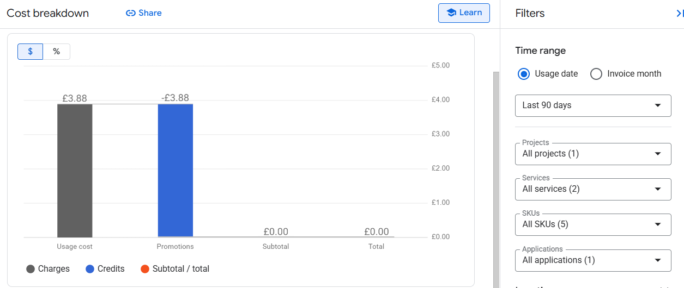

*Figure 56: Volume of API calls made to Gemini 1.5 Pro over the project timeline.*

The total number of API calls and associated cost metrics during the project. The first API call was made on March 17, and testing continued until April 29. The total number of requests made during this period was 882. The associated cost for these requests was approximately £3.88, which was covered by Google's free credit tier for API usage. (see Figure 57)

*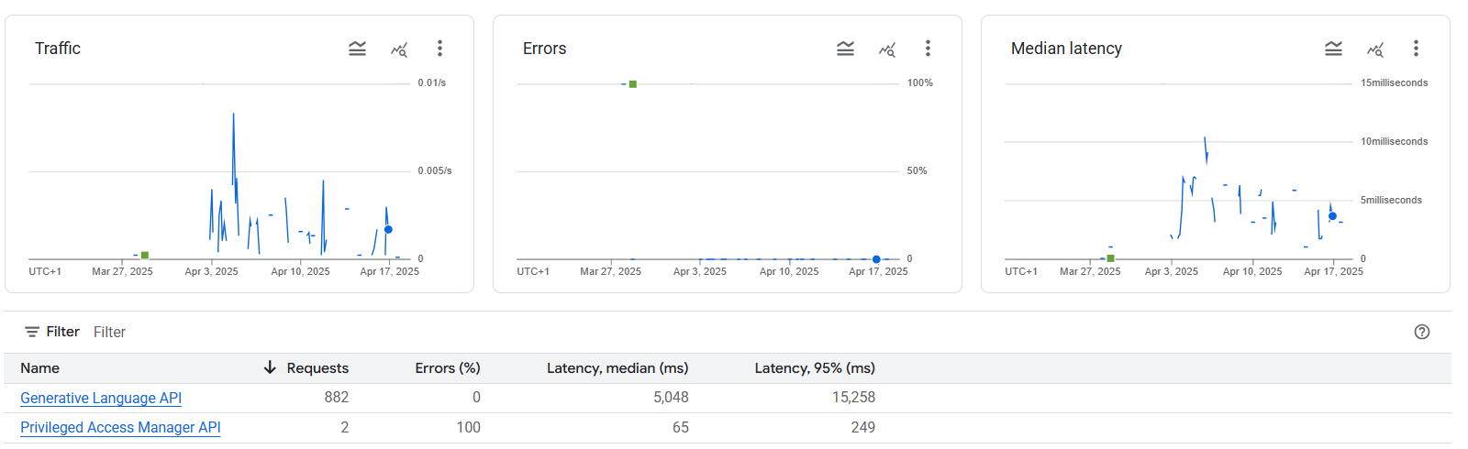Figure 57: Associated cost metrics about the project*

# 9. Conclusion and Future Work

## 9.1 Summary of Project Achievements

The project delivered the LLM-powered, dynamic visualization dashboard for the University of Leicester to easily work with HESA data. Currently, the project contains 392 CSV HESA cleaned files, which are all the relevant files up to date. It uses integrated Google Gemini 1.5 Pro to interpret free-text queries into structured parameters. Using Chart.js configuration to generate charts on demand. Created a responsive and nicely looking User Interface with feedback collection and data upload feature. The system is fully tested, and it has a 100% pass rate.

## 9.2 Conclusions

The system successfully overcomes the limitations of the manual and static original approach by:

* Reducing technical barriers and allowing a user without preparation to ask complex benchmarking questions in plain English
* Improving flexibility by enabling dynamic filtering, chart-type generation and changing without rebuilding pipelines.
* Enhancing the efficiency by cutting the time from a question to insights, from hours to seconds.

## 9.3 Future Work and Recommendations

To extend and strengthen the dashboard, some things can be done:

Broader HESA coverage & automation

* Automate data ingestion directly if HESA ever provide a public API and update the system so it can work even with detailed CSV files.

Predictive analytics & modelling

* Integrate Machine Learning (ML) driven trend projection so the user can see future trend changes, therefore gain more insights on the data.

Creating Administrator Panel

* The panel would allow the administrator to access the stored data directly through the User Interface (UI) and remove files or even data in case something was uploaded incorrectly

# 10. References

[1]. EleutherAI, ‘GPT-J 6B’, Hugging Face, 2021. [Online]. Available: <https://huggingface.co/EleutherAI/gpt-j-6B> (Accessed: 22 February 2025).

[2]. Brown, T. B. et al., ‘Language Models are Few-Shot Learners’, in Advances in Neural Information Processing Systems, 2020, pp. 1877–1901. [Online]. Available: <https://proceedings.neurips.cc/paper/2020/hash/1457c0d6bfcb4967418bfb8ac142f64a-Abstract.html> (Accessed: 22 February 2025).

[3]. Vaswani, A. et al., ‘Attention is All You Need’, in Advances in Neural Information Processing Systems, 2017, pp. 5998–6008. [Online]. Available: <https://papers.nips.nips.cc/paper/7181-attention-is-all-you-need.pdf> (Accessed: 22 February 2025).

[4]. Mitchell, R., Web Scraping with Python: Collecting Data from the Modern Web, 2nd ed., O'Reilly Media, 2018.

[5]. Higher Education Statistics Agency, ‘HESA Data and Analysis’, Higher Education Statistics Agency, 2023. [Online]. Available: <https://www.hesa.ac.uk/data-and-analysis> (Accessed: 22 February 2025).

[6]. Django Software Foundation, Django Documentation, 2023. [Online]. Available: <https://docs.djangoproject.com/en/4.2/> (Accessed: 22 February 2025).

[7]. McKinney, W., Python for Data Analysis: Data Wrangling with Pandas, NumPy, and IPython, 2nd ed., O’Reilly Media, 2017.

[8]. Tailwind Labs, Tailwind CSS Documentation, 2023. [Online]. Available: <https://tailwindcss.com/docs> (Accessed: 22 February 2025).

[9]. Wolf, T. et al., ‘Transformers: State-of-the-Art Natural Language Processing’, in Proceedings of the 2020 Conference on Empirical Methods in Natural Language Processing: System Demonstrations, pp. 38–45, 2020.

[10]. Prometheus Authors, Prometheus Documentation, 2023. [Online]. Available: <https://prometheus.io/docs/introduction/overview/> (Accessed: 23 February 2025).

[11]. Grafana Labs, Grafana Documentation, 2023. [Online]. Available: <https://grafana.com/docs/grafana/latest/> (Accessed: 23 February 2025).

[12]. Sentry, Sentry for Python, 2023. [Online]. Available: <https://docs.sentry.io/platforms/python/> (Accessed: 24 February 2025).

[13] <https://le.ac.uk/policies/privacy/students/student-information>

[14] <https://jobs.le.ac.uk/popups/displayfile.aspx?StoredFilePathID=wjMZlU3HiW3WxTamN-cedQ>

[15] Kuc-Czarnecka, M., et al. (2024) Ethical Considerations in Data Collection and Analysis: A Review: Investigating Ethical Practices and Challenges in Modern Data Collection and Analysis. Available at: <https://www.researchgate.net/publication/378789304_ETHICAL_CONSIDERATIONS_IN_DATA_COLLECTION_AND_ANALYSIS_A_REVIEW_INVESTIGATING_ETHICAL_PRACTICES_AND_CHALLENGES_IN_MODERN_DATA_COLLECTION_AND_ANALYSIS> (Accessed: 22 April 2025).

[16] Sobha, D. N. K., et al. (2017) The Use of Quantitative Research Method and Statistical Data Analysis in Dissertation: An Evaluation Study. Available at: <https://www.researchgate.net/publication/319468820_THE_USE_OF_QUANTITATIVE_RESEARCH_METHOD_AND_STATISTICAL_DATA_ANALYSIS_IN_DISSERTATION_AN_EVALUATION_STUDY> (Accessed: 22 April 2025).

[17] Commission on Higher Education Policy Advice (IHEC) (2024) Data Matters in Higher Education. Available at: <https://ihecommission.uk/wp-content/uploads/2024/06/IHEC_Data-Matters_03.06.2024.pdf> (Accessed: 22 April 2025).

[18] Department of Education, Australia (2023) Benchmarking Cost Efficiency and Productivity in Universities. Available at: <https://www.education.gov.au/download/18234/accord-report-benchmarking-cost-efficiency-and-productivity-universities/37655/document/pdf> (Accessed: 22 April 2025).

[19] OWASP (2025) OWASP Top 10 for LLM Applications 2025. Available at: <https://wtit.com/blog/2025/04/17/owasp-top-10-for-llm-applications-2025/> (Accessed: 22 April 2025).

[20] Nagaraja, N. and Bahsi, H. (2025) Cyber Threat Modeling of an LLM-Based Healthcare System. Available at: <https://www.scitepress.org/Papers/2025/132897/132897.pdf> (Accessed: 22 April 2025).

[21] Sun, Y., et al. (2024) Natural Language Interfaces for Tabular Data Querying and Visualization: A Survey. Available at: <https://www.researchgate.net/publication/380581799_Natural_Language_Interfaces_for_Tabular_Data_Querying_and_Visualization_A_Survey> (Accessed: 22 April 2025).

[22] Sankhla, H. (2025) Next-Generation Database Interfaces: A Comprehensive Survey of LLM-Based Text-to-SQL. Available at: <https://dev.to/hardiksankhla/next-generation-database-interfaces-a-comprehensive-survey-of-llm-based-text-to-sql-20i> (Accessed: 22 April 2025).

[23] Google, ‘Our next-generation model: Gemini 1.5’, Google Blog, 2024. [Online]. Available: <https://blog.google/technology/ai/google-gemini-next-generation-model-february-2024/> (Accessed: 2 April 2025).

[24]. Higher Education Statistics Agency, ‘HESA Data and Analysis’, Higher Education Statistics Agency, 2023. [Online]. Available: <https://www.hesa.ac.uk/data-and-analysis/upcoming> (Accessed: 2 May 2025).

# 11. Appendix

## A: Pandas-Based Data Processing Pipeline

### A.1 Data Transformation for Visualization

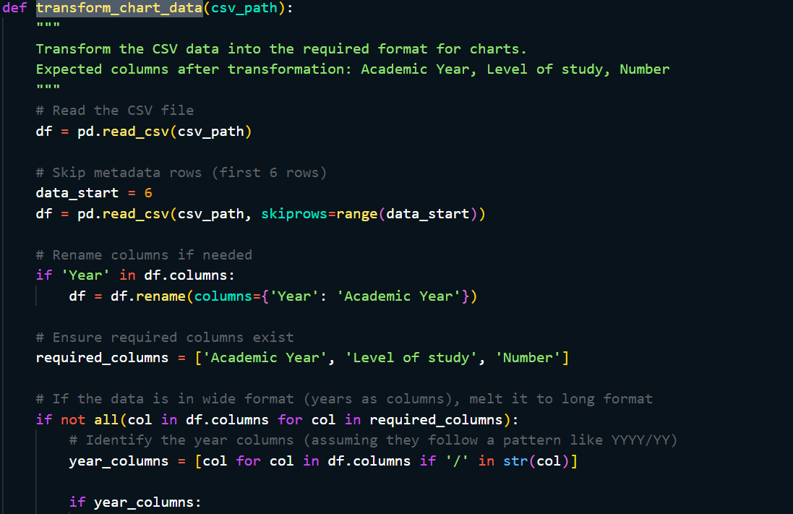

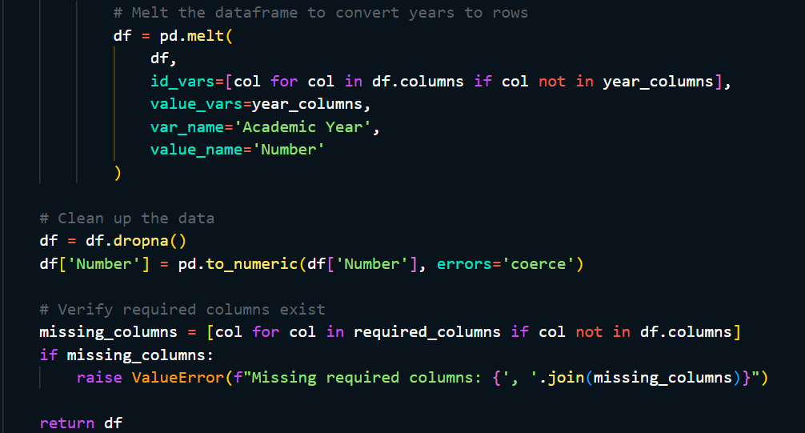

### A.2 Multi-format Data Loading in Correlation Engine

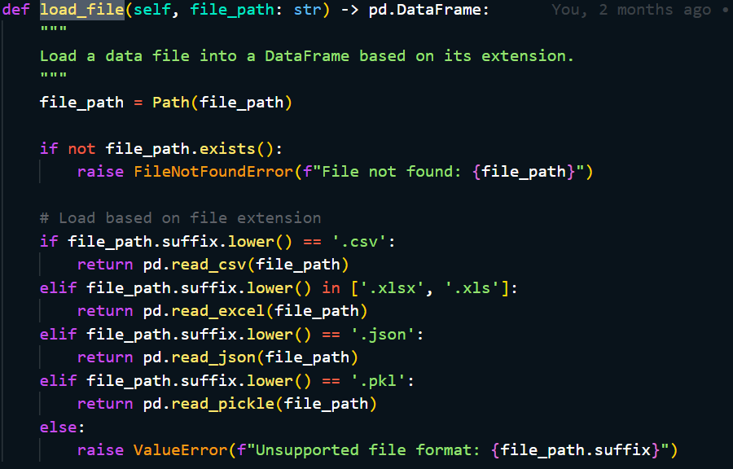

### A.3 Chart Data Preparation with Pandas Pivot

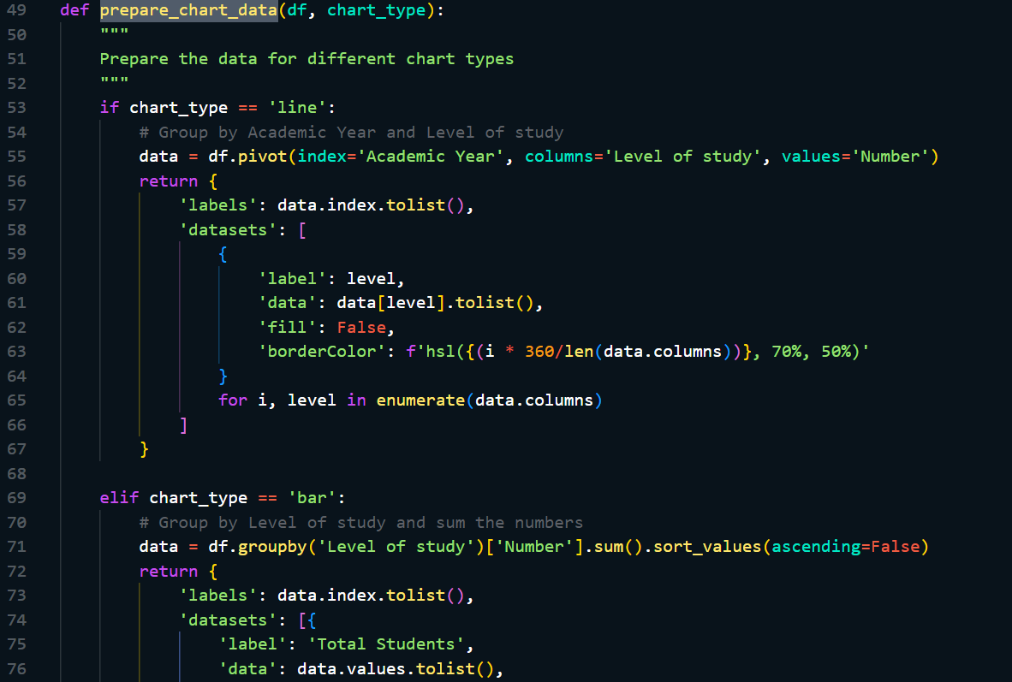

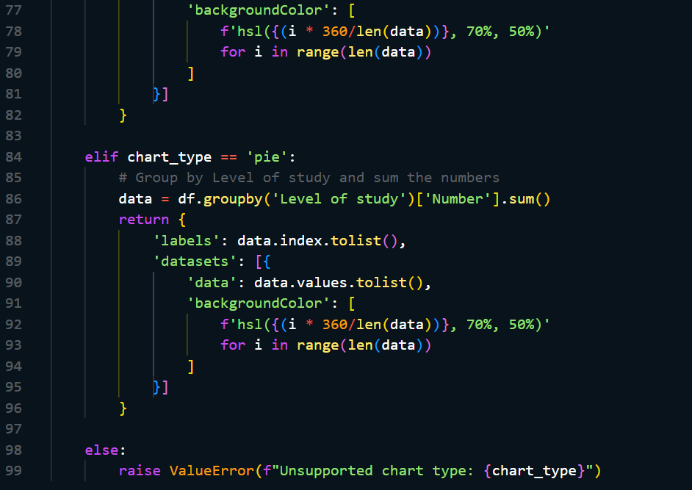

## B: Unit Testing

### B.1, B.2 Data Processing and LLM Integration

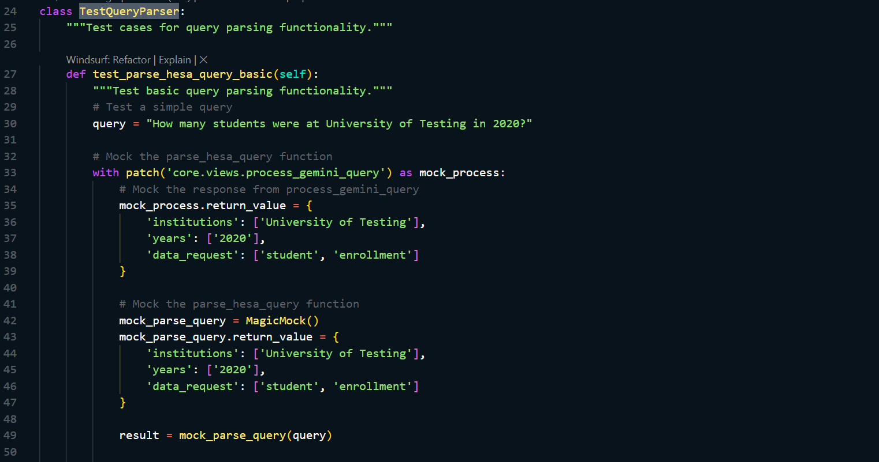

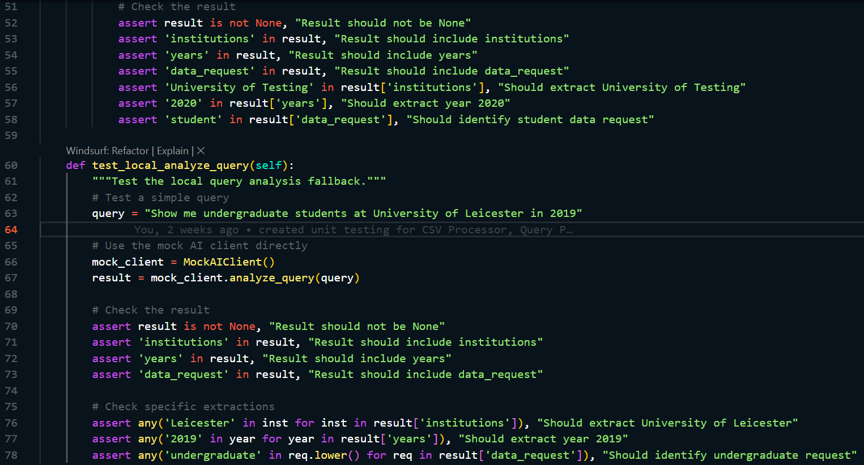

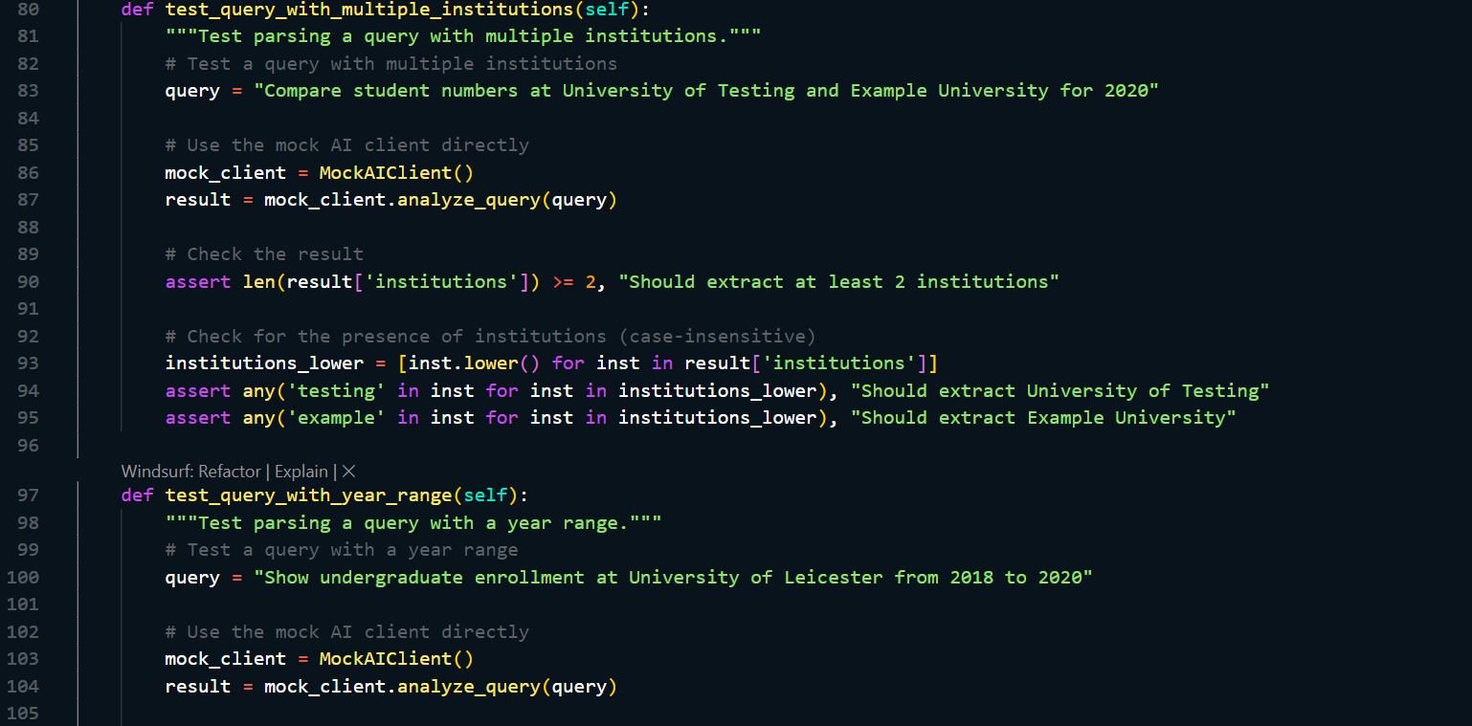

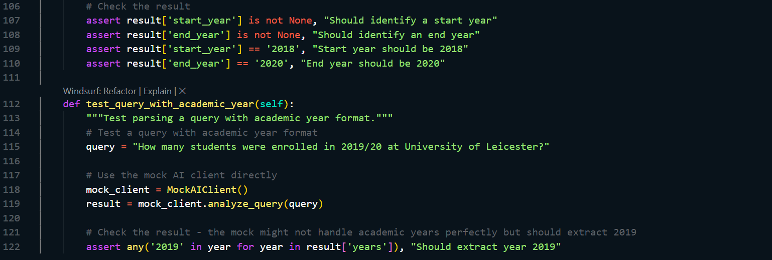

### B.3 Visualization

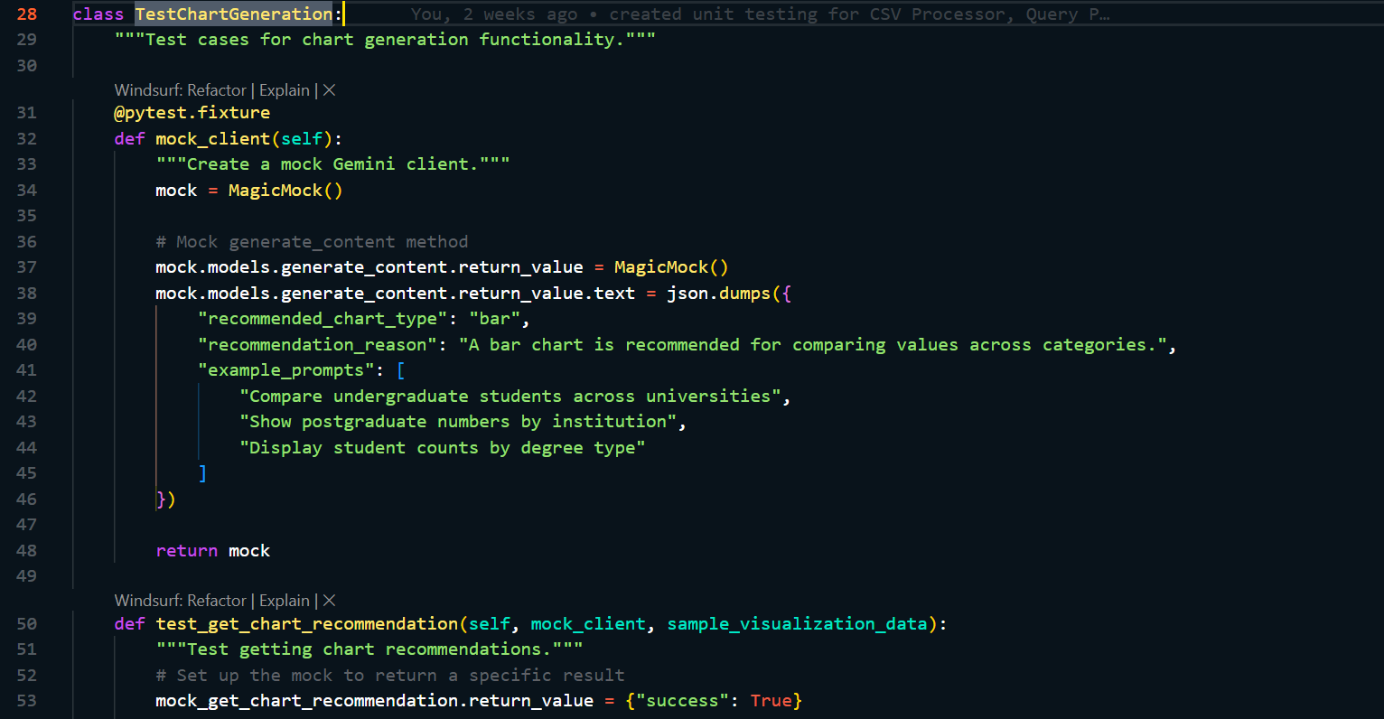

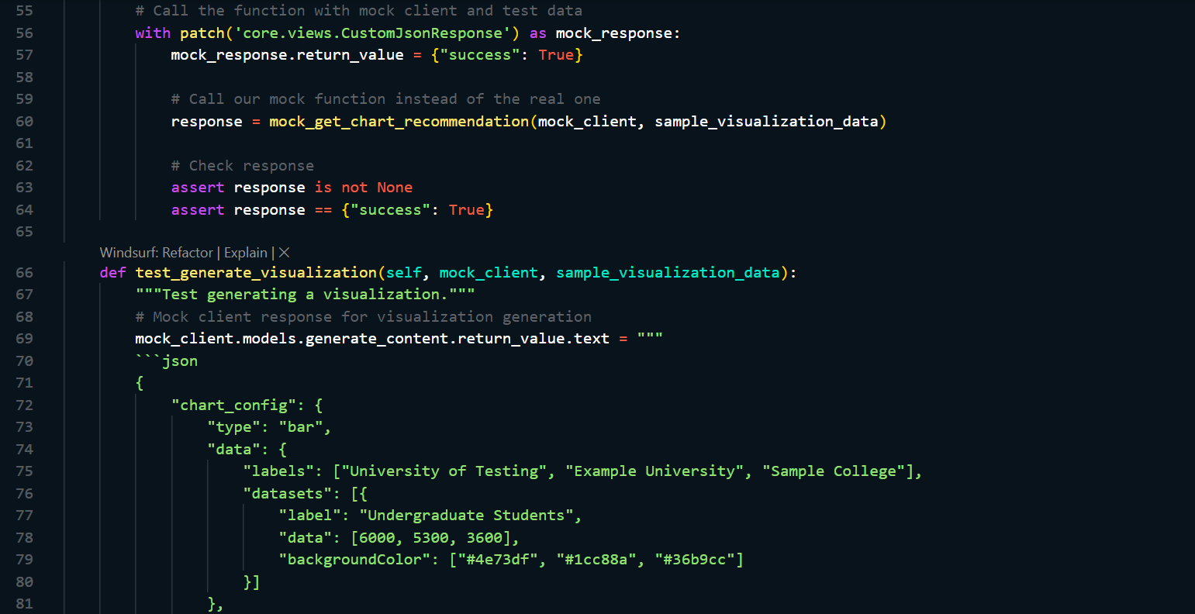

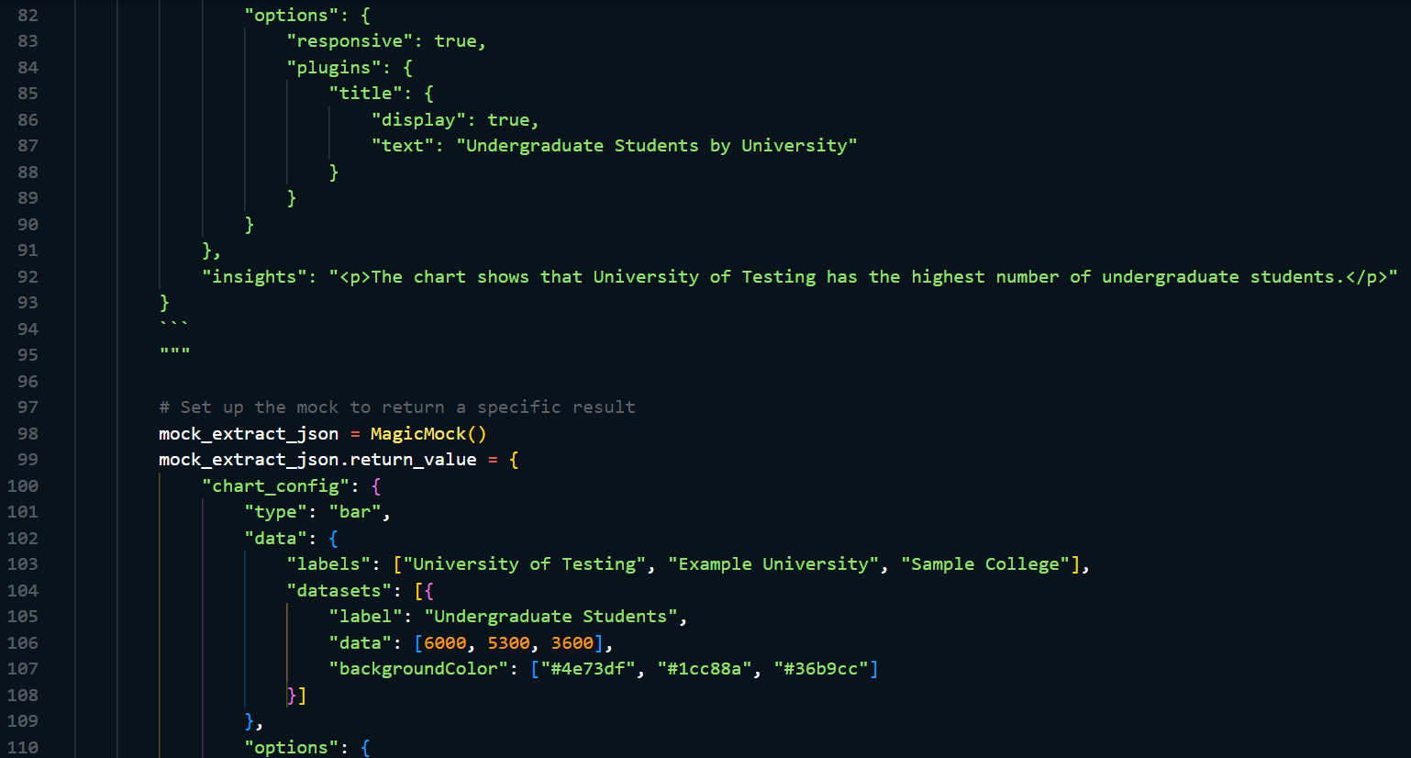

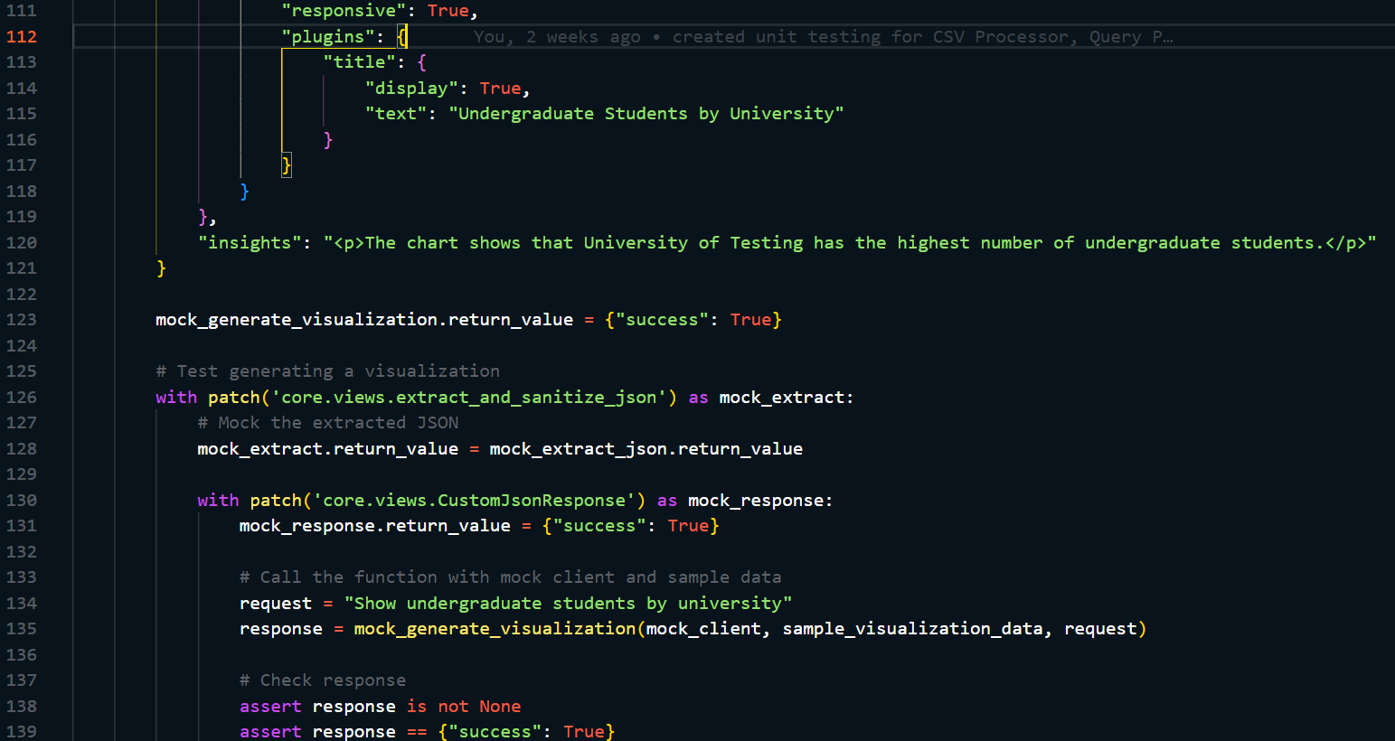

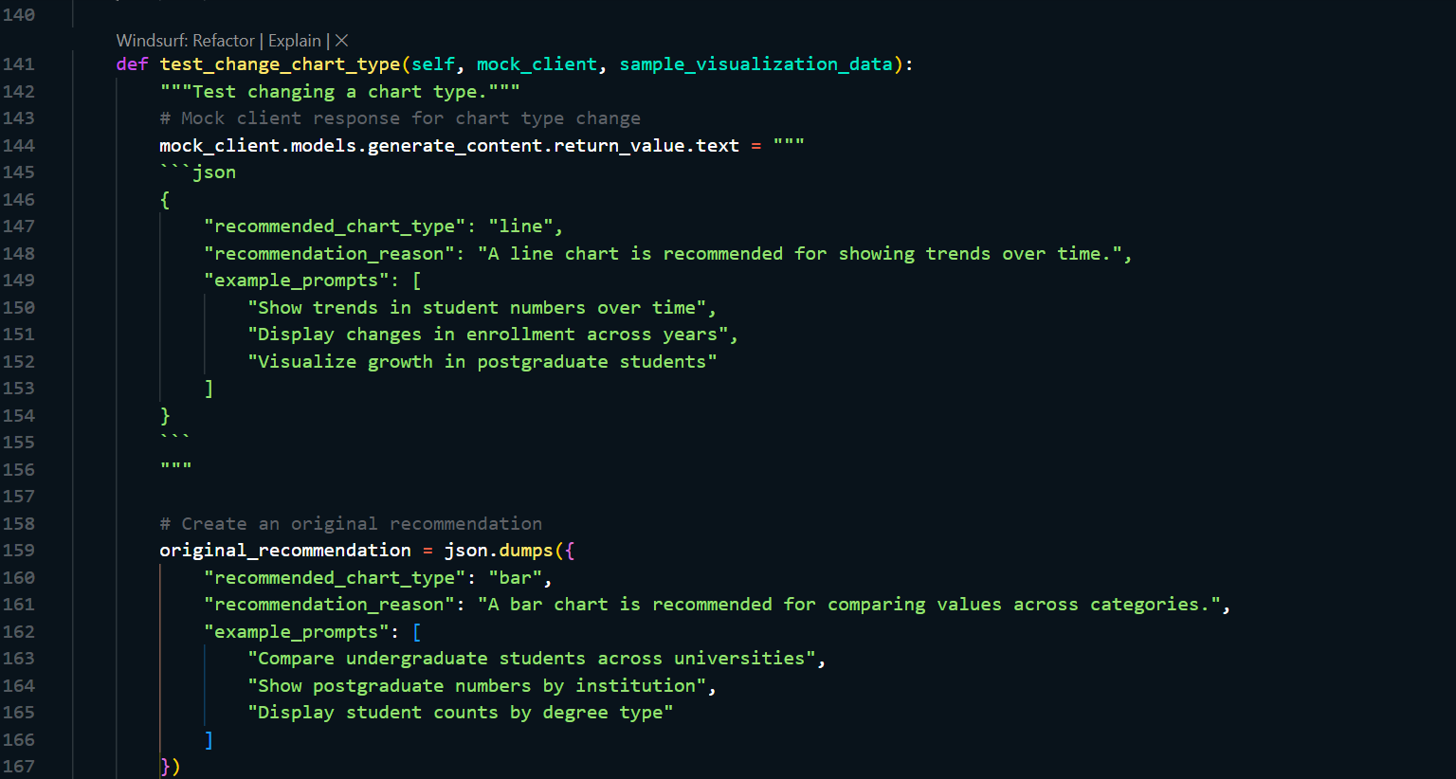 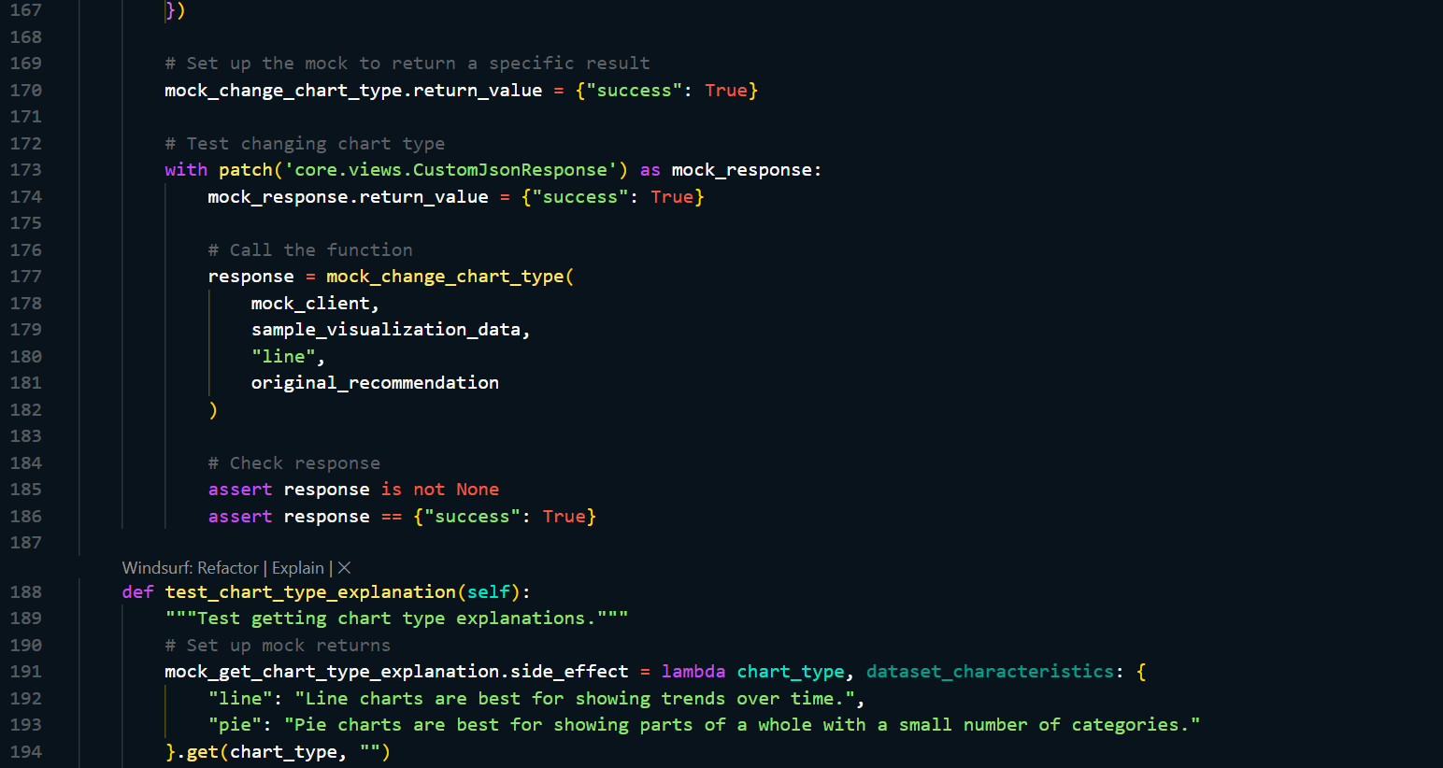 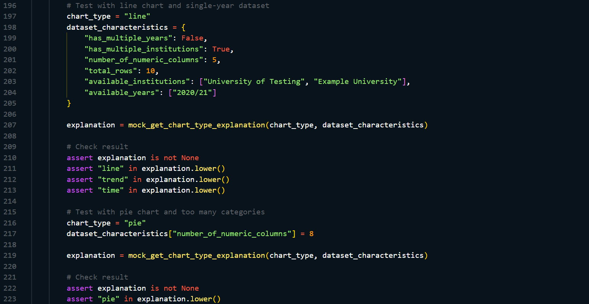

## C: Integration tests

### C.1 Query to Visualization Flow

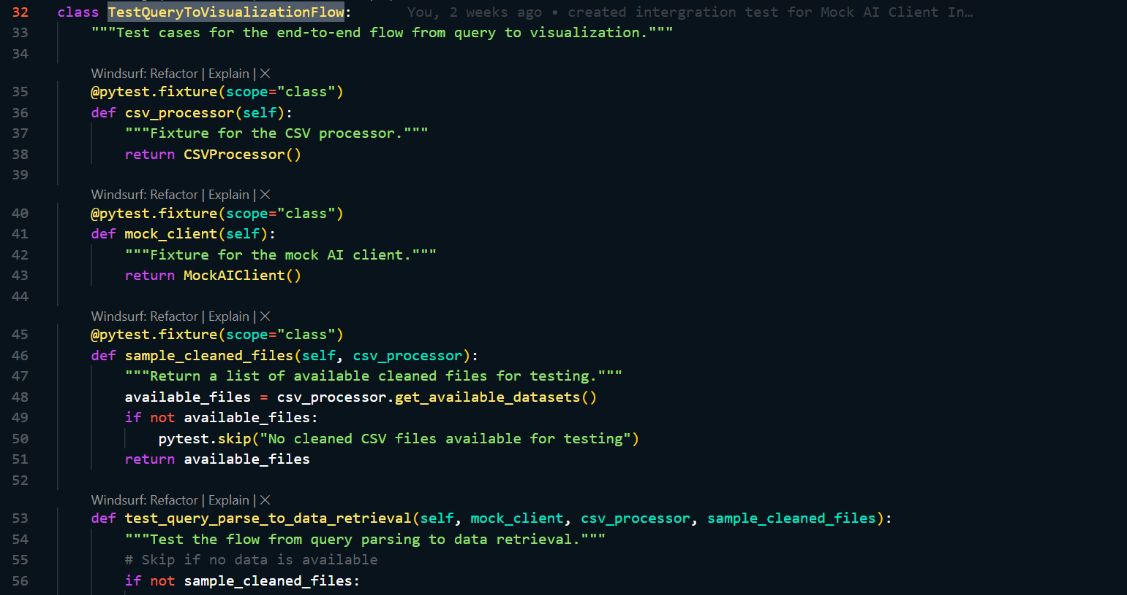 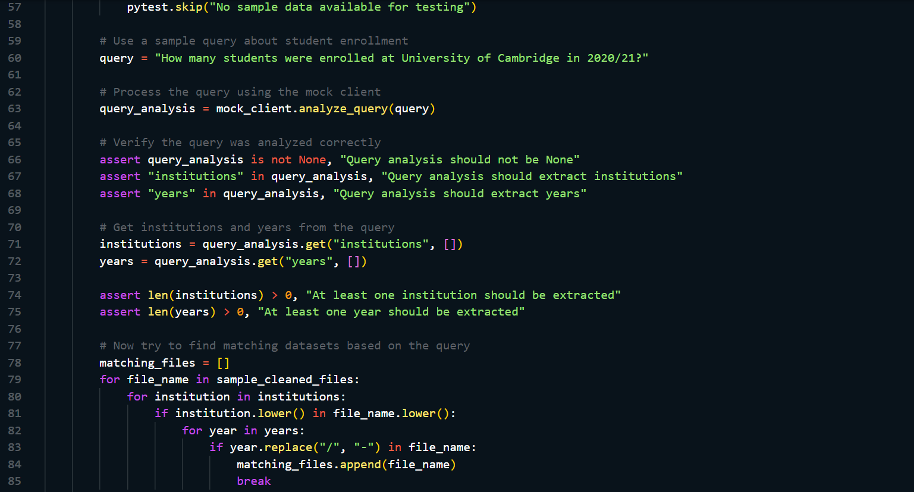 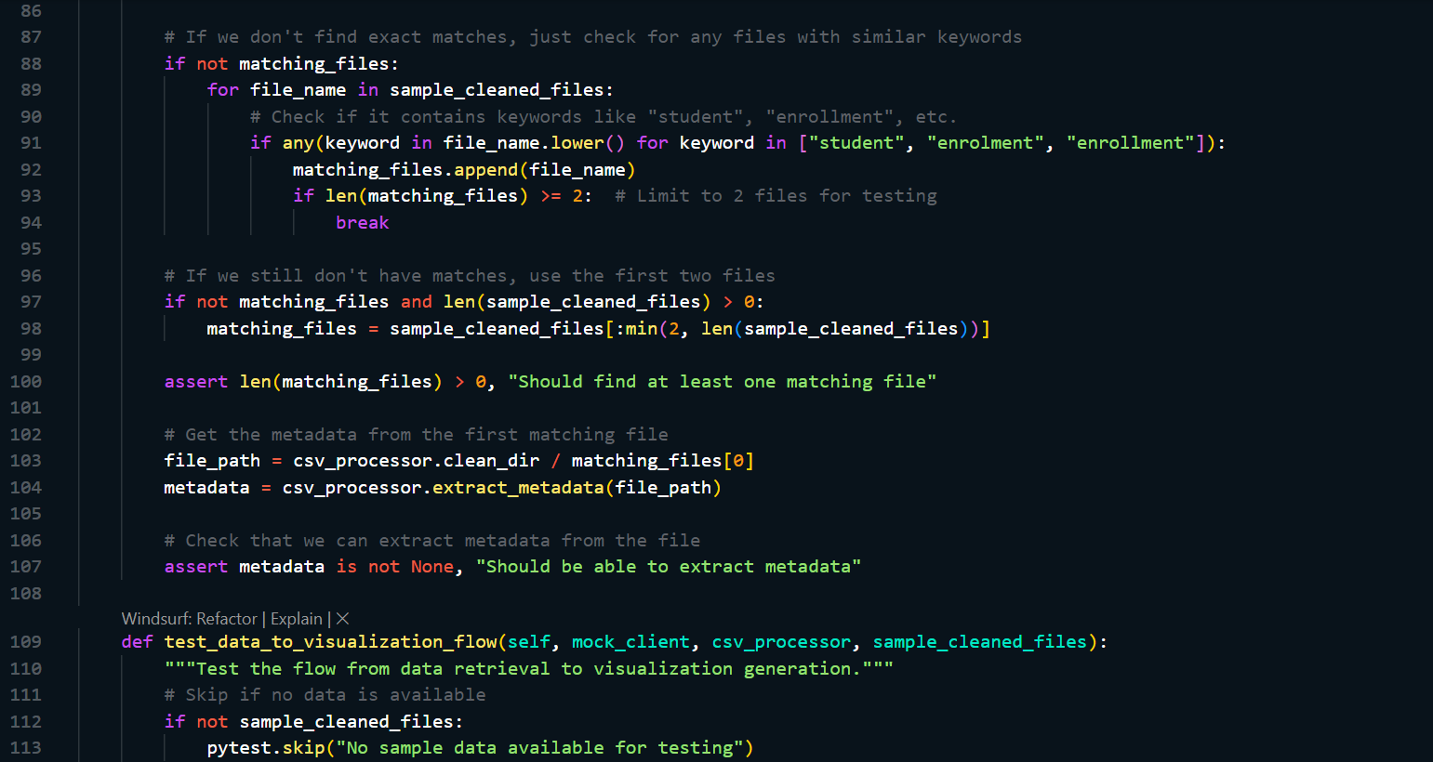 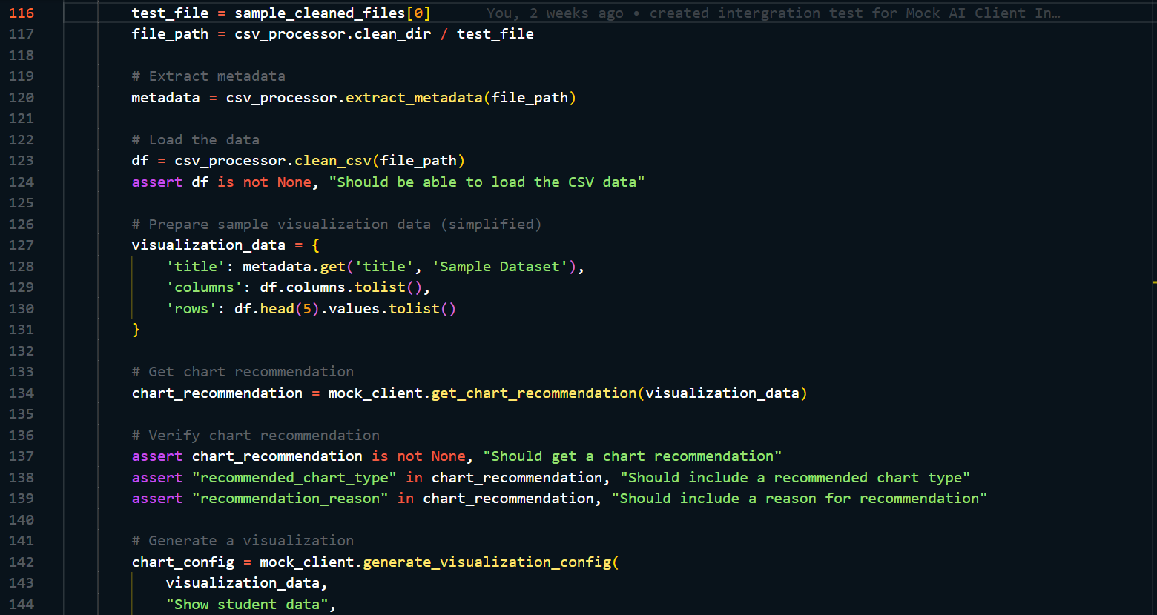 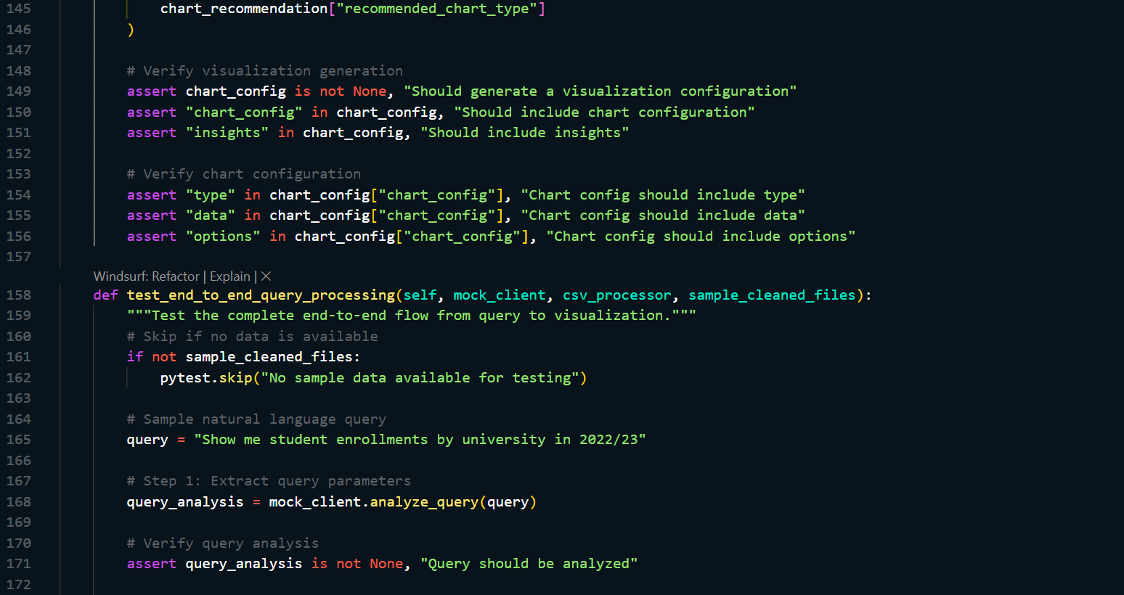 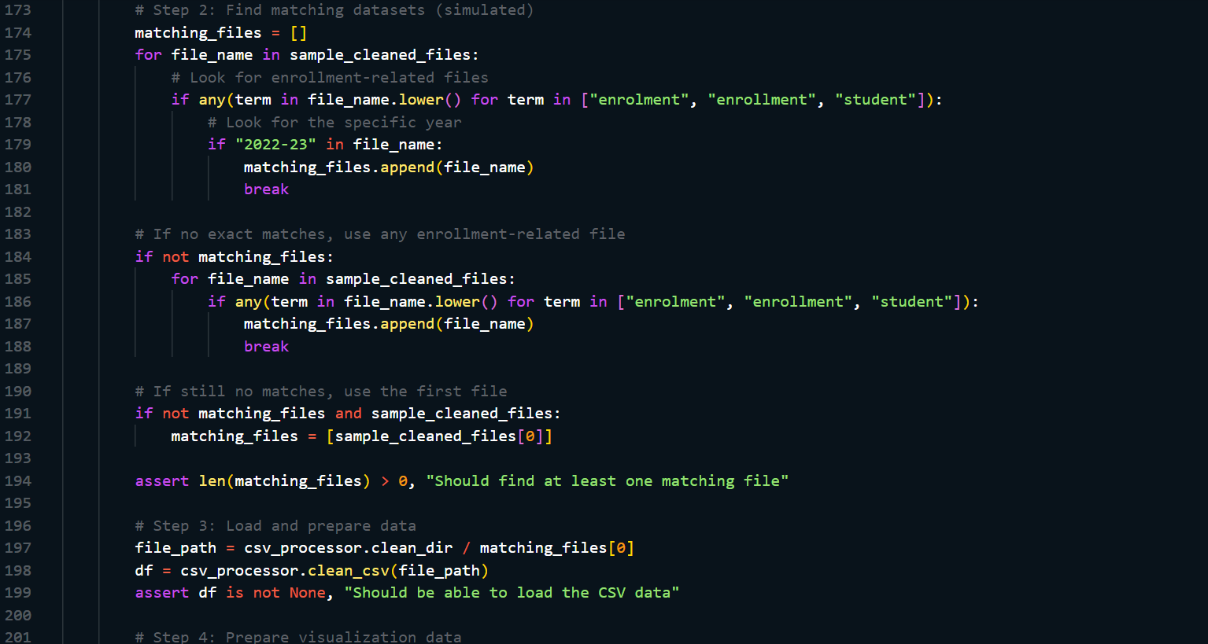 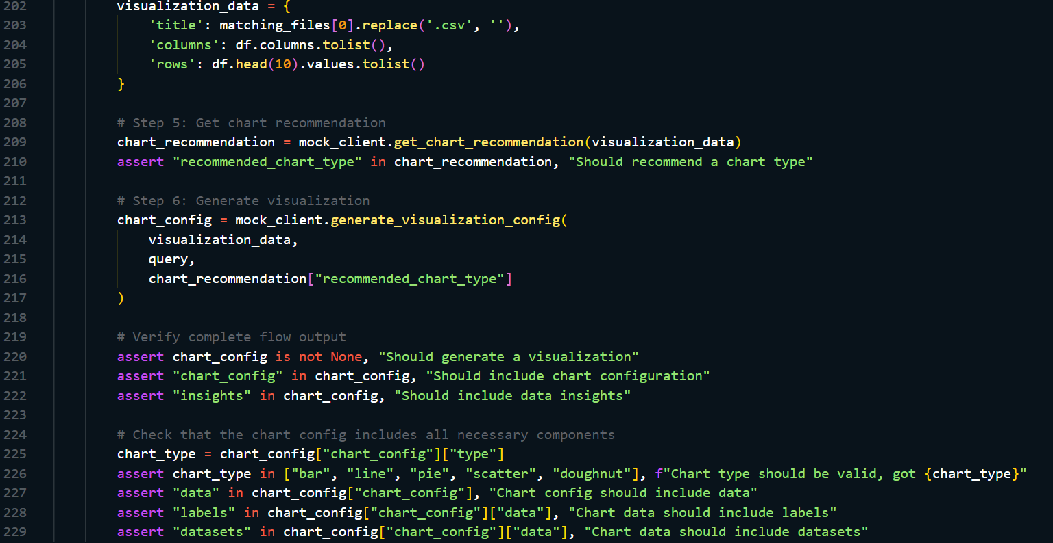

### C.2 Mock AI Client Integration

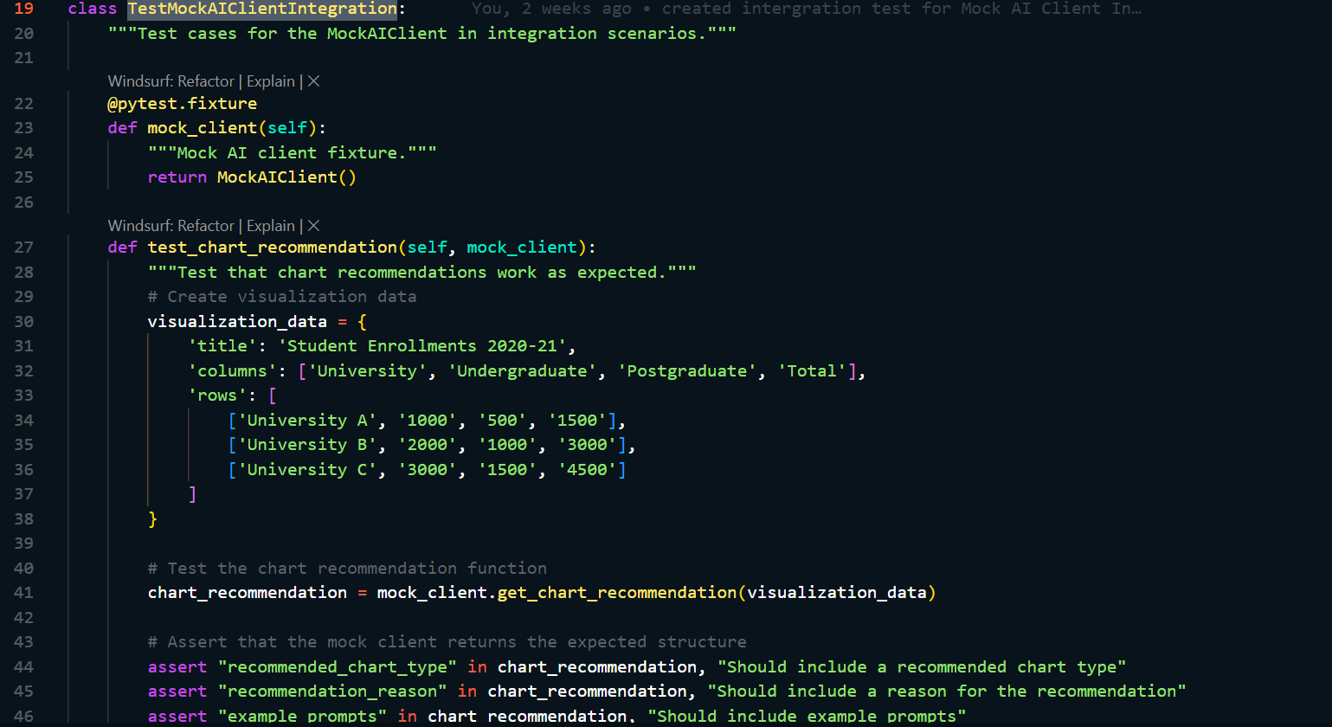 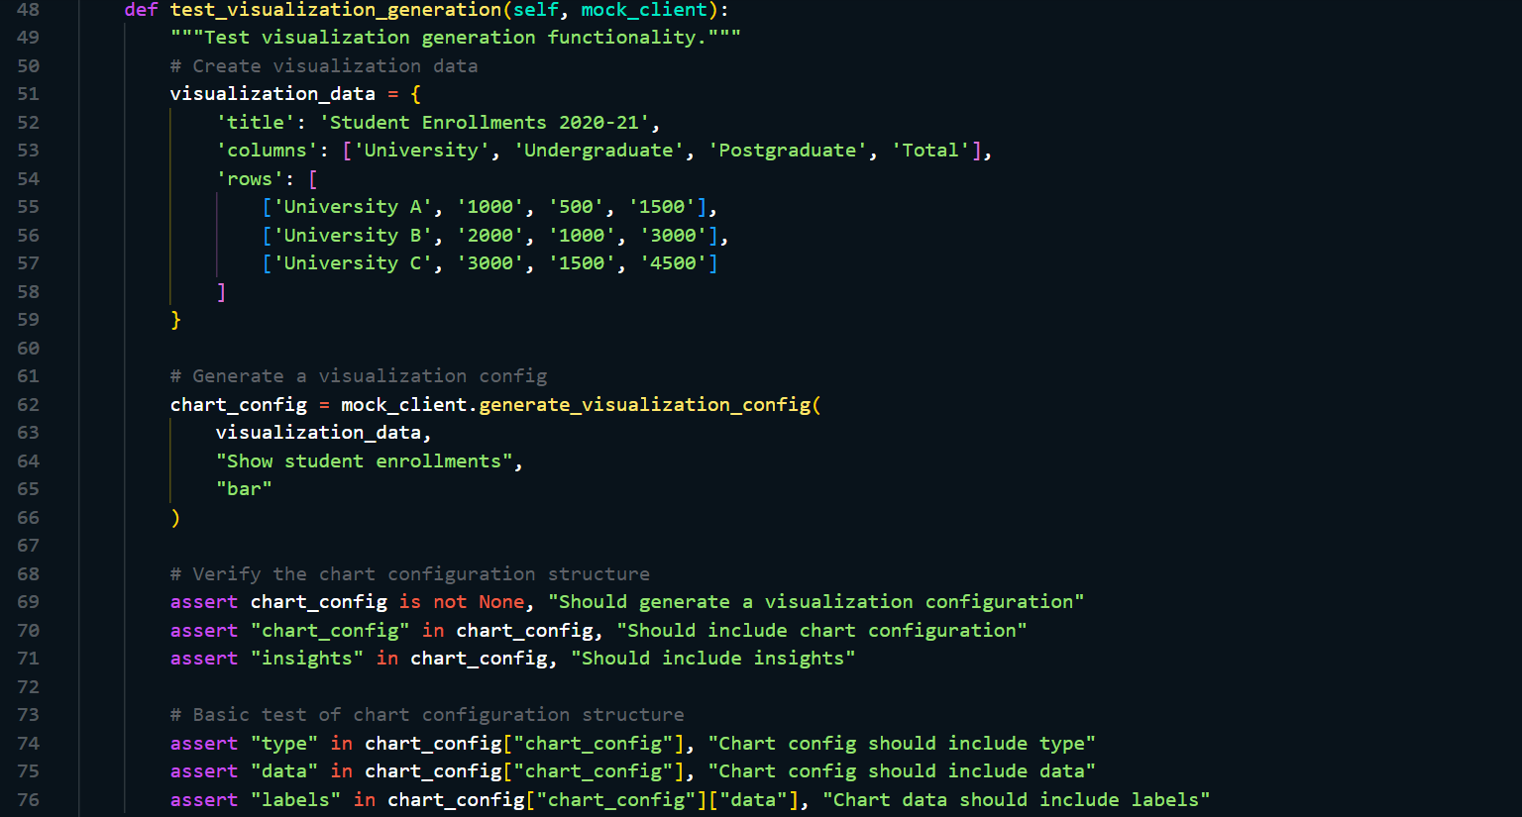 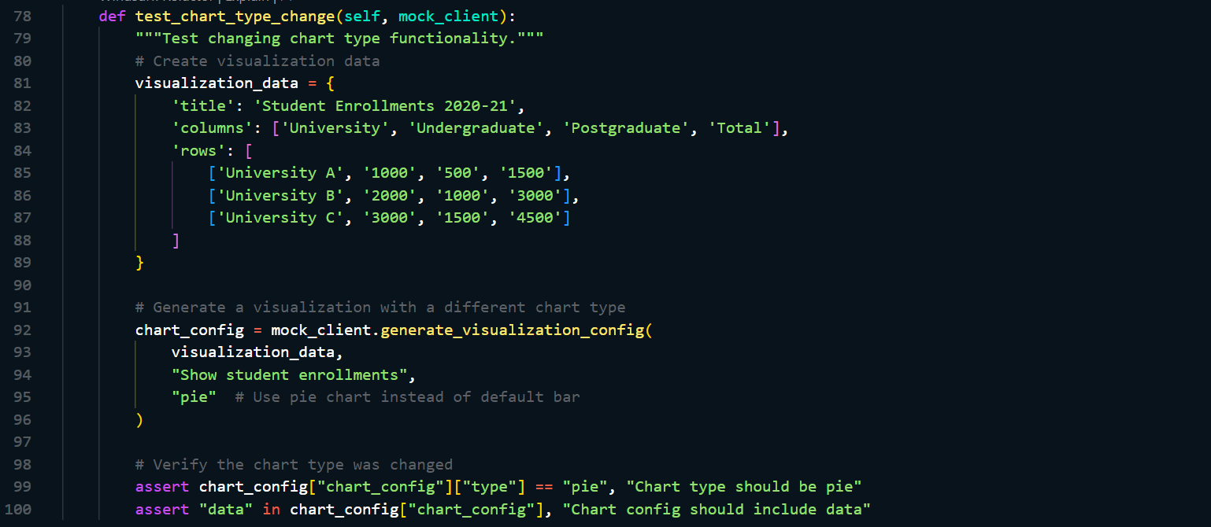

## D: Data Processing Pipeline Implementation

### D.1 Data Ingestion Process

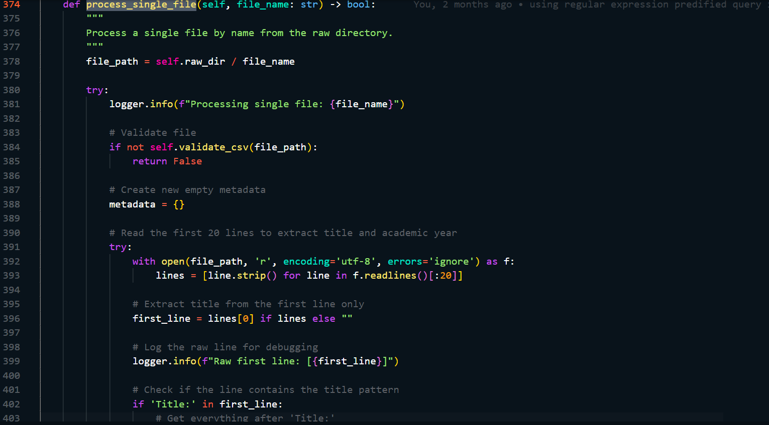 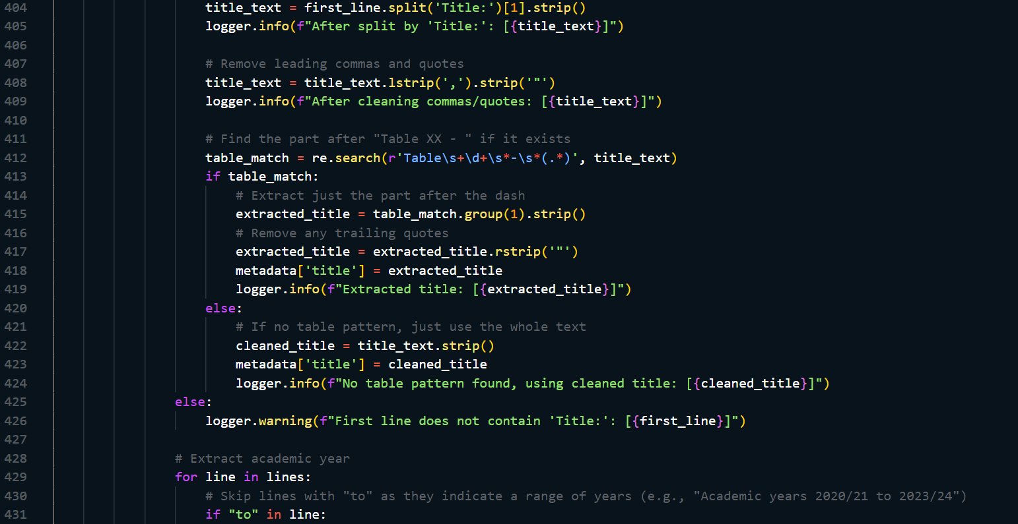 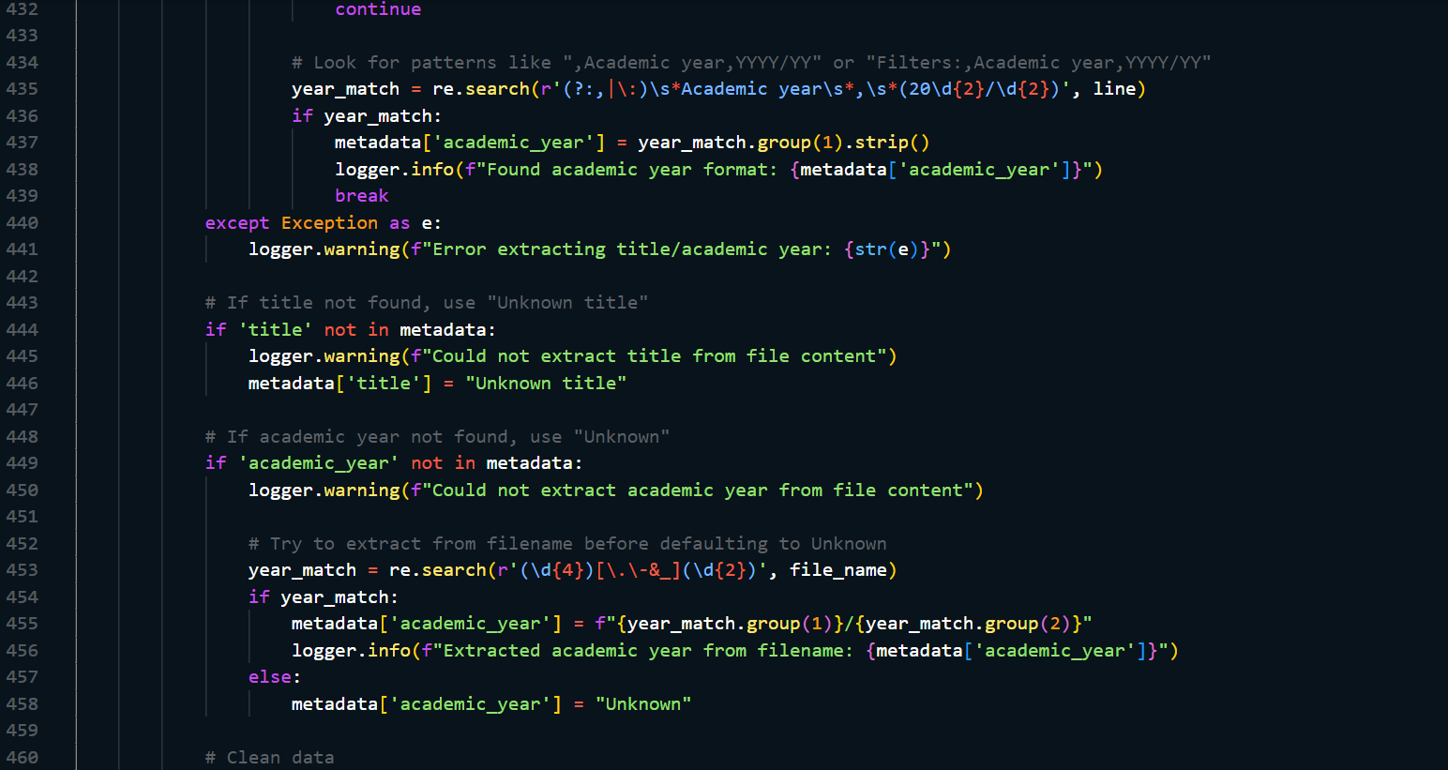 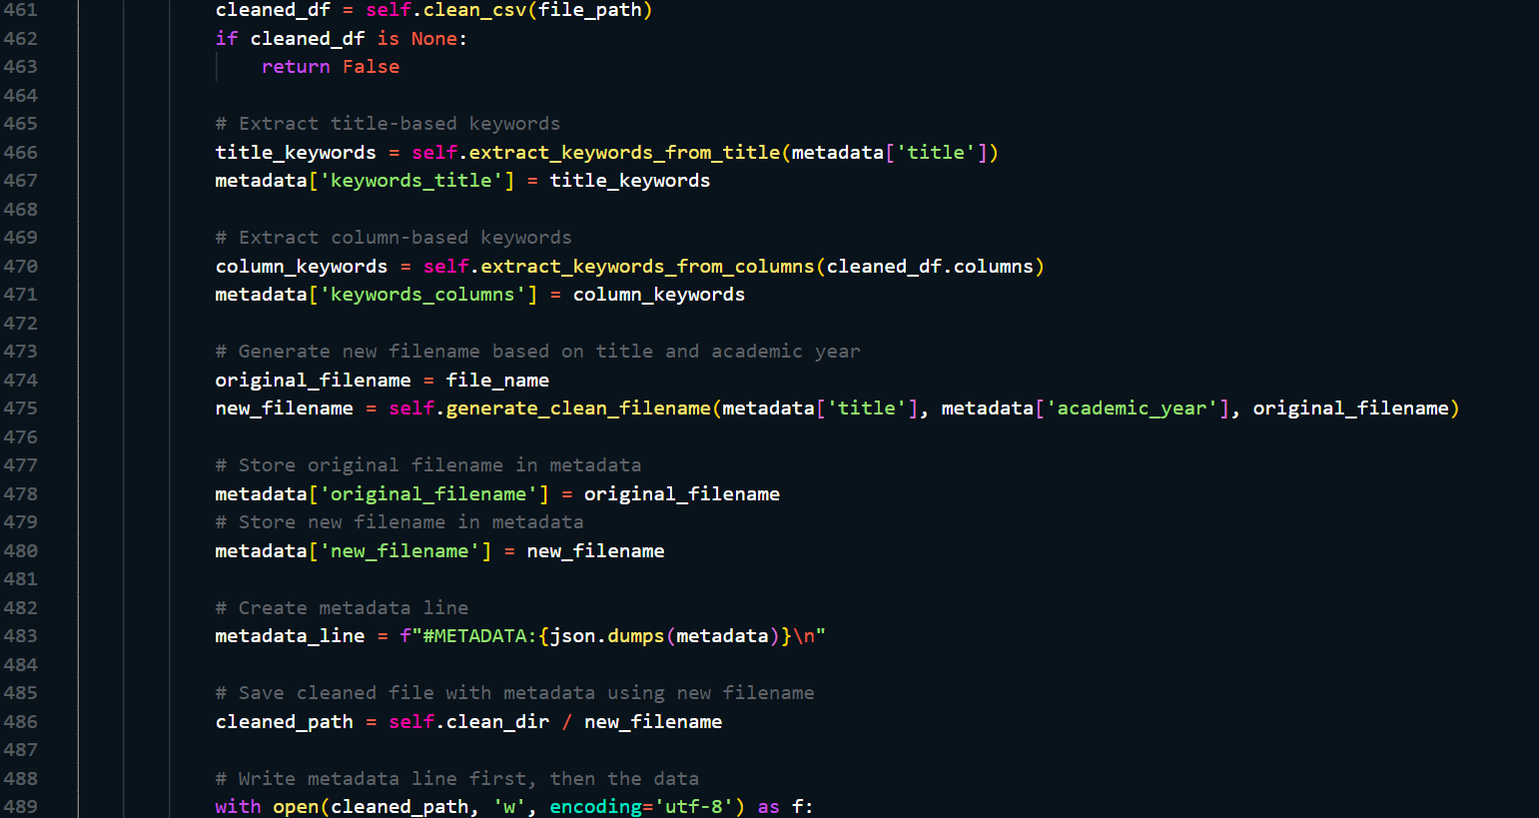 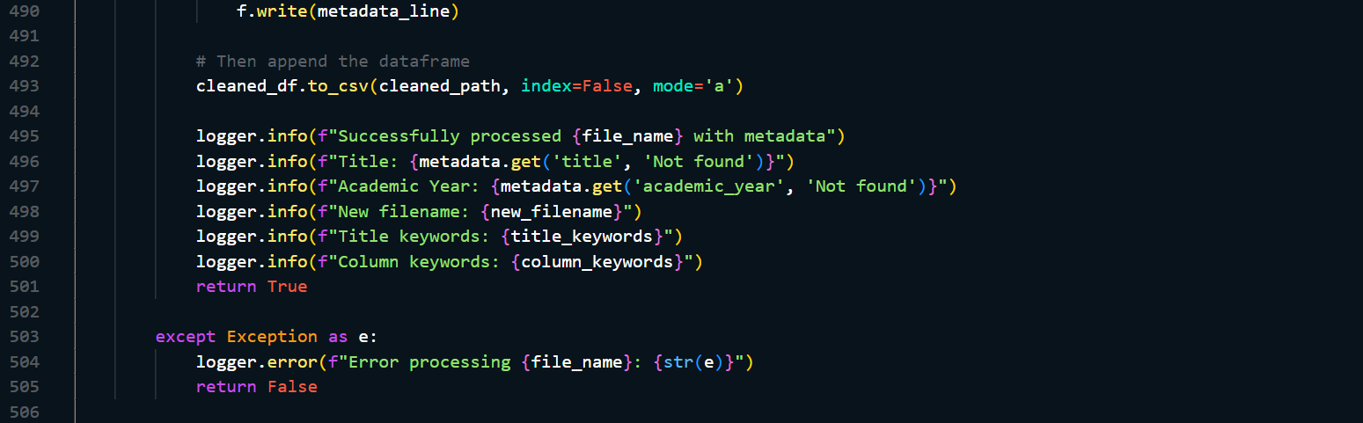

### D.2 Manual Update Process

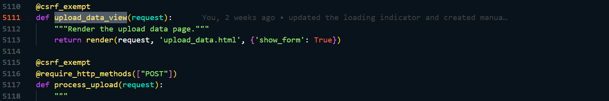 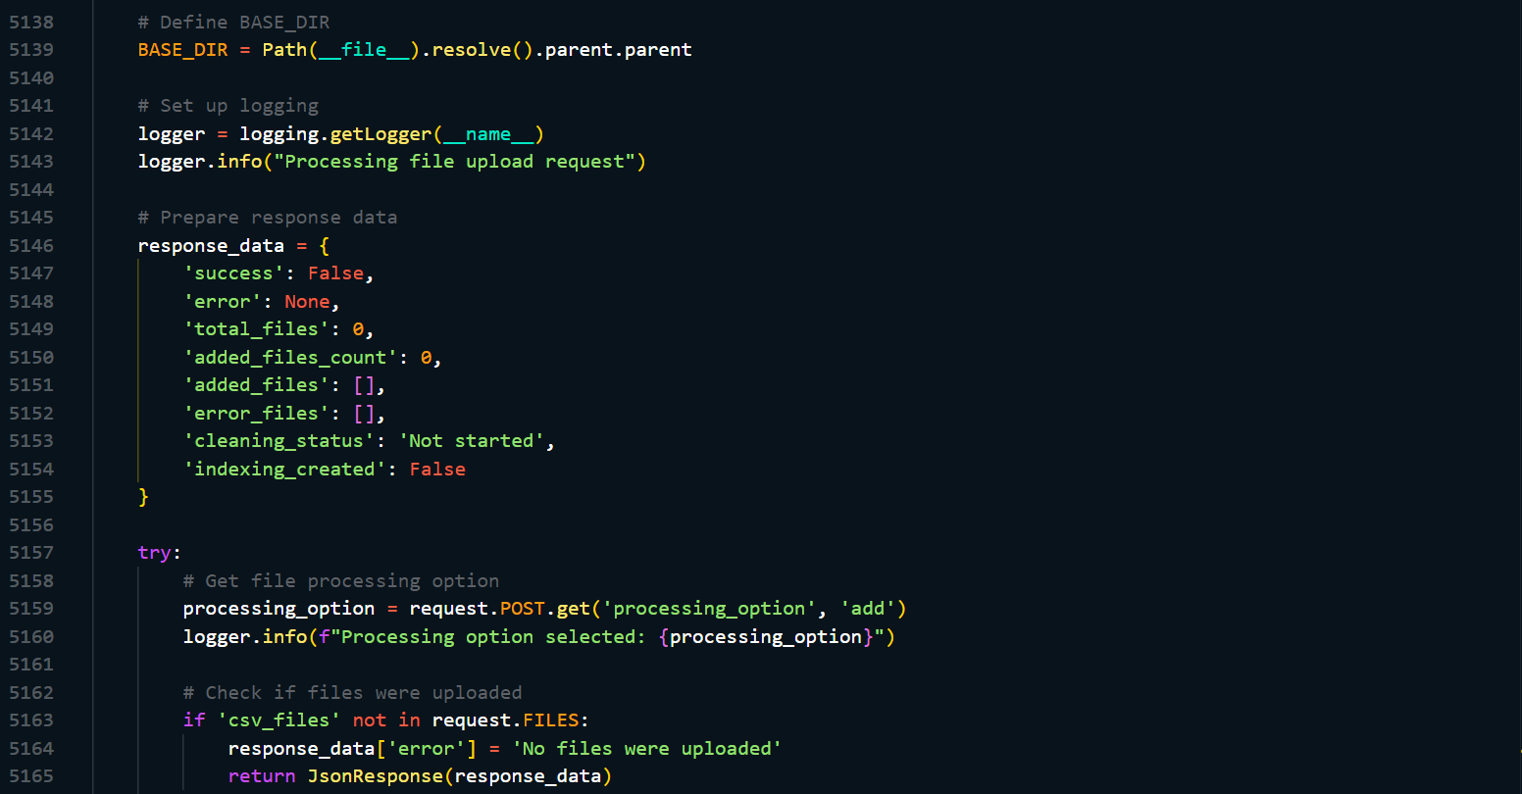 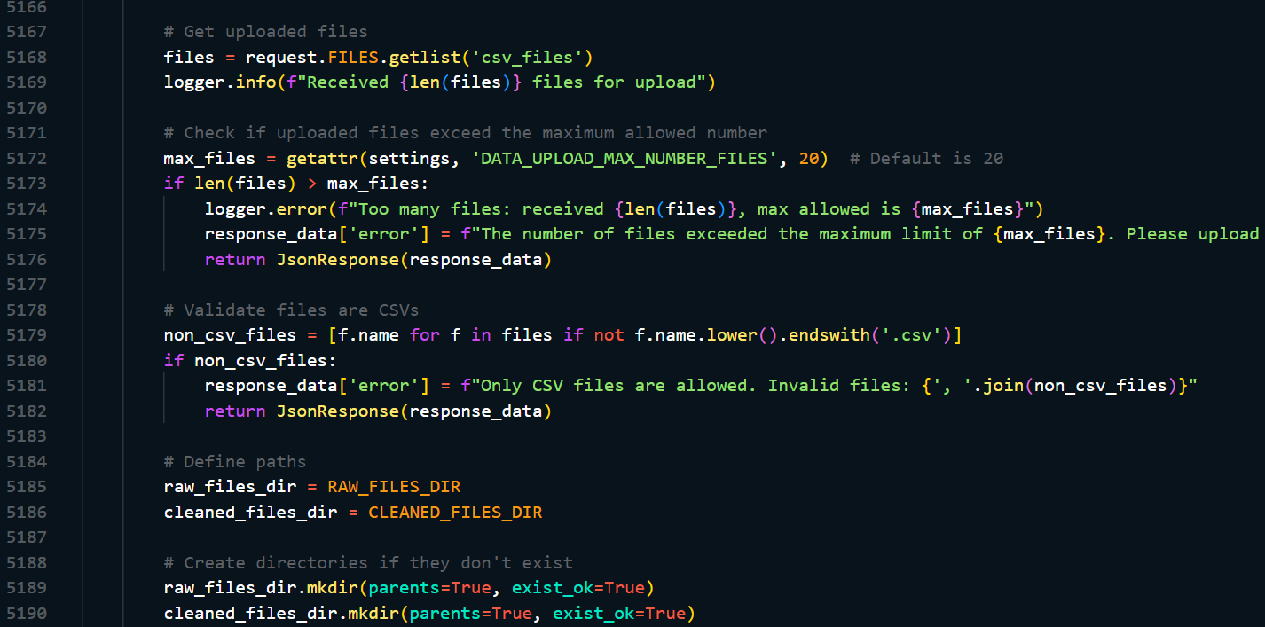 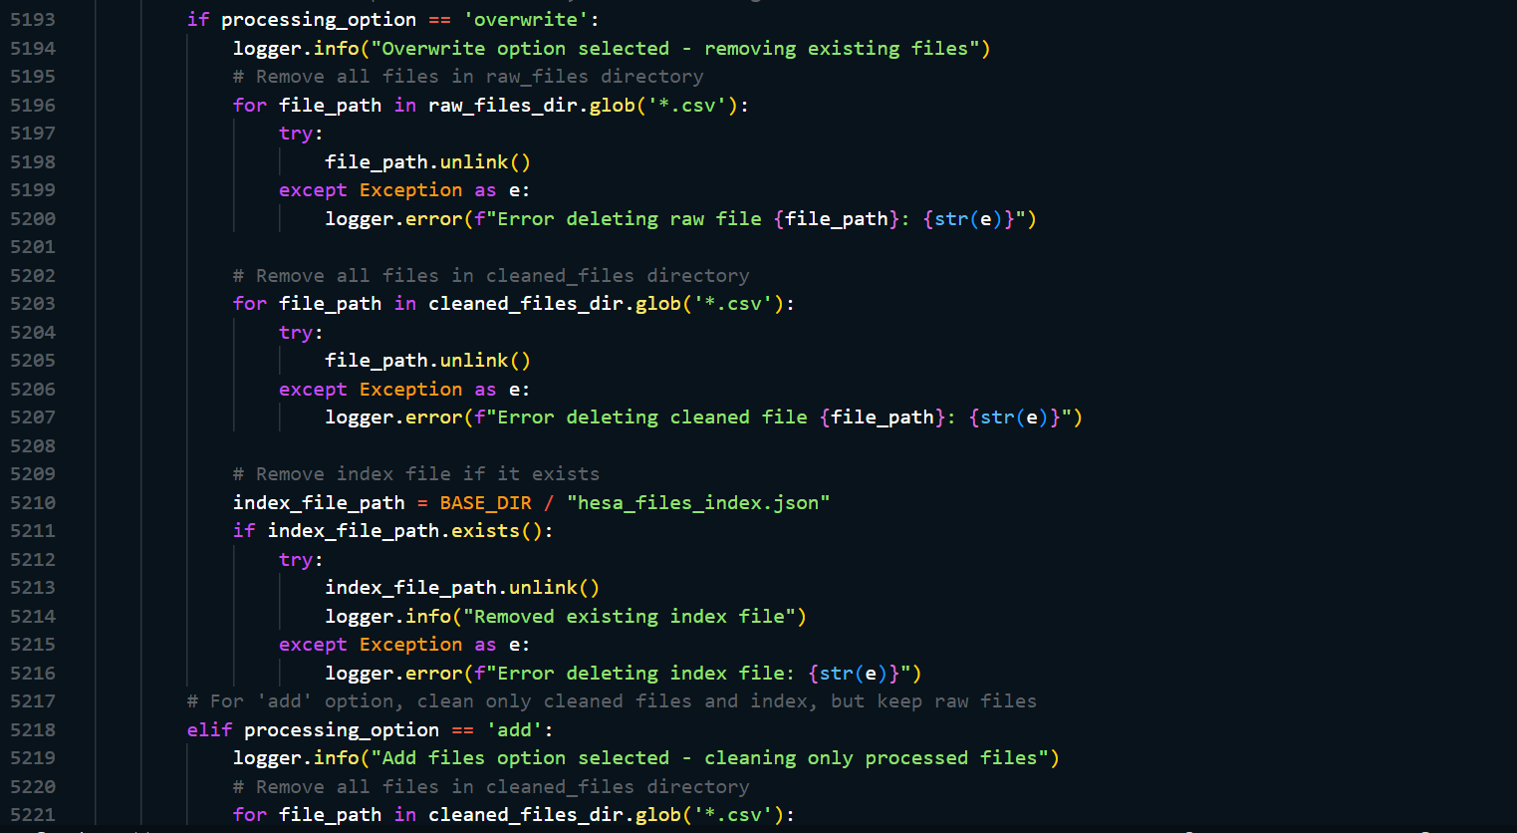 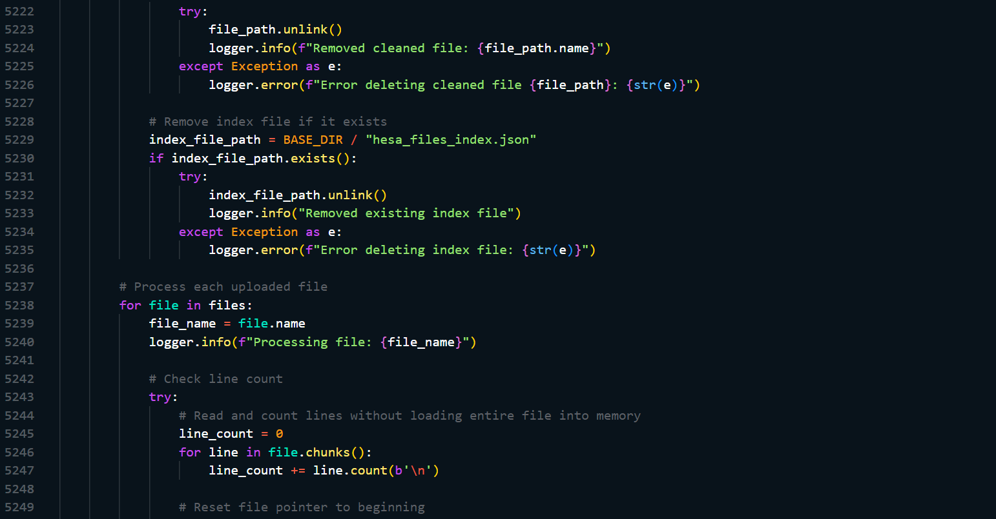 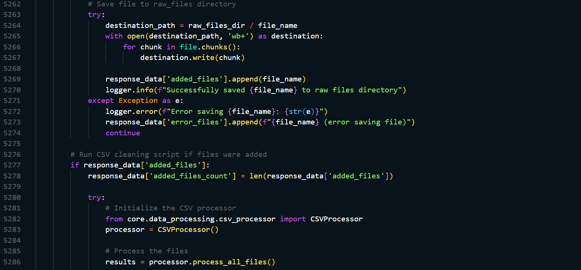

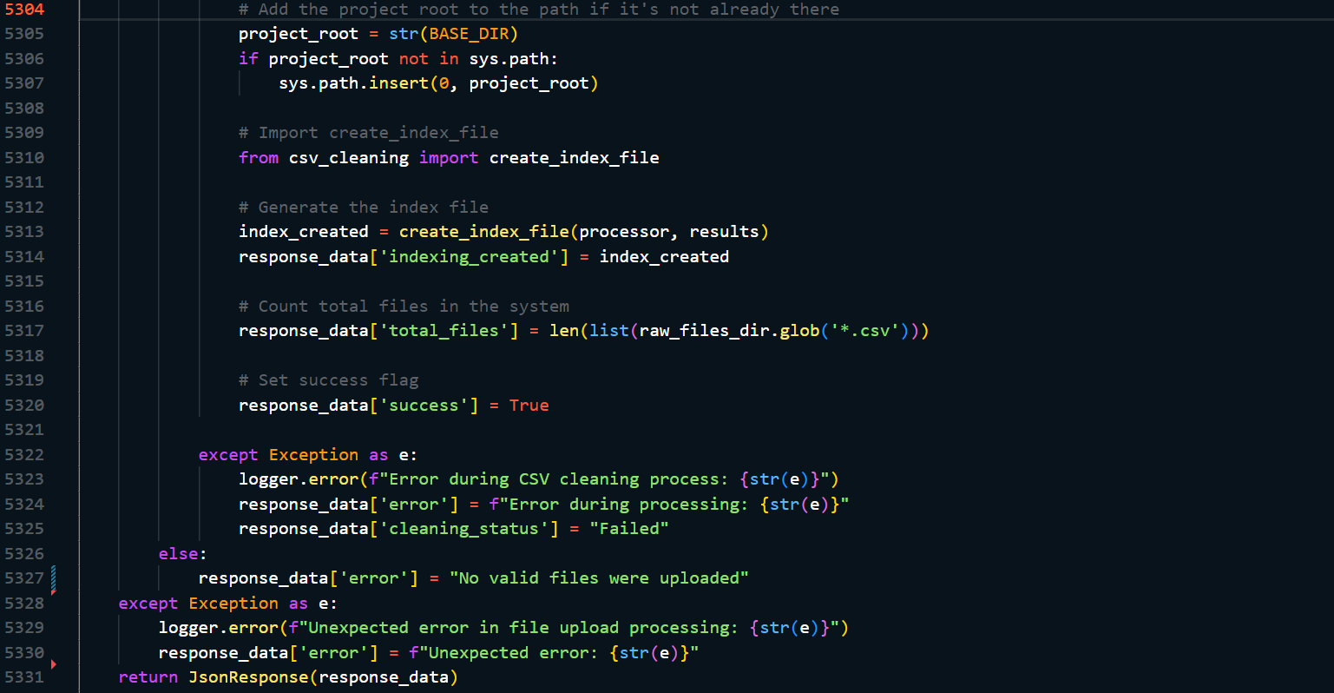

### D.3 Metadata Extraction

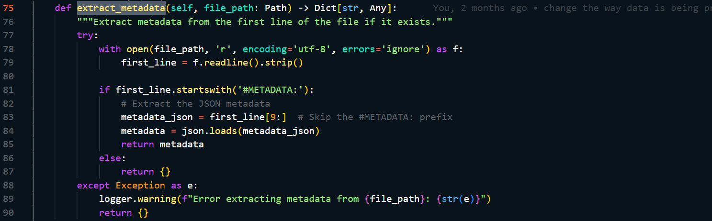

### D.4 Indexing

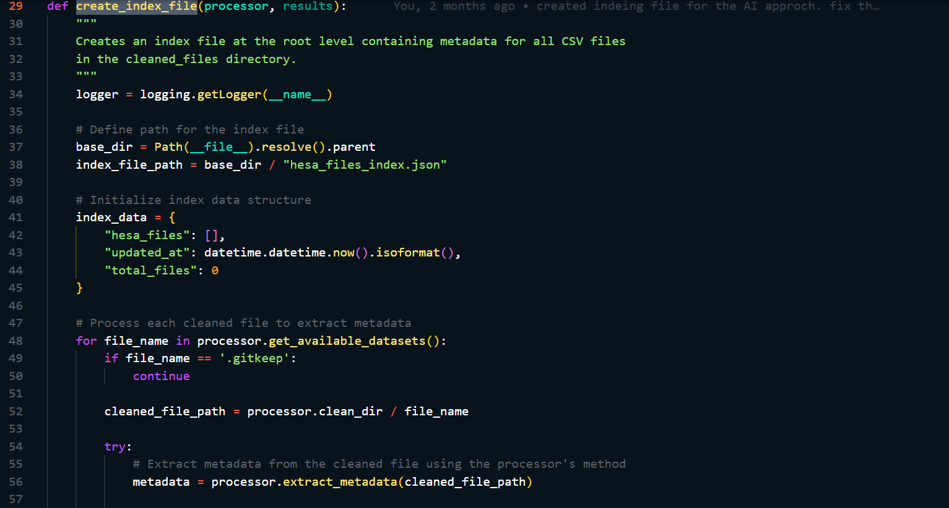 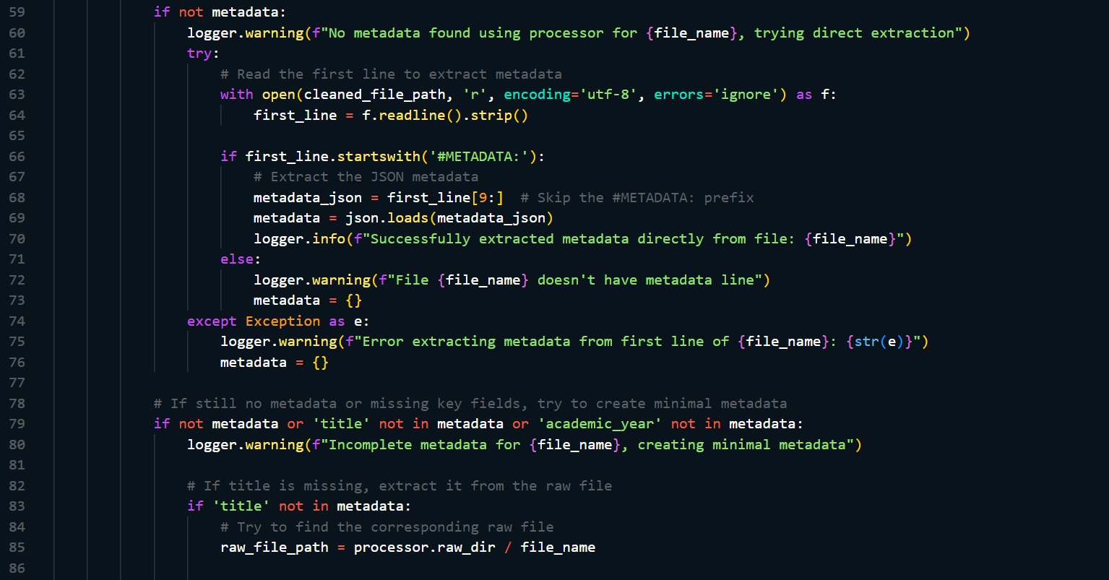 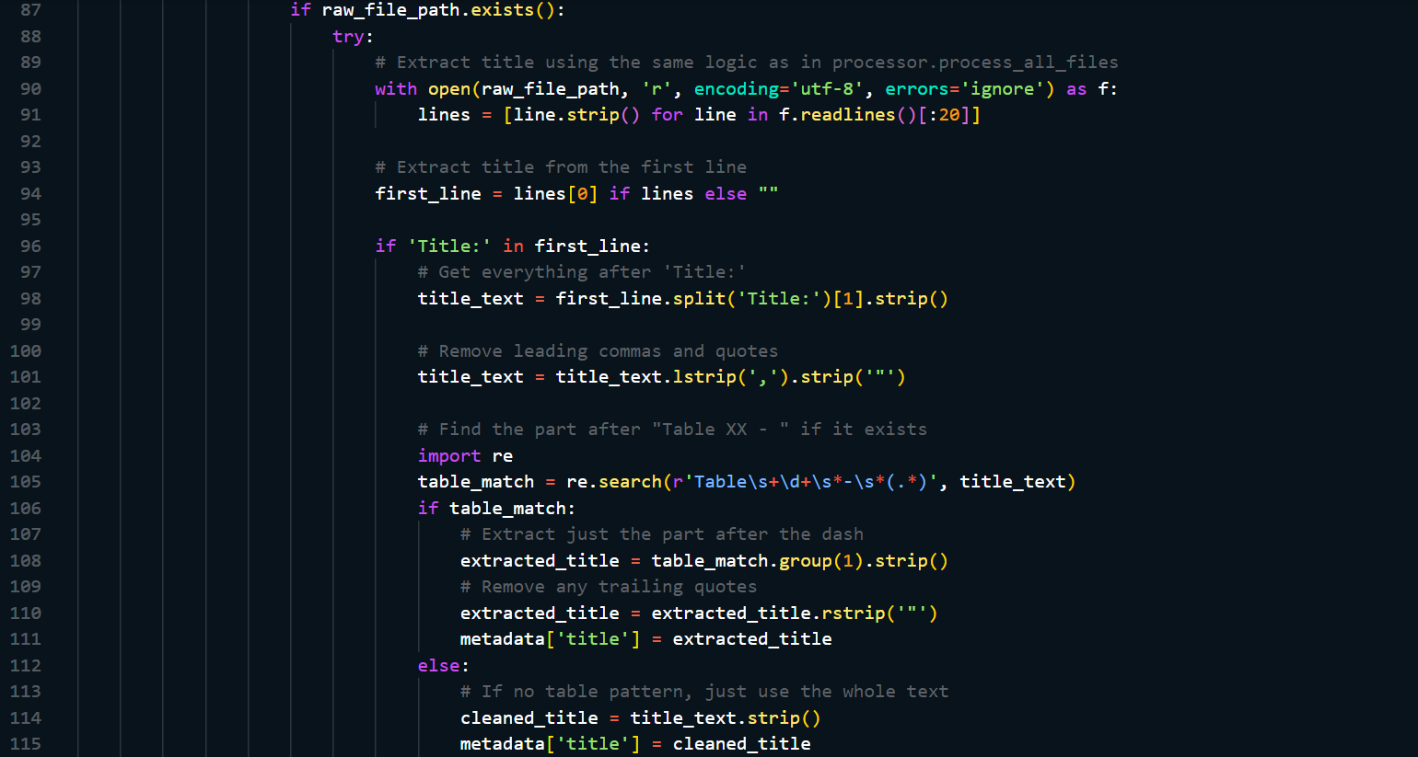 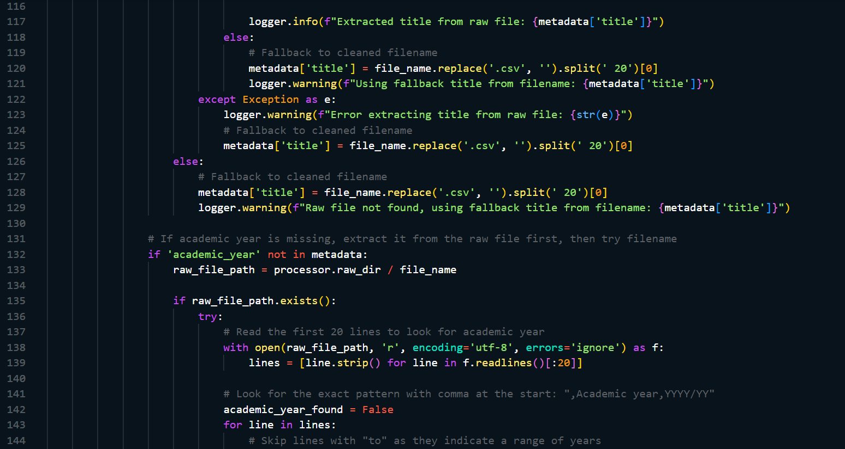 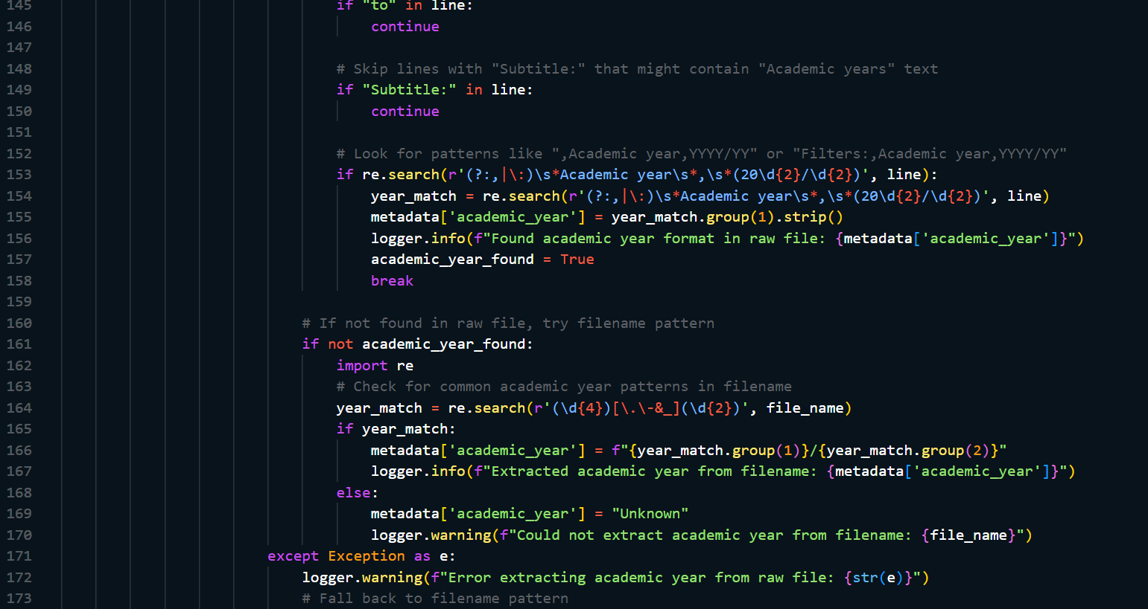 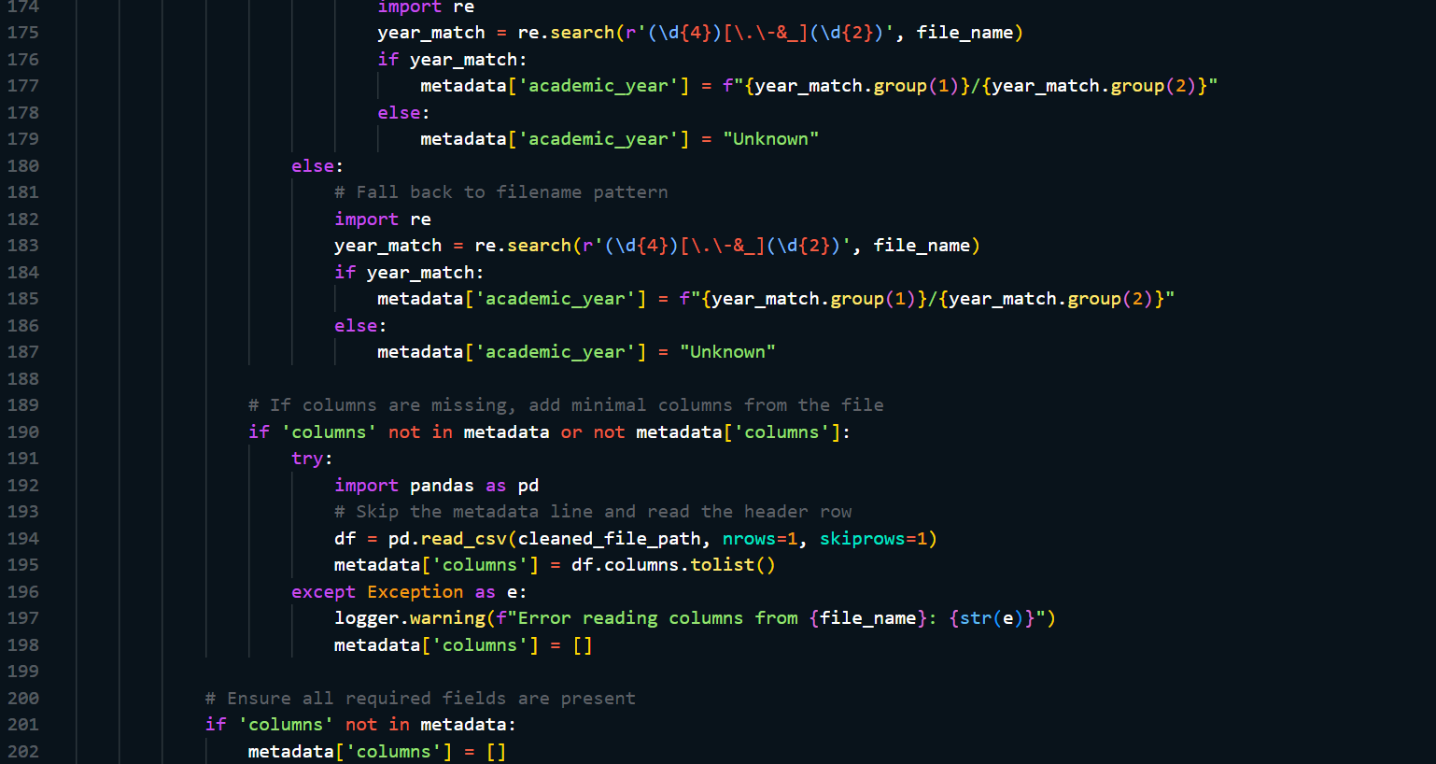 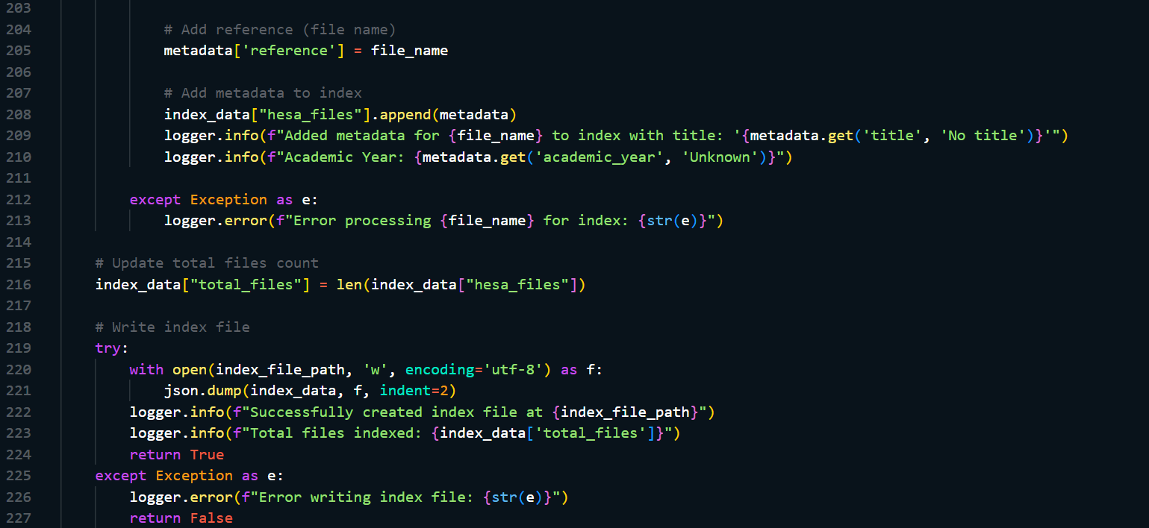

### D.5 Cleaning Process

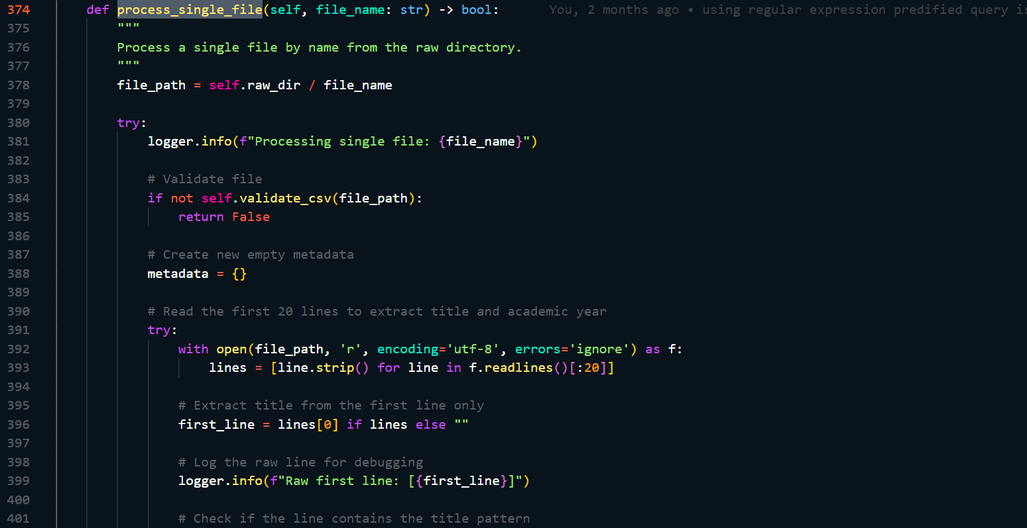 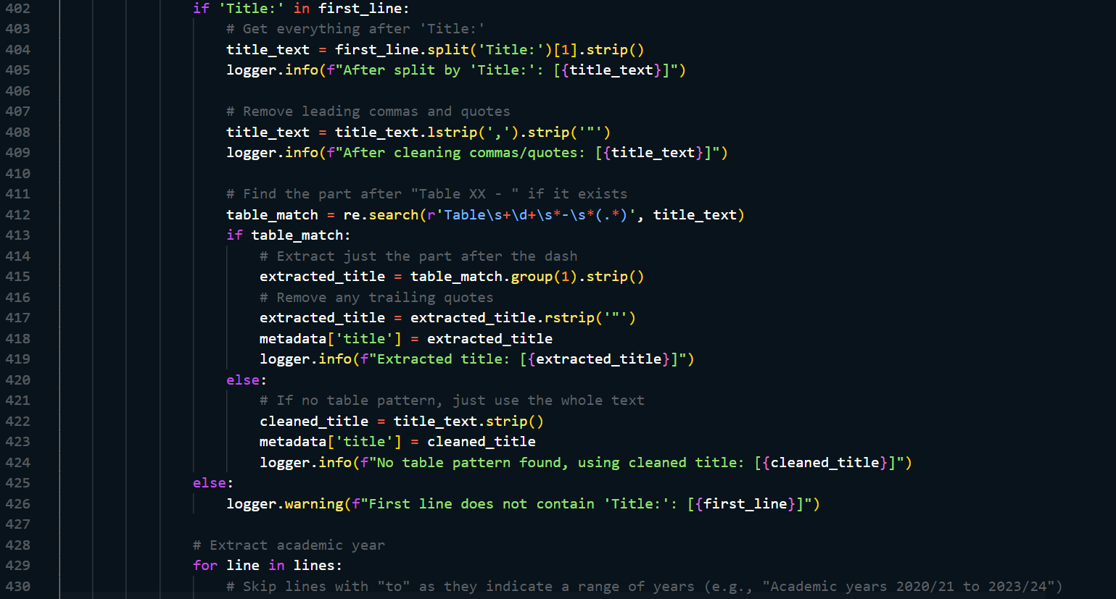 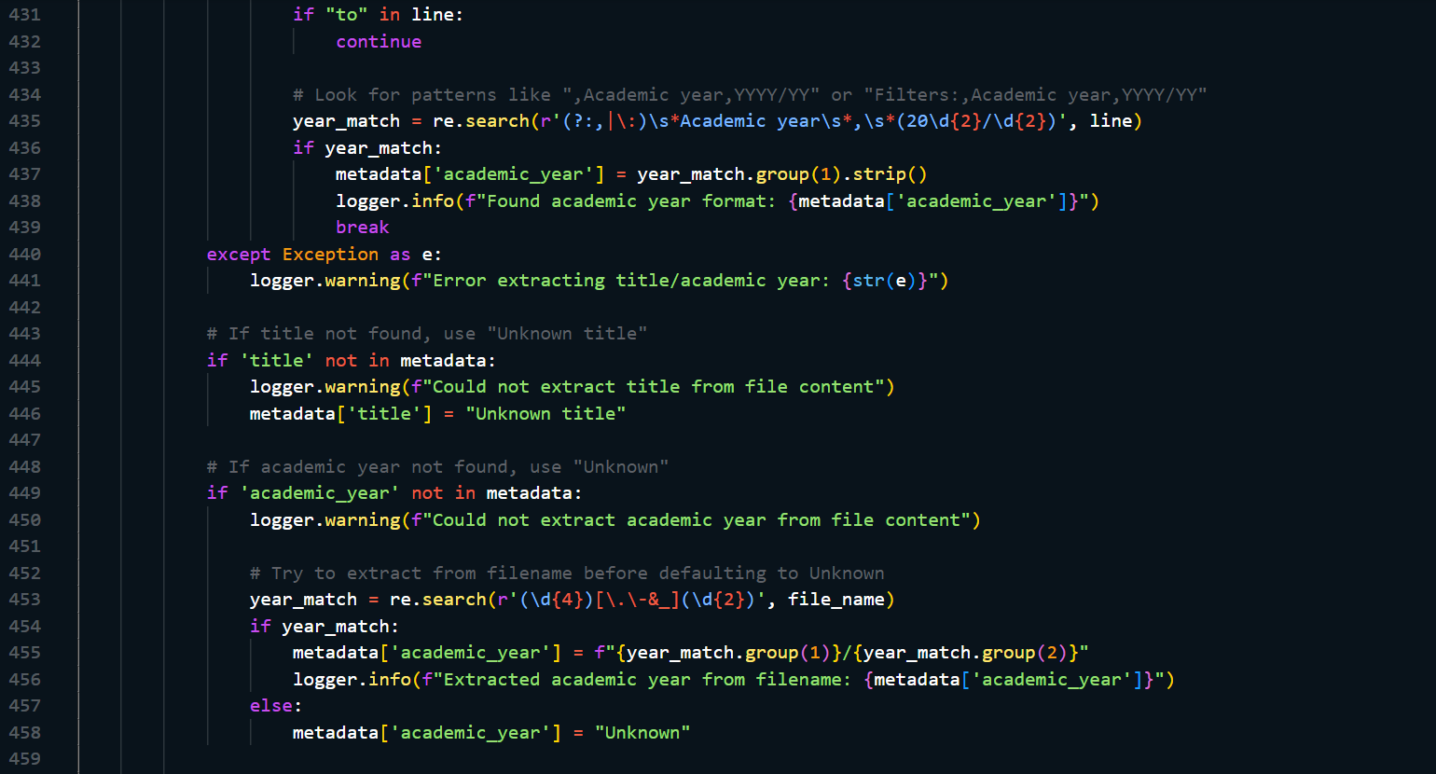 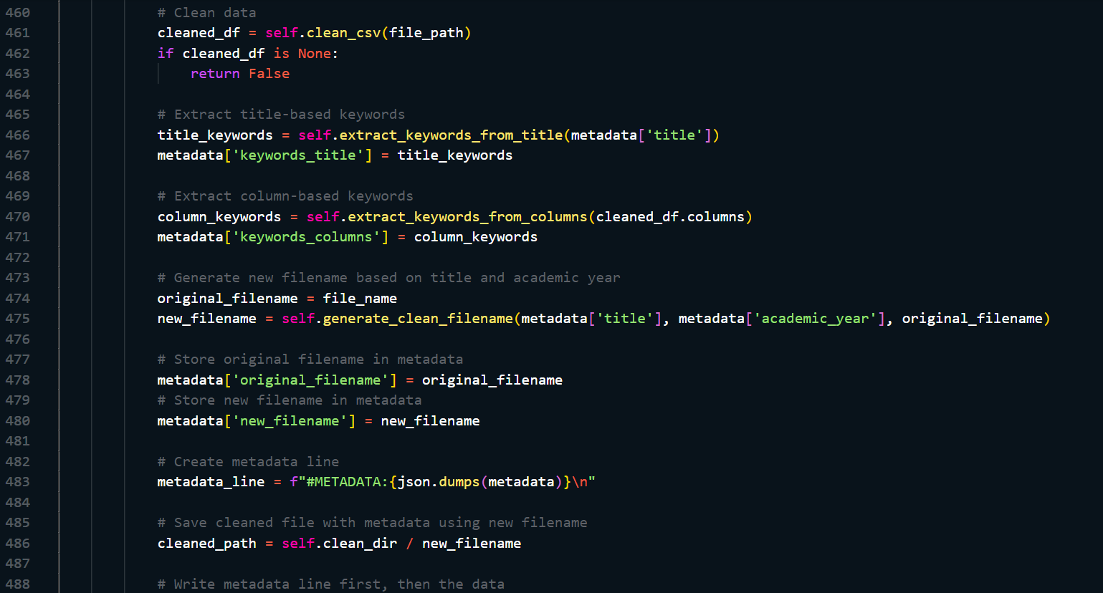 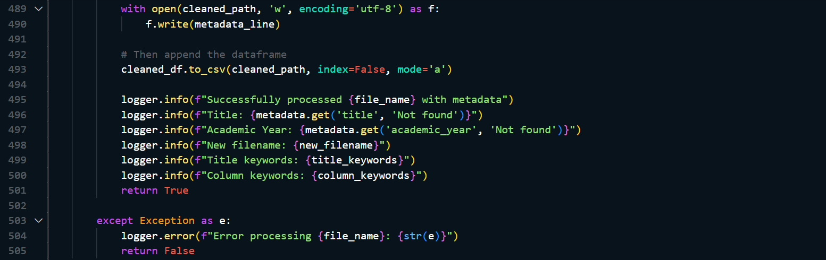

### D.6 CSVProcessor

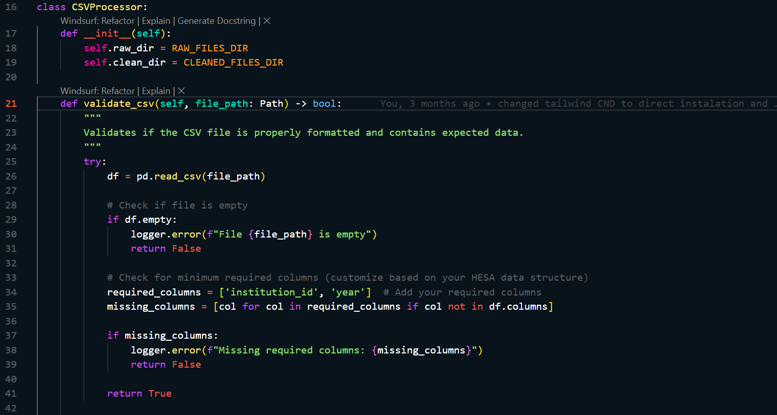 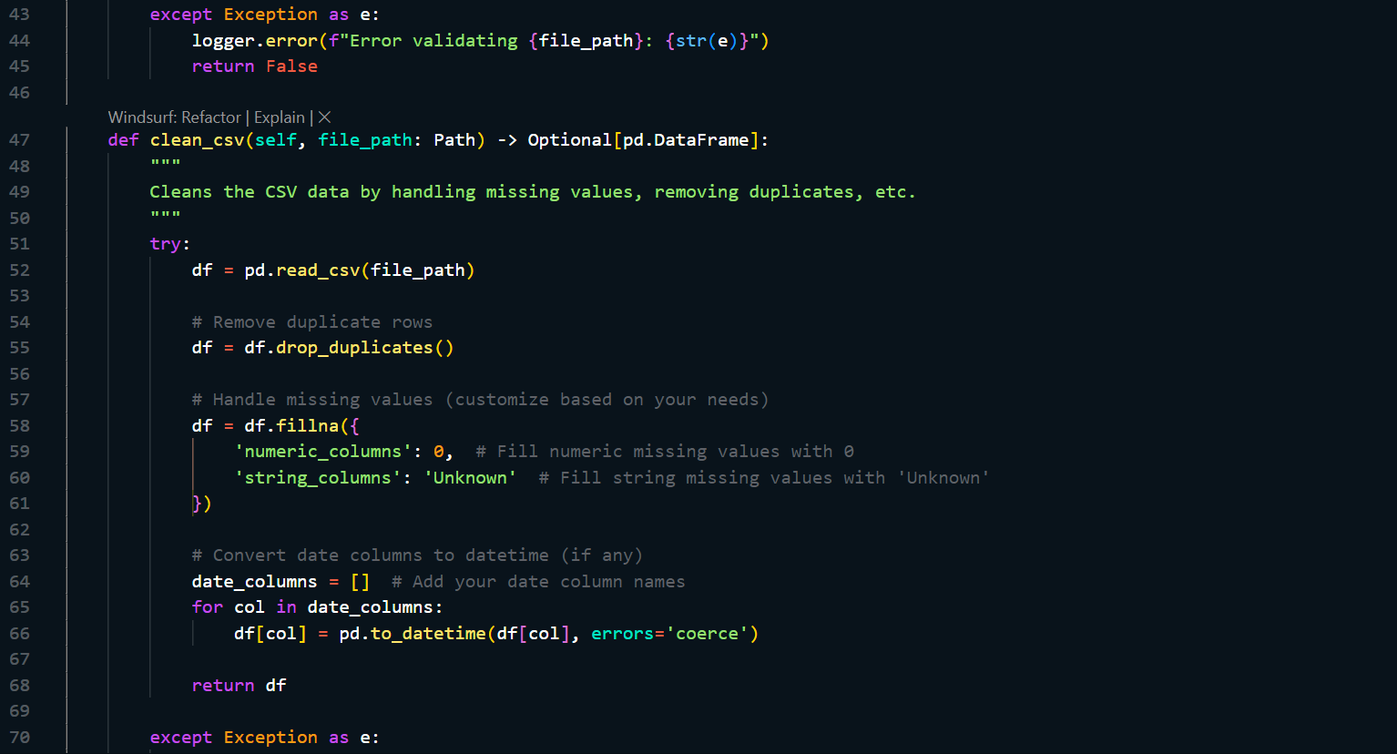 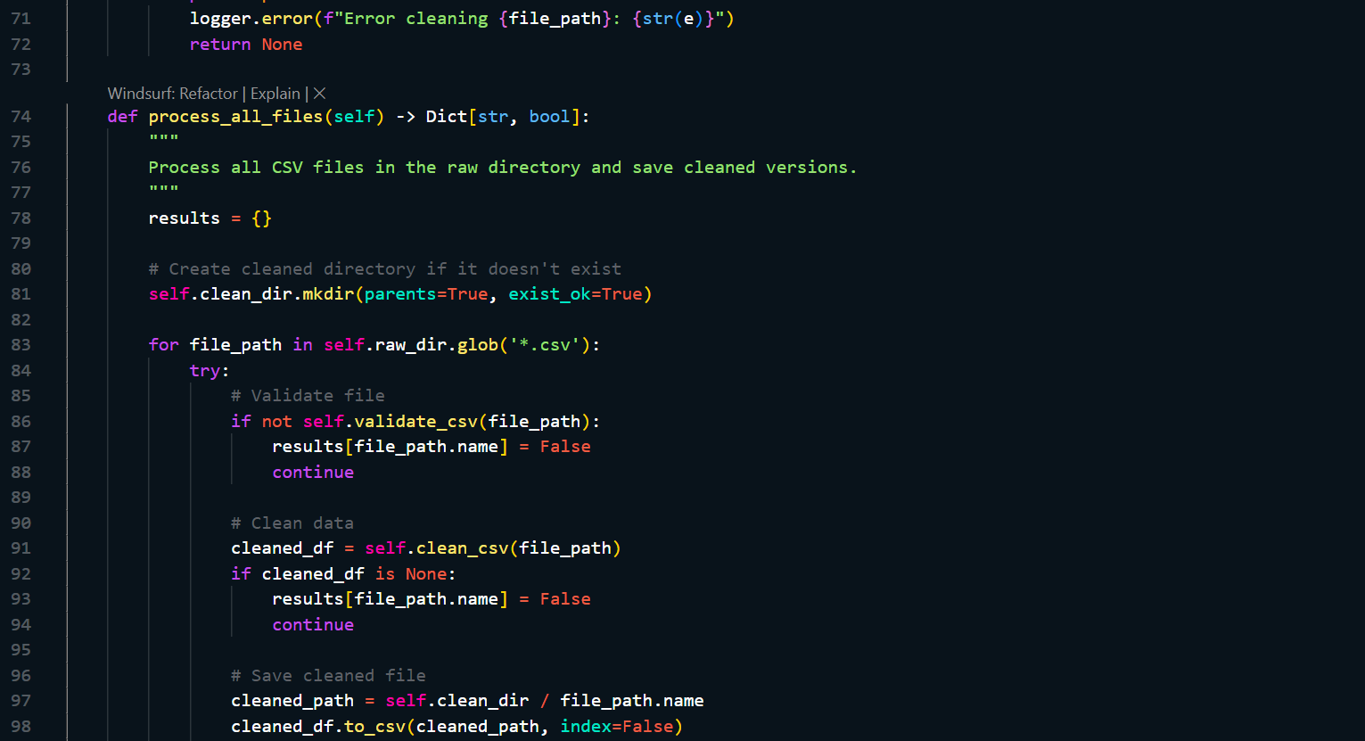 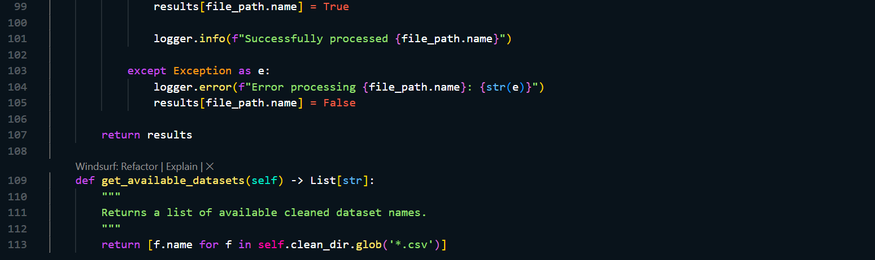

## E: Query Processing and Interpretation

### E.1 Transform free text into query parameters

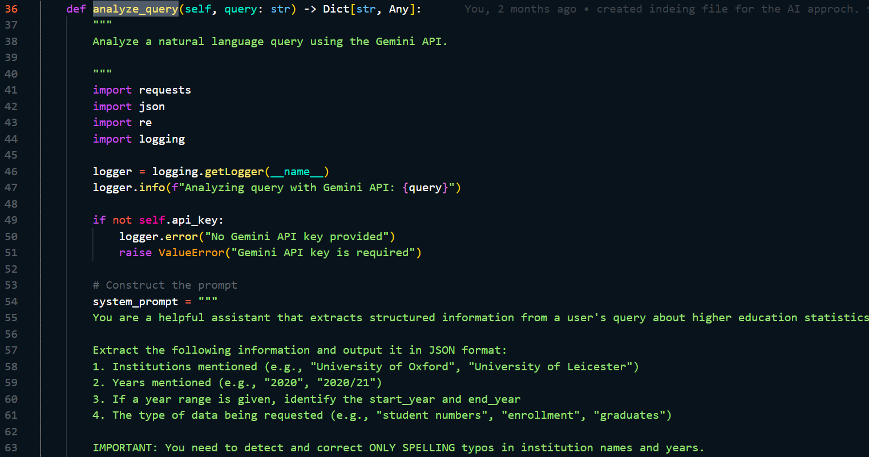 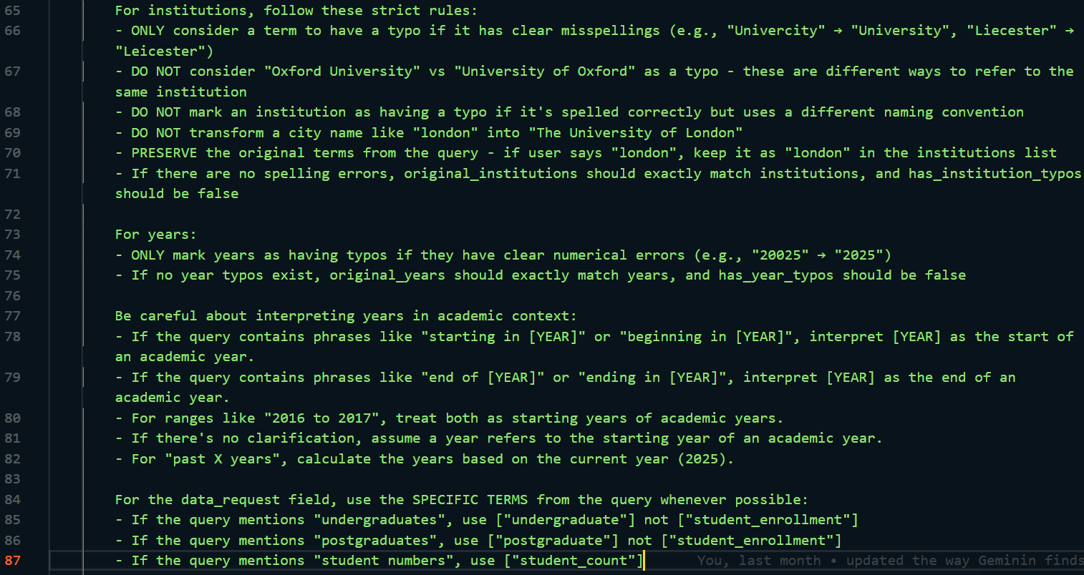 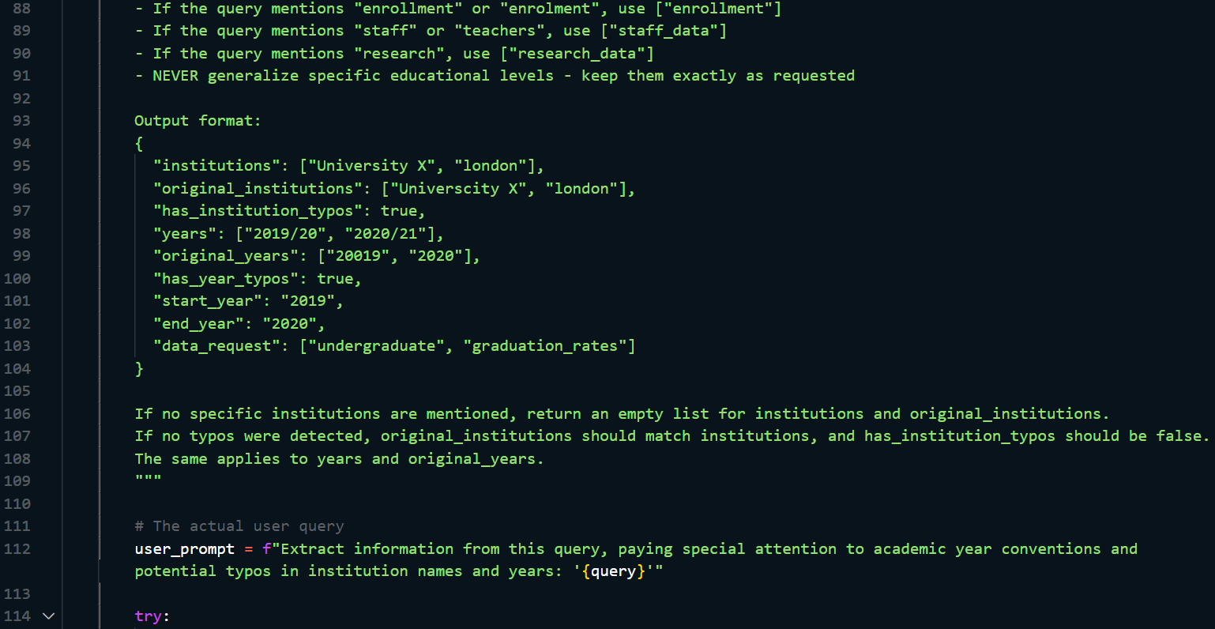 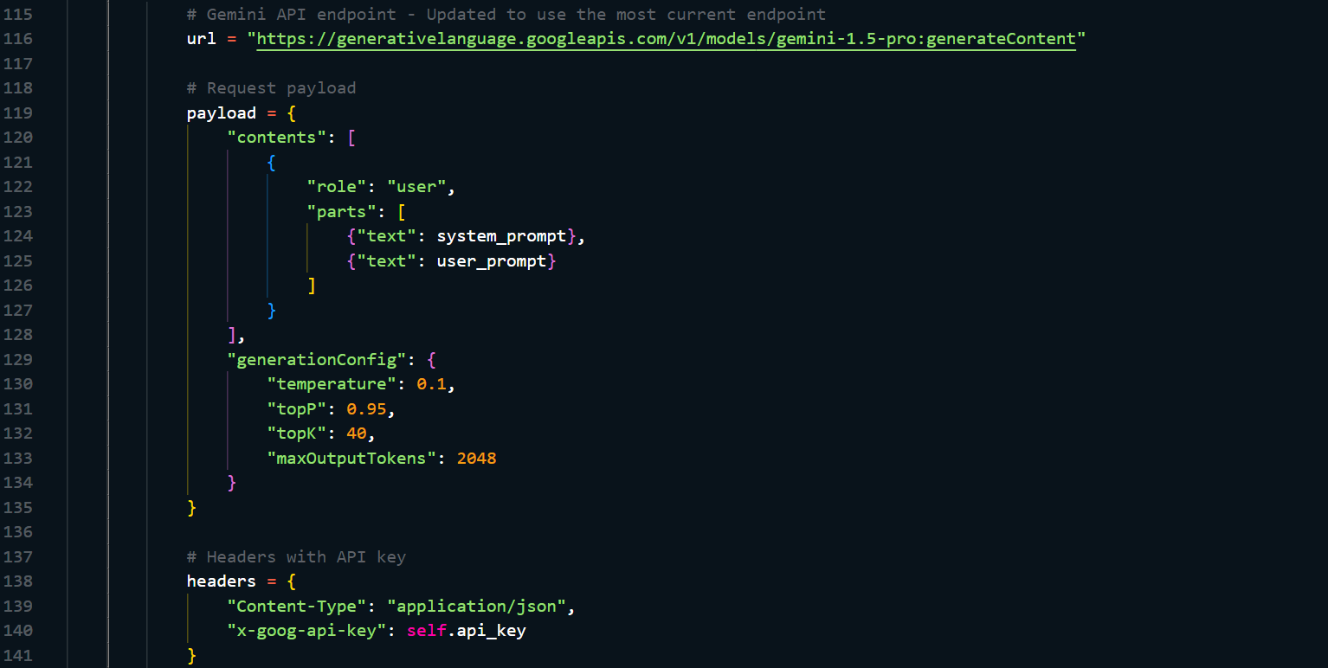 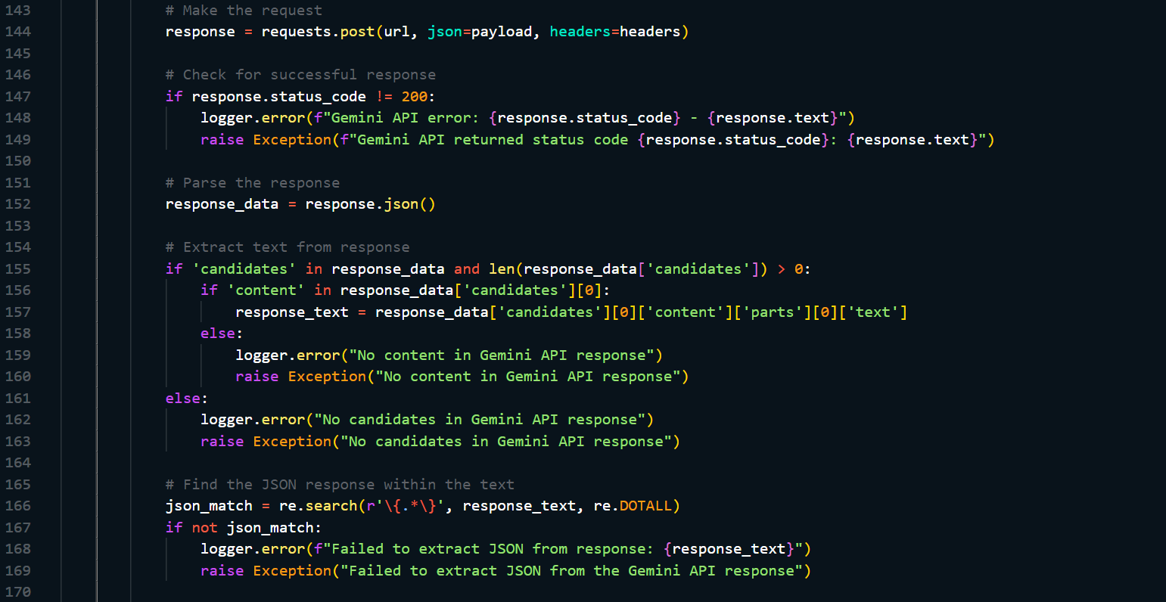

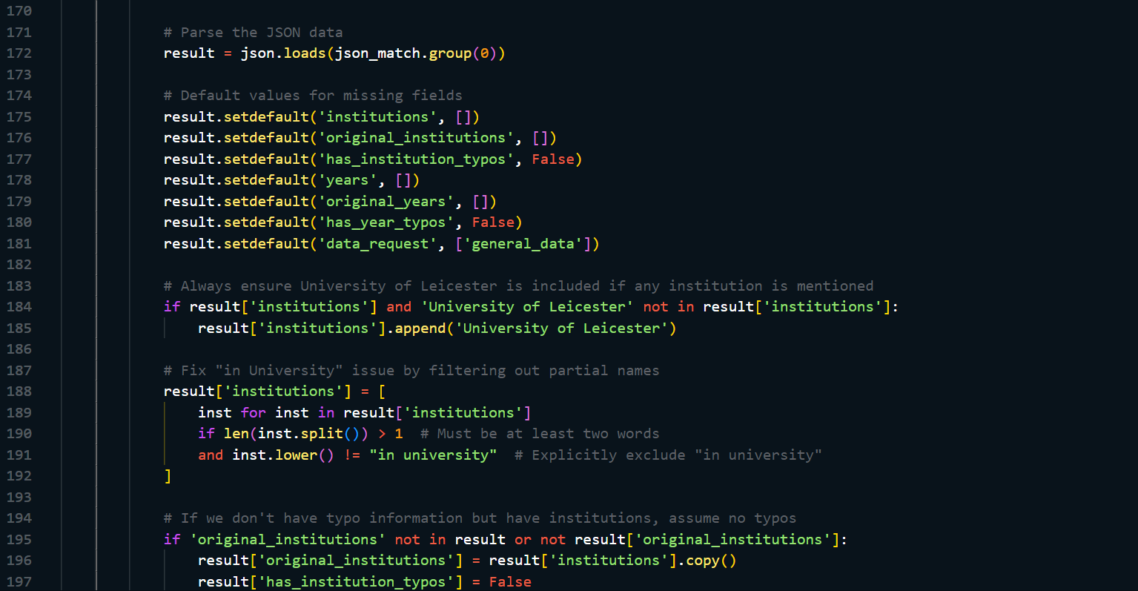 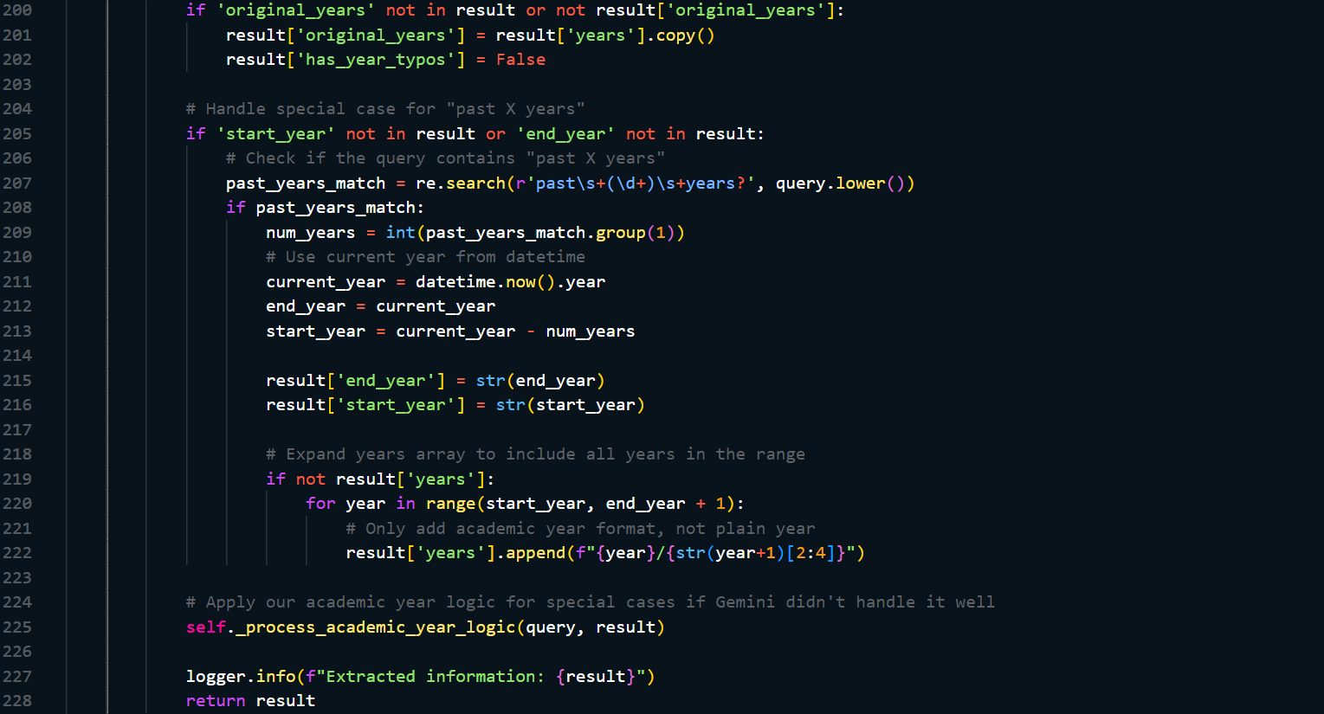

### E.2 Date Interpretation

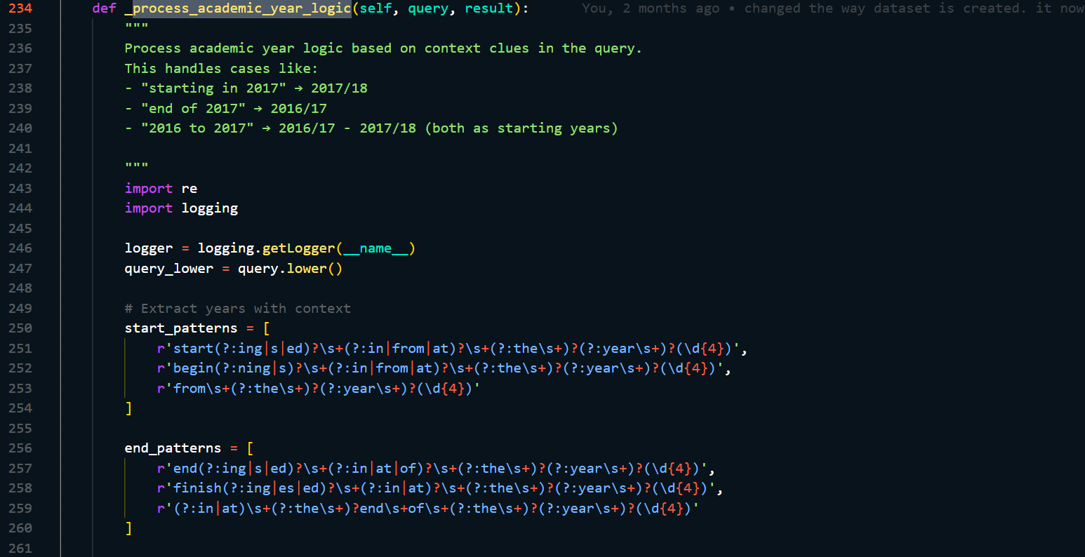 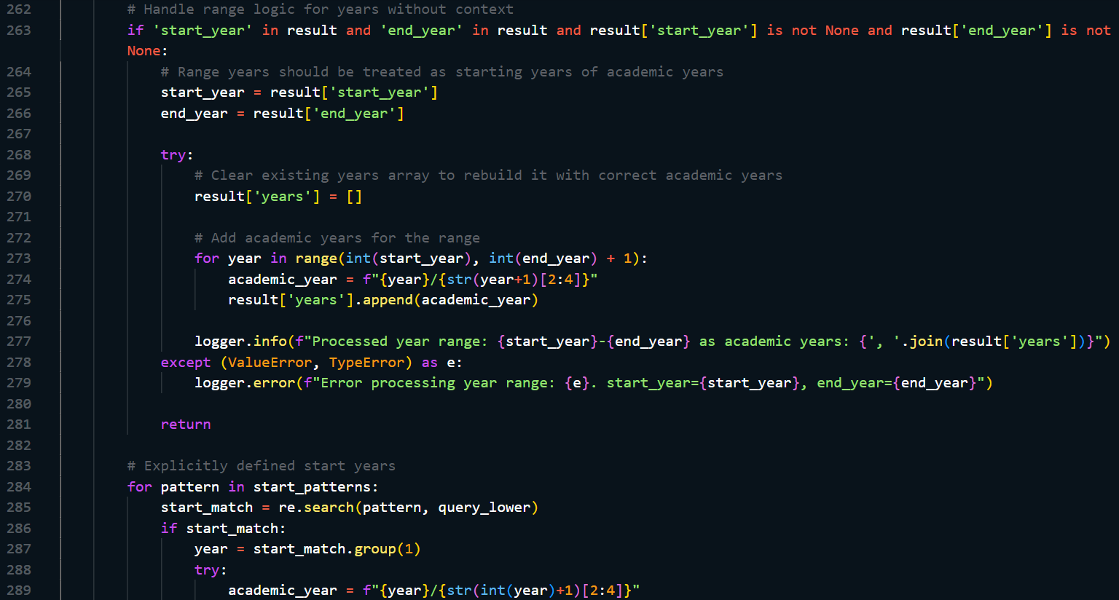 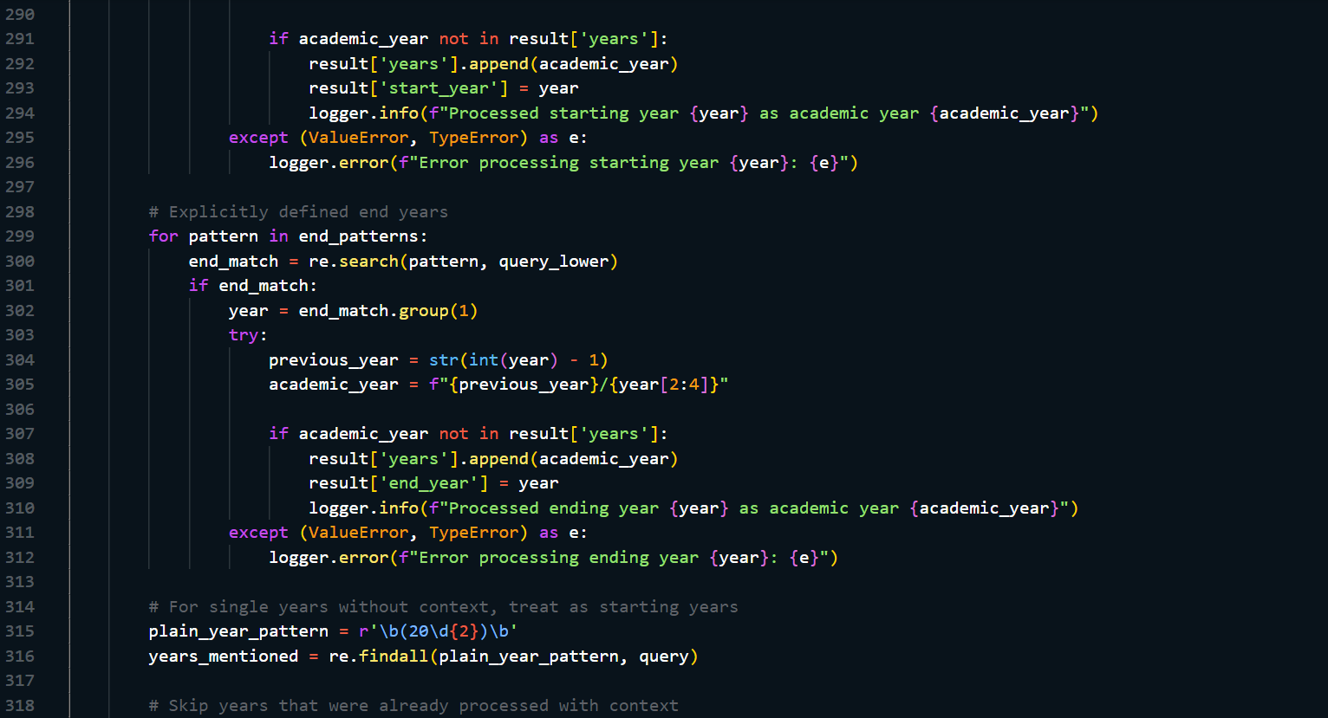 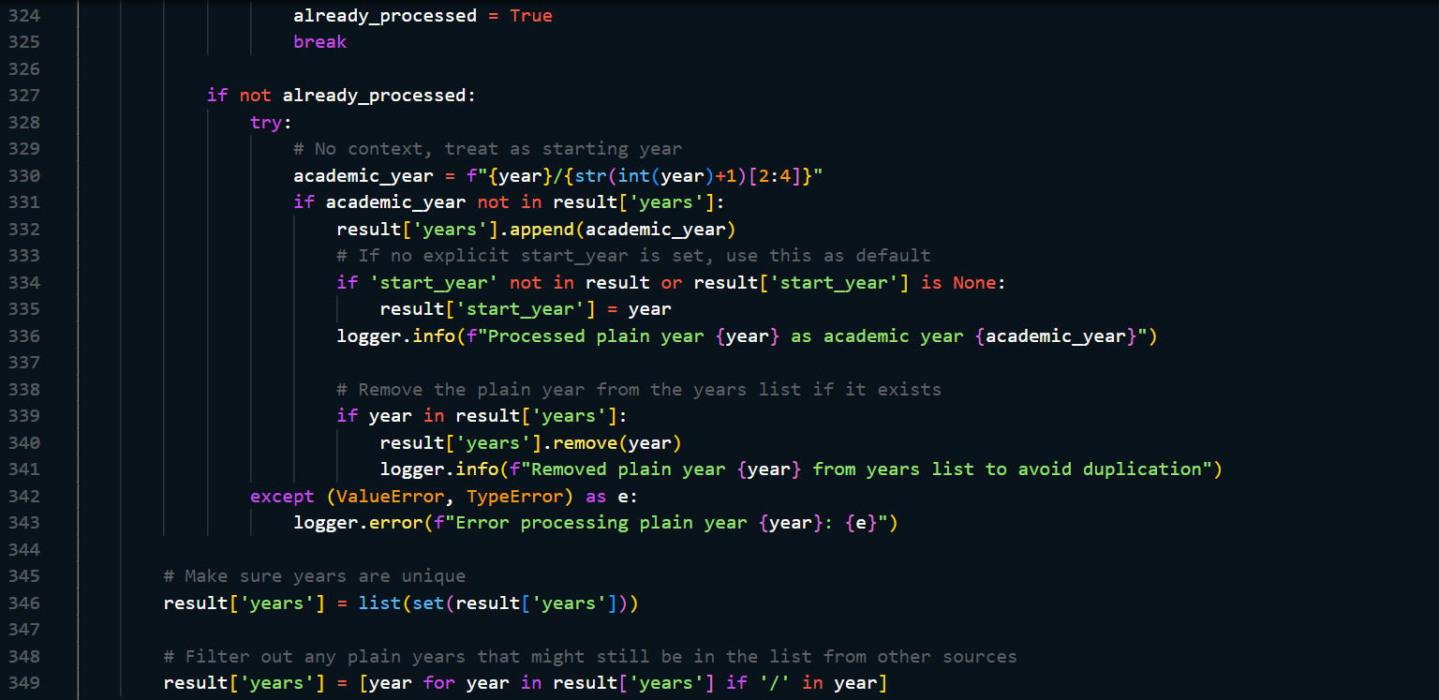

## F: Visualization Generation

### F.1 Chart Generation

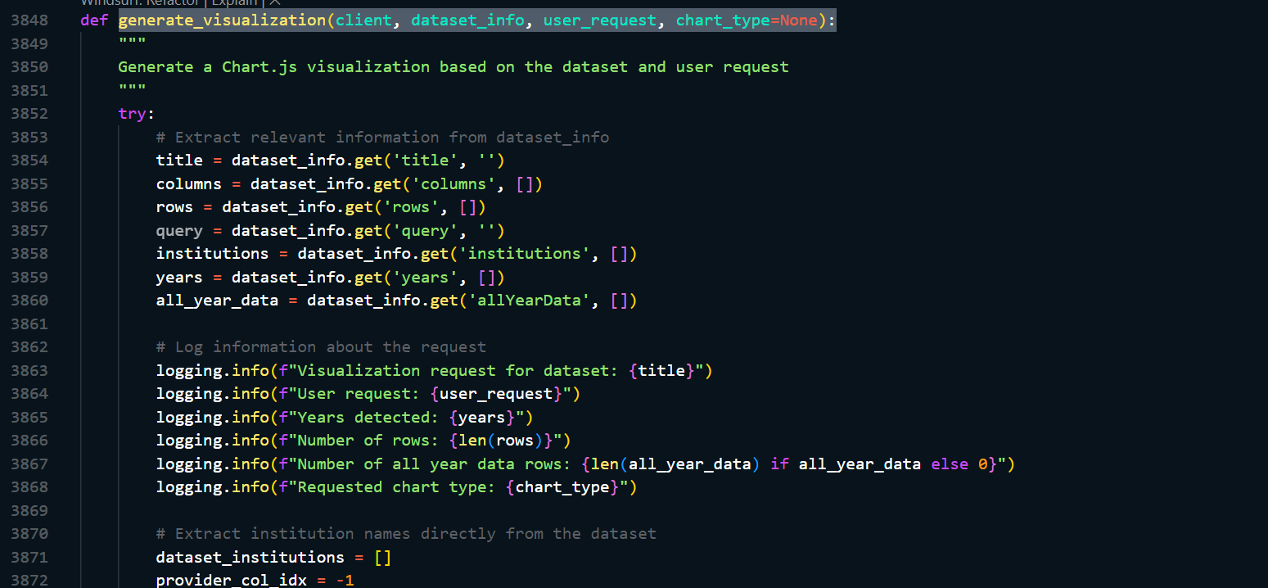 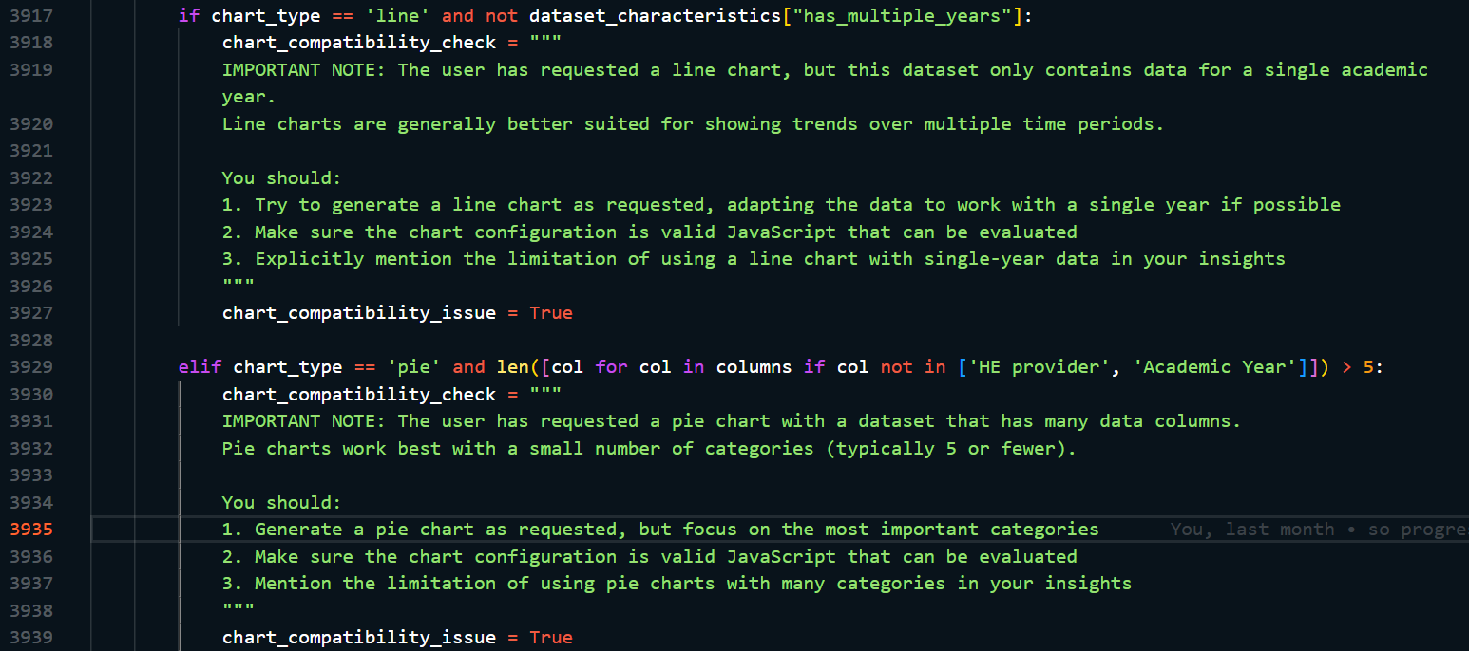 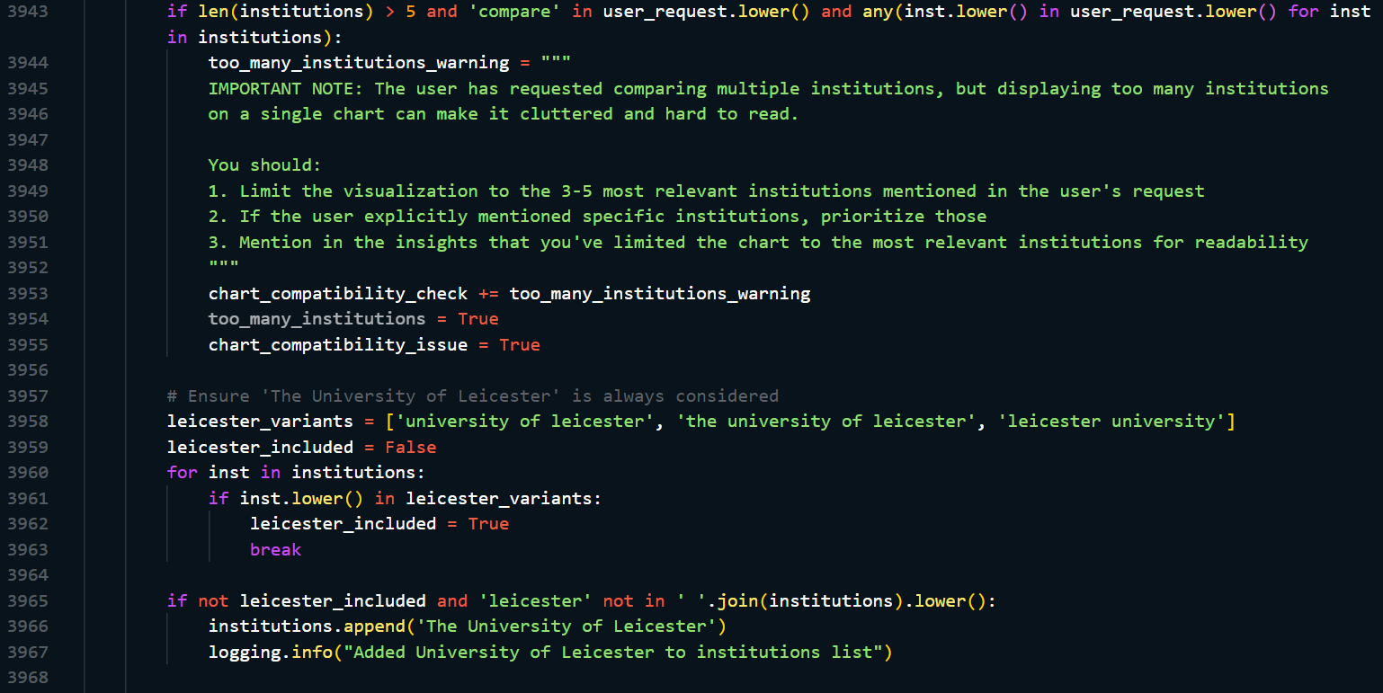 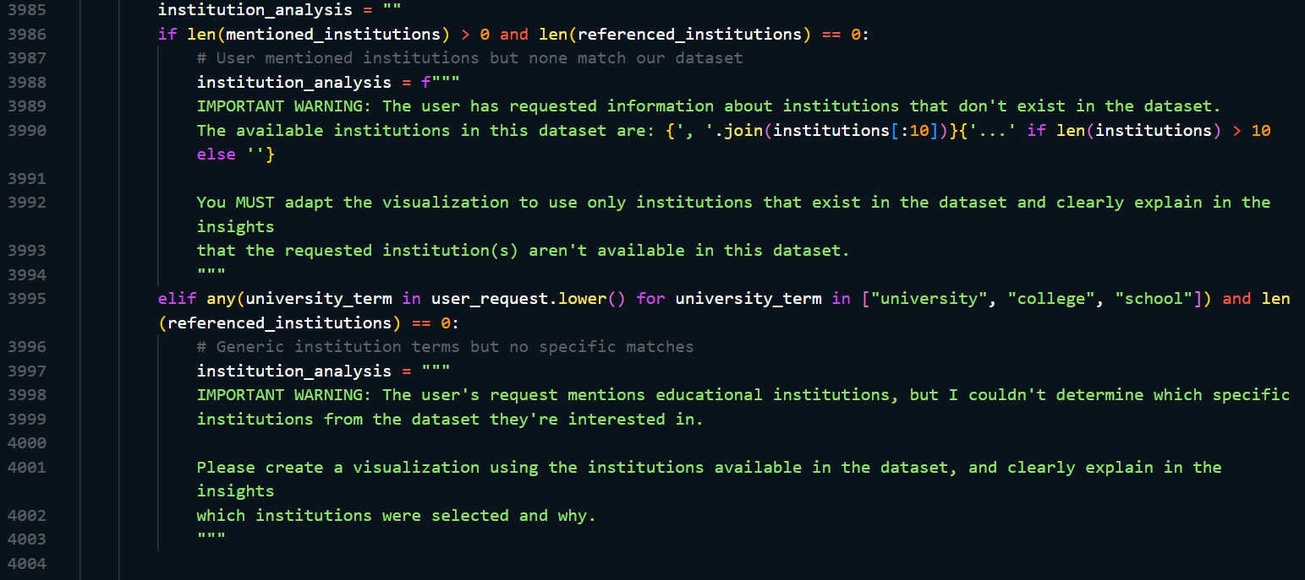 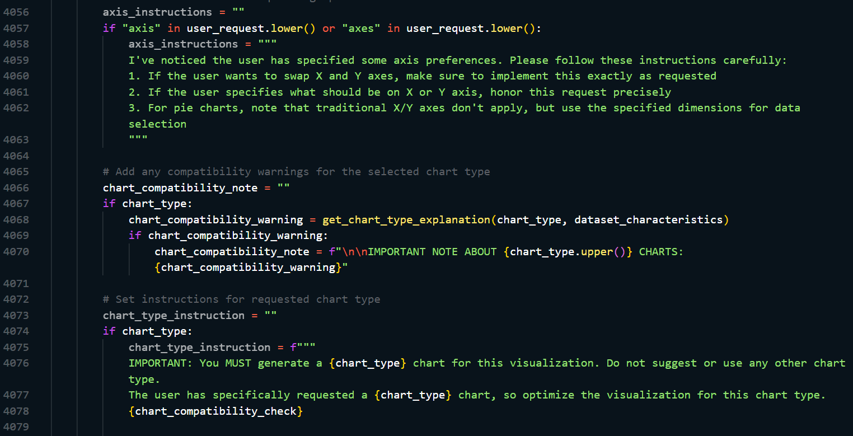 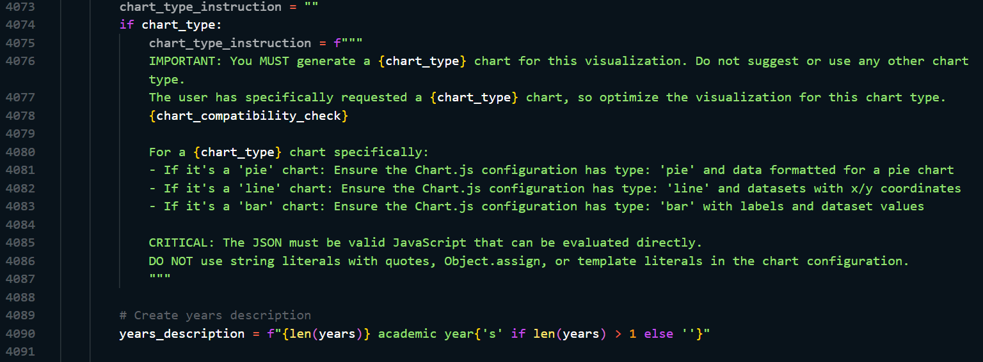 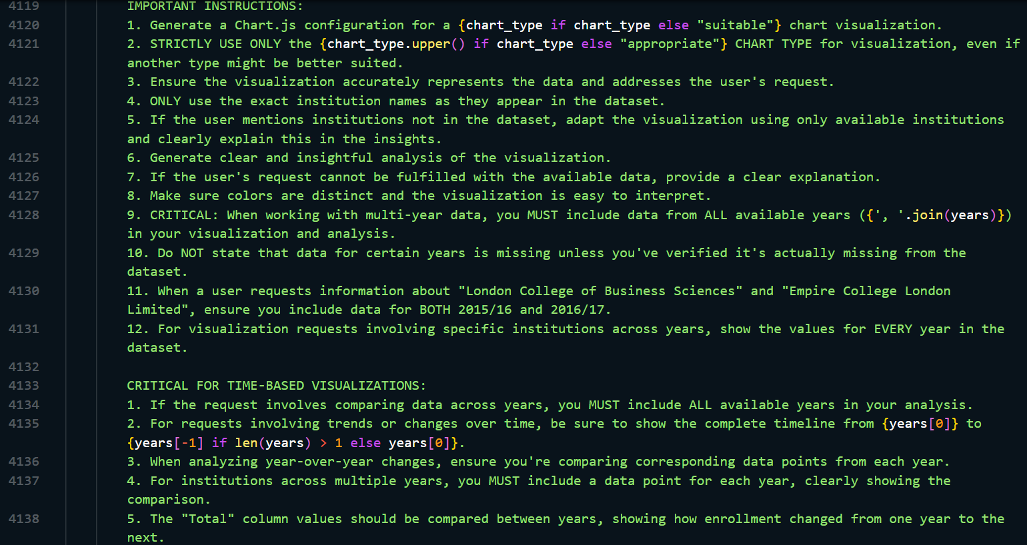

### F.2 Handles different chart type requests

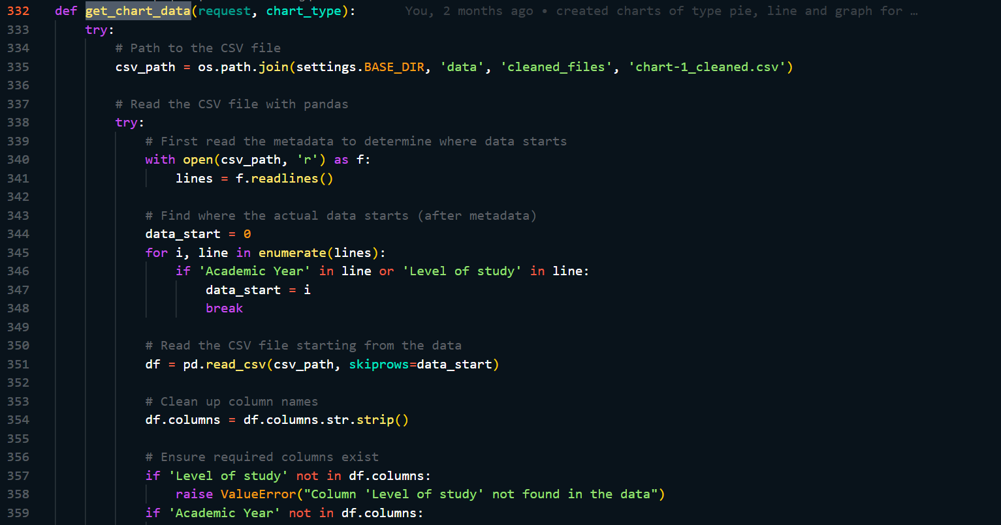 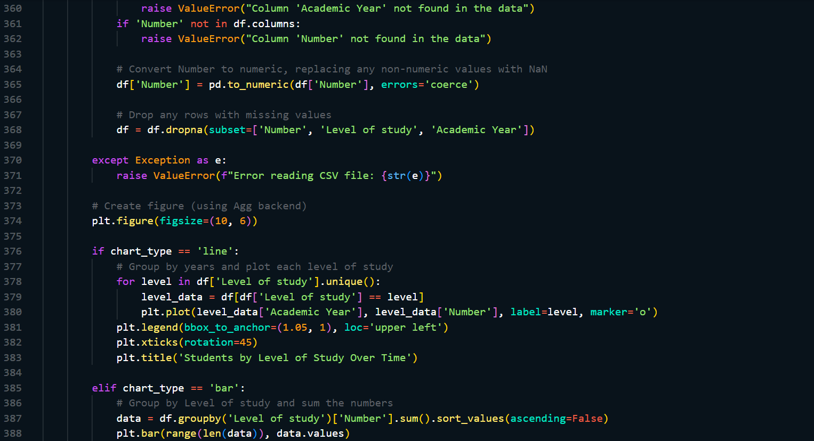 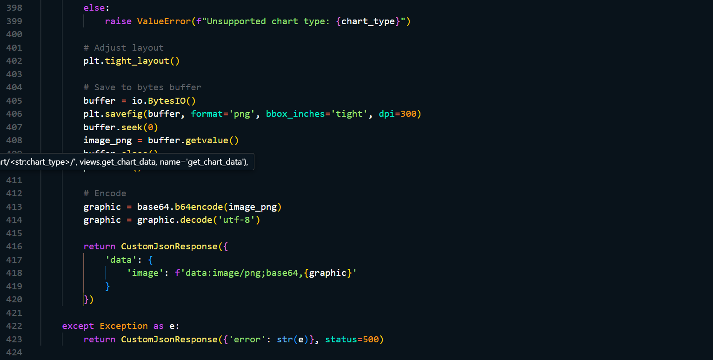

### F.3 Gets AI recommendations for chart types

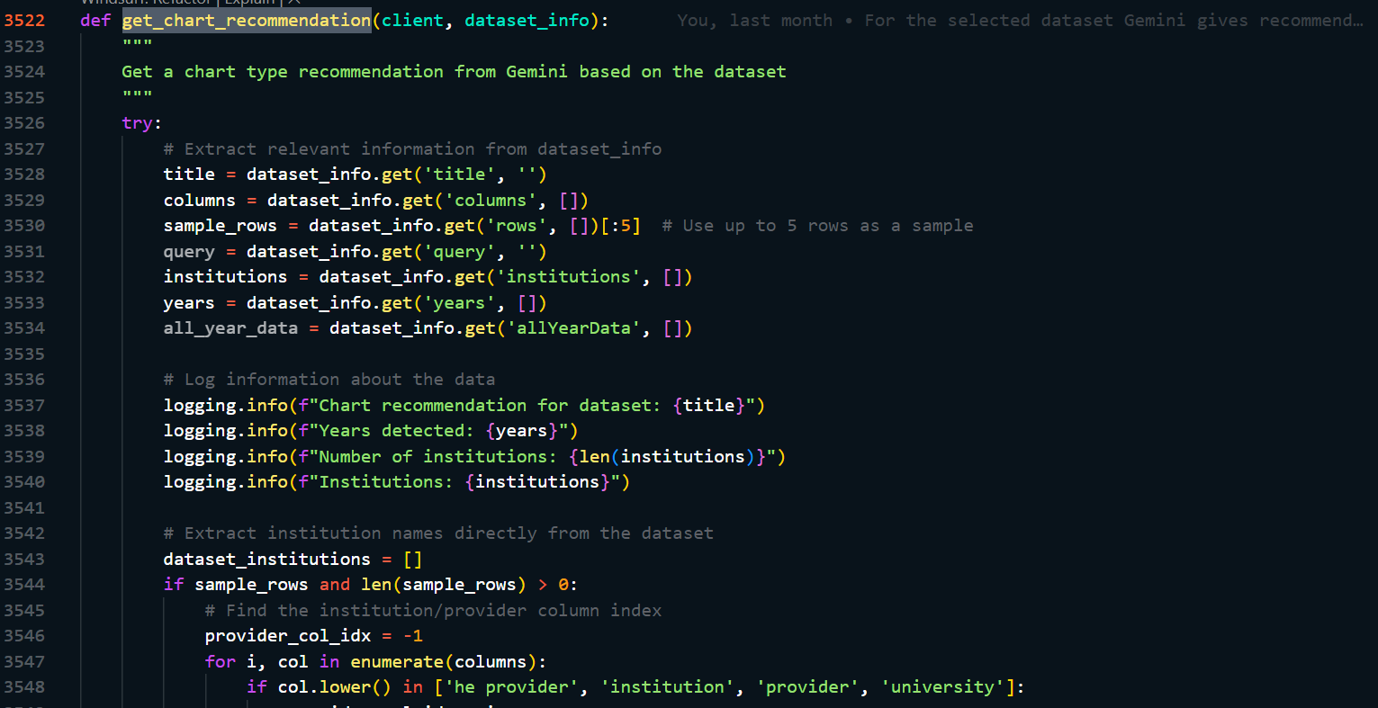 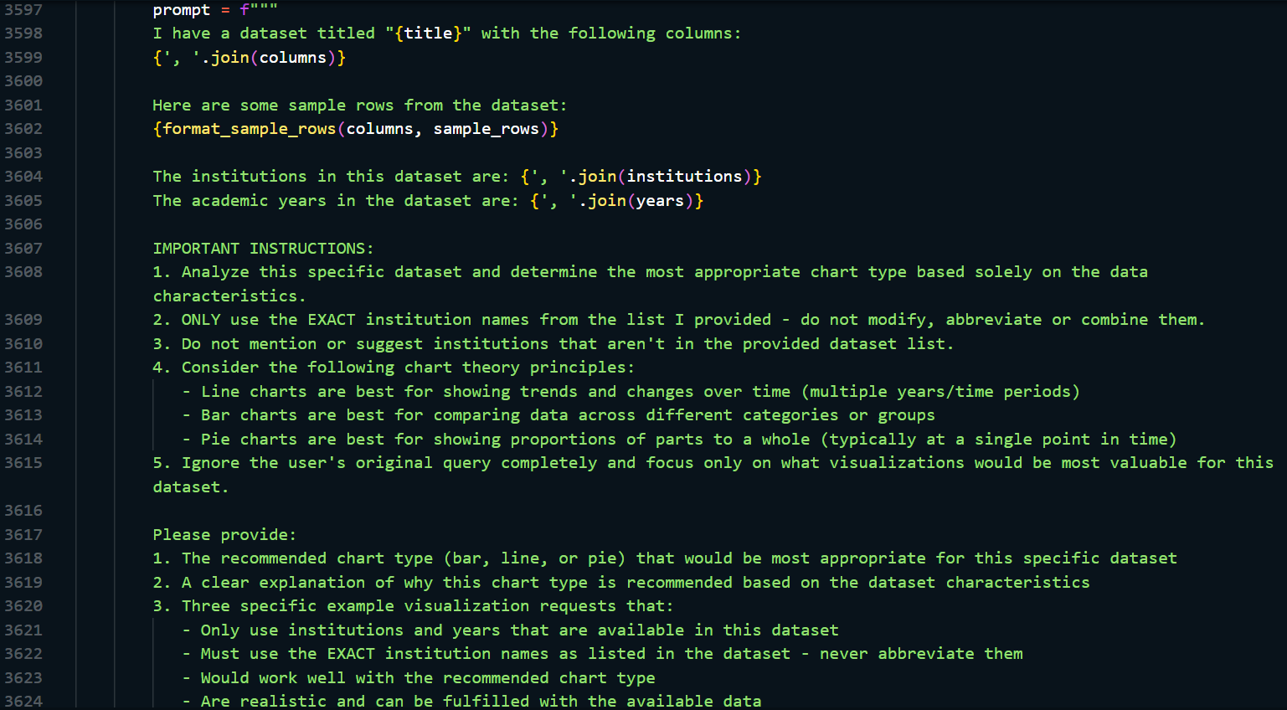

### F.4 Dynamically changing the visualization

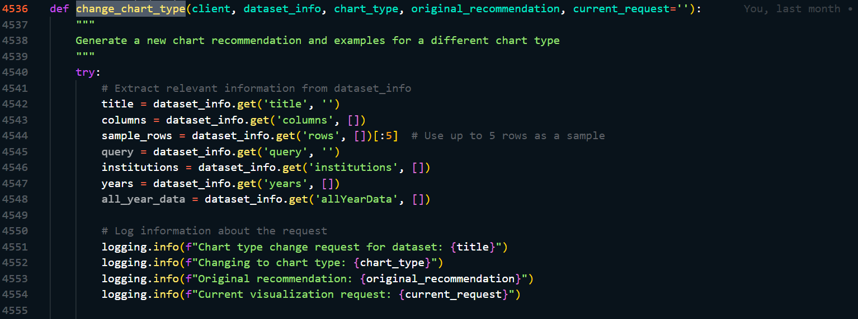 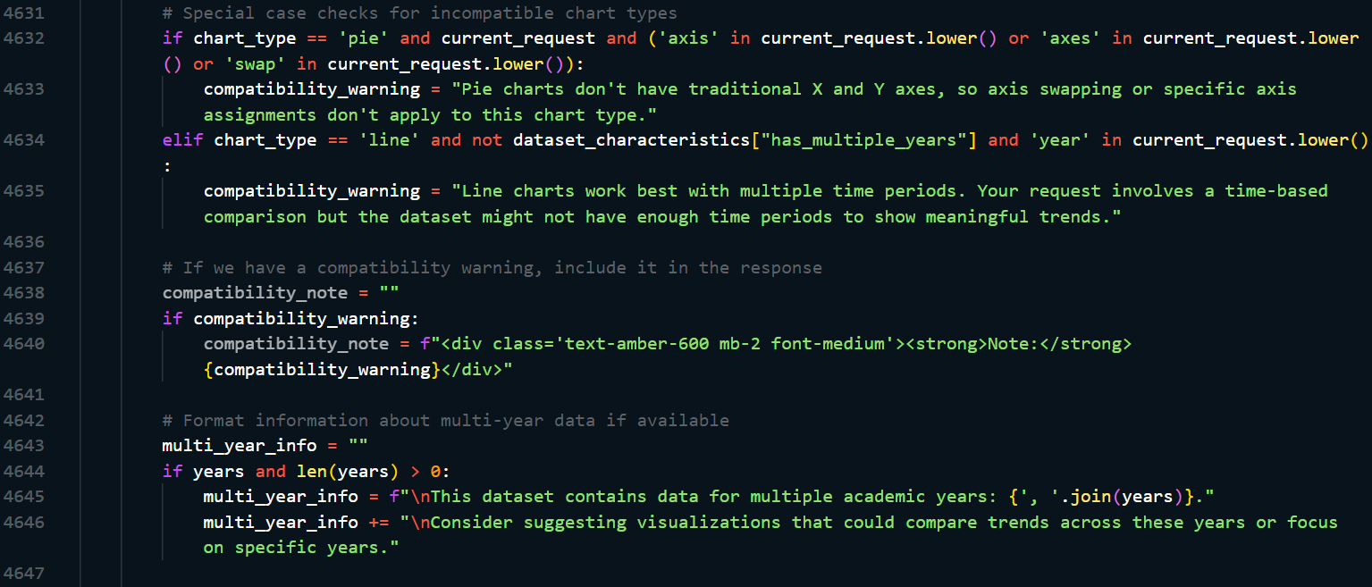 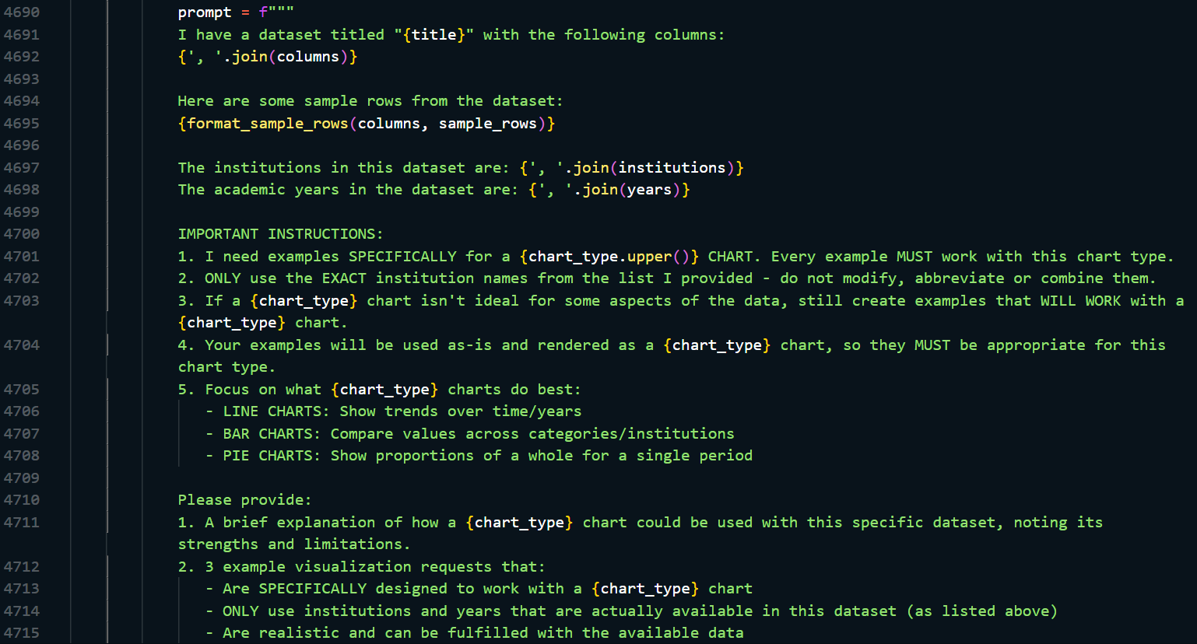 

## G: Front-End Rendering

### G.1 Rendering Visualization

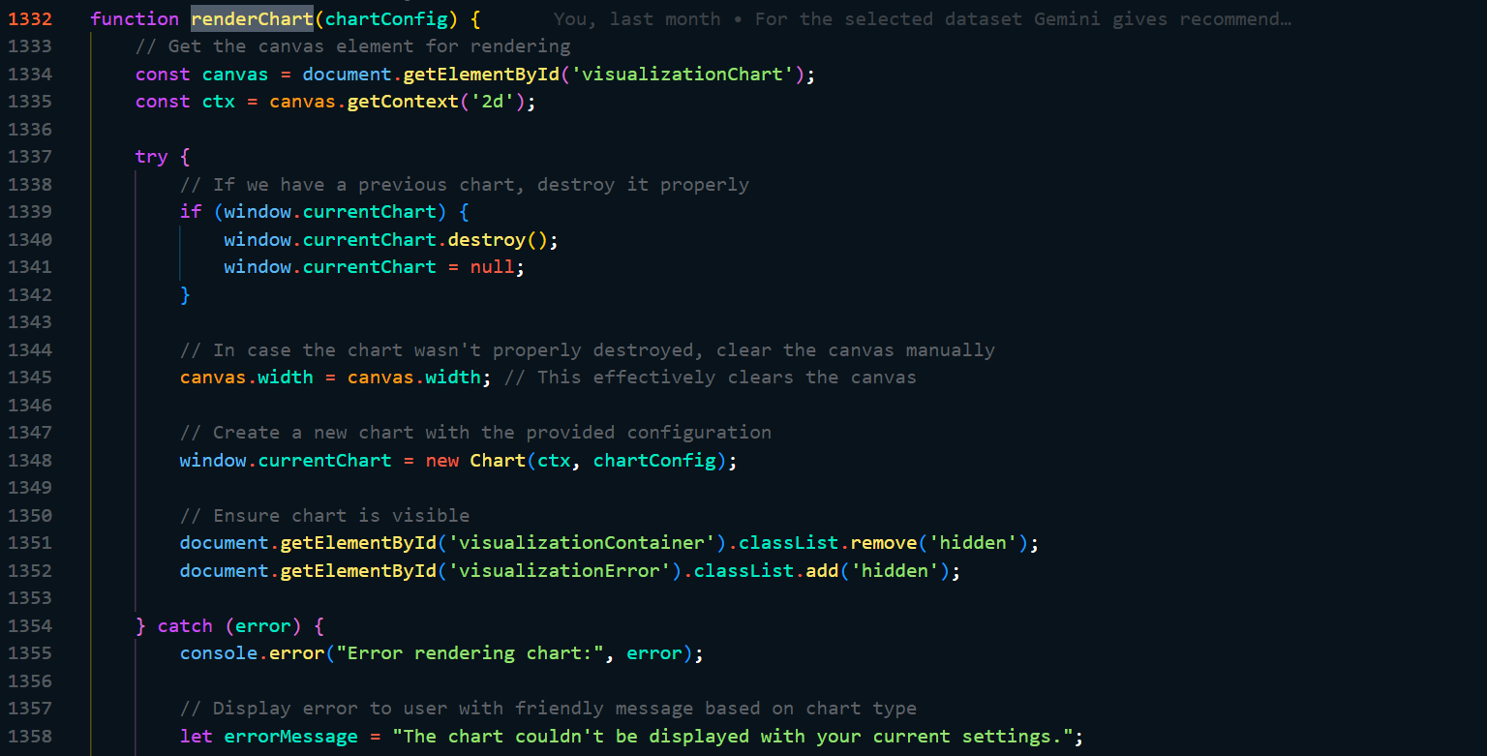 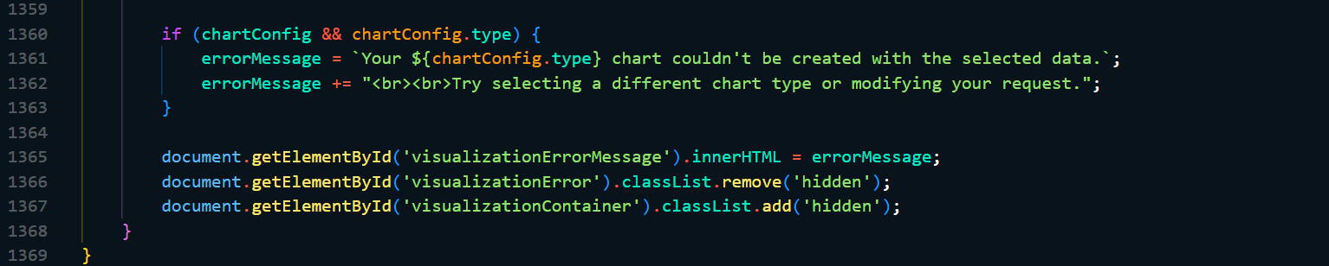

### G.2 Interaction Control

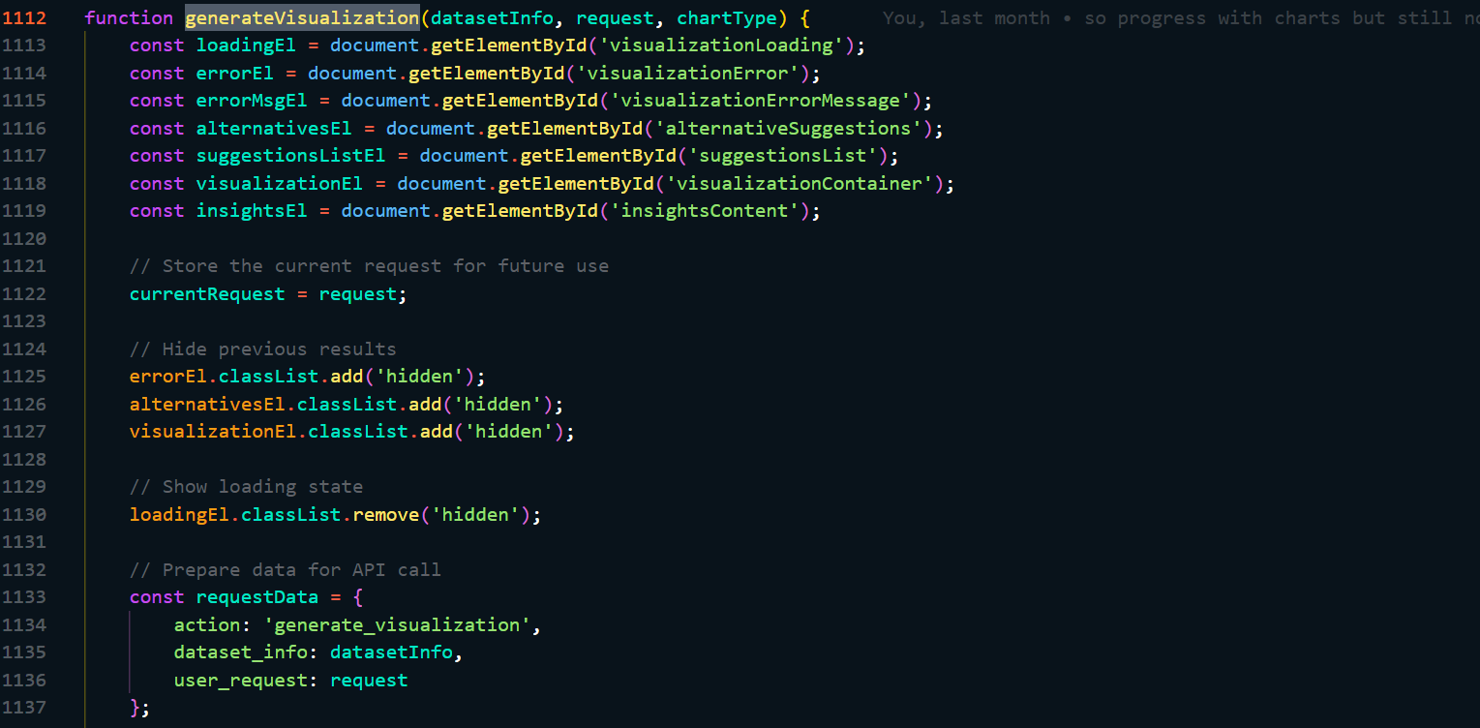 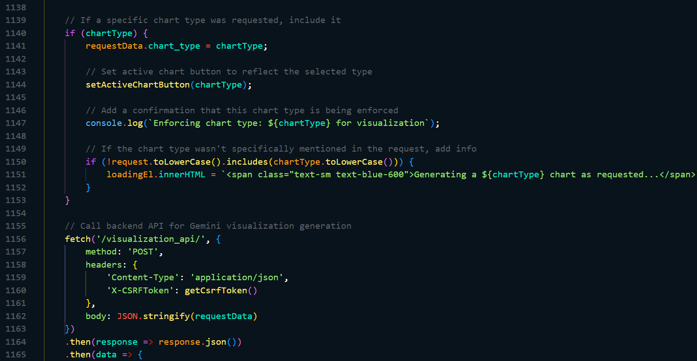 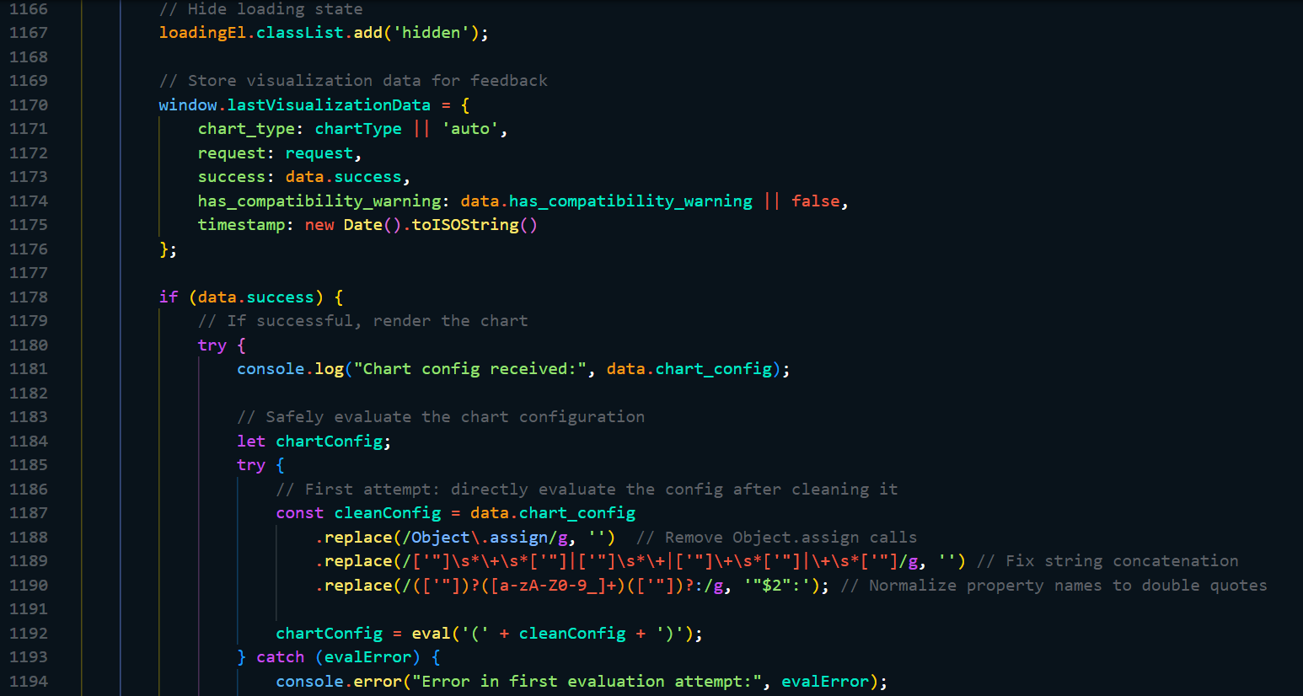 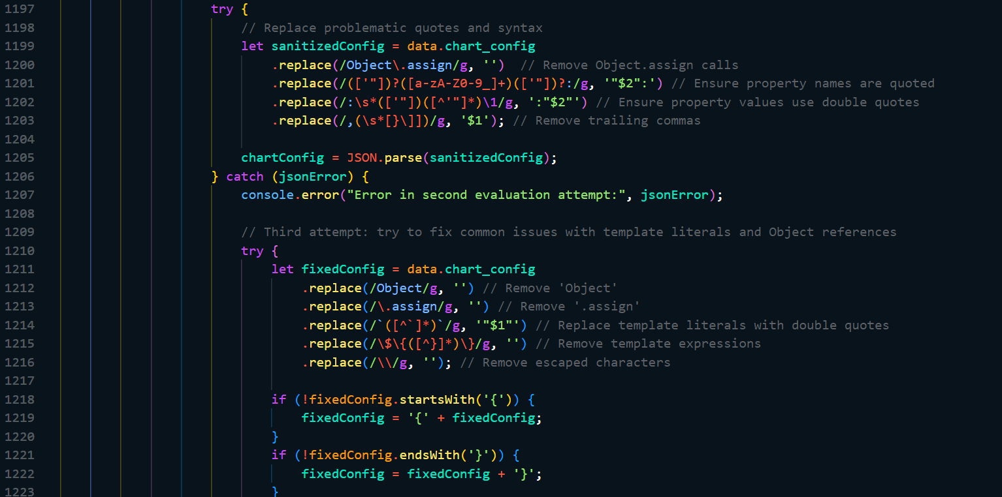 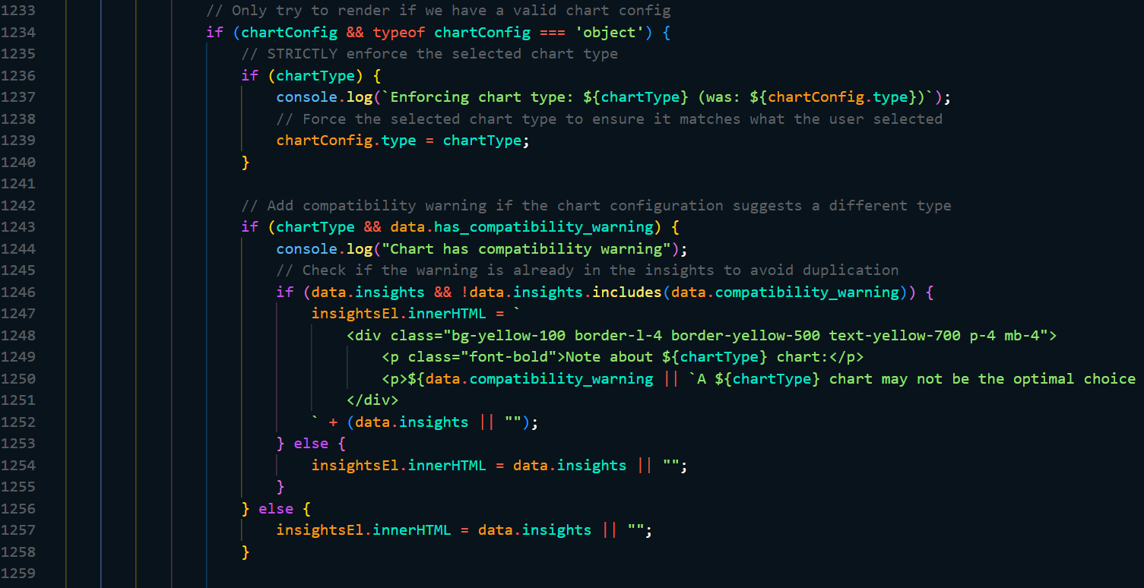

### G.3 Changing Chart Type

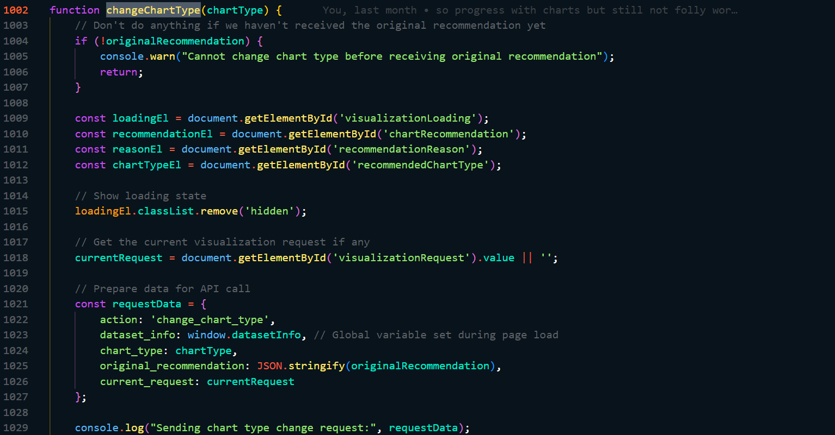 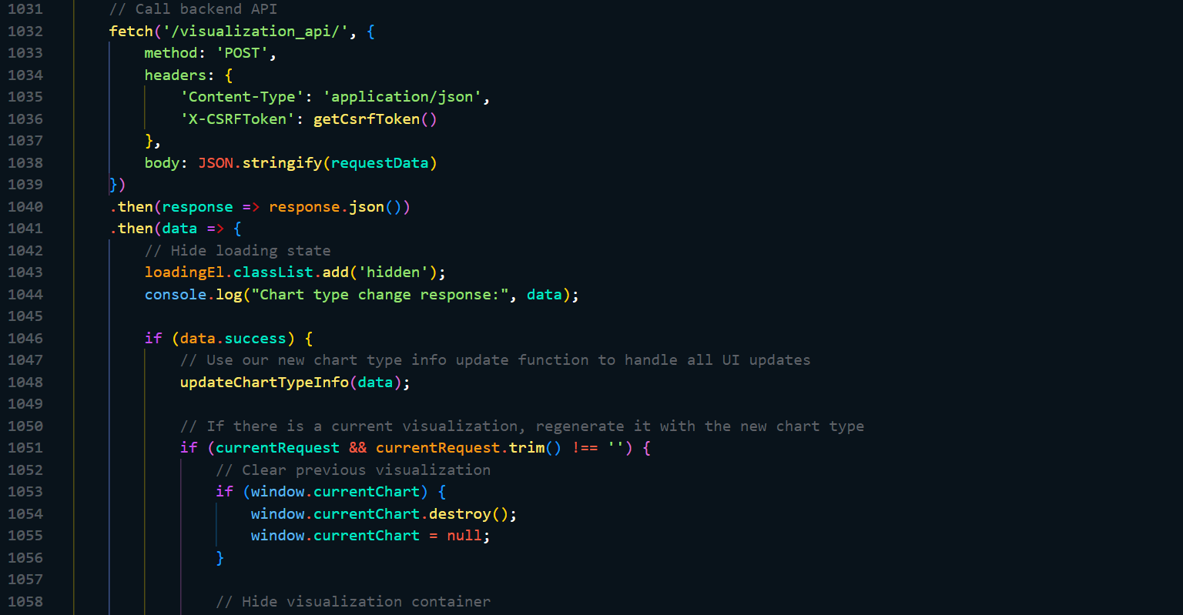 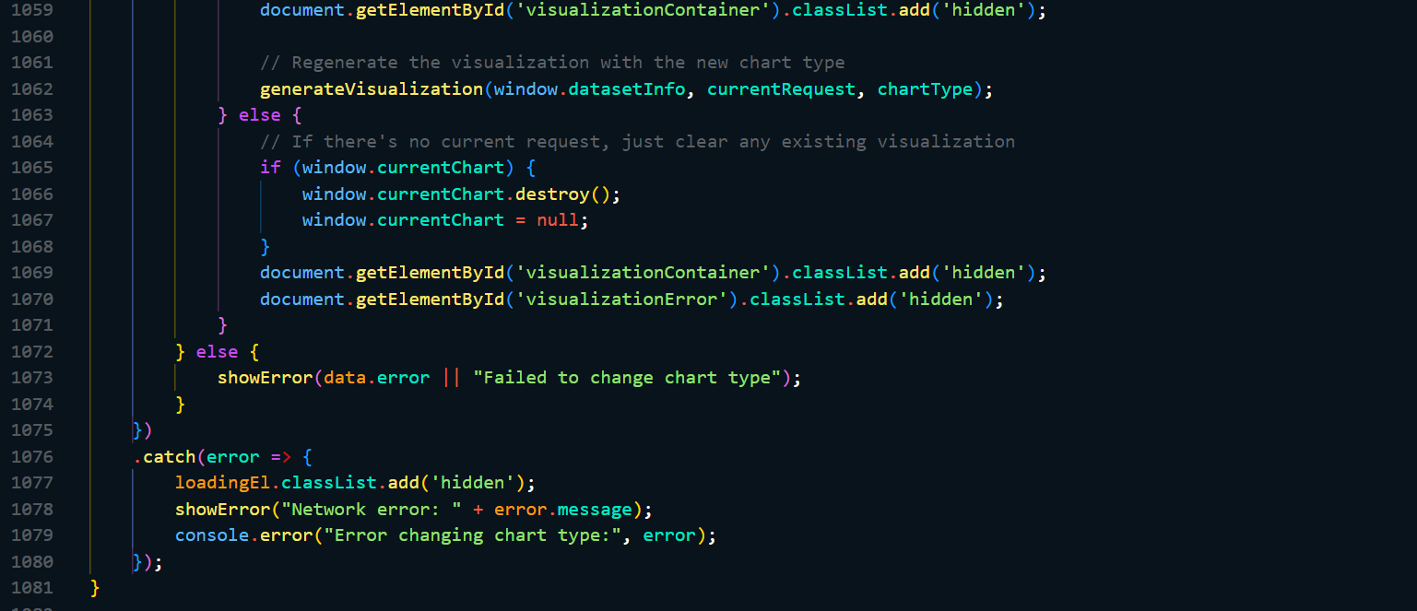

## H: Interactive Visualization Controls

### H.1 Back-end connection

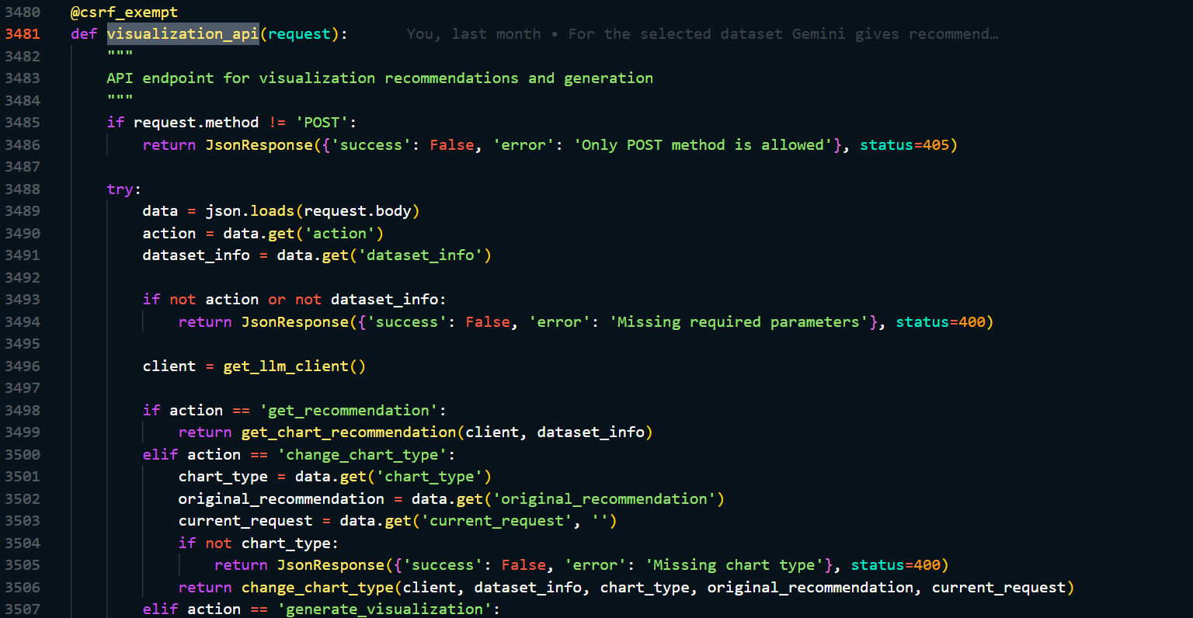 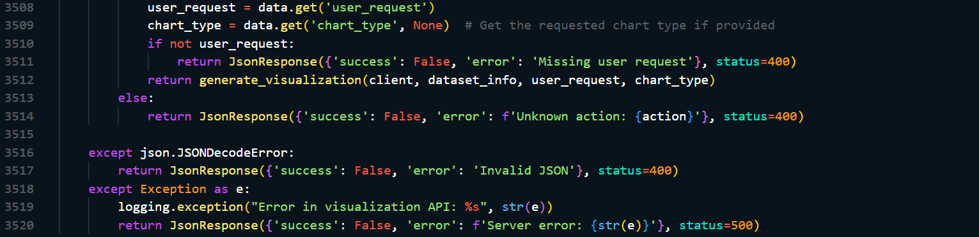

### H.2 Chart Type Explanation

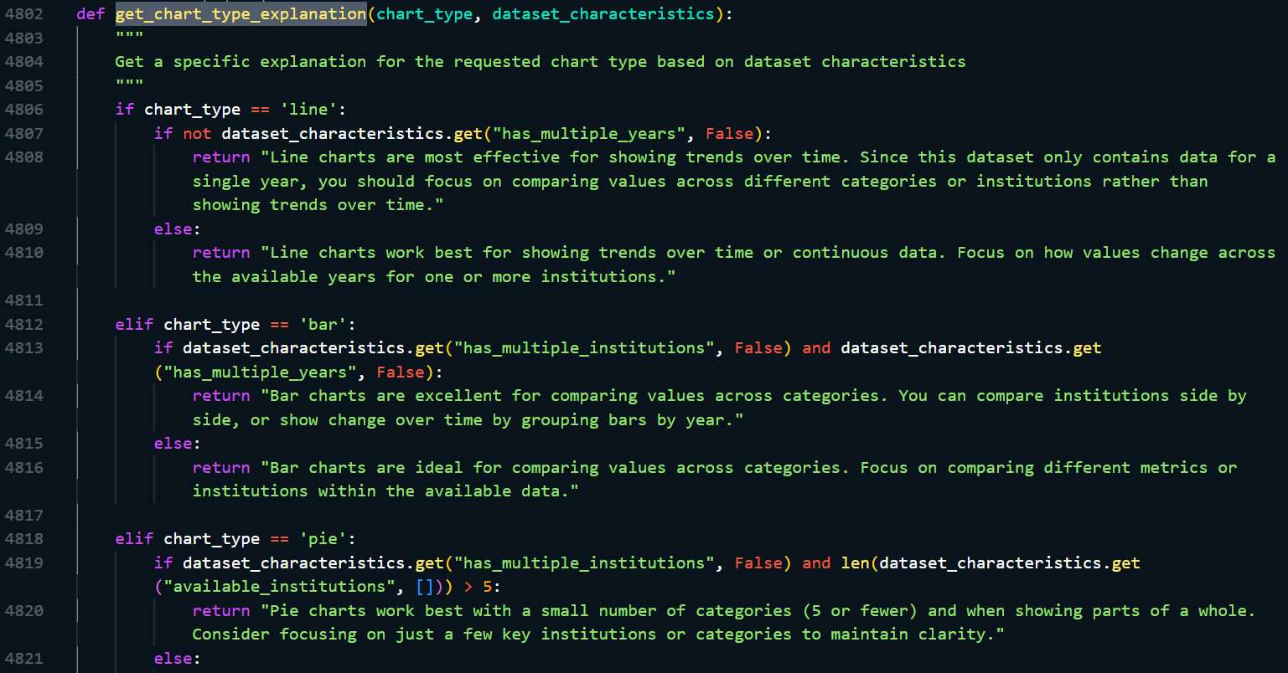 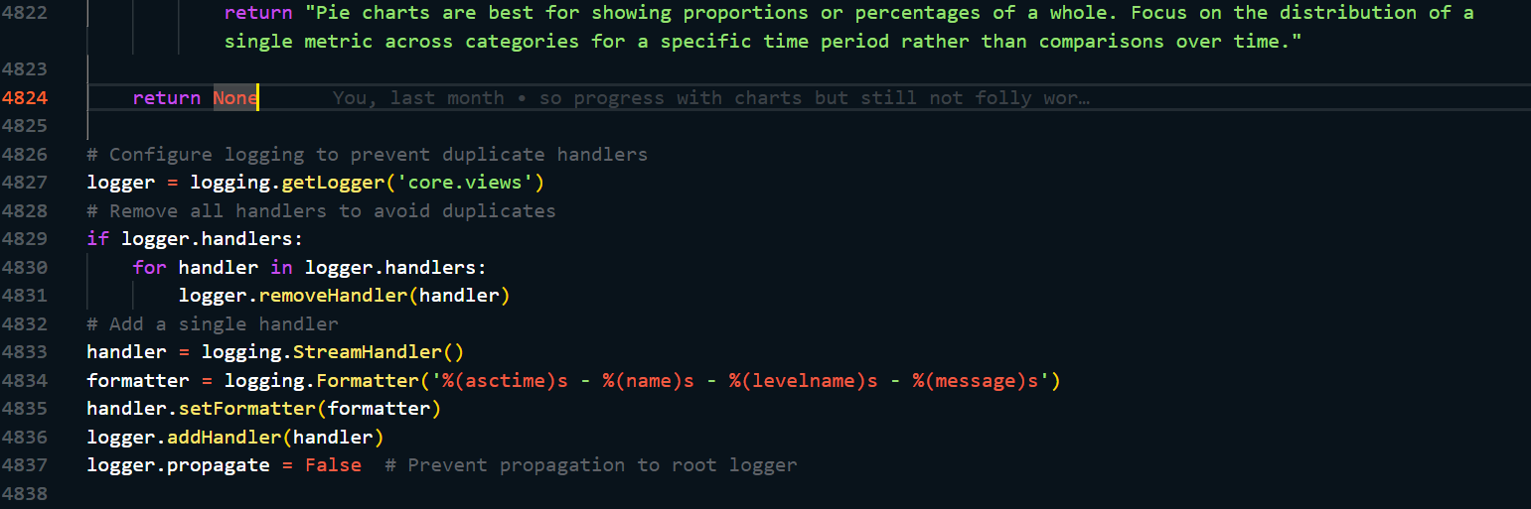

## I: Dashboard Interface

### I.1 Display Query Results

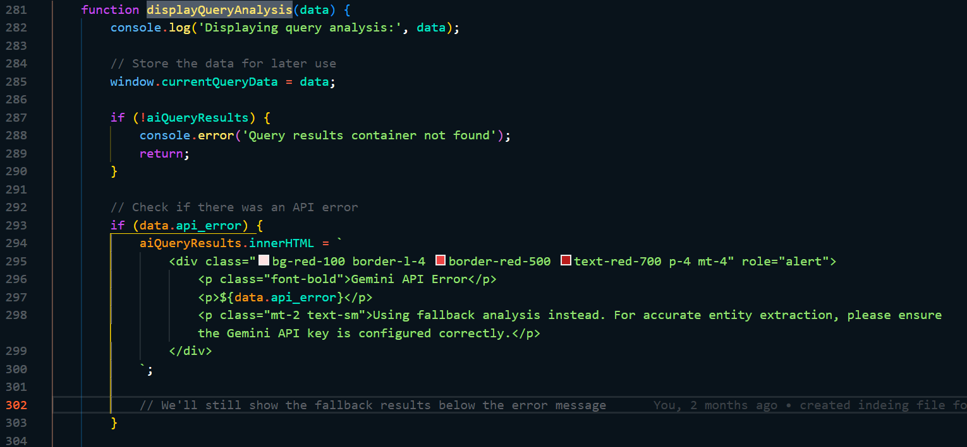 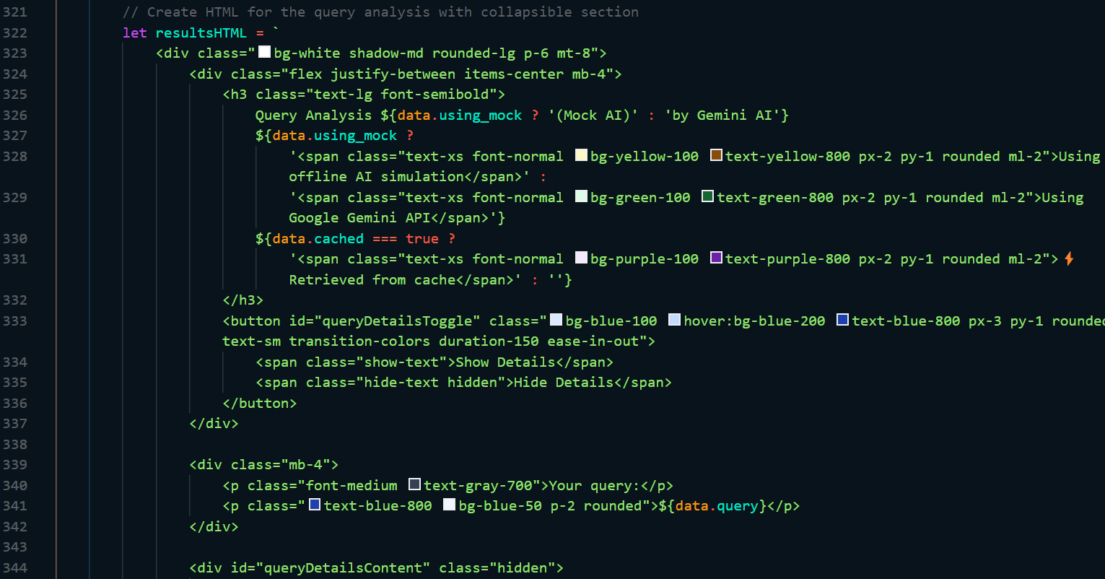 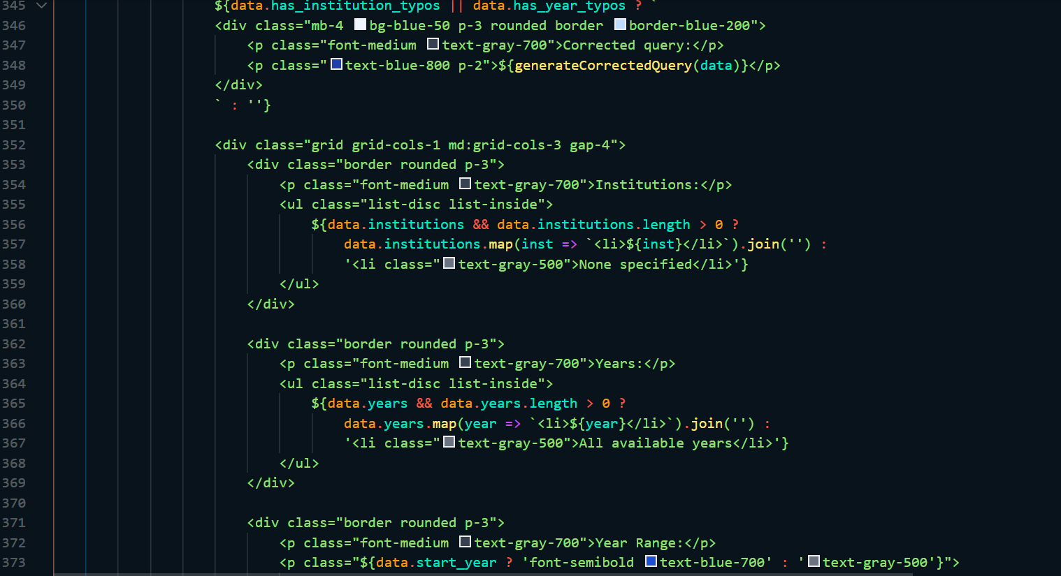 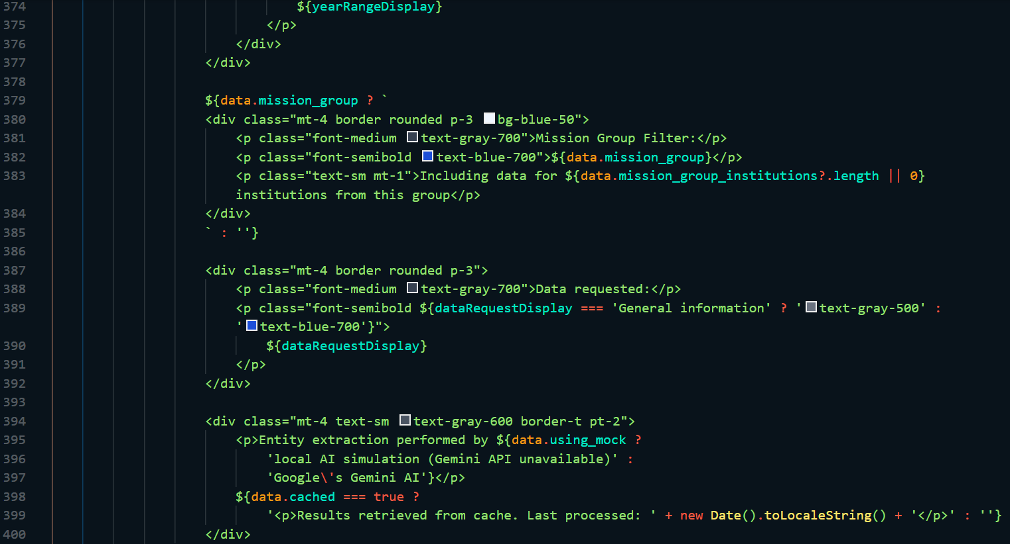 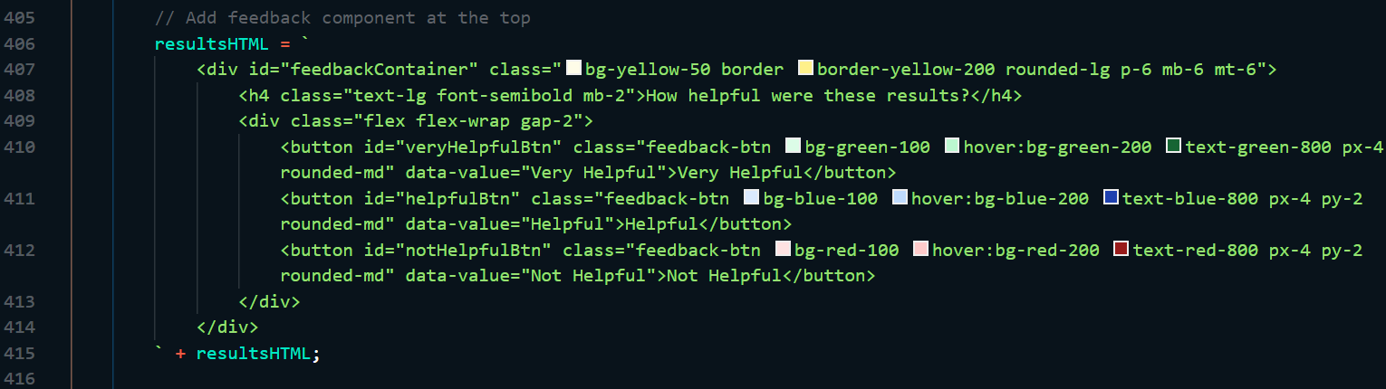

### I.2 Reviewable Dataset

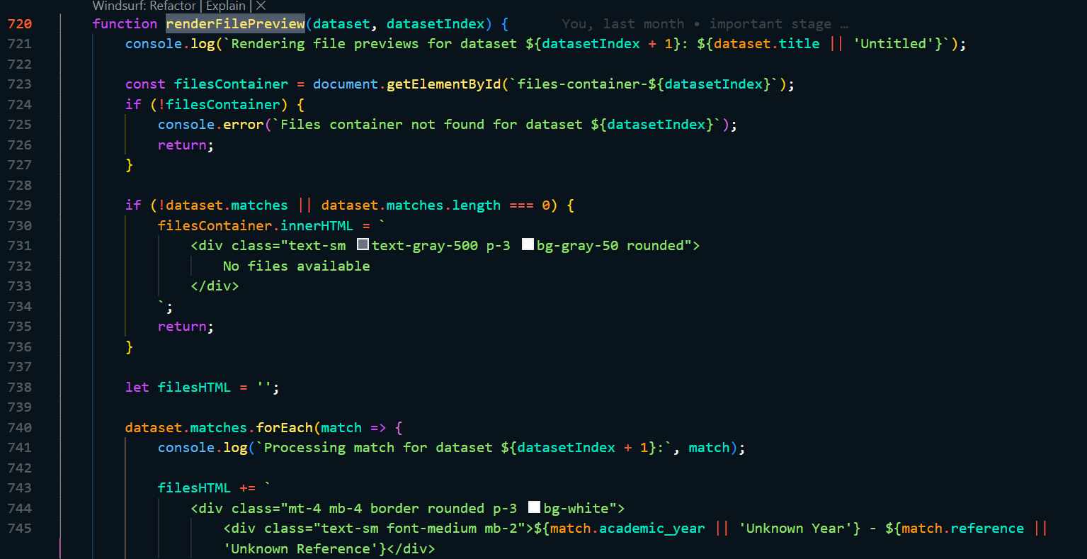 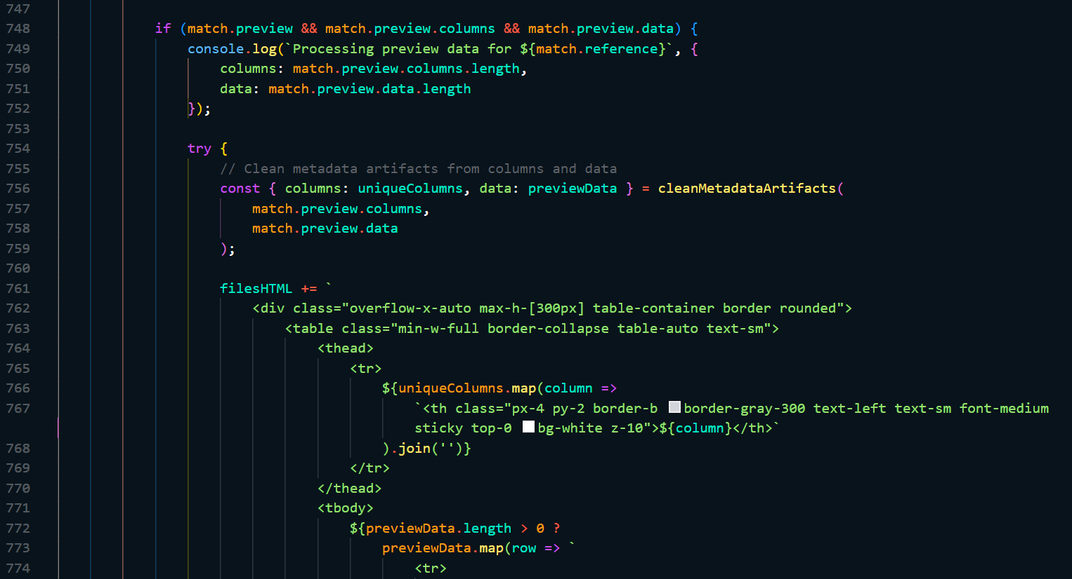 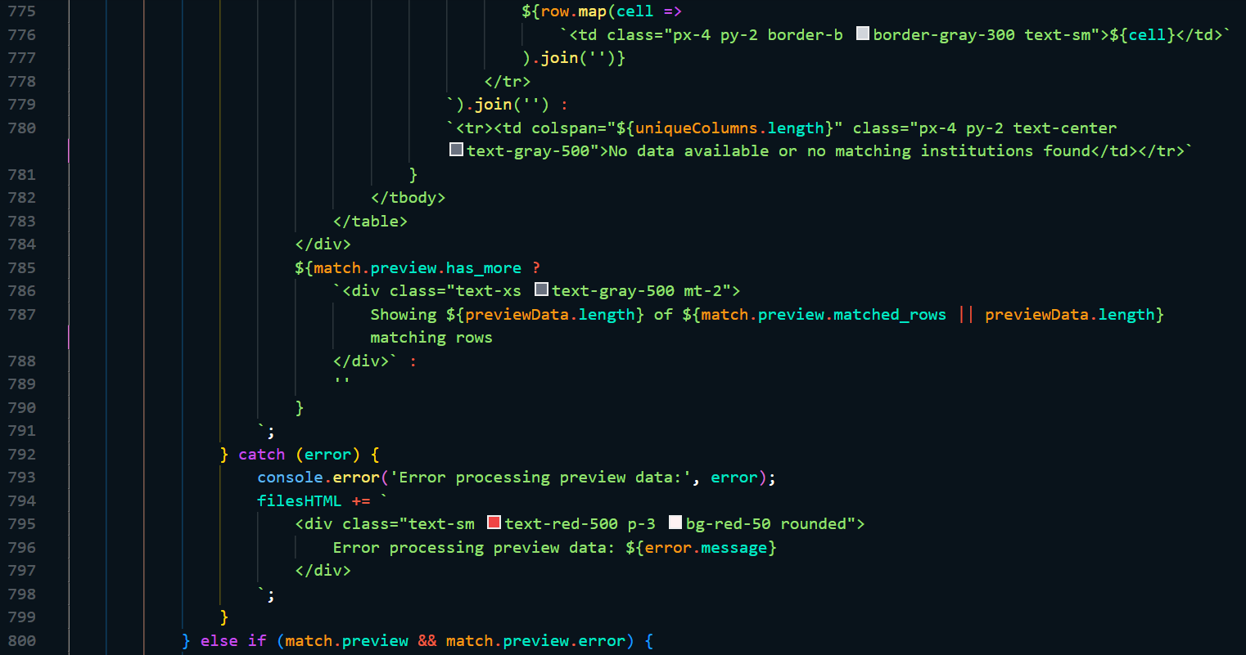 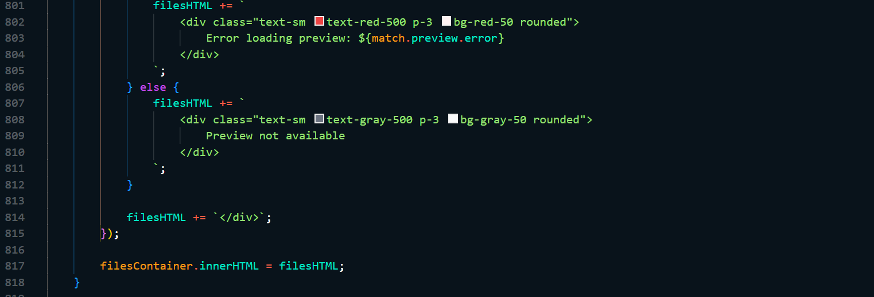

### I.3 Manage loading states

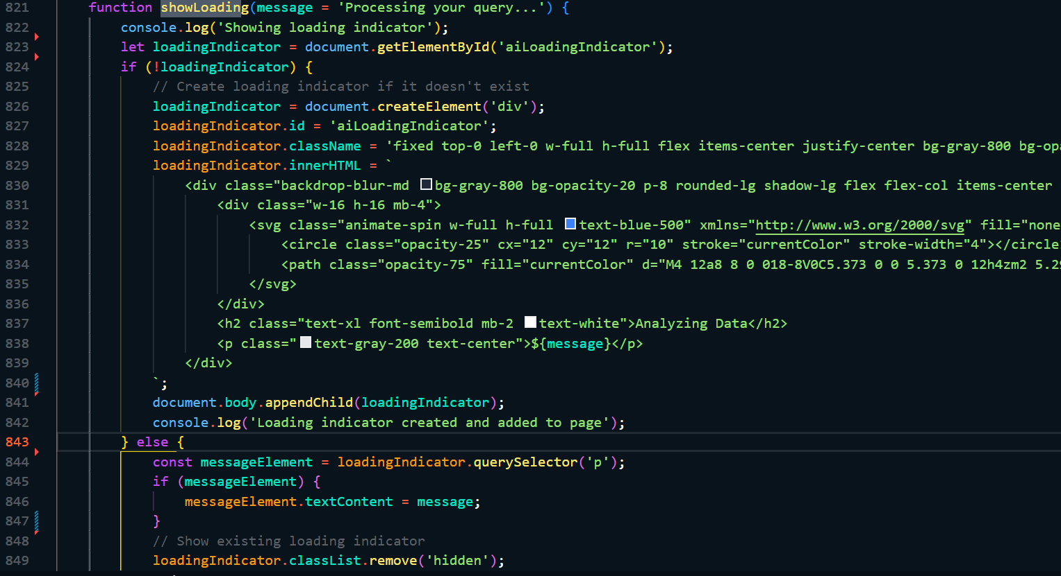

### I.4 Query Input

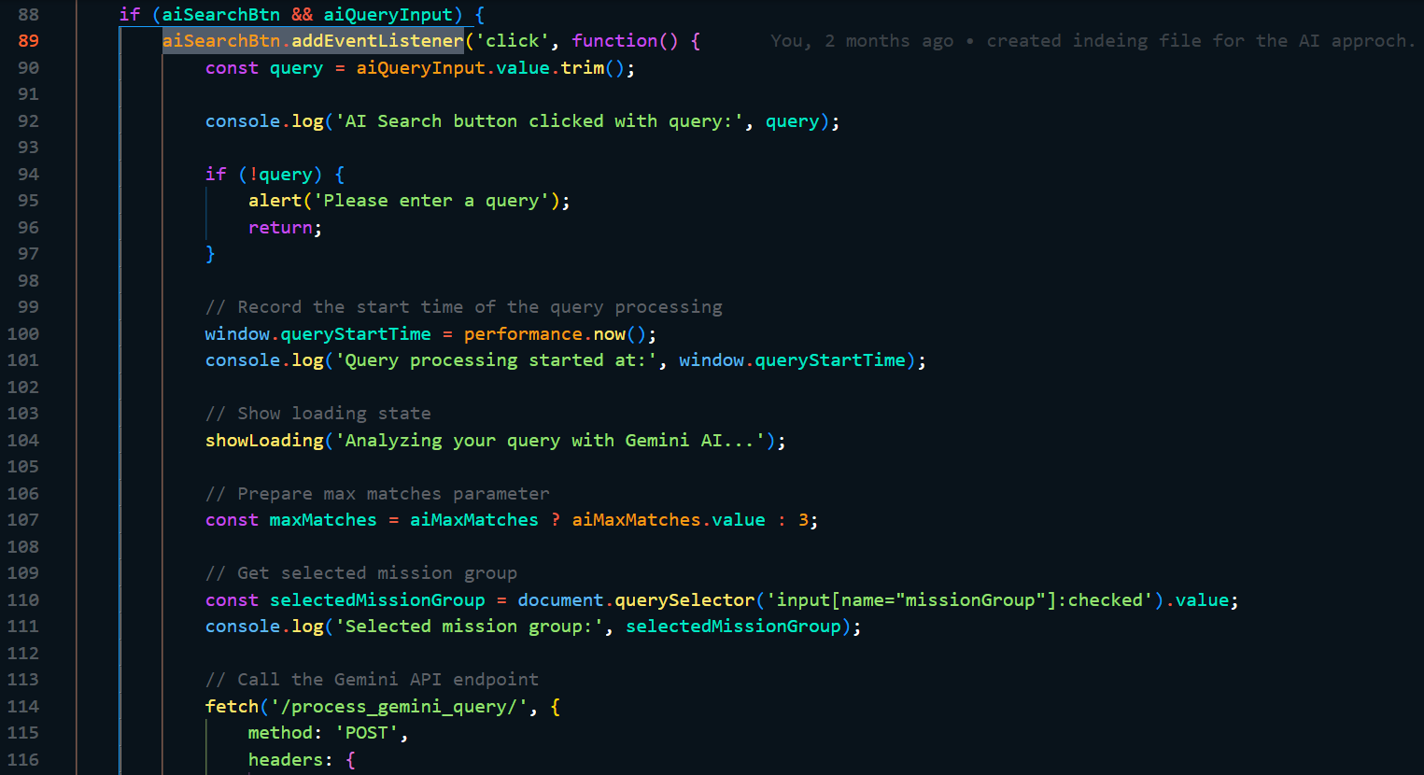 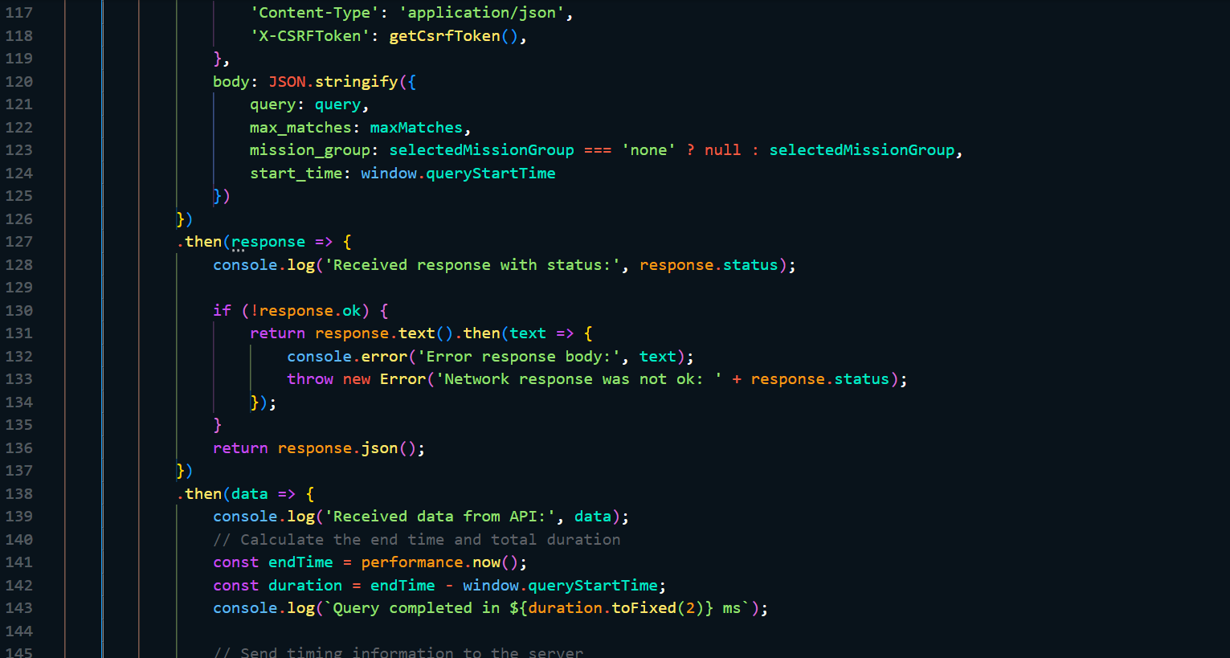 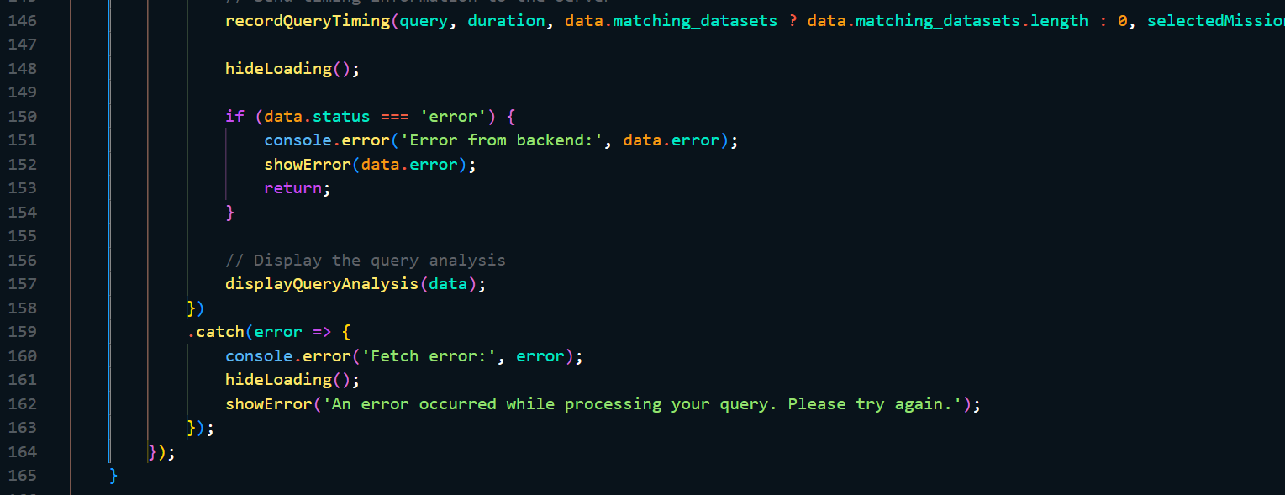

### I.5: Exporting data

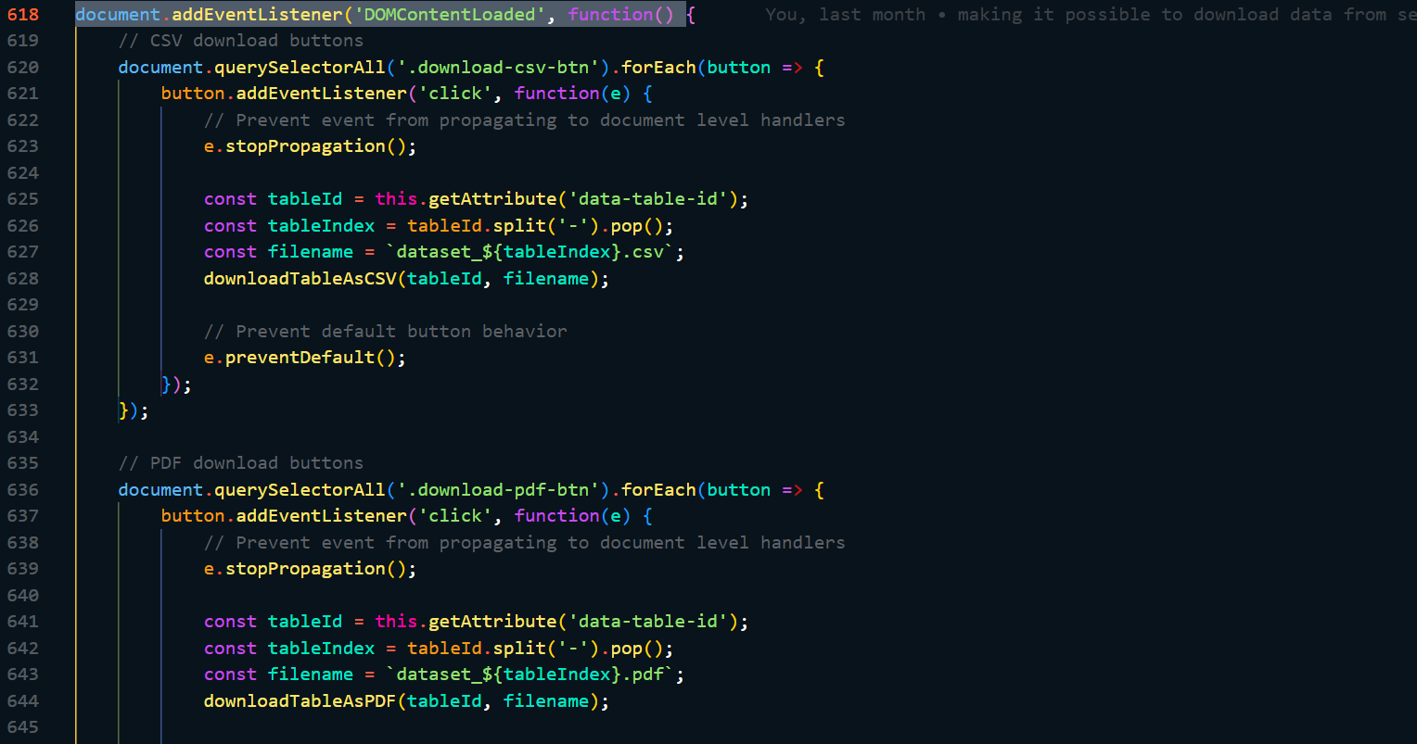 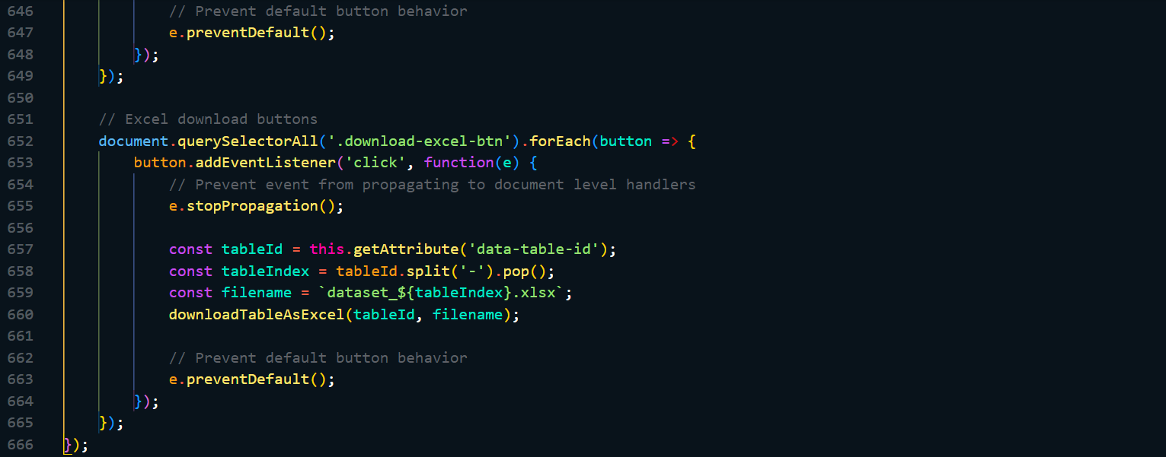

### I.6 Prepare Data for Clean Display

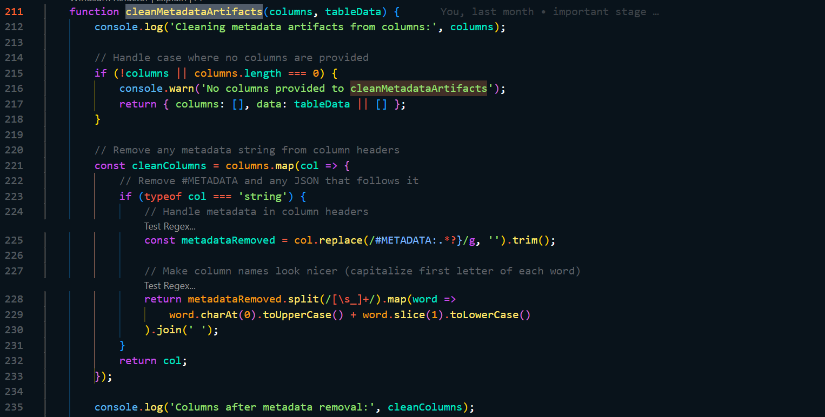 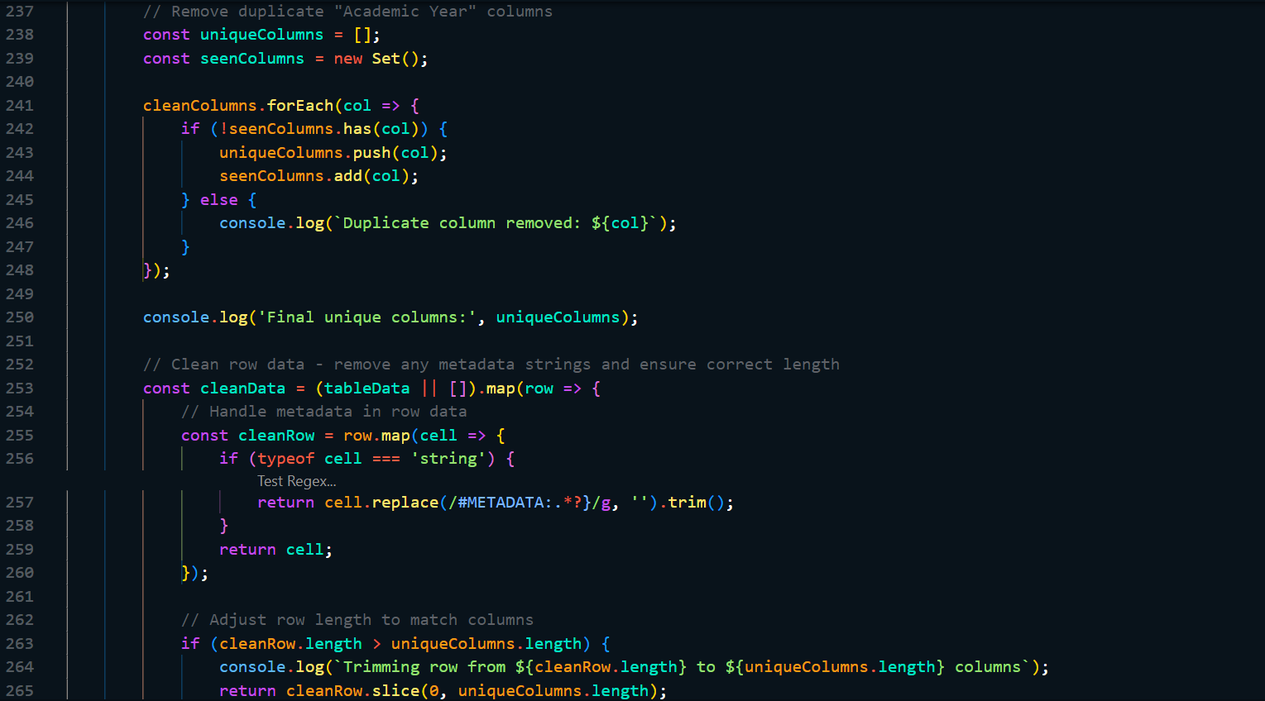 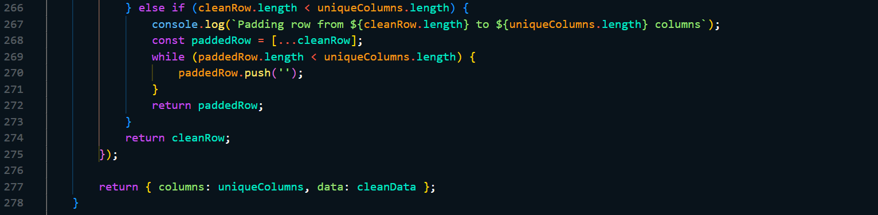

### I.7 Dynamic dataset preview toggle

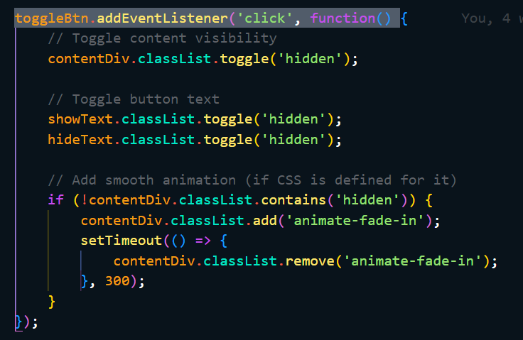

## J: Feedback System

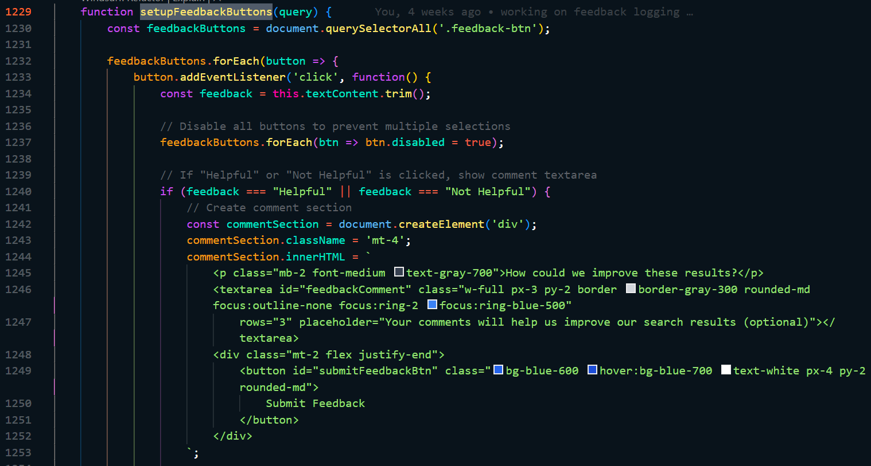 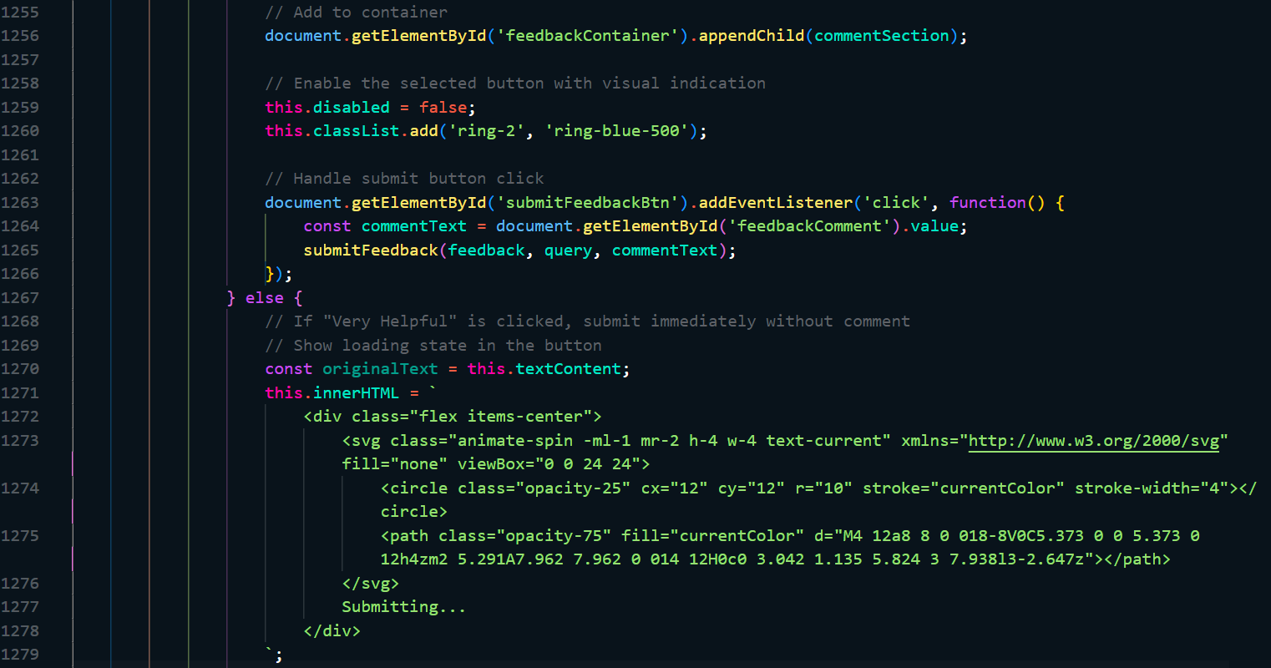 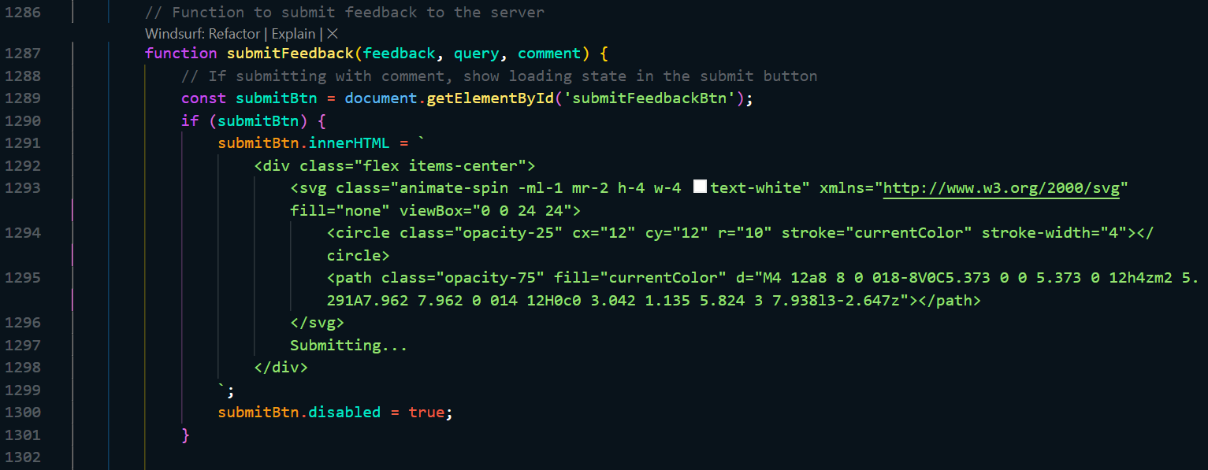 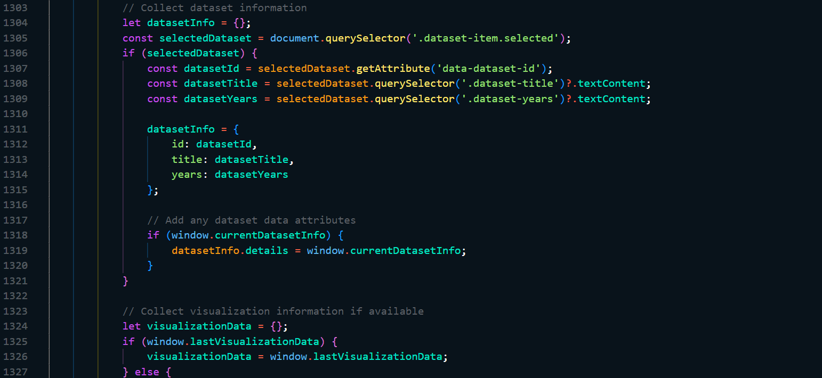 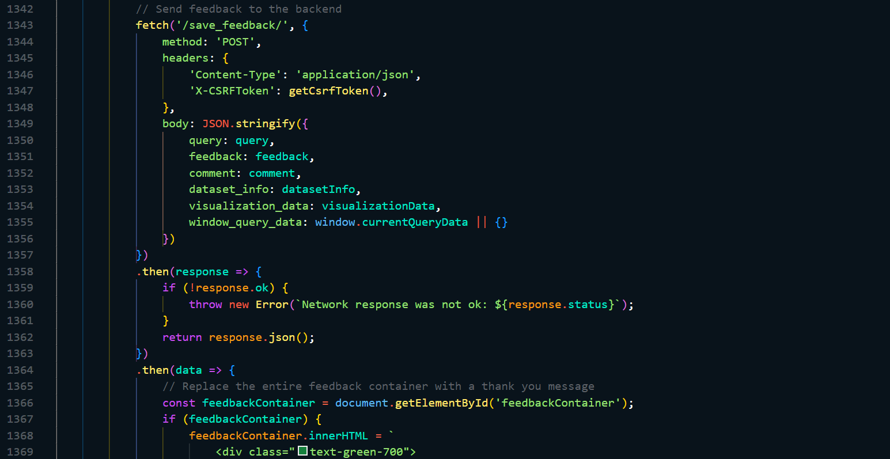 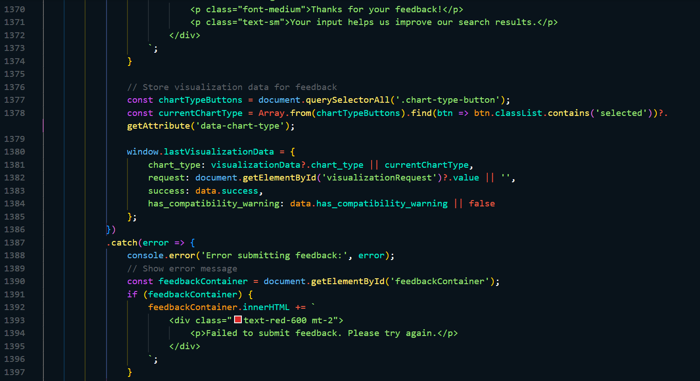

## K: Caching

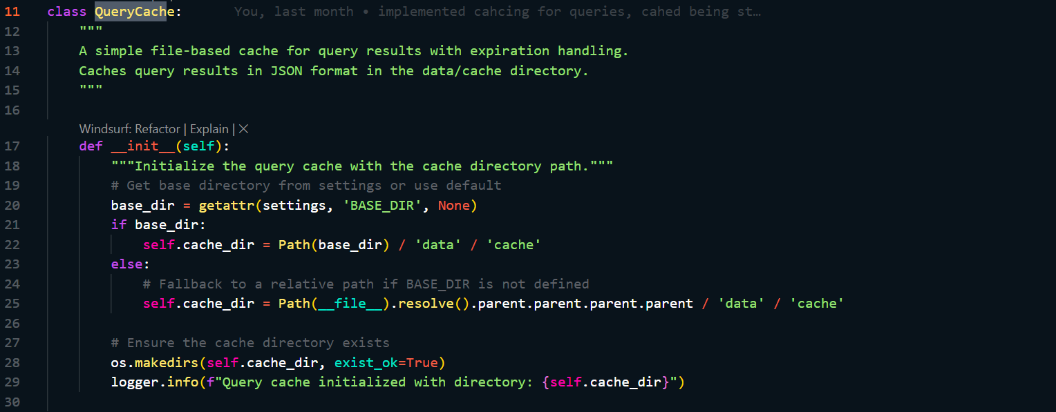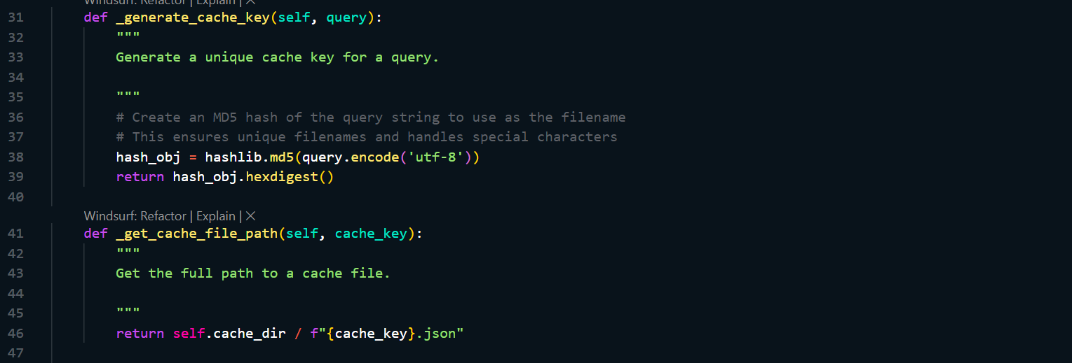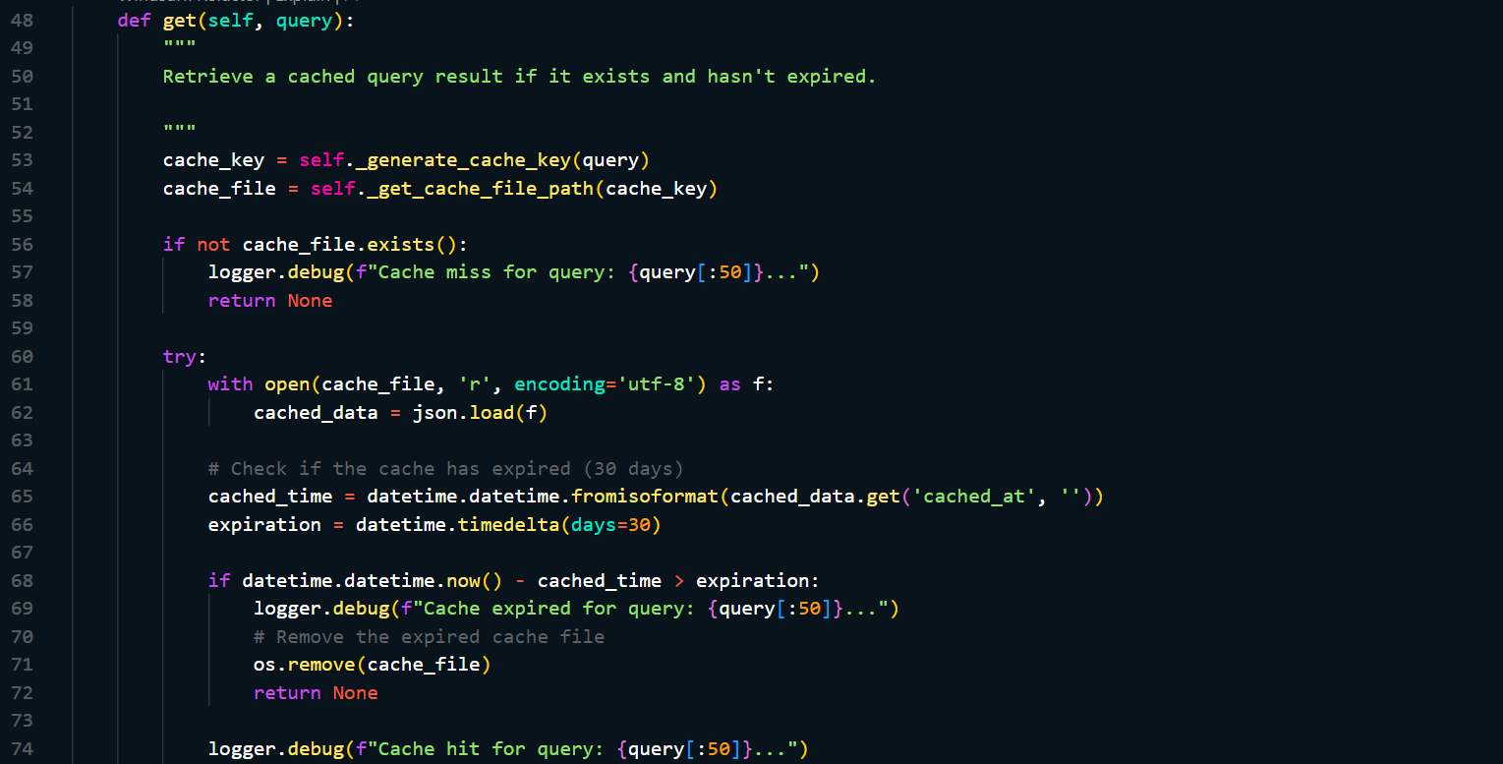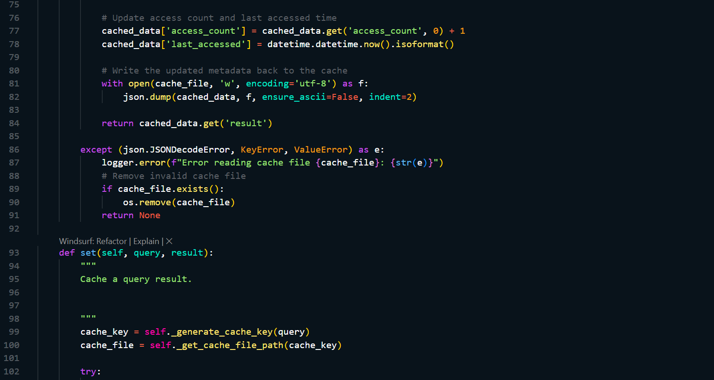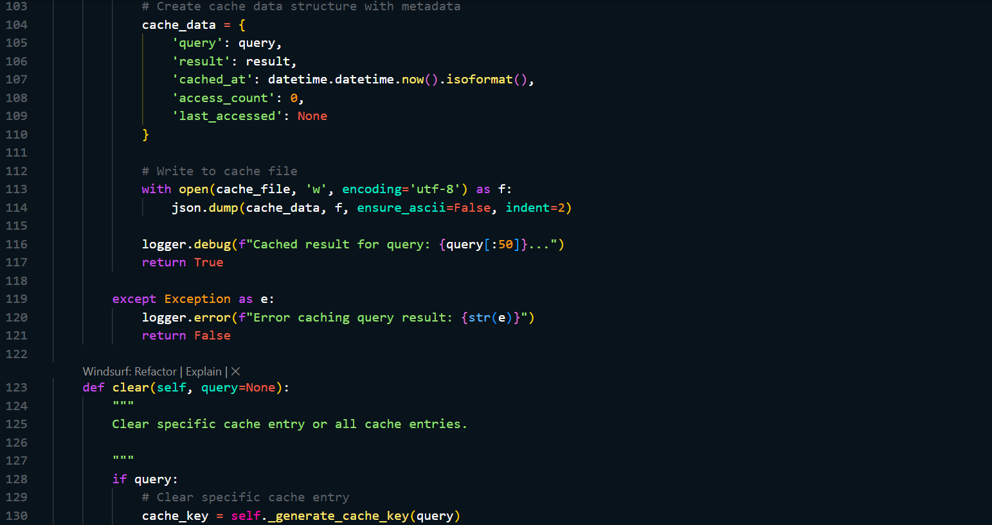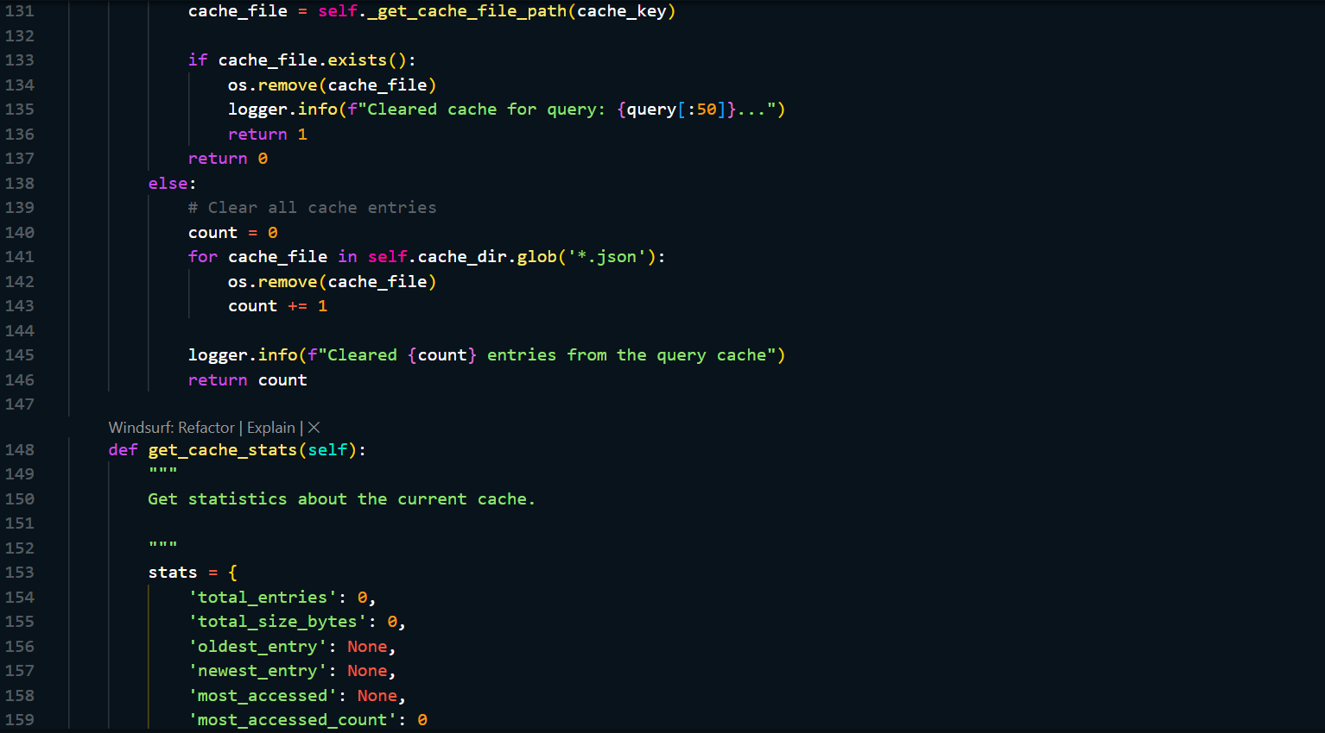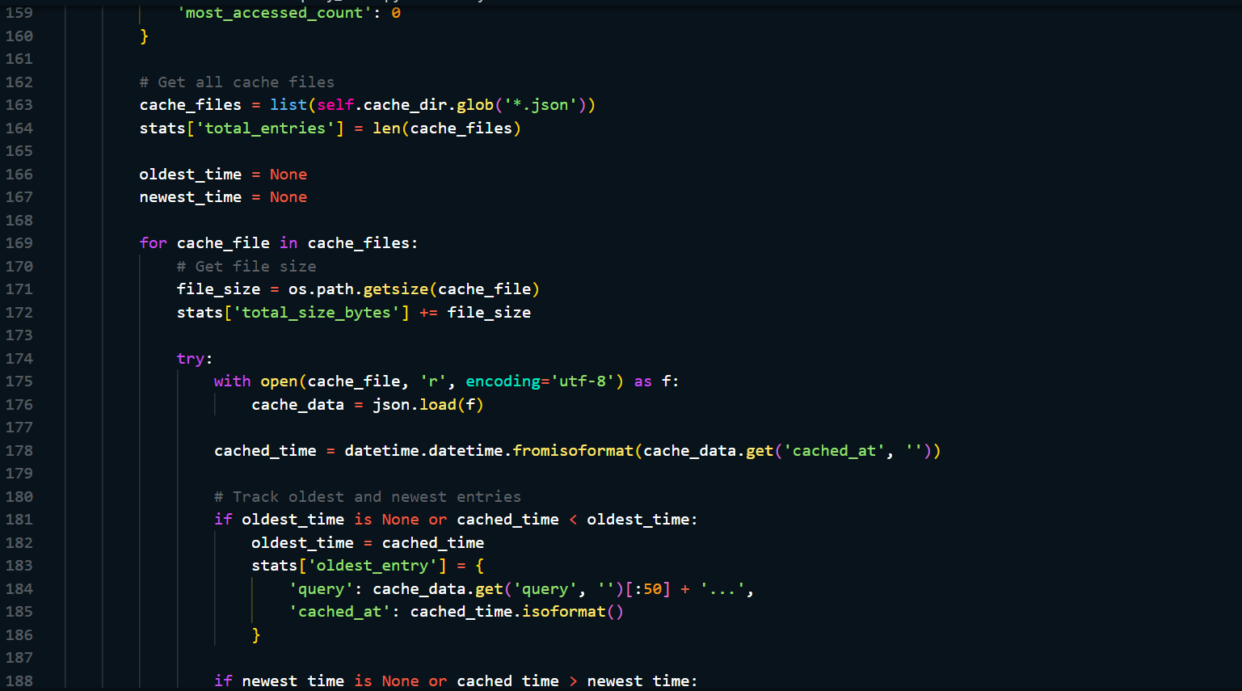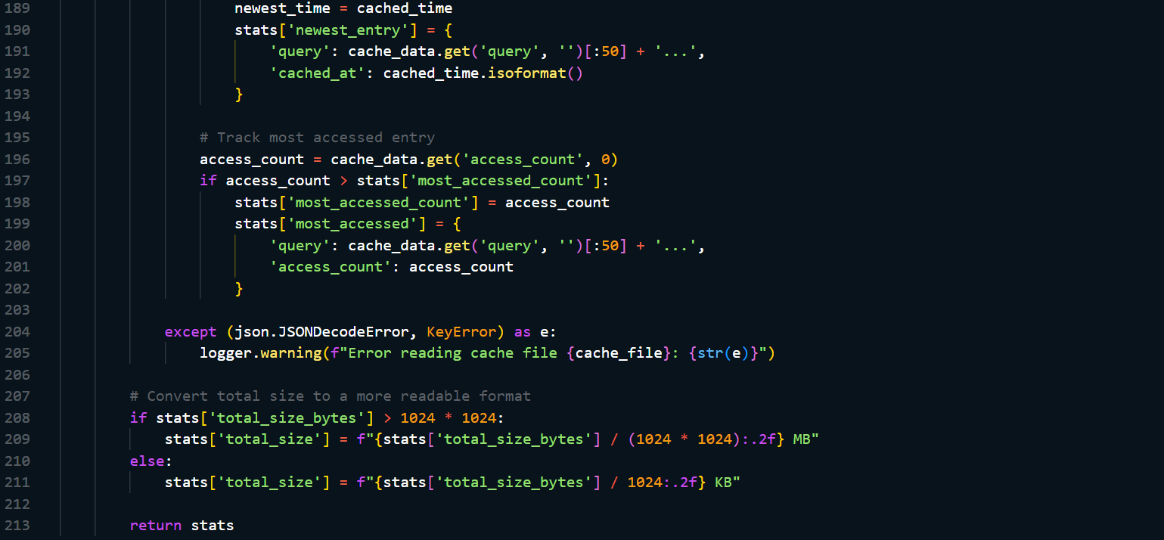

## L: Gemini Client

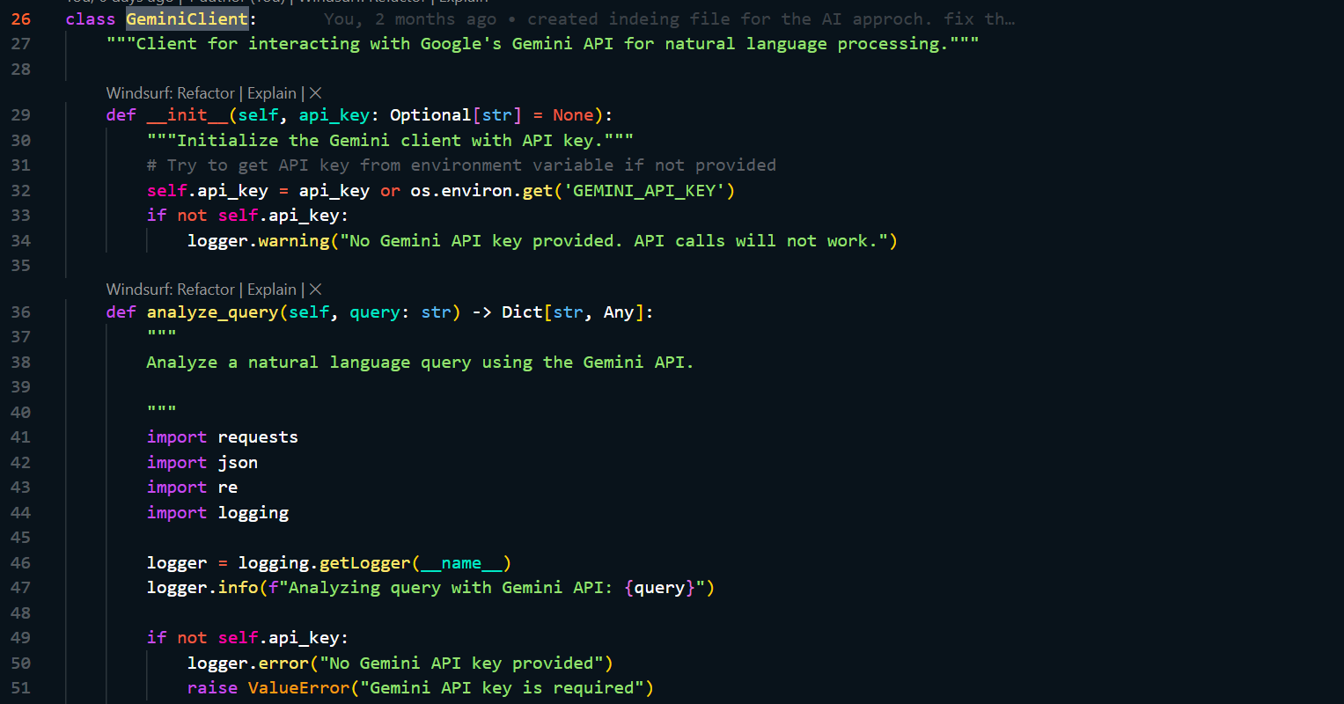 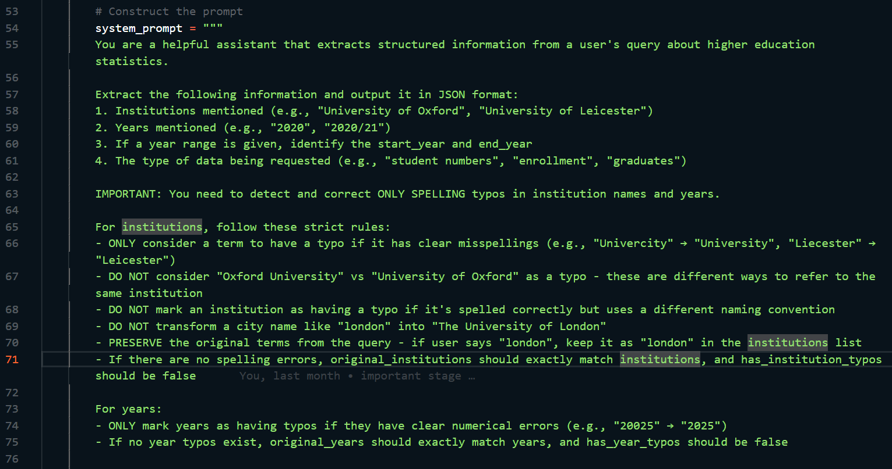 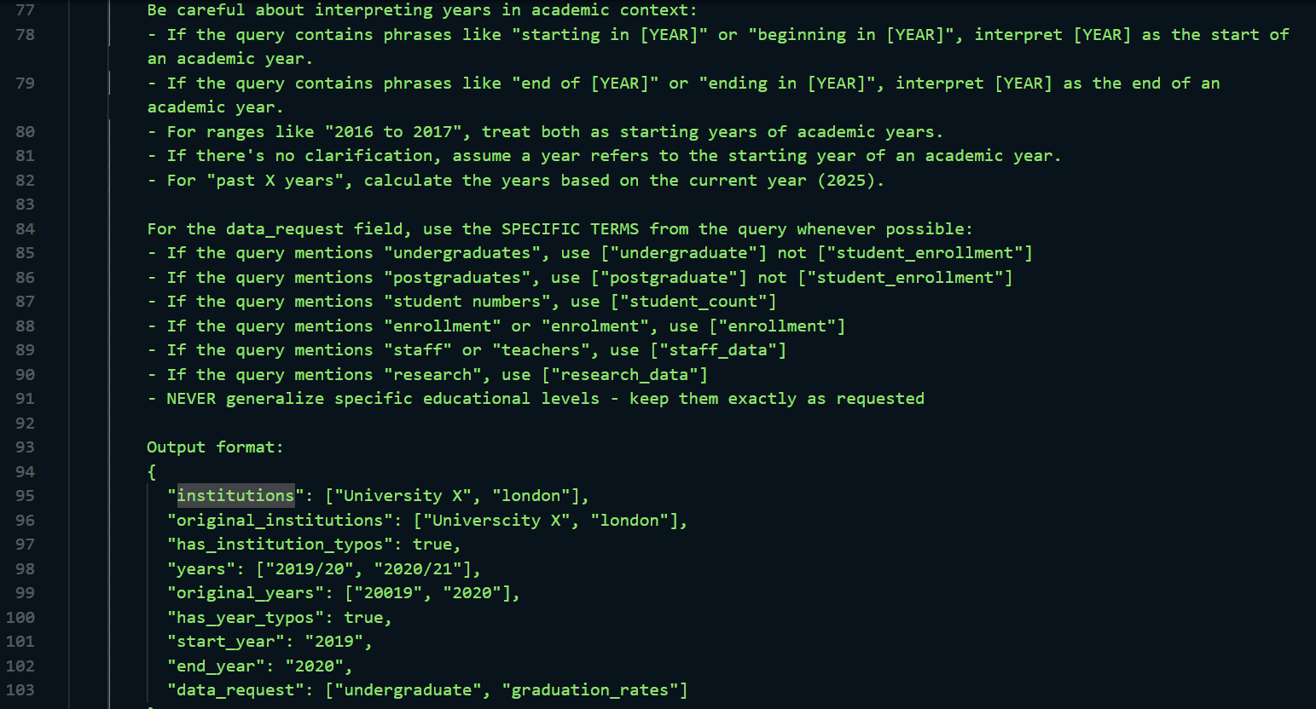 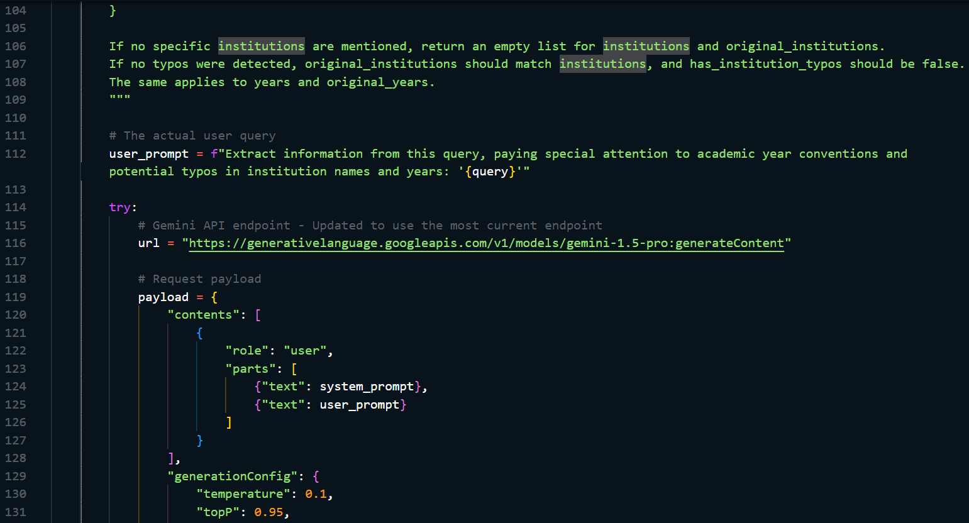 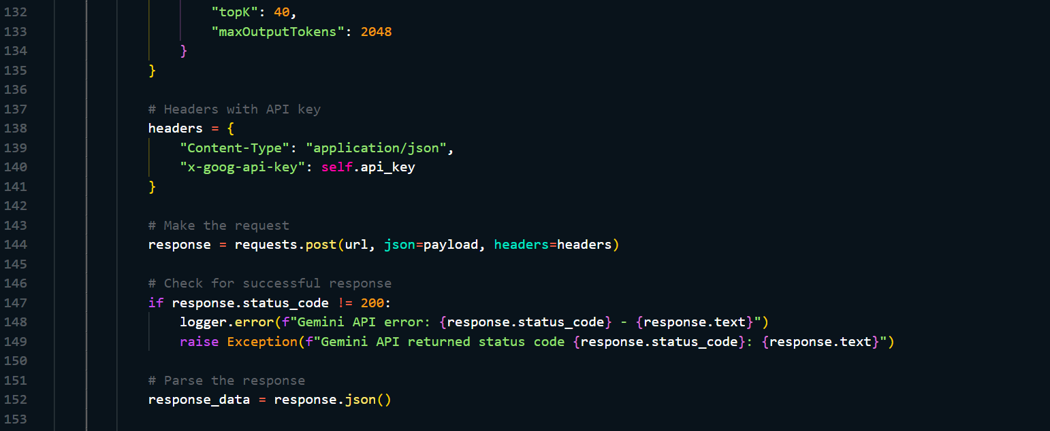 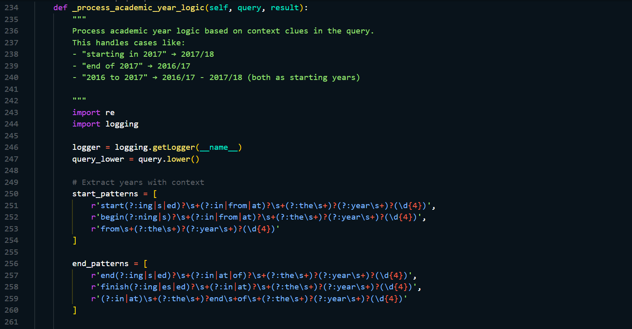 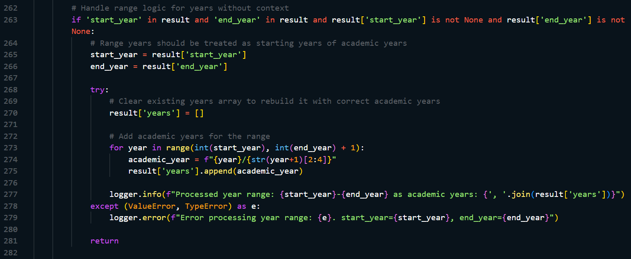 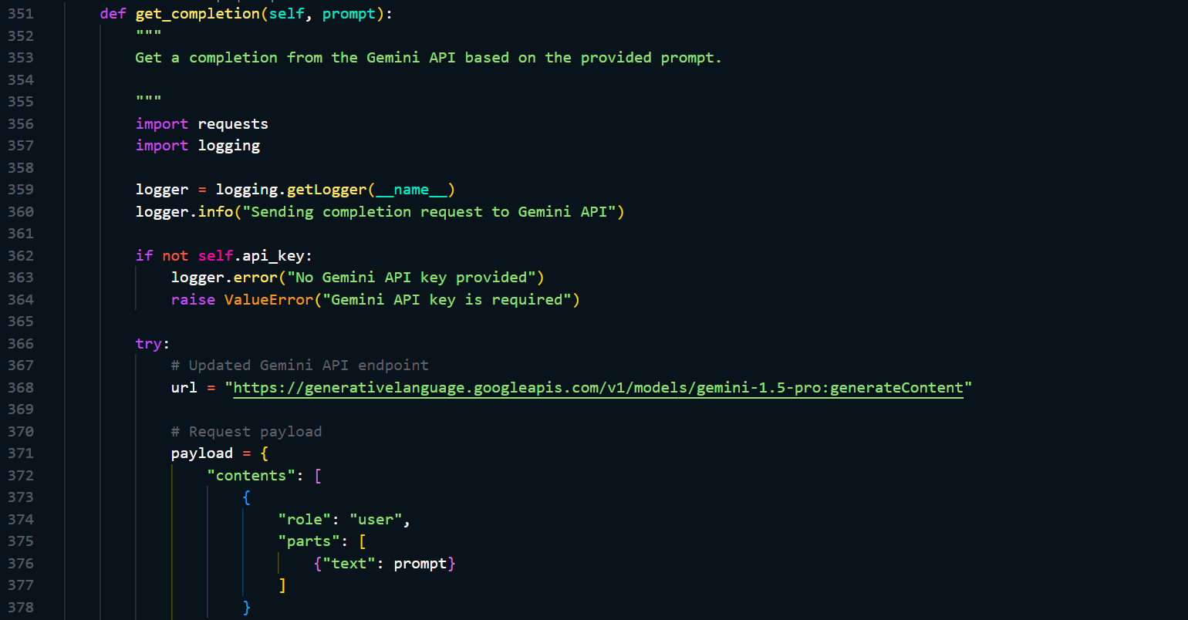 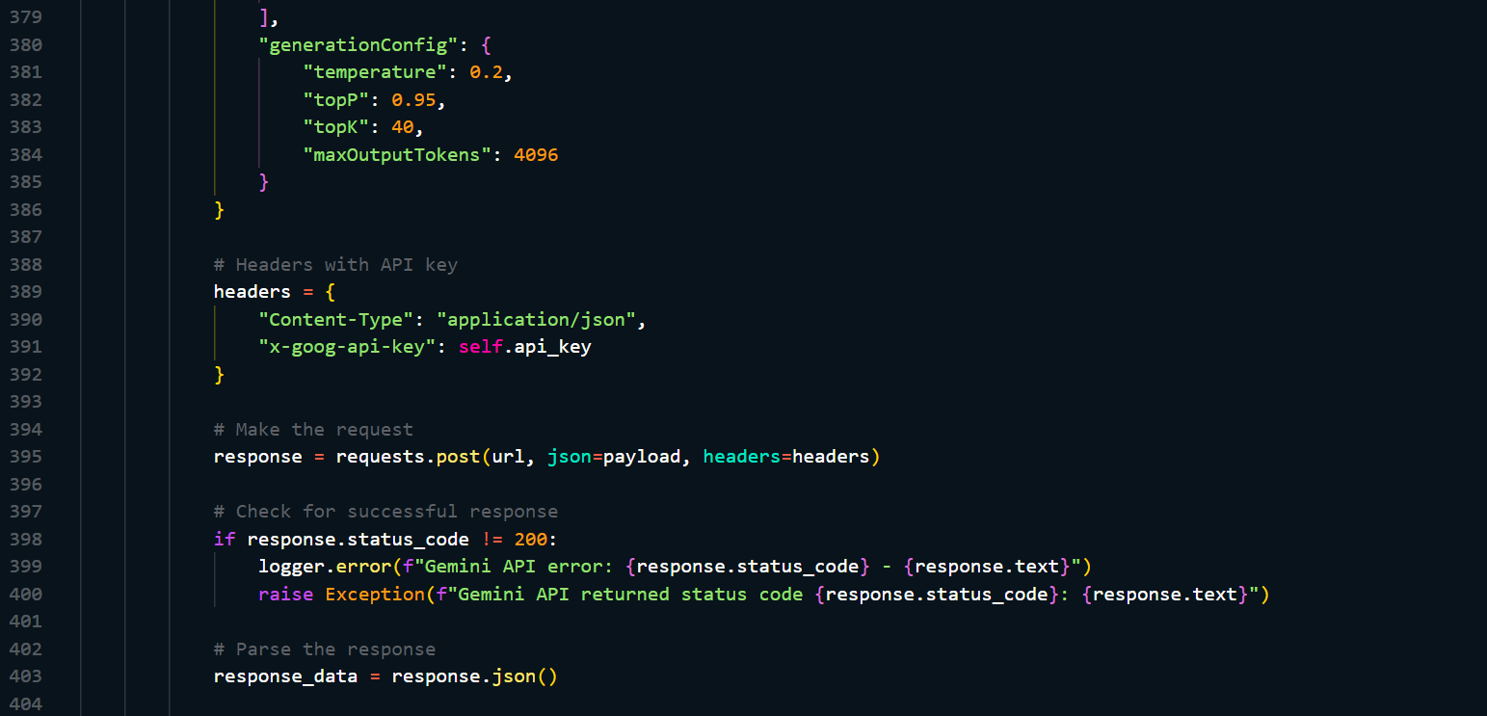 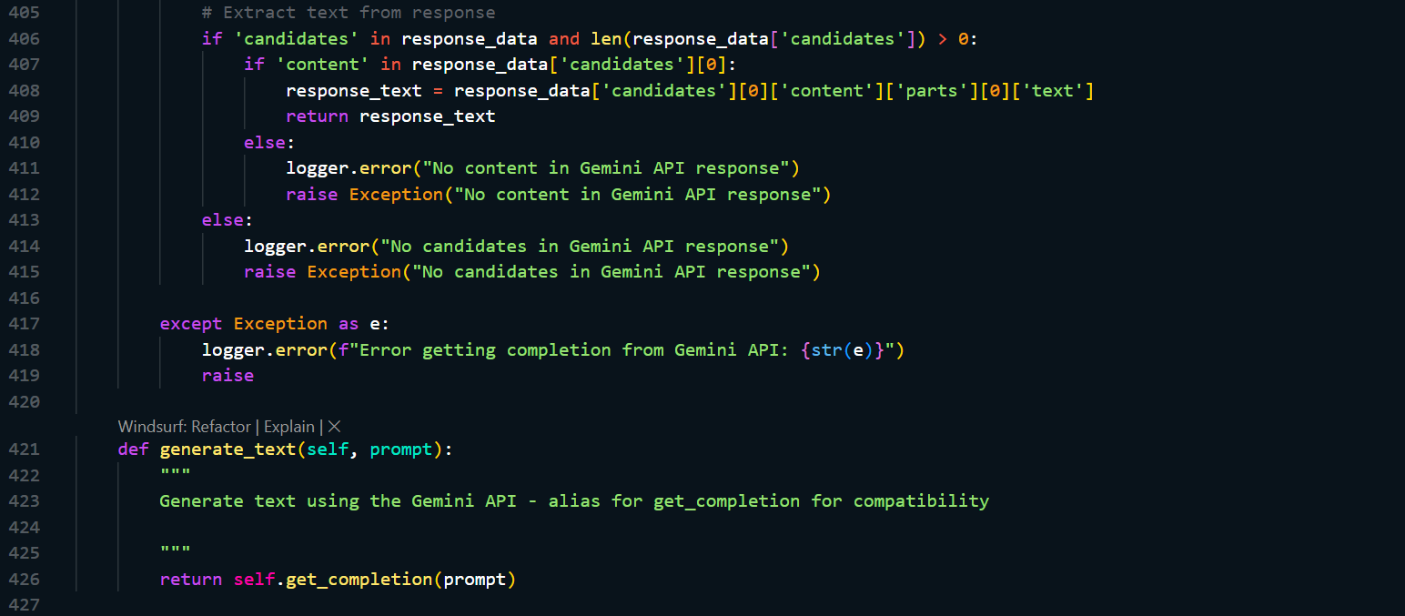

## M: Timing Queries

### M.1 Recording the time of query processing

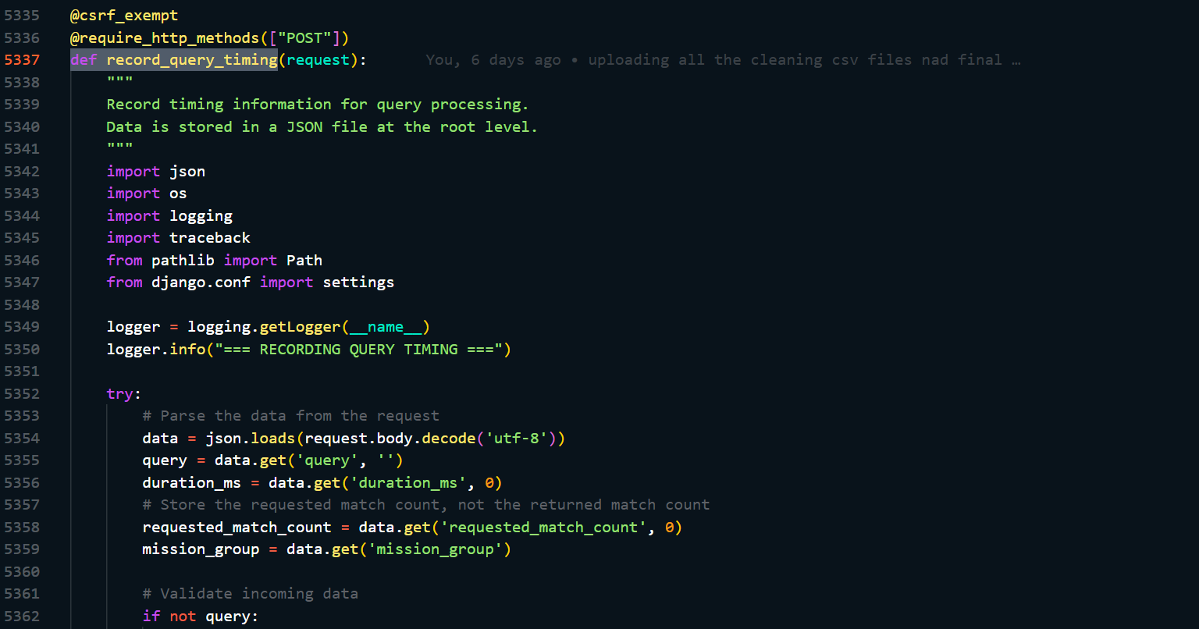 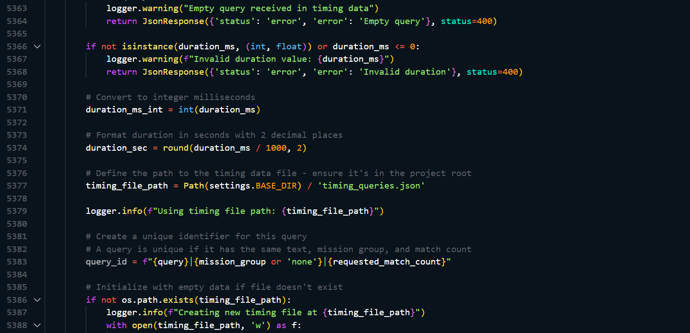 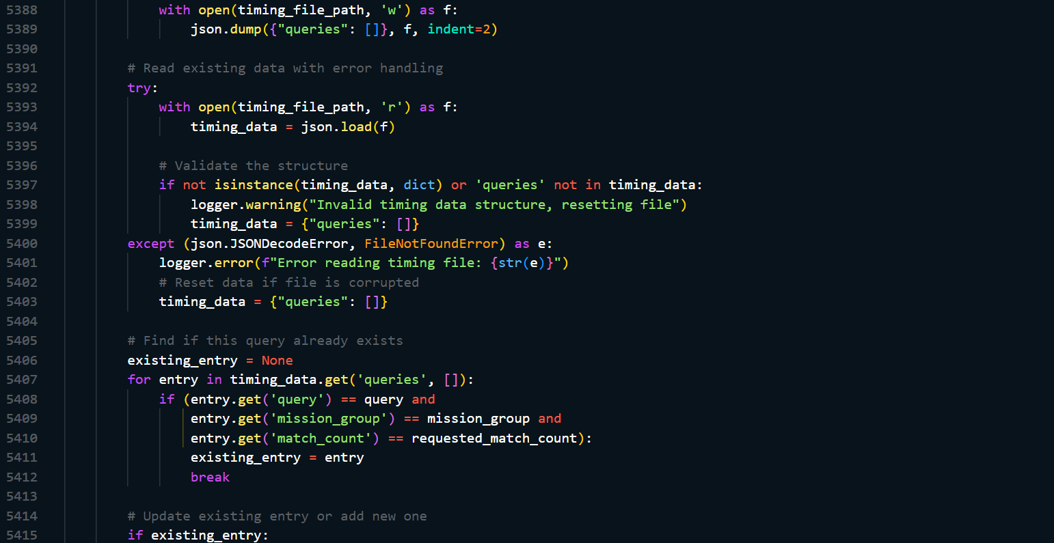 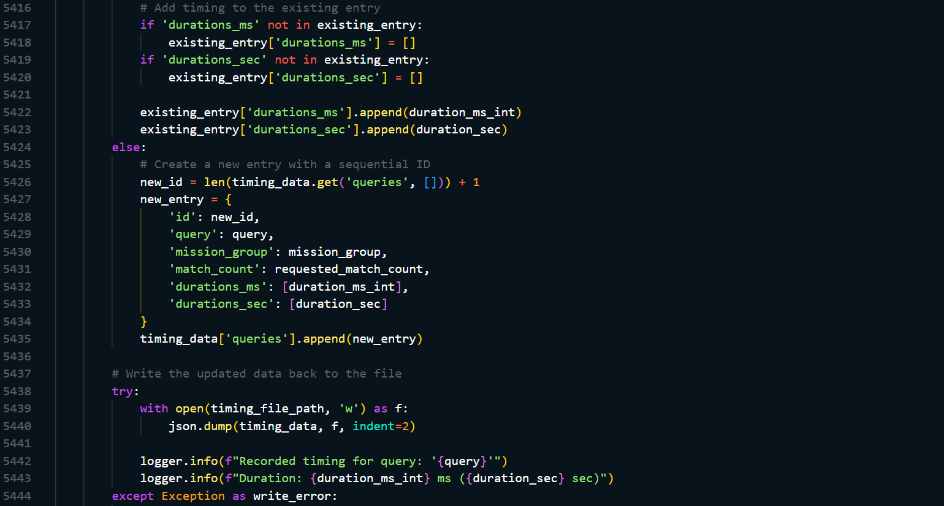 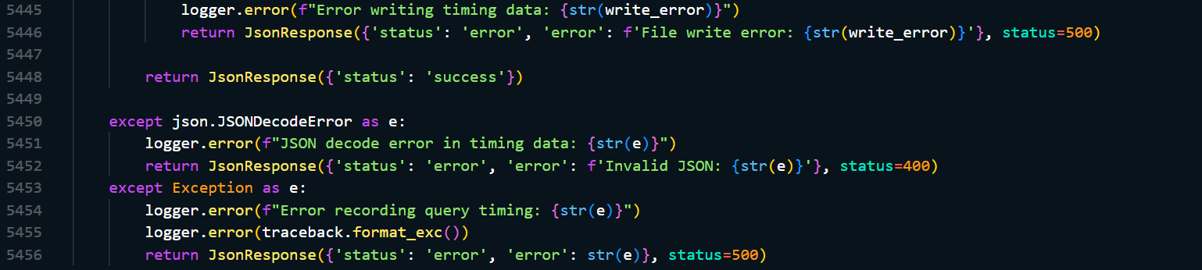

### M.2 Recorded time of processed queries

